1.Draw the V-Model diagram on paper or using any digital tool, and clearly label each phase with both the developer and tester roles involved at each step.

- V-Model:-

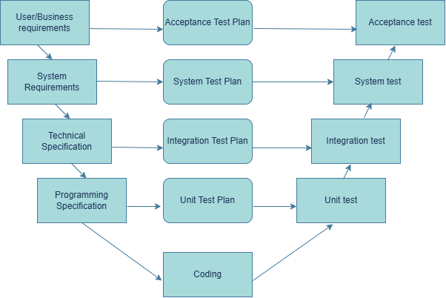

- First phase is developer parts.
- Second phase is process parts.
- Third phase is testing parts.

- DEVELOPER and TESTER phase and roles:-

Development Phase | Developer Role | Testing Phase | Tester Role
Business Requirements | Understand client requirements and prepare requirement documents. | Acceptance Testing | Verify the software meets business requirements and user expectations.
System Requirements | Create system specifications and architecture. | System Testing | Test the complete application to ensure all features work correctly.
High-Level Design (HLD) | Design modules and define interactions between them. | Integration Testing | Verify that different modules communicate correctly.
Low-Level Design (LLD) | Design classes, methods, and program logic. | Unit Testing | Developers test individual functions or modules before integration.
Coding | Write and implement the application code. | Bug Fixing & Retesting | Testers verify fixes and perform regression testing after developers resolve defects.

2.Pick any app you use daily (like Zomato, Instagram, or Paytm) and write a short table mapping each SDLC phase (Requirement, Design, Coding, Testing, Deployment, Maintenance) to a real activity that would happen for that app.

- SDLC Phases Mapping – Paytm App

SDLC Phase | Real Activity in Paytm
Requirement | Gather requirements for a new UPI Payment feature, such as QR code scanning and instant money transfer.
Design | Design the UPI payment screen, QR scanner interface, transaction flow, database, and security architecture.
Coding | Developers implement QR code scanning, UPI PIN verification, transaction processing, and payment confirmation.
Testing | Testers verify successful payments, invalid UPI PIN, insufficient balance, network failure handling, transaction history, and payment notifications.
Deployment | Release the UPI payment feature to production through the Play Store, App Store, and Paytm servers.
Maintenance | Monitor transactions, fix payment-related bugs, improve security, optimize performance, and release updates based on user feedback.

3.For each phase of the V-Model, list one specific testing activity that should be performed, using examples from a food delivery app (like Swiggy or Zomato).<br><br><em><strong>Hint:</strong> For example, during 'System Testing', you might test if the order placement works end-to-end.</em> .

V-Model Phase | Specific Testing Activity | Example
Business Requirement → Acceptance Testing (UAT) | Verify that the feature satisfies business requirements. | Confirm that users can place an order, receive food, and track the delivery as expected by the business.
System Requirement → System Testing | Test the complete application from end to end. | Verify the complete flow: Login → Search Restaurant → Add Food → Apply Coupon → Payment → Order Confirmation → Live Tracking.
High-Level Design (HLD) → Integration Testing | Verify that different modules work together correctly. | Check that the Restaurant, Payment, and Order Tracking modules communicate properly after an order is placed.
Low-Level Design (LLD) → Unit Testing | Test individual functions or methods. (Usually performed by developers.) | Verify that the discount calculation function correctly applies a 20% promo code and calculates the final amount.
Coding / Implementation | Perform code review and unit test execution before integration. | Developers test the "Add to Cart" function to ensure items are added correctly and the cart total is updated.

4.Compare the V-Model and RAD Model by listing 3 strengths and 2 weaknesses of each, focusing on how testing is handled in both models.

Model | Strengths | Weaknesses
V-Model | 1. Testing is planned from the beginning of the project.  2. Every development phase has a corresponding testing phase, making defects easier to detect early.  3. Well-suited for projects with clear and stable requirements, ensuring thorough testing and documentation. | 1. Difficult to accommodate requirement changes once development has started.  2. Testing begins after coding for each module, so the overall process can be time-consuming.
RAD (Rapid Application Development) | 1. Testing is performed continuously during development through frequent prototypes.  2. Quick user feedback helps identify and fix defects early.  3. Faster delivery because development and testing happen in short iterations. | 1. Less documentation may cause some test scenarios to be missed.  2. Not suitable for large or complex systems where extensive testing and stability are required.

