1.Create a table comparing Agile and Waterfall models across 5 factors relevant to software testing, such as requirements, feedback cycle, tester involvement, documentation, and flexibility.

Agile vs Waterfall Models (Software Testing Comparison)

Factor | Agile Model | Waterfall Model
Requirements | Can change during development. | Fixed before development starts.
Feedback Cycle | Continuous feedback after each sprint. | Feedback usually comes after the full project is completed.
Tester Involvement | Testers are involved from the beginning of the project. | Testers mainly start after the development phase is completed.
Documentation | Minimal and updated as needed. | Detailed documentation is created before development.
Flexibility | Highly flexible and adapts to changes easily. | Less flexible; changes are difficult and costly.

2.Pick any app you use daily (like Instagram, Zomato, or Paytm) and describe how the testing process would look different if the team used Agile instead of Waterfall. Mention at least 3 specific testing activities or practices that would change.
App Chosen: Instagram
If the Instagram team used Agile instead of Waterfall, the testing process would be different in the following ways:

Testing Activity | Agile | Waterfall
Testing Time | Testing is done in every sprint along with development. | Testing starts only after all development is completed.
Bug Fixing | Bugs are fixed immediately in the same sprint. | Bugs are fixed after the testing phase, which may take longer.
Regression Testing | Regression testing is performed after every sprint or feature update. | Regression testing is usually done once before the final release.

- Conclusion
In Agile, testing is continuous, faster, and involves close collaboration between developers and testers. In Waterfall, testing happens at the end of the project, making feedback and bug fixes slower.

3.Draw a simple workflow diagram showing the main roles (such as Scrum Master, Product Owner, Development Team, Tester) and ceremonies (like Sprint Planning, Daily Standup, Sprint Review) in a SCRUM process.
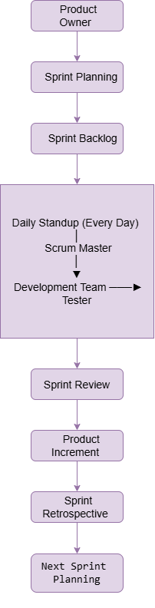
4.For a food delivery app (like Swiggy), map out which testing activities should happen during each phase of a typical Agile sprint (e.g., backlog grooming, sprint planning, development, review).<br><br><em><strong>Hint:</strong> Include activities like writing user stories, test case design, test execution, and bug reporting.</em>
Agile Sprint Testing Activities for a Food Delivery App (Swiggy)
Agile Sprint Phase | Testing Activities
Backlog Grooming | Review user stories, understand requirements, identify test scenarios, clarify acceptance criteria.
Sprint Planning | Estimate testing effort, prepare test plan, design test cases, identify test data.
Development | Execute test cases, perform functional testing, report bugs, verify bug fixes, run regression testing.
Sprint Review | Demonstrate tested features, validate acceptance criteria, collect stakeholder feedback, verify completed user stories.

- Example
Feature: Apply Coupon
- Backlog Grooming: Understand coupon rules and acceptance criteria.
- Sprint Planning: Create test cases for valid, invalid, and expired coupons.
- Development: Test coupon functionality, report defects, and retest after fixes.
- Sprint Review: Demonstrate the coupon feature and confirm it meets business requirements.

