1.Create a decision table for a Flipkart-style coupon validation system where a coupon is only valid if: (1) the user is logged in, (2) the cart value is above ₹500, and (3) the coupon has not expired. Show all possible combinations and the resulting action (accept/reject).

1. Decision Table – Flipkart-Style Coupon Validation
Conditions
A coupon is accepted only when all three conditions are true:
- User is logged in.
- Cart value is above ₹500.
- Coupon is not expired.

Rule | Logged In? | Cart Value > ₹500? | Coupon Not Expired? | Action
R1 | Yes | Yes | Yes | Accept Coupon
R2 | Yes | Yes | No | Reject
R3 | Yes | No | Yes | Reject
R4 | Yes | No | No | Reject
R5 | No | Yes | Yes | Reject
R6 | No | Yes | No | Reject
R7 | No | No | Yes | Reject
R8 | No | No | No | Reject

2.Draw a state transition diagram for a Paytm login feature that locks the account after 3 failed password attempts and only unlocks after a successful OTP verification.

State Transition Diagram – Paytm Login
Requirement
- User gets 3 password attempts.
- After 3 failed attempts, the account becomes Locked.
- A successful OTP verification is required to unlock the account.
State Diagram
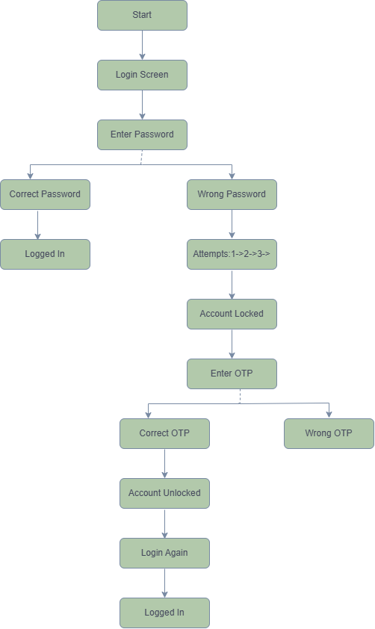

3.Given the following use case: 'A Zomato user can place an order, cancel it before it is prepared, or track the order once prepared,' create a use case diagram and list at least 3 possible test scenarios based on it.

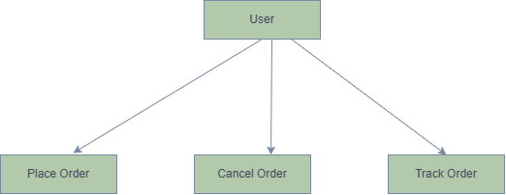

Test Scenarios
Test Scenario ID | Test Scenario | Expected Result
TS-01 | Place a food order successfully | Order is placed successfully and confirmation is displayed.
TS-02 | Cancel the order before it is prepared | Order is cancelled successfully and status changes to Cancelled.
TS-03 | Track the order after it is prepared | User can view the current order status (Prepared, Out for Delivery, Delivered).

