1.Sign up for a free Jira account, create a new project named 'Food Delivery App QA', and add a sample bug titled 'Order status not updating after payment'.

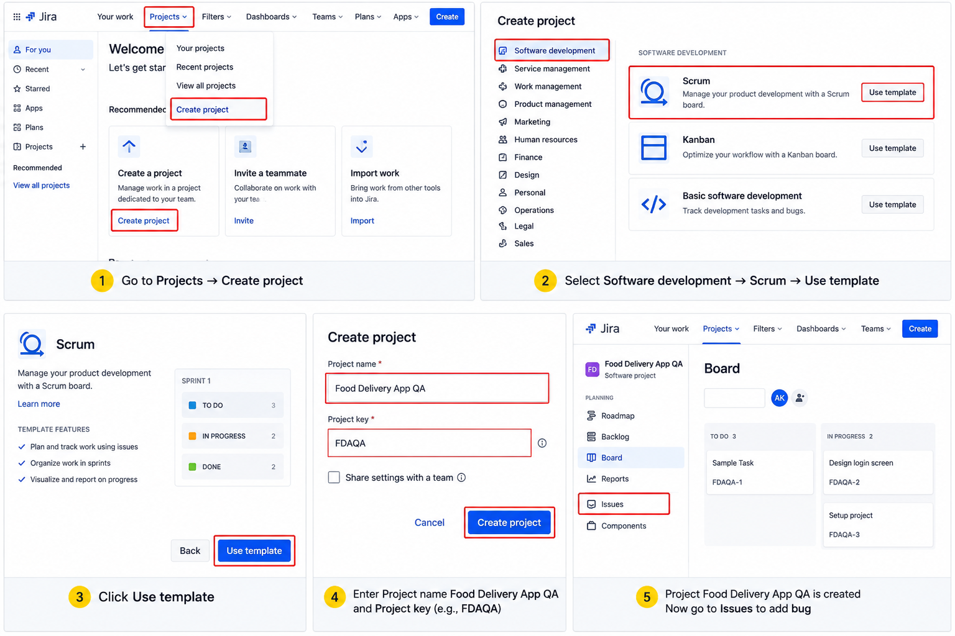

2.Fill out a defect report in Jira for a bug you found in any app you use daily (like Zomato, Flipkart, or Paytm), using all main fields: Summary, Description, Steps to Reproduce, Expected Result, Actual Result, Severity, and Priority.<br><br><em><strong>Hint:</strong> Use a real or imagined bug, but make the details specific and realistic.</em>
Jira Defect Report
Field | Details
Project | Food Delivery App QA
Issue Type | Bug
Summary | Order status not updating after successful payment
Description | After completing a successful online payment, the order status remains stuck on the payment/processing screen instead of changing to “Order Confirmed.” The payment is deducted successfully, but the customer cannot see the updated order status.
Steps to Reproduce | 1. Open the food delivery app.  2. Log in with a valid account.  3. Select any restaurant.  4. Add an item to the cart.  5. Proceed to checkout.  6. Select an online payment method.  7. Complete the payment successfully.  8. Return to the order tracking screen.
Expected Result | After successful payment, the order status should automatically update to “Order Confirmed” and the user should be able to track the order.
Actual Result | Payment is successful and the amount is deducted, but the order status remains “Processing/Payment Pending” and does not update.
Severity | High
Priority | High
Environment | Chrome / Android – latest available version
Status | Open / To Do
Reported By | Tester
Attachment | Screenshot or screen recording of the issue

Bug Title: Order status not updating after successful payment
Description:
After completing a successful online payment, the order status remains stuck on the payment/processing screen instead of changing to “Order Confirmed.” The payment is deducted successfully, but the customer cannot see the updated order status.
Steps to Reproduce:
- Open the food delivery app.
- Log in with a valid account.
- Select any restaurant.
- Add an item to the cart.
- Proceed to checkout.
- Select an online payment method.
- Complete the payment successfully.
- Return to the order tracking screen.
Expected Result:
After successful payment, the order status should automatically update to “Order Confirmed” and the user should be able to track the order.
Actual Result:
Payment is successful and the amount is deducted, but the order status remains “Processing/Payment Pending” and does not update.
Severity: High
Priority: High

3.Given these three bugs found in a movie ticket booking app: (1) Payment fails for UPI, (2) Movie poster image is blurry, (3) App crashes if you book more than 10 tickets at once — classify each bug as High/Medium/Low Severity and High/Medium/Low Priority, and justify your choices.
Bug | Severity | Priority | Justification
1. Payment fails for UPI | High | High | Payment is a critical part of movie booking. UPI failure can prevent users from completing their booking and can directly affect revenue and customer experience.
2. Movie poster image is blurry | Low | Low | The poster is mainly a visual/content element. A blurry image does not prevent users from searching, selecting, or booking a movie.
3. App crashes when booking more than 10 tickets | High | Medium | An application crash is technically serious and affects stability. However, the issue occurs only when booking more than 10 tickets, which may be less common than normal bookings, so the priority can be Medium.

4.Draw the complete bug life cycle for a typical defect in Jira, labeling each stage (for example: New, Assigned, In Progress, Fixed, Retest, Closed, Reopened) and describing what happens at each step.<br><br><em><strong>Hint:</strong> You can use a simple flowchart tool or draw and scan a diagram, but your answer must include both the diagram and brief descriptions.</em>
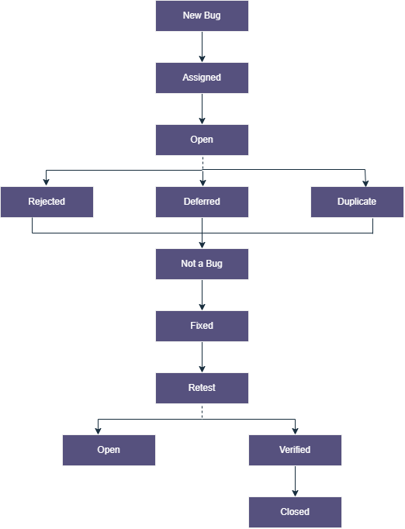

Stage Descriptions
Stage | Description
New Bug | Tester identifies and reports a new defect in Jira.
Assigned | The defect is assigned to the appropriate developer/team member.
Open | The defect has been reviewed and is ready for investigation/fixing.
Rejected | The defect is rejected because it is invalid, incorrect, or cannot be reproduced.
Deferred | The defect is valid but fixing it is postponed to a future release.
Duplicate | The same defect has already been reported.
Not a Bug | The reported behavior is working according to the requirements.
Fixed | Developer fixes the defect and changes its status to Fixed.
Retest | Tester tests the application again to verify the fix.
Open | If the bug still exists after retesting, it is sent back for fixing.
Verified | Tester confirms that the defect has been successfully fixed.
Closed | The defect is completely verified and closed in Jira.

5.Download a sample defect template from the internet (or use a template provided in class), and fill it out for a bug you noticed in any social media app (like Instagram or WhatsApp), making sure to include Severity and Priority fields.
Sample Defect Report
Field | Details
Defect ID | BUG-SM-001
Application | Instagram
Module | Direct Messages
Issue Type | Bug
Summary | Sent image remains stuck on “Sending” in Direct Messages
Description | When a user sends an image through Instagram Direct Messages, the image sometimes remains in the “Sending” state even though the network connection is stable. The recipient does not receive the image.
Precondition | User is logged into a valid Instagram account and has an active internet connection.
Steps to Reproduce | 1. Open Instagram.  2. Log in with a valid account.  3. Open Direct Messages.  4. Open any user's chat.  5. Tap the image/gallery option.  6. Select an image.  7. Tap Send.  8. Observe the message status.
Test Data | JPG image, approximately 2 MB
Expected Result | The selected image should be sent successfully and should appear in the chat for both sender and recipient.
Actual Result | The image remains stuck on “Sending” and is not delivered to the recipient.
Severity | Medium
Priority | High
Environment | Android / Chrome or Instagram App
Frequency | Intermittent
Status | New
Reported By | Tester
Attachment | Screenshot / screen recording

