1.Sign up for a free Jira account (cloud version), create a new project using the Scrum template, and take a screenshot of your empty Scrum board.
Create a Scrum Project in Jira Cloud
Objective
To create a new Scrum project in Jira Cloud and verify that the Scrum board is created successfully.
Steps Performed
- Signed up for a free Jira Cloud account.
- Logged into the Jira dashboard.
- Clicked Create Project.
- Selected the Scrum project template.
- Entered the project details:
  - Project Name: Shopping Cart Testing
  - Project Key: SCT
- Clicked Create.
- Verified that the Scrum board was created with the default columns:
  - To Do
  - In Progress
  - Done
- Captured a screenshot of the empty Scrum board.
Expected Result
A new Scrum project is created successfully, and an empty Scrum board is displayed with the default workflow columns.

Screenshot
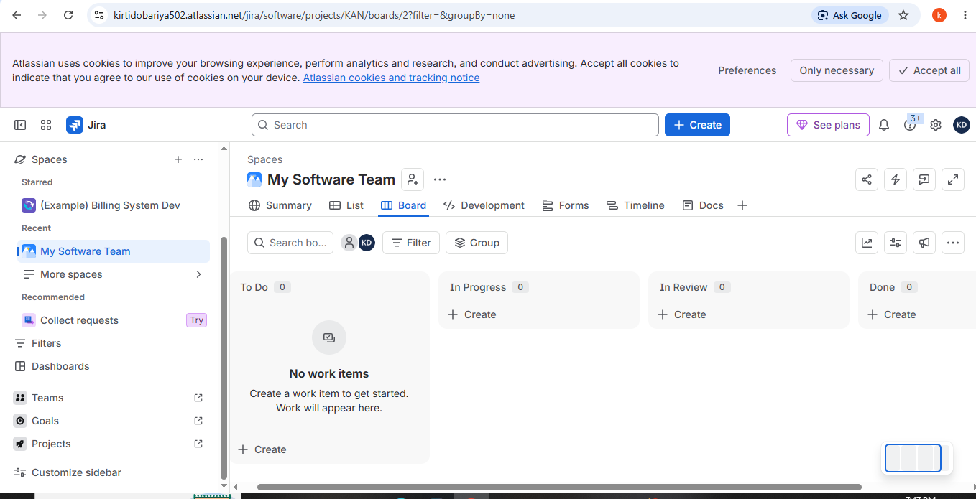

Conclusion
The Scrum project was created successfully in Jira Cloud, and the empty Scrum board is ready for creating and managing user stories, tasks, and bugs.

2.In your Jira Scrum board, create an epic named 'Food Delivery App Features' and add three user stories under it: 'As a user, I want to search for restaurants', 'As a user, I want to track my order in real-time', and 'As a user, I want to pay using UPI'.

Epic
Issue Type: Summary
Epic: Food Delivery App Features

User Stories
Issue Type | Epic Link | User Story
Story | Food Delivery App Features | As a user, I want to search for restaurants so that I can find food from nearby restaurants.
Story | Food Delivery App Features | As a user, I want to track my order in real-time so that I know the current delivery status.
Story | Food Delivery App Features | As a user, I want to pay using UPI so that I can complete my payment quickly and securely.

3.For the user story 'As a user, I want to search for restaurants', add two sub-tasks: 'Design search UI' and 'Integrate restaurant API'.

Jira Scrum Board – Add Sub-tasks
Parent User Story:
As a user, I want to search for restaurants so that I can easily find nearby restaurants.

Sub-tasks
Issue Type | Parent Story | Sub-task
Sub-task | As a user, I want to search for restaurants | Design search UI
Sub-task | As a user, I want to search for restaurants | Integrate restaurant API

Expected Result
- The user story "As a user, I want to search for restaurants" contains 2 sub-tasks.
- Design search UI is created and linked to the user story.
- Integrate restaurant API is created and linked to the same user story.
- Both sub-tasks appear under the parent story in the Jira Scrum backlog.

4.Change the status of one of your sub-tasks from 'To Do' to 'In Progress' and then to 'Done' using the Jira board workflow.<br><br><em><strong>Hint:</strong> Drag and drop the task across columns to update its status.</em>

Jira Scrum Board – Update Sub-task Status
Sub-task Selected: Design search UI

Workflow Status Update
Step | Action | Status
1 | Sub-task created | To Do
2 | Drag the sub-task from To Do to In Progress | In Progress
3 | After completing the work, drag the sub-task from In Progress to Done | Done

5.Explore the different issue types available in Jira (Epic, Story, Task, Bug). For each type, create a sample issue in your project and write one line explaining when you would use that issue type in a real Zomato or Swiggy-like app.

Jira Issue Types – Sample Issues

Project: Food Delivery App
Issue Type | Sample Issue | When to Use
Epic | Food Delivery App Features | Used to group a large feature or module, such as the complete food ordering functionality.
Story | As a user, I want to search for restaurants | Used to describe a feature or requirement from the user's perspective.
Task | Create Restaurant Search UI | Used for a specific development or testing activity that needs to be completed.
Bug | UPI Payment Fails After Successful Transaction | Used to report a defect or issue that needs to be fixed before or after release.

