**Oracle SQL Developer Setup**

Your Oracle account information is available in My Grades from the course page on Blackboard.

Use the following link to download Oracle Developer:

<https://www.oracle.com/tools/downloads/sqldev-downloads.html>

Choose the proper download compatible to your OS.

For instance, if your OS is Windows_X64 choose the first option to download.

Windows 64-bit with JDK 8 included

If you have MAC, download the MAC version, you also need to download the JDK and install it. You can find the link to JDK on the Notes column.

Decompress the file and execute the sqldeveloper.exe

…\sqldeveloper

If you have any problems with the font size of the SQL DEVELOPER program (menu bar and navigation panel, and …) go to the following link for the instruction to fix the problem:

<https://christian-gohmann.de/2018/10/25/running-sql-developer-on-high-dpi-screens/>

When you have SQL Developer running, you need to create a new connection to connect to Seneca Oracle.

To create a new connection:

* Choose a name for your connection.
* Connection Name: DBS311 (or any name you want)
* Host name: **myoracle12c.senecacollege.ca**
* Service name: **oracle12c**
* Your Oracle username and password

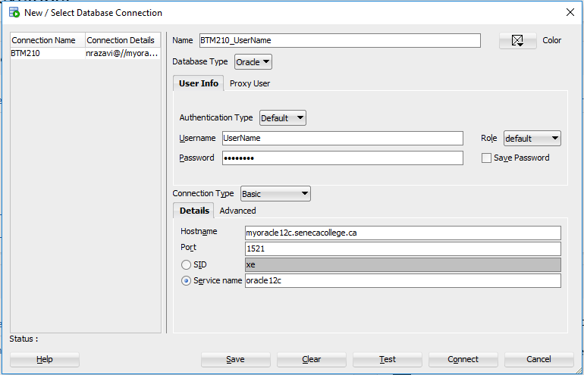

Figure 1

**You have already created the schema but you have different tables**

If you have created the schema you should see the following table under “Tables” in your DBS211 connection:

DBS211_CUSTOMERS

DBS211_EMPLOYEES

DBS211_OFFICES

DBS211_ORDERDETAILS

DBS211_ORDERS

DBS211_PAYMENTS

DBS211_PRODUCTLINES

DBS211_PRODUCTS

If you see different tables from the above tables, you need to remove them and do the following instruction to create correct tables in your database.

To remove tables:

1. Right click on the table name in the navigation panel and select “Table” and the select “Drop”.

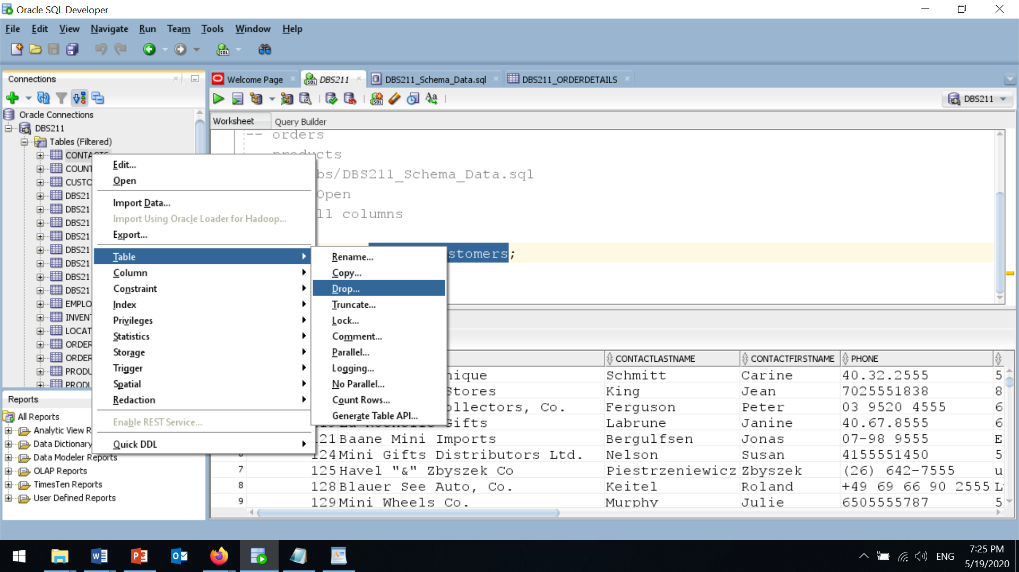

Figure 2

1. In the “Drop” page, check “Cascade Constraints” and click on the “apply” Button.

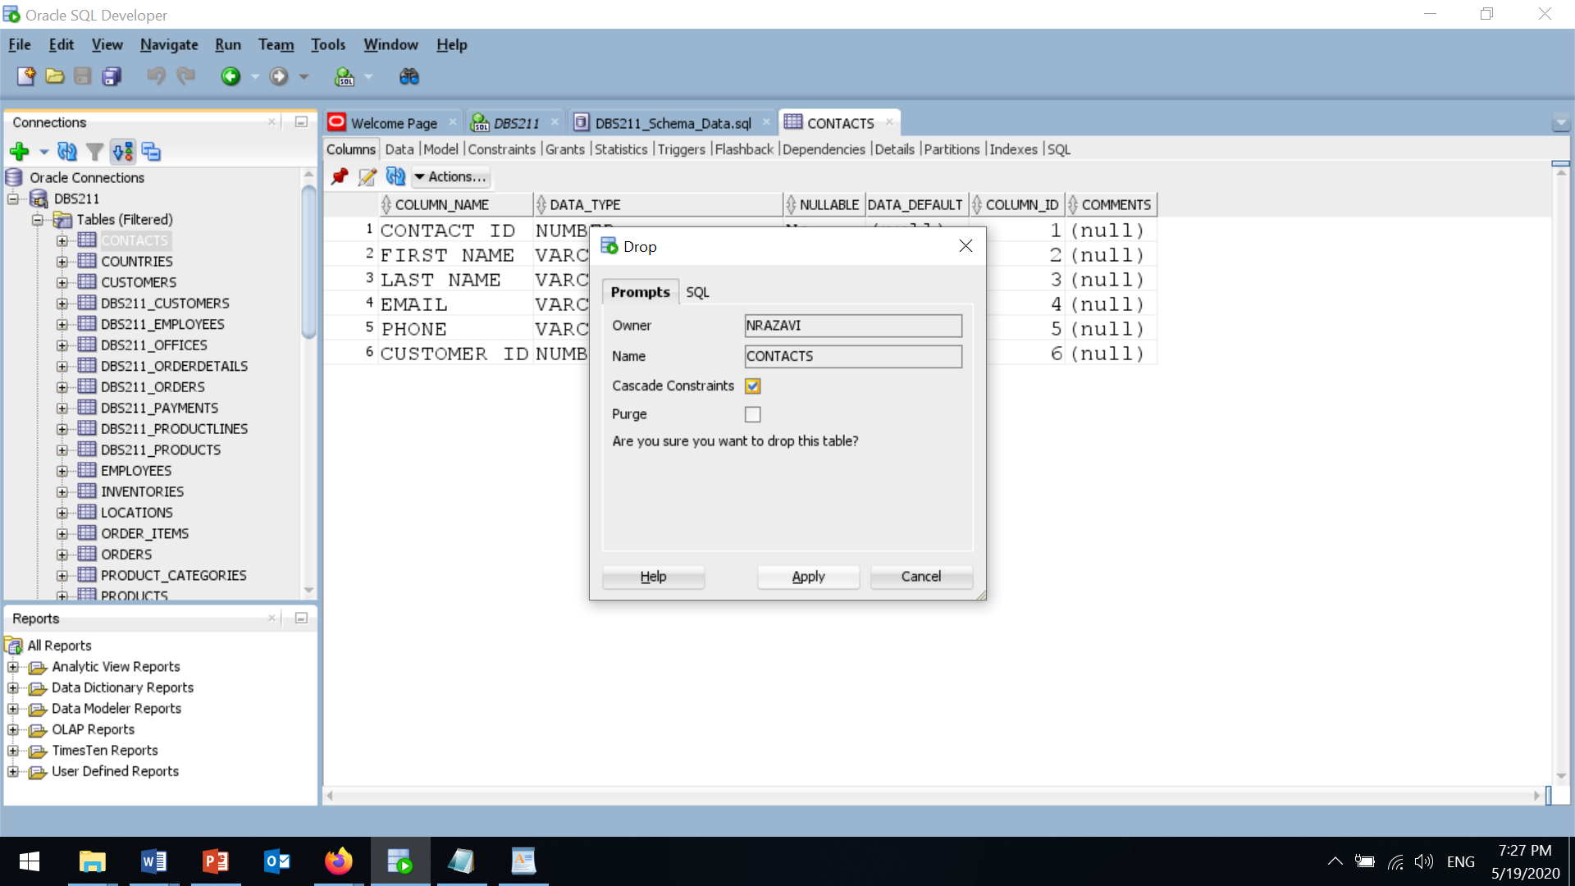

Figure 3

Repeat this to drop (remove) all tables and create the correct tables following the instruction below:

**Schema (Create Tables and Insert Data)**

To create the schema, download and execute the file from

Blackboard/Labs/Schema Creation and Data Insertion

You can find all the files you need in this content folder.

Right click on “Schema Creation Script” and select the “Save link as” to save the file on your computer.

**DBS211_Schema_Data.sql**

Open this file in SQL Developer.

1. From the file menu, select **Open**.
2. Select the downloaded scripts (DBS211_Schema_Data.sql) and hit the open button.

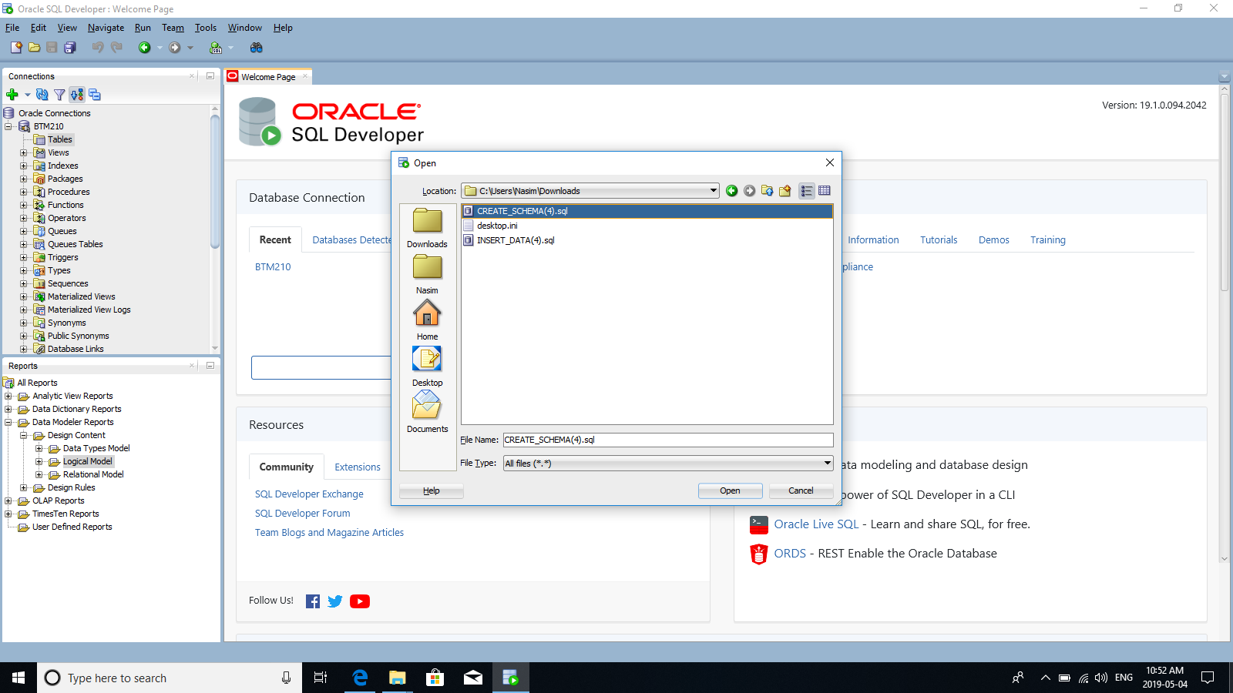

Figure 4

1. To execute the script, hit “**Run Script (F5)**” icon (the icon next the green triangle).

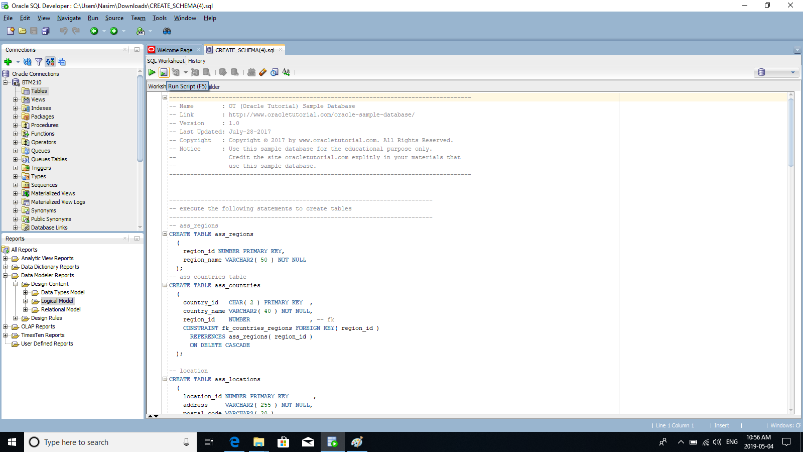

Figure 5

1. From the drop-down list, select the connection that you have created at the beginning of this lab and hit **OK**.

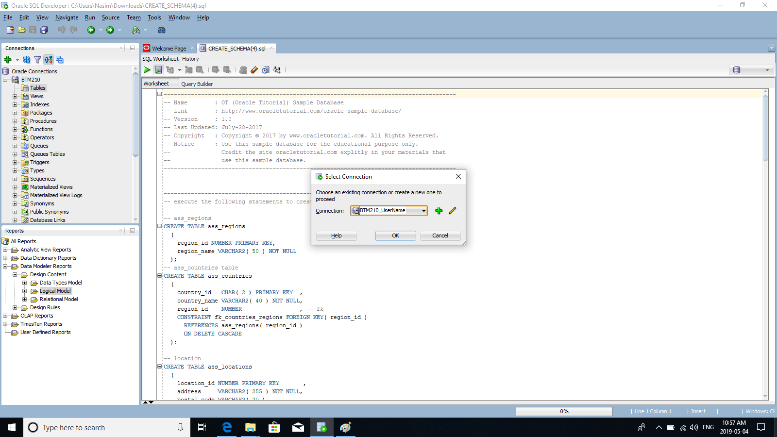

Figure 6

After all tables are created, you may not see the tables under “Tables” in the navigation panel. Right click on “Tables” and select “Refresh”. Now, expand “Tables”. You should see the following tables:

DBS211_CUSTOMERS

DBS211_EMPLOYEES

DBS211_OFFICES

DBS211_ORDERDETAILS

DBS211_ORDERS

DBS211_PAYMENTS

DBS211_PRODUCTLINES

DBS211_PRODUCTS