**Overview of backend :**

The Android app acts as the sensor of the system which would send raw data from individual residential homes to the centralized server.

The centralized server then, after obtaining the analytics from all homes, computes the power needed from the Grid to be directed through the existing switching system placed in by the Municipal, in order to maximize the efficient usage of power.

Essentially, cutting supply to homes which are self-sufficient (charge rate > discharge rate) or supplying a certain calculated amount of supply if it is not (discharge rate > charge rate).

The aforementioned calculated amount would be calculated by the server based on parameters provided by the user as well as the Grid (the grid may have maximum power output but that has not been implemented).

The server provides the statistics to the Grid as well as back to the user (Android) so that they may monitor their usage and maybe take necessary steps to reduce consumption (for example).

**Functionality of backend :**

**Pre-setting up:**

There is a need for web server to simulate the centralized system, a database server like MySQL and PHP for scripting.

A dummy user is created for MySQL-server (poweruser) so that the PHP scripts reference the database through this user.

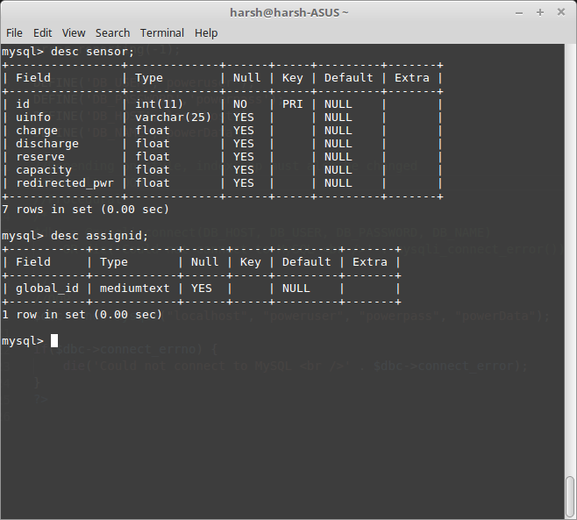

**Setting up:**

The Android app’s first set up requires the user to register with a certain username and mention their household battery capacity.

The server will then give back a unique ID [regist.php]

It does so by interacting with a database which has a table containing only a variable. The script gets the value from the table, increments it since it has to be unique, and ideally it should be transmitted back to the app using a secure Web socket, but for the time being, we have exploited the HTTP protocol for the same.

The picture demonstrates how a new registration gets its id (variable), the Android app parses it and stores it for itself. All future communications will require this unique ID.

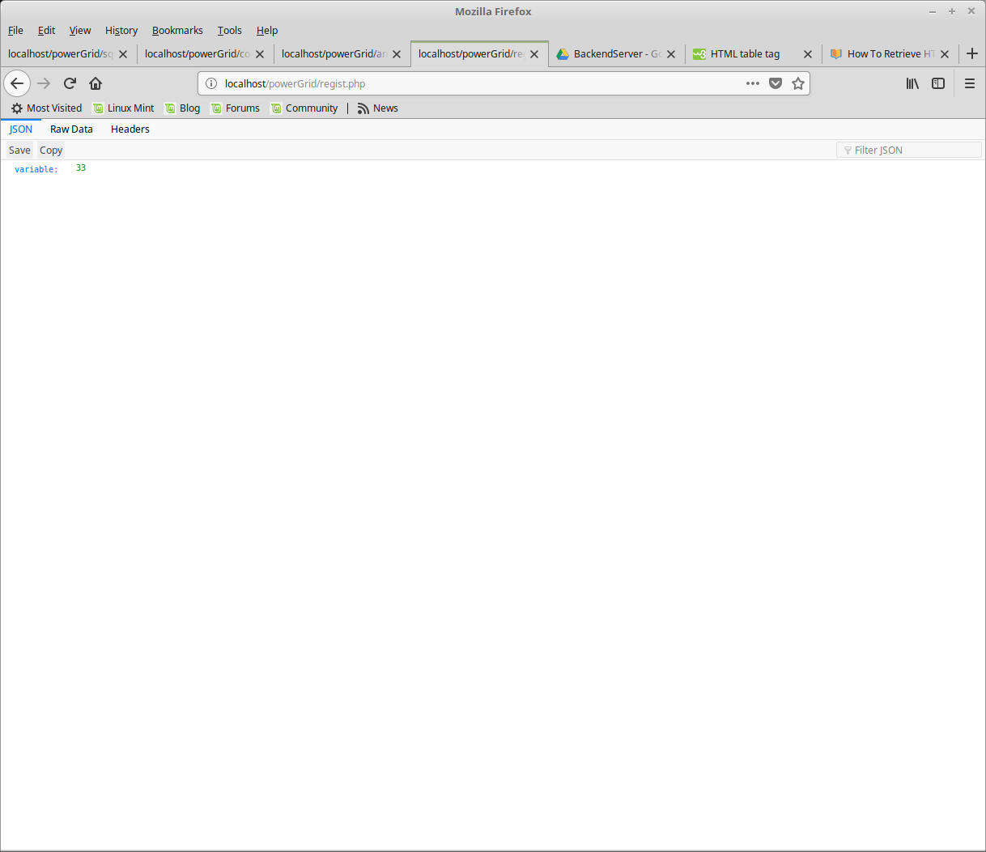

The server side

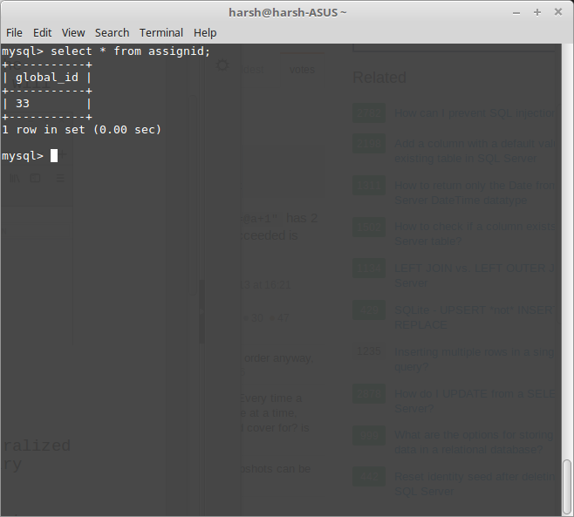

The app (for the time being transmits sensor data) communicates with centralized system using the HTTP protocol and HTTP GET request which has the necessary parameters needed by the server.

The server receives the parameters, calculates a ‘redirected power’ parameter.

Then it sends it on to the Grid(for redirect purpose) as well as the Android app(user monitoring purposes).

All the parameters (including ‘redirected power’) is stored in a MySQLdatabase at the Centralized system for System administration and future reference.[collect.php]

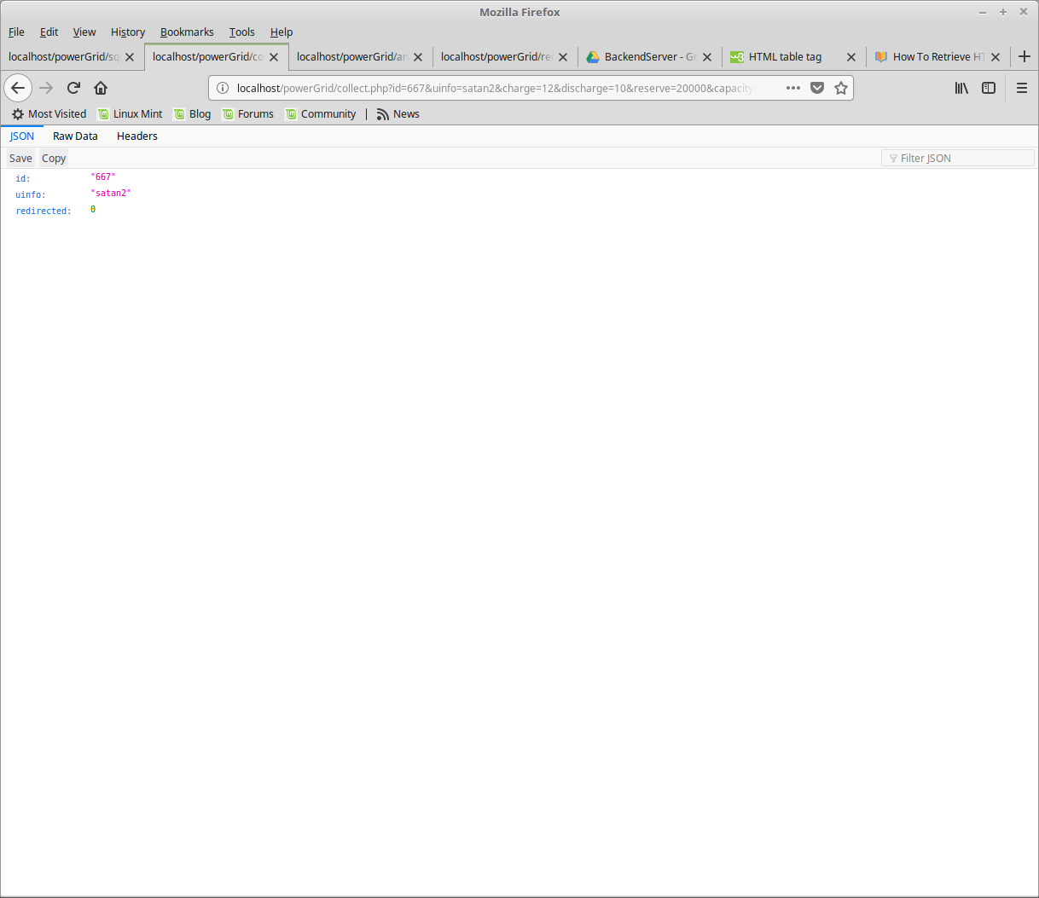

collect.php also passes the server analyzed data back to the app in JSON format again.

There is another file [analytics.php] which is used to monitor server data used by the system administrator and the users (through an authentication system) to fetch data in real time

