**Lab: DOM Manipulations**

Problems for in-class lab for the [“JavaScript Advanced” course @ SoftUni](https://softuni.bg/courses/javascript-advanced). Submit your solutions in the SoftUni judge system at <https://judge.softuni.bg/Contests/1549/Lab-DOM-Manipulation>.

1. **List of Items**

Write a JS function that **reads** the text inside an input field and **appends** the specified text to a list inside an HTML page.

Submit **only** the **addItem()** function in judge.

**Input/Output**

There will be no input/output, your program should instead **modify** the DOM of the given HTML document.

|  |
| --- |
| **Sample HTML** |
| **<h1>List of Items</h1>**  **<ul id="items"><li>First</li><li>Second</li></ul>**  **<input type="text" id="newItemText" />**  **<input type="button" value="Add" onclick="addItem()">**  **<script>**  **function addItem() {**  **// TODO: add new item to the list**  **}**  **</script>** |

**Examples**

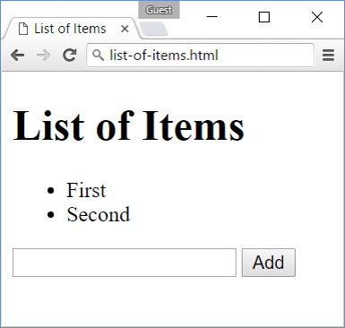 🡪 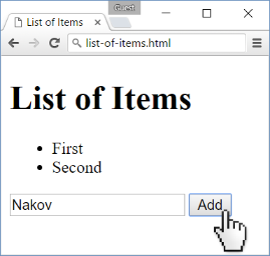 🡪 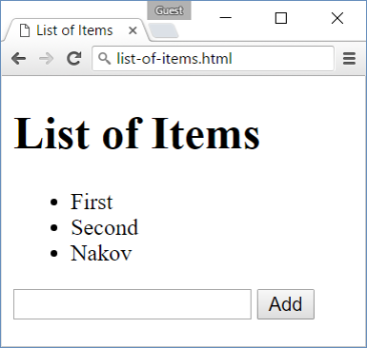

1. **Add / Delete**

Extend the previous problem to display a **[Delete] link** after each list item. **Clicking** it should **delete** the item with no confirmation.

Submit **only** the **addItem()** function in judge.

**Input/Output**

There will be no input/output, your program should instead **modify** the DOM of the given HTML document.

|  |
| --- |
| **Sample HTML** |
| **<h1>List of Items</h1>**  **<ul id="items"></ul>**  **<input type="text" id="newText" />**  **<input type="button" value="Add"  onclick="addItem()">**  **<script>**  **function addItem() {**  **//TODO**  **function deleteItem() {**  **//TODO**  **}**  **}**  **</script>** |

**Examples**

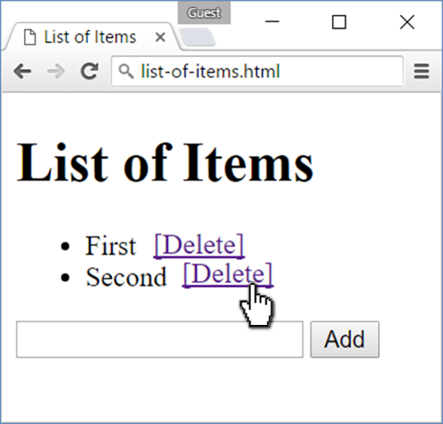🡪 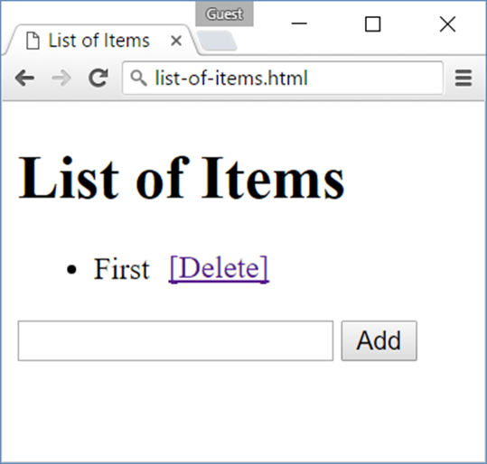

1. **Delete from Table**

Write a JS program that **takes** an e-mail from an **input field** and **deletes** the matching row from a table. If no entry is found, an **error** should be displayed in a **<div>** with ID "**results**". The error should be "**Not found**."

Submit **only** the **deleteByEmail()** function in judge.

**Input/Output**

There will be no input/output, your program should instead **modify** the DOM of the given HTML document.

|  |
| --- |
| **Sample HTML** |
| **<table border="1" id="customers">**  **<tr><th>Name</th><th>Email</th></tr>**  **<tr><td>Eve</td><td>eve@gmail.com</td></tr>**  **<tr><td>Nick</td><td>nick@yahooo.com</td></tr>**  **<tr><td>Didi</td><td>didi@didi.net</td></tr>**  **<tr><td>Tedy</td><td>tedy@tedy.com</td></tr>**  **</table>**  **Email: <input type="text" name="email" />**  **<button onclick="deleteByEmail()">Delete</button>**  **<div id="result" />**  **<script>**  **function deleteByEmail() {**  **//TODO**  **}**  **</script>** |

**Examples**

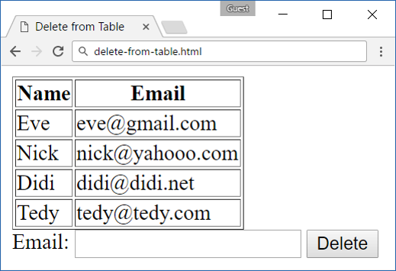 🡪 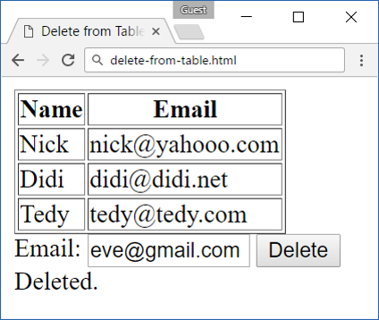

1. **Stopwatch**

Write a **timer** that counts **minutes** and **seconds**. The user should be able to control it with **buttons**. Clicking **[Start]** **resets** the timer back to zero. Only **one** of the buttons should be enabled at a time (you cannot stop the timer, if it is not running).

Submit only the **stopwatch()** function in judge.

**Input/Output**

There will be no input/output, your program should instead **modify** the DOM of the given HTML document.

|  |
| --- |
| **Sample HTML** |
| **<div id="time" style="border:3px solid blue; text-align:center; font-size:2em; margin-bottom:10px">00:00</div>**  **<button id="startBtn">Start</button>**  **<button id="stopBtn" disabled="true">Stop</button>**  **<script>**  **window.onload = function stopWatch() {**  **//TODO**  **}**  **</script>** |

**Examples**

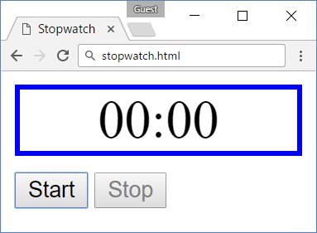

1. **Mouse Gradient**

Write a JS program that **detects** and **displays** how far along a gradient the user has **moved** their **mouse**. Use the provided HTML and stylesheet (CSS) to test locally. The result should be **rounded down** and displayed as a **percentage** inside the **<div>** with ID "**result**".

Submit **only** the **attachGradientEvents()** function in judge. Make sure you write it in a **separate** file, called **gradient.js**.

**Input/Output**

There will be no input/output, your program should instead **modify** the DOM of the given HTML document.

|  |
| --- |
| **Sample HTML** |
| **<html>**  **<head>**  **<title>Mouse in Gradient</title>**  **<link rel="stylesheet" href="gradient.css" />**  **<script src="gradient.js"></script>**  **</head>**  **<body onload="attachGradientEvents()">**  **<div id="gradient-box">**  **<div id="gradient">Click me!</div>**  **</div>**  **<div id="result"></div>**  **</body>**  **</html>** |

|  |
| --- |
| **gradient.css** |
| **#gradient-box {**  **width: 300px;**  **border: 2px solid lightgrey;**  **}**  **#gradient-box:hover {**  **border: 2px solid black;**  **}**  **#gradient {**  **height: 30px;**  **color: white;**  **text-shadow: 1px 1px 10px black;**  **text-align: center;**  **line-height: 30px;**  **background: linear-gradient(to right, black, white);**  **cursor: crosshair;**  **}** |

**Examples**

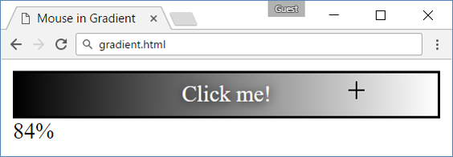

1. **Highlight Active**

Write a JS function that **highlights** the **currently active** section of a document. There will be **multiple** divs with **input fields** inside them. Set the class of the div that contains the **currently focused** input field to "**focus**". When focus is lost (**blurred**), **remove the class** from the element.

Submit only the **focus()** function in judge.

**Input/Output**

There will be no input/output, your program should instead **modify** the DOM of the given HTML document.

|  |
| --- |
| **Sample HTML** |
| **<!DOCTYPE html><html lang="en">**  **<head>**  **<meta charset="UTF-8"><title>Focus</title>**  **<style>**  **div { width: 470px; }**  **div div {**  **text-align: center;**  **display: inline-block;**  **width: 200px;**  **height: 200px;**  **margin: 15px;**  **border: 1px solid #999;**  **}**  **.focused { background: #999999; }**  **</style>**  **</head>**  **<body onload="focus()">**  **<div>**  **<div><h1>Section 1</h1><input type="text"/></div>**  **<div><h1>Section 2</h1><input type="text"/></div>**  **<div><h1>Section 3</h1><input type="text"/></div>**  **<div><h1>Section 4</h1><input type="text"/></div>**  **</div>**  **<script>**  **function focus() {**  ***// TODO***  **}**  **</script>**  **</body>**  **</html>** |

**Example**

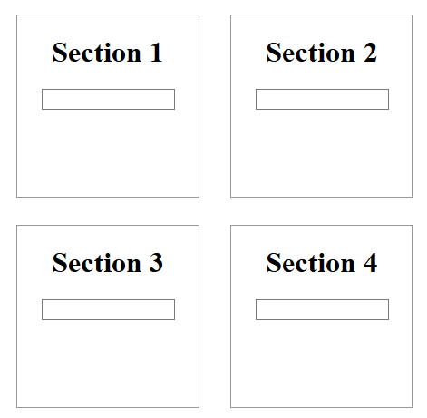 🡪 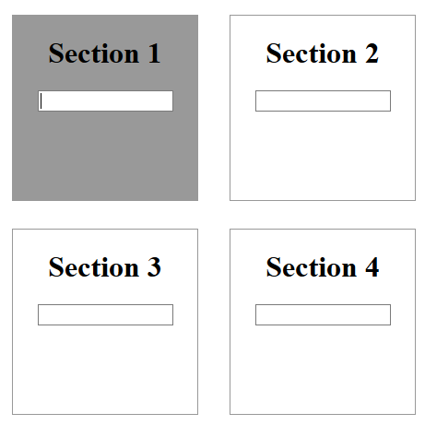

1. **Dynamic Validation**

Write a JS function that **dynamically validates** an email input field when it is **changed**. If the input is **invalid**, apply the style "**error**". Do **not** validate on every keystroke, as it is annoying for the user, consider only **change** events.

A valid email is considered to be in the format: **<name>@<domain>.<extension>**

Only **lowercase Latin characters** are allowed for any of the parts of the email. If the input is valid, clear the style.

Submit **only** the **validate()** function in judge.

**Input/Output**

There will be no input/output, your program should instead **modify** the DOM of the given HTML document.

|  |
| --- |
| **Sample HTML** |
| **<!DOCTYPE html><html lang="en">**  **<head>**  **<meta charset="UTF-8"><title>Focus</title>**  **<style>.error { border: 2px solid red; }</style>**  **</head>**  **<body onload="validate()">**  **<label for="email">Enter email:</label>**  **<input id="email" type="text"/>**  **<script>**  **function validate() {**  ***// TODO***  **}**  **</script>**  **</body>**  **</html>** |

**Example**

 