# Exercises: Templating

Problems for exercises and homework for the ["JavaScript Applications" course @ SoftUni](https://softuni.bg/trainings/2082/js-applications-november-2018).

## List Towns

You are a given an **input field** with a **button**. In the input field you should enter **elements** **separated** by comma and whitespace ("**,** "). Your task is to create a simple **template** that defines a **list** of towns. Each **town** comes from the **input** field.

|  |
| --- |
| listTown.html |
| <!DOCTYPE **HTML**> <**HTML lang="en"**> <**head**>  <**meta charset="UTF-8"**>  <**title**>List Town</**title**>  <**script src="node_modules/handlebars/dist/handlebars.min.js"**></**script**>  <**script src="https://code.jquery.com/jquery-3.1.1.min.js"**></**script**>  <**link** **href**=**"./style.css"**, **type**=**"text/css"** **rel**=**"stylesheet"**></**link**>  <**script src="towns.js"**></**script**> </**head**> <**body**> <**input id="towns" type="text"**/> <**button id="btnLoadTowns"**>Load</**button**> <**div id="root"**></**div**> </**body**> <**script**>  $(() => *attachEvents*()) </**script**> <**script type="text/x-handlebars-template" id="towns-template"**>  // TODO: Create the template here </**script**> </**HTML**> |

In your **attachEvents**() function you **should** attach a click event to the **button** with **id "**btnLoadTowns**"** and **render** the **towns** that come from the input field in the **HTML** **template** with **id "**towns-template**".**

### Screenshots

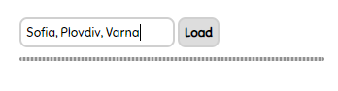

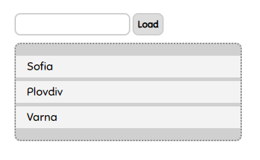

This is how the HTML looks like:

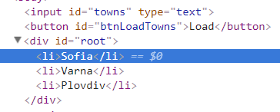

## HTTP Status Cats

We all love cats. They are also a fun way to learn all the HTTP status codes.

Your task is to **refactor** the given **HTML** and to create a **template** to represent **each** cat card block on it's own. After you have **created** the templete **render** it into the div with **id "**allCats**".**

A **cat** has an id**,** statusCode**,** statusMessageandimageLocation. The cats are **seeded** using the **function** from the js **file** named **"**catSeeder.js**"**

Each card block has a **button** that **unveils** status code information **connected** to each cat. You should **toggle** the button and change it's text from "Showstatuscode" to "Hidestatuscode".

### Screenshots

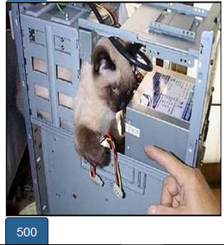

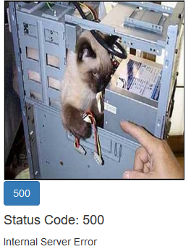

## Popular Monkeys

You are provided with a **skeleton.** Your task is to implement the function in the **'monkeysTemplate.js'** file to render the six most popular monkeys in the browser. You should also add an **event** to each **'Info'** button to show the **details** about the monkey. Each monkey also has a **name** and an **image**. Explore the **'monkeys.js'**file for more details. At the end the page should look like this:

