DSC 450: Database Processing for Large-Scale Analytics

Assignment Module 5

Part 1

  - Write a function to generate a list of x random numbers, where x is the parameter indicating how many numbers to generate. Each generated number should randomly fall in the range between 31 and 100.

import numpy as np
import pandas

def genRand(x):
myarray = np.random.randint(low = 31, high = 100, size = x)
print(myarray)

genRand(x)

  - Use your function from 1-a to create a list of 60 random numbers with your code and use pandas.Series to determine how many of the numbers are below 37

import numpy as np
import pandas

def genRand(x):
myarray = np.random.randint(low = 31, high = 100, size = x)
print(myarray)
series1 = pandas.Series(myarray)
n = len(series1[series1>37])
print(n)

genRand(60)

  - Using the same list of 60 random numbers, 1) create a numpy array, modify it to 6x10 (you can do this by calling numpy.reshape(yourArray, (6,10)) and then replace all the numbers that are greater than or equal to 50 (50-100) by 50.

﻿
import numpy as np
import pandas

def genRand(x):
myarray = np.random.randint(low = 31, high = 100, size = x)
print(myarray)
series1 = pandas.Series(myarray)
n = len(series1[series1>37])
print(n)
np.reshape(myarray, (6, 10))
myarray[myarray>50] = 50
print(myarray)

genRand(60)

Part 2

In this part we are going to work with a larger collection of tweets (10,000) that are available here. Note that file name is Assignment5.txt for historical reasons but the file belongs to Module7.
http://rasinsrv07.cstcis.cti.depaul.edu/CSC455/Assignment5.txt

The tweets are all on separate lines, but some of the tweets are intentionally damaged and will not parse properly. You will need to store these tweets in a separate “error” file. At the bottom of the page you can find python code that will let you skip over badly formed tweets.

  - Create a new SQL table for the user dictionary. It should contain the following attributes “id”, “name”, “screen_name”, “description” and “friends_count”. Modify your SQL table from Module 5 to include “user_id” columns which will be a foreign key referencing the user table.

  - Write python code that is going to read and load the Assignment5.txt file directly from the web and populate both of your tables (Tweet table from Module5 and User table from this assignment). You can use the same code from the previous assignment with an additional step of inserting data into the newly created table.
For tweets that could not parse, write them into a Module7_errors.txt file.

You can gracefully catch JSON errors using the following code:

for tweet in allTweets:
try:
tdict = json.loads(tweet.decode('utf8'))
except ValueError:
# Handle the problematic tweet, which in your case would require writing it to another file
print (tweet)

﻿
import urllib
import json
import sqlite3

def createDict(url):
conn = sqlite3.connect('dsc450_HW7_6.db')
c = conn.cursor()
conn.commit()
webFD = urllib.request.urlopen(url)
x = webFD.readlines()
tweets = '''CREATE TABLE UserDict
(
id VARCHAR2(45),
name NUMBER(20),
screen_name VARCHAR2(140),
description VARCHAR2(75),
friend_count VARCHAR2(25),
user_id VARCHAR2(25),

CONSTRAINT userDict_PK
PRIMARY KEY(id),

Foreign Key (user_id)
REFERENCES tweet1(user_id)
); '''
c.execute(tweets)
other_table = '''CREATE TABLE tweet1
(
created_at VARCHAR2(45),
id_str NUMBER(20),
text VARCHAR2(140),
source VARCHAR2(75),
in_reply_to_user_id VARCHAR2(25),
in_reply_to_screen_name VARCHAR2(25),
in_reply_to_status_id VARCHAR2(25),
retweet_count NUMBER(5),
contributors VARCHAR2(25),

CONSTRAINT tweet_PK
PRIMARY KEY(id_str)
); '''
c.execute(other_table)
for line in x:
try:
tweets1 = json.loads(line.decode('utf8'))
tweetID = tweets1['user']['id']
created_at = tweets1['created_at']
name = tweets1['user']['name']
screen_name = tweets1['user']['screen_name']
description = tweets1['user']['description']
friends_count = tweets1['user']['friends_count']
user_id = tweets1['id_str']
tweetList = [tweetID, name, screen_name, description, friends_count, user_id]
c.executemany("INSERT INTO UserDict VALUES(?,?,?,?,?,?)", (tweetList,))
text = tweets1['text']
source = tweets1['source']
replyuserid = tweets1['in_reply_to_user_id']
replyscreenname = tweets1['in_reply_to_screen_name']
replystatusid = tweets1['in_reply_to_status_id']
retweet = tweets1['retweet_count']
constributors = tweets1['contributors']
tweetList1 = [created_at, user_id, text, source, replyuserid, replyscreenname, replystatusid, retweet, constributors]
c.executemany("INSERT INTO tweet1 VALUES(?,?,?,?,?,?,?,?,?)", (tweetList1,))
except ValueError:
file = open('Module7_errors.txt', 'w')
tweet = line.decode()
file.write(tweet)

createDict('http://rasinsrv07.cstcis.cti.depaul.edu/CSC455/Assignment5.txt')

Part 3

- Write a PL/SQL trigger that will cap the course number column in the university.sql database at 598. That is, any time an update or an insert would provide course number 599 or higher, automatically reset the value back to 598. Be sure to verify that your trigger is working with some sample data.

The code for my trigger is below. I attempted to insert a new course, “All About Maps” with a course number of 600. As can be seen in the screenshot of the new course table. The trigger flagged this insert and changed the value of the course number to 598.

CREATE OR REPLACE TRIGGER CapCourseNo
BEFORE INSERT OR UPDATE ON course
FOR EACH ROW
WHEN(new.CourseNr > 598)
BEGIN
:new.CourseNr := 598;
END;
/

insert into course
values ( 2989, 'All About Maps', 'GPH', 600);

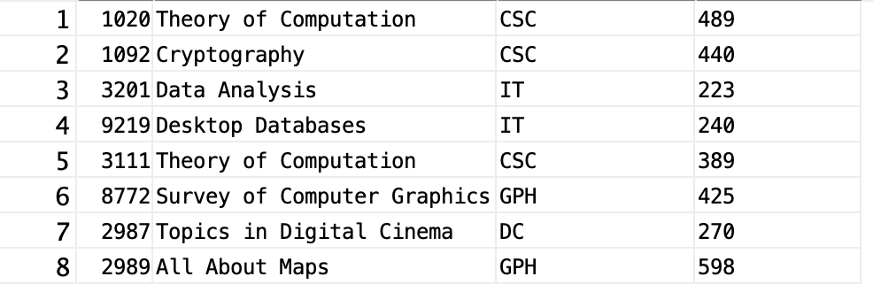

- Write a regular expression to match credit card numbers, assuming a 16-digit credit card that may or may not include spaces after each 4 digits. Create the code to validate that your regular expression works in either python or Oracle.

SELECT CardNr
FROM CardTable
WHERE REGEXP_LIKE(CardNr, '\d{4}\s?\d{4}\s?\d{4}\s?\d{4}');

