**Analysis over $ω_{m}$ and $v_{m}$ White Noise Assumption**

**For each grid, the proposed Kalman filter model assumes the number of ride requests in the same time interval to be stable between two consecutive days. Also, the number of ride requests is stable between consecutive time intervals in the same day. Therefore, there are two noise assumptions in the model. For a time interval $t$ in day $m$, first, the ride requests number difference (i.e., the process noise $ω_{m}$) from the time interval $t$ of the previous day $m$-1 is assumed to be white noise; second, the ride requests number difference (i.e., the measurement noise $v_{m}$) from previous time interval $t-1$ of day $m$ is assumed to be the white noise. These two assumptions are supported by our** **analysis of ride requests number distribution on two real-world datasets.**

$ω_{m}$**and $v_{m}$ are white noise if the sequence of ride requests number differences is identically distributed with a mean of zero and are not autocorrelated. We checked these two conditions for both datasets.**

**On the San Francisco dataset, the distribution of process noise $ω_{m}$ is shown as the following figure 1, the mean is 0.01 and the standard deviation is 1.34:**

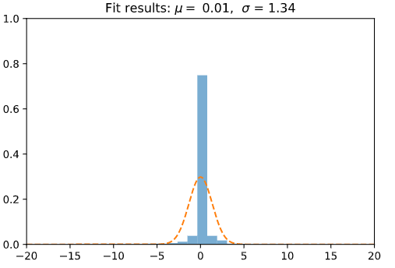

**Figure 1. Process noise $ω_{m}$ distribution on SF**

**The correlogram of $ω_{m}$ is shown in the following figure 2, where all spikes are within the 95% confidence interval. The correlogram does not show any obvious autocorrelation pattern of $ω_{m}$. Therefore, $ω_{m}$ is assumed to be the white noise on San Francisco dataset.**

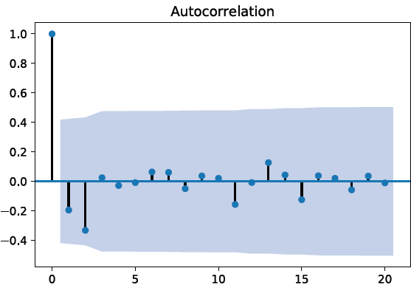

**Figure 2. Process noise $ω_{m}$ autocorrelation on SF**

**Similarly, we checked $v_{m}$ on the San Francisco dataset. The distribution and correlogram are shown in Figure 3.**

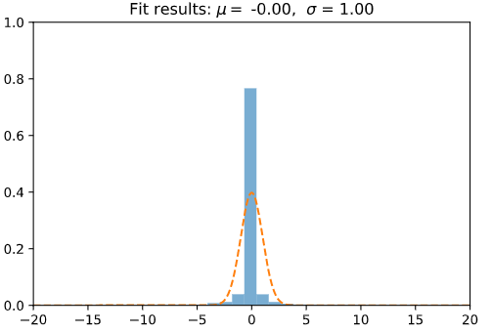 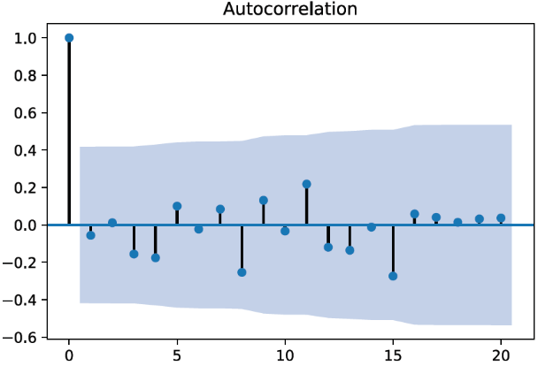

**Figure 3. measurement noise $v_{m}$ distribution and autocorrelation on SF**

**Since $v_{m}$ is also identically distributed with a mean of zero and is not autocorrelated, it is assumed to be the white noise on San Francisco dataset.**

**The distribution and autocorrelation check of $ω_{m}$ and $v_{m}$ on Wuhan dataset is shown in Figure 4 and Figure 5, respectively.**

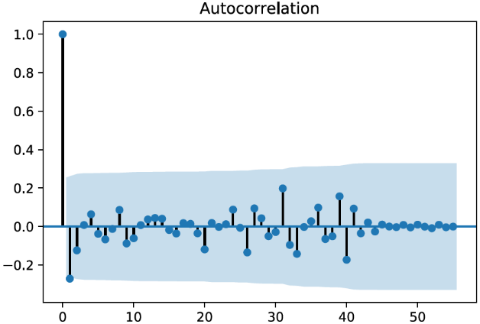

**Figure 4. Process noise $ω_{m}$ distribution and autocorrelation on WH** Chart, line chart, histogram

Description automatically generated 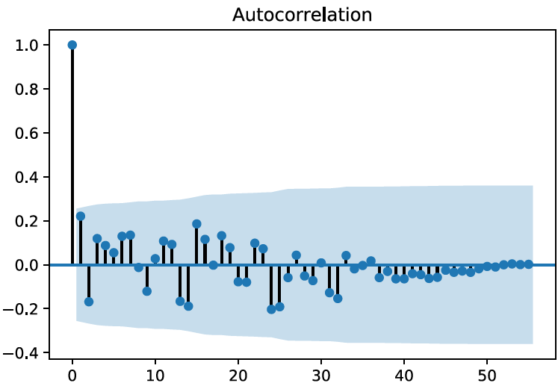

**Figure 5. measurement noise $v_{m}$ distribution and autocorrelation on WH**

**Based on the distribution and autocorrelation, it is assumed $ω_{m}$ and $v_{m}$ are white noise on the Wuhan dataset.**

**Therefore, we assume $ω_{m}$ and $v_{m}$ are white noise.**