Artemis Program
Lunar Exploration Status Report

National Aeronautics and Space Administration
Exploration Systems Development Mission Directorate
Document No. ESDMD-2024-0042
October 2024 | Revision 3

Distribution: Public Release

Table of Contents

1. Executive Summary 3
2. Program Overview 3
3. Mission Architecture 4
4. Vehicle Systems Status 5
5. Mission Timeline 6
6. Budget Summary 7
7. Risk Assessment 8
8. International Partnerships 8
9. Points of Contact 9

1. Executive Summary
The Artemis program represents NASA's efforts to return humans to the Moon and establish a sustained presence for scientific discovery, economic benefits, and inspiration. Building on more than 50 years of exploration experience, Artemis aims to land the first woman and first person of color on the lunar surface while preparing for future crewed missions to Mars.
This report provides a status overview of the program as of Q4 2024, covering vehicle readiness, mission architecture updates, budget allocation, risk posture, and international partnership agreements. All major hardware elements remain on track, with Artemis II crew training activities progressing through integrated simulation milestones.
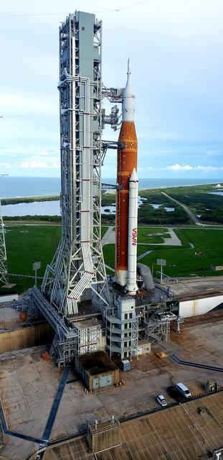
Figure 1. The Space Launch System (SLS) and Orion spacecraft at Launch Complex 39B, Kennedy Space Center. Credit: NASA/Joel Kowsky

2. Program Overview

2.1 Background
Authorized under Space Policy Directive 1 (December 2017), the Artemis program leverages the Space Launch System (SLS), Orion spacecraft, Gateway lunar orbital station, and Human Landing System (HLS) to achieve crewed lunar surface operations. The program is managed by the Exploration Systems Development Mission Directorate (ESDMD) at NASA Headquarters in Washington, D.C.

2.2 Objectives
- Demonstrate crew transportation beyond low-Earth orbit using SLS and Orion
- Land astronauts on the lunar South Pole region for surface science operations
- Deploy the Gateway station in lunar near-rectilinear halo orbit (NRHO) as a staging platform
- Establish sustainable infrastructure for long-duration lunar missions
- Develop and validate technologies required for eventual crewed Mars missions
- Foster commercial and international partnerships to expand exploration capabilities

2.3 Key Stakeholders
The program involves coordination across multiple NASA centers, including Johnson Space Center (crew operations), Kennedy Space Center (launch operations), Marshall Space Flight Center (SLS propulsion), and the Jet Propulsion Laboratory (communications and navigation). Industry partners include Boeing, Lockheed Martin, Northrop Grumman, SpaceX, and Blue Origin.

3. Mission Architecture
The Artemis campaign is structured as a series of progressively complex missions, each building on the capabilities demonstrated by its predecessor. The architecture integrates expendable and reusable elements to balance cost, schedule, and risk.
Mission | Type | Key Objectives | Status
Artemis I | Uncrewed | SLS/Orion flight test; lunar flyby; re-entry validation | Completed (Nov 2022)
Artemis II | Crewed Flyby | First crewed SLS/Orion flight; lunar flyby with 4 crew | In Preparation
Artemis III | Crewed Landing | First crewed lunar landing since Apollo 17; South Pole EVA | Development
Artemis IV | Gateway Deployment | Deliver I-HAB module to Gateway; crew rotation | Planning
Artemis V | Sustained Operations | Deliver ESPRIT refueling module; extended surface stays | Pre-formulation

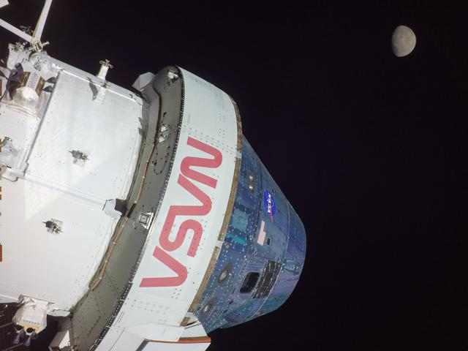
Figure 2. The Orion spacecraft approaches the Moon during the Artemis I mission, Flight Day 5. Credit: NASA
Each mission phase undergoes a series of formal reviews including System Requirements Review (SRR), Preliminary Design Review (PDR), Critical Design Review (CDR), and Flight Readiness Review (FRR) before proceeding to launch operations.

4. Vehicle Systems Status

4.1 Space Launch System (SLS)
The SLS Block 1 configuration, which successfully launched Artemis I, provides 70 metric tons of lift capacity to low-Earth orbit. The Block 1B variant under development for Artemis IV incorporates an upgraded Exploration Upper Stage (EUS) to increase payload capacity to 105 metric tons. Core stage production at the Michoud Assembly Facility in New Orleans is proceeding on schedule.

4.2 Orion Spacecraft
Orion crew and service modules for Artemis II have completed final integration at Kennedy Space Center. The European Service Module (ESM), provided by the European Space Agency, has passed all pre-flight acceptance testing. Life support system qualification was completed in Q3 2024, with crew cabin pressure and thermal control systems verified across the full operational envelope.

4.3 Human Landing System (HLS)
SpaceX continues development of the Starship HLS variant under contract for Artemis III. Key milestones include propellant transfer demonstrations in low-Earth orbit and an uncrewed lunar landing test. Blue Origin has been selected to provide a second HLS option for Artemis V and subsequent missions, increasing program resilience through competitive redundancy.
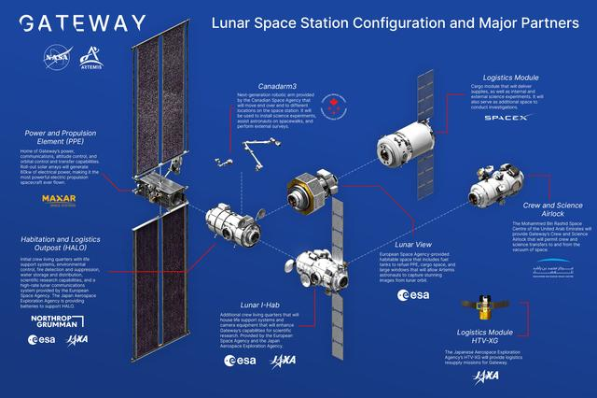
Figure 3. Conceptual rendering of the Gateway lunar orbital station in near-rectilinear halo orbit. Credit: NASA/JSC

4.4 Readiness Summary
System | Component | Readiness Level | Notes
SLS | Core Stage (Block 1B) | CDR Complete | EUS integration in progress
SLS | Solid Rocket Boosters | Flight Qualified | Northrop Grumman production
Orion | Crew Module | Integration Complete | Artemis II vehicle
Orion | European Service Module | Acceptance Testing | ESA delivery confirmed
HLS | Starship (SpaceX) | Prototype Testing | Orbital refueling demo pending
HLS | Blue Moon (Blue Origin) | Preliminary Design | Artemis V assignment
Gateway | PPE + HALO | Assembly | Launch on Falcon Heavy
Ground Sys. | Mobile Launcher 1 | Operational | ML-2 under construction

5. Mission Timeline
The following timeline reflects the current baseline schedule, incorporating adjustments approved at the October 2024 Program Management Council. Schedule reserves have been applied in accordance with NASA Procedural Requirements (NPR) 7120.5F for Category 1 programs.
Milestone | Target Date | Confidence Level
Artemis II — Flight Readiness Review | Q3 2025 | High
Artemis II — Launch | Q4 2025 | High
Starship HLS Uncrewed Landing Demo | 2025 | Medium
Gateway PPE + HALO Launch | 2025 | Medium-High
Artemis III — Crew Training Complete | 2026 | Medium
Artemis III — Launch | 2026 | Medium
Artemis IV — SLS Block 1B First Flight | 2028 | Medium-Low
Artemis V — Sustained Surface Ops Begin | 2029+ | Planning

Note: Dates are subject to change based on hardware delivery schedules, test outcomes, and annual budget appropriations. The program maintains a rolling 12-month schedule assessment updated quarterly.

6. Budget Summary
Artemis program funding is allocated across multiple NASA appropriation accounts. The following table summarizes enacted and requested funding levels for the major program elements. All figures are in millions of U.S. dollars.
Program Element | FY 2023 Enacted | FY 2024 Enacted | FY 2025 Request
Space Launch System | $2,600 | $2,480 | $2,500
Orion Spacecraft | $1,340 | $1,380 | $1,400
Exploration Ground Systems | $590 | $600 | $620
Human Landing System | $1,480 | $1,900 | $1,850
Gateway | $935 | $820 | $880
Extravehicular Activity (xEVA) | $340 | $380 | $410
Total | $7,285 | $7,560 | $7,660

Funding levels reflect congressional appropriations and may differ from the President's Budget Request. The program utilizes Earned Value Management (EVM) to track cost and schedule performance against baseline plans.

7. Risk Assessment
The Artemis program maintains a continuous risk management process in accordance with NPR 8000.4B. The following table summarizes the top program-level risks as reviewed at the most recent Risk Management Board.
Risk ID | Description | Likelihood | Impact
R-001 | HLS orbital refueling demonstration schedule delay | Medium | High
R-002 | SLS Block 1B EUS development cost growth | Medium | Medium
R-003 | International partner delivery schedule for Gateway modules | Low | Medium
R-004 | Spacesuit (xEMU) qualification timeline | Medium | High
R-005 | Launch pad infrastructure readiness for ML-2 | Low | High
R-006 | Workforce retention across key contractor teams | Medium | Medium

Mitigation strategies are documented in the Program Risk Register and reviewed monthly. Risks rated High likelihood and High impact are escalated to the Associate Administrator for disposition.

8. International Partnerships
The Artemis Accords, established in 2020, provide a framework for international cooperation in lunar exploration. As of October 2024, 43 nations have signed the Accords. Key bilateral and multilateral contributions include:
European Space Agency (ESA): Provides the Orion European Service Module, the I-HAB pressurized module for Gateway, and the ESPRIT refueling element.
Japan Aerospace Exploration Agency (JAXA): Contributing the Gateway I-HAB life support system components and a pressurized lunar rover for surface operations.
Canadian Space Agency (CSA): Developing Canadarm3, a robotic system for Gateway external maintenance and payload handling. A Canadian astronaut will fly on Artemis II.
Italian Space Agency (ASI): Providing habitation module structural elements and participating in lunar surface science instrument packages.

9. Points of Contact
For questions regarding this report or the Artemis program, please contact the following offices:
Role | Organization | Contact
Program Manager | ESDMD, NASA HQ | artemis-pm@nasa.gov
Chief Engineer | ESDMD, NASA HQ | artemis-ce@nasa.gov
SLS Program Office | Marshall Space Flight Center | sls-info@nasa.gov
Orion Program Office | Johnson Space Center | orion-info@nasa.gov
Public Affairs | NASA HQ, Office of Communications | public-inquiries@nasa.gov

— End of Document —

Distribution Statement: Approved for public release; distribution is unlimited. This document does not contain export-controlled information.

