Study of block transport using Excel + ArcGIS

Sources of Error
Considering 3 sources of error:
- Measurement error
- Pole error
- GPS error

Measurement Error
Accuracy of placement of the measuring device, GPS, on the centre of the top face of the block. Block might be buried etc.

Illustrate with photo/figure

Pole Error
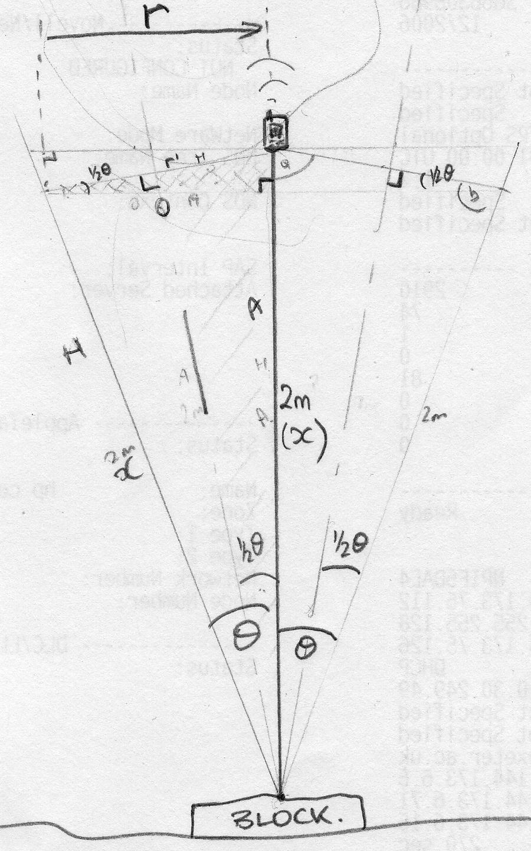
Figure 1: Schematic of GPS pole error

GPS receiver located on top of pole, base of pole positioned on centre of block …if pole not vertical we can calculate contribution to position error as follows:

Where:
r = radius of maximum horizontal distance of GPS receiver from pole-block contact point
x = length of pole

GPS Error
The accuracy of the GPS navigation system can be considered as the degree of conformance between the estimated or measured position, time, and/or velocity of a GPS receiver and its true time, position, and/or velocity as compared with a constant standard. Radio navigation system accuracy is usually presented as a statistical measure of system error and is characterized as follows:

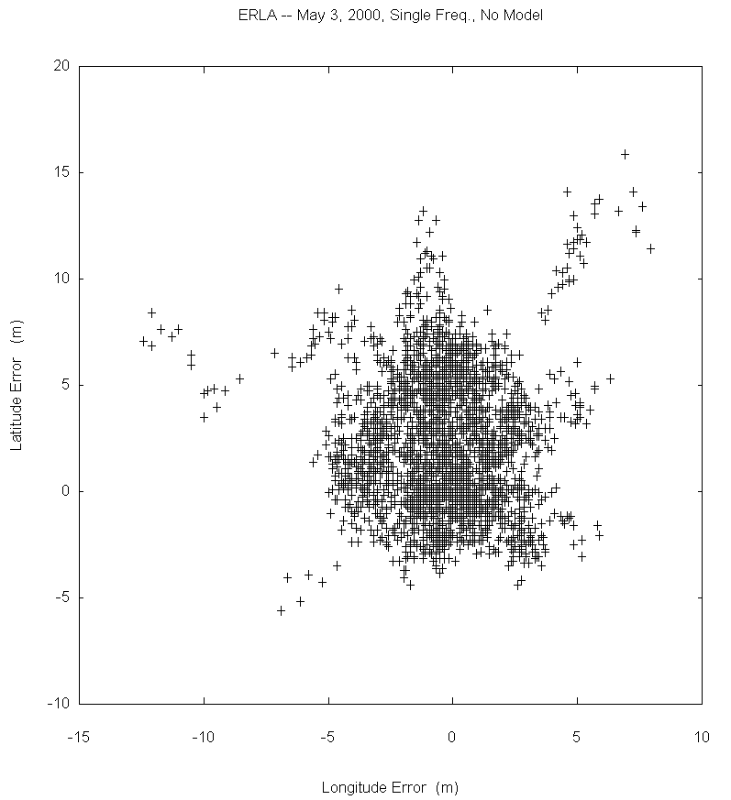
Figure 2: GPS receiver error
Predictable - The accuracy of a radio navigation system's position solution with respect to the charted solution. Both the position solution and the chart must be based upon the same geodetic datum.
Repeatable - The accuracy with which a user can return to a position whose coordinates have been measured at a previous time with the same navigation system.
Relative - The accuracy with which a user can measure position relative to that of another user of the same navigation system at the same time.
http://edu-observatory.org/gps/gps_accuracy.html

---

GPS Error Sources

Errors in the positional accuracy of the GPS signal arise from a variety of sources - equipment, atmosphere and some were deliberately built into the system. A summary of these errors and their sources can be seen in the following table:

Error source | 1-σ error, m
Error source | Standard error model - L1 C/A |  |  |  |  |  |  | Precise error model,  PPS dual-frequency, P/Y code
Error source | With SA |  |  | Without SA |  |  | DGPS
Error source | Bias | Random | Total | Bias | Random | Total | DGPS | Bias | Random | Total | DGPS
Ephemeris data | 2.1 | 0.0 | 2.1 | 2.1 | 0.0 | 2.1 | 0.0 | 2.1 | 0.0 | 2.1 | 0.0
Satellite clock | 20.0 | 0.7 | 20.0 | 2.0 | 0.7 | 2.1 | 0.0 | 2.0 | 0.7 | 2.1 | 0.0
Ionosphere | 4.0 | 0.5 | 4.0 | 4.0 | 0.5 | 4.0 | 0.4 | 1.0 | 0.5 | 1.2 | 0.1
Troposphere | 0.5 | 0.5 | 0.7 | 0.5 | 0.5 | 0.7 | 0.2 | 0.5 | 0.5 | 0.7 | 0.1
Multipath | 1.0 | 1.0 | 1.4 | 1.0 | 1.0 | 1.4 | 1.4 | 1.0 | 1.0 | 1.4 | 1.4
Receiver | 0.5 | 0.2 | 0.5 | 0.5 | 0.2 | 0.5 | 0.5 | 0.5 | 0.2 | 0.5 | 0.5
User equivalent range (UERE) rms* | 20.5 | 1.4 | 20.6 | 5.1 | 1.4 | 5.3 | 1.6 | 3.3 | 1.5 | 3.6 | 1.5
Filtered UERE rms | 20.5 | 0.4 | 20.5 | 5.1 | 0.4 | 5.1 | 1.5 | 3.3 | 0.4 | 3.3 | 1.4
Vertical error  VDOP= 2.5 |  |  | 51.4 |  |  | 12.8 | 3.9 |  |  | 8.3 | 3.7
Horizontal error  HDOP= 2.0 |  |  | 41.1 |  |  | 10.2 | 3.1 |  |  | 6.6 | 3.0

*Statistical ranging error (1-σ) representing the total of all contributing sources; the dominant error is usually the ionosphere. A horizontal error of 10 m (1-σ) is the expected performance for the temperate latitudes using civilian (C/A-code) receivers. Errors for dual-frequency P/Y code are similar to those for C/A except that SA errors are eliminated because the authorized user can decode the magnitude as part of a classified message.

Adapted from: Chapter 11, "GPS Error Analysis", pages 478-483, Global Positioning System: Theory and Applications by Bradford W. Parkinson, James J. Spilker Jr. Eds.
Source: http://edu-observatory.org/gps/gps_accuracy.html

---

A GPS signal travels at the speed of light in space (e.g. vacuum) but is diffracted by the charged particles of the ionosphere and then the water vapour in the troposphere and slows down slightly creating another source of error. This error can be minimised by (1) attempting to predict what a typical delay might be on a typical day, this is called modelling but, of course, atmospheric conditions are constantly changing (2) comparing the relative speeds of two different frequency signals, this measurement is very sophisticated and is only possible with ‘dual-frequency’ receivers.

http://www.trimble.com/gps/howgps-error2.shtml#3

---

The US Department of Defence intentionally introduced random timing errors into the satellite clock data used for GPS navigation for safety concerns (e.g. terrorists should not be able to use the GPS in the targeting systems of remote control weapons), this degraded the positional accuracy for civil GPS receivers and was called selective availability (SA). This degradation was turned off on 1st May 2000 and the resulting improvement in positional determination can be seen in the following diagrams:

---
“The plots show that SA causes 95% of the points to fall within a radius of 45.0 meters. Without SA, 95% of the points fall within a radius of 6.3 meters.”

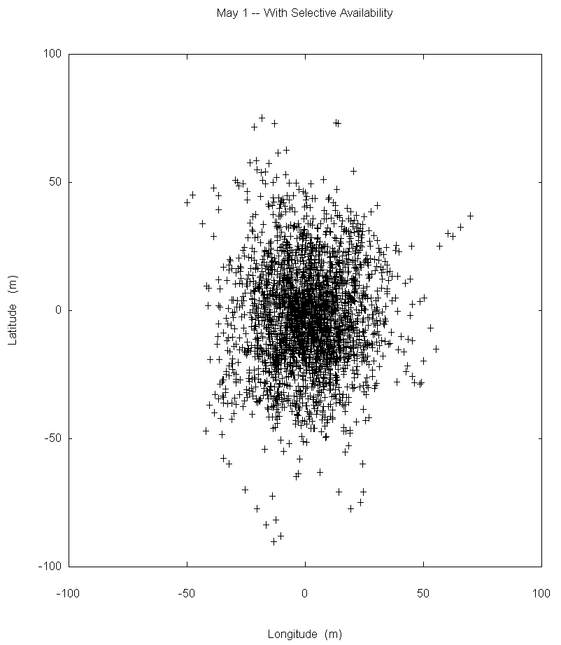(a)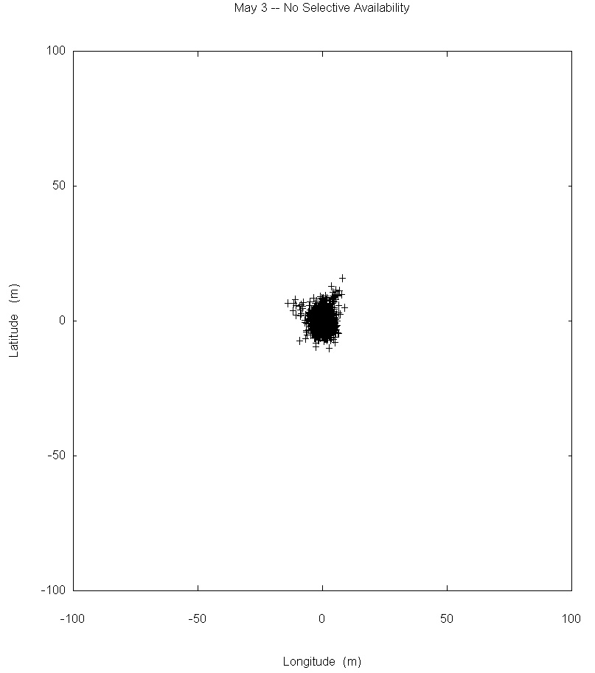(b)

Figure 3: Variability in GPS data sampled (a) with selective availability (b) without selective availability.

Dr. Dennis G. Milbert, Chief Geodesist, National Geodetic Survey, NOAA - http://pnt.gov/public/sa/diagram.shtml

---

The main observation taken from the diagrams above is that the vast majority of the GPS measurements lie approximately within the bounds of a circle.

Using satellite + ground based systems such as EGNOS (European) or WAAS (US) which mainly reduce ionospheric errors (but also orbit and clock errors), the overall error can be further reduced to typically provide better than ± 1-1.5 metre accuracies.

---

The European Geostationary Navigation Overlay Service (EGNOS) augments the US GPS satellite navigation system and makes it suitable for safety critical applications such as flying aircraft or navigating ships through narrow channels.
Consisting of three geostationary satellites and a network of ground stations, EGNOS achieves its aim by transmitting a signal containing information on the reliability and accuracy of the positioning signals sent out by GPS.
The EGNOS Open Service has been available since 1 October 2009. EGNOS positioning data are freely available in Europe through satellite signals to anyone equipped with an EGNOS-enabled GPS receiver.

http://www.esa.int/esaNA/GGG63950NDC_egnos_0.html

---

To achieve even greater accuracies, differential GPS (dGPS) can be used. “The underlying premise of differential GPS (DGPS) is that any two receivers that are relatively close together will experience similar atmospheric errors. DGPS requires that a GPS receiver be set up on a precisely known location. This GPS receiver is the base or reference station. The base station receiver calculates its position based on satellite signals and compares this location to the known location. The difference is applied to the GPS data recorded by the second GPS receiver, which is known as the roving receiver. The corrected information can be applied to data from the roving receiver in real time in the field using radio signals or through postprocessing after data capture using special processing software.” http://www.esri.com/news/arcuser/0103/differential1of2.html

The GPS data of block locations over time can be used as recorded, but the inherent errors of the system and other factors need to be taken into account if we need to find error bounds for the total distance moved by a given block between successive measurements taken in the field.

Combining Errors
To combine the effect of these three sources of error we can use their RMS value, square root of the arithmetic mean, as follows:

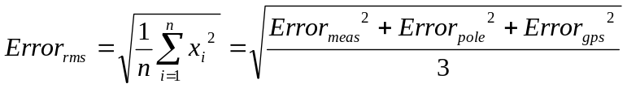

Explanation why not Monte-Carlo simulation

Block transport model
To attempt to quantify the error in the measurements of block transport, it is useful to consider the following scenarios:

- The overall distance moved, that is from start point to end point shown as line AF in Figure 4, can be calculated readily using Pythogora’s Theorem but takes no account of movement that double back or of the error in block position data.
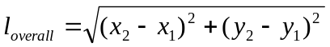
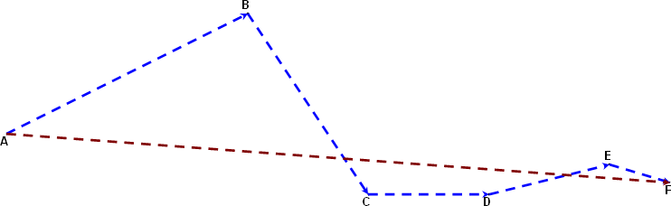
Figure 4: Block transport routes using test data showing actual distance travelled
ABCDEF (blue) and distance travelled between AF (burgundy).

- The total actual/raw/discrete distance moved by the block between each movement record can be found from the sum of the individual block movements, again using Pythagora’s Theorem (shown as blue poly-line ABCDEF in Figure 4).

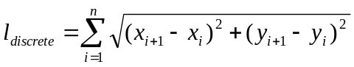

- As can be seen in Figure 5(a), the ‘longest’ distance moved has been assumed to be the line joining the outer intersection of the line bisecting the angle between three successive block measurements and the middle block’s GPS ‘error circle’ which is represented by the circles drawn around each block. The distance for the first and last block measurements are found by projecting a line from the second or penultimate outer intersection point through the actual GPS measurement point to the far side of the GPS error circle. Figure 5(b) shows this process applied to the 6 block positions from Figure 4. The size of the GPS error circles have been greatly exaggerated relative to the magnitude of the block movement.

(a) 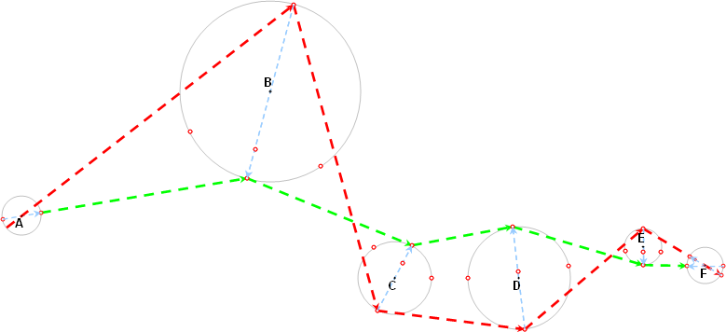 (b)
A
B
C
Long
Shherefore, ction inthe 6 block positions from Figurer we can use their RMS value, square root of the arithmetic mean, as followsort

Figure 5: Various transport routes calculated using test data. (a) long and short route between 3 points to show principle of construction (b) Showing longest distanced travelled ABCDEF (red) and possible ‘short’ distanced travelled ABCDEF (green).

- The ‘short’ route was originally investigated for application to block measurements with large changes in direction and more acute angles. It follows a similar method to the ‘longest’ route in Figure 5, but can readily be seen to have shortcomings since the true position of a measurement may lie anywhere within the GPS error circle not just at the inner intersection. A single line from the inner intersection of circle C can be drawn to the inner intersection of circle F which passes through both circles D and E.

C
D
E
F

Therefore, to determine the actual longest or shortest route passing through each successive point measurement using the basis given above, we also need to take into account the following factors:
- Route between three or more block measurements can pass through interior of inner GPS error circles to give a straight line.
- Overlapping GPS error circles
- Direction of movement between successive measurements equal to 0 or 180°.
- Significance of block movement e.g. > ½ main axis of block or a proportion of the GPS error.

