### Recent Experience

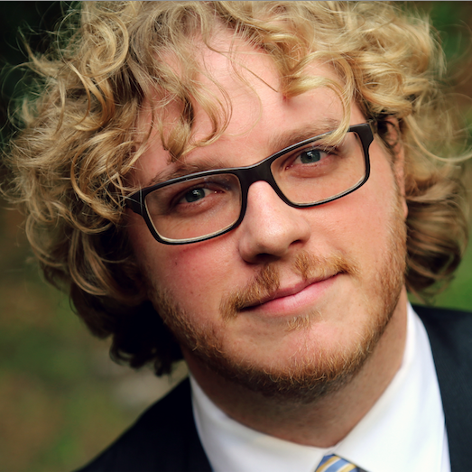

**James T Snell**

Professional Engineer

312 7th Ave NE,

Calgary Alberta, T2E0M9, Canada

1-403-616-7685

[james@dawning.ca](mailto:james@dawning.ca)

# **Objective**

I love to develop excellent and meaningful devices, products and services. I seek to face interesting unknowns together, with clever & motivated people.

## **PERSONALITY**

* Self-starter, adaptive and driven
* Comfortable architecting and leading development.
* Very willing to follow excellent leaders
* Life-long exposure entrepreneurial mentality

## **Buzzword bingo**

Java, Objective-C, C/C++, PHP, Python, Swift3, Javascript, jQuery, Ajax, HTML, CSS, BASH, Geoserver, MySQL, Postgres/PostGIS, Virtualization, svn, git, gitlab, devops, continuous integration, Apache2, nginx, CAD (Fusion 360), VHDL, FPGAs, PCB layout, Agile method, DRY principle

#### Lidar Services International (LSI)

#### & GasRecon (GRI)

##### September 2011 to present, Full-Time

|  |  |
| --- | --- |
| 2017 | Design and implementation of tools to improve behind-the-scenes automated reporting (via Slack/MatterMost webhooks). Created a unified application to handle deployment, config & self-managed updating of cross-platform tools. Continued ownership of all GRI systems and LSI Software. Rapidly designed and implemented an inexpensive precision-logging prototype system towards next-gen aerial data collection requirements. |
| 2016 | Created GRI semi-automated pipeline to reduce overhead of incoming field data. Migrated GRI Cloud servers from EC2 to in-house ESX infrastructure. Ported all dev IP from Trac/SVN and in to Gitlab. Replaced my original LSI build system with a gitlab-CI. Autobuilds gained automatic unit test reports. Data processing and handling support for GRI field operations, fed back in to development priorities. |
| 2015 | On-going rapid iterative GRI R&D. Architected and owned Roll-out of Cloud services (leveraged AWS EC2 and S3 for approx. 20 servers). Much on-the-fly R&D to adapt field systems to rapidly shifting needs. Flew data collection flights for large LSI project in Costa Rica. Became sole on-staff developer for GRI. Co-integration of higher accuracy GPS receivers in to GRI field systems. |
| 2014 | Co-developed integration of a new high quality LiDAR scanner to the LSI Matrix platform. Integrated new COTS still-cameras for aerial use. On-going heavy GRI development. Coordinated through rapid prototyping cycles with 2 other developers. Sole, on-going DevOps role. Field operations of new GRI platform began. Owned connection between field operations and R&D. |
| 2013 | Major Participant from the very start, as LSI created GRI (pipe mapping and CH4 leak detection). Contributed much to architectural design of backpack sensor platform. Attended nearly all LSI field operations. |
| 2012 | Began on-going iterative software R&D for LSI’s *Matrix* platform (data collection system, used in-flight). Founded LSI’s DevOps strategy. Continued field operations role. |
| 2011 | Hardware-focused. Installed, flew and field-repaired aerial platforms (Helicopters & Fixed-wing aircraft, for maned flight operations). |

#### Columbia College Calgary

## App Store

<https://dawning.ca/apps>

I’ve recently released a few glorified *hello-world* apps to Apple’s App Store. I’ve especially enjoyed watchOS and macOS dev.

## personal lab

I maintain a home environment of Linux and BSD servers. I prototype with them and frequently roll-out my findings beyond my lab. I’m a major lover & very seasoned user of all-things Unix.

## 3D Printers

<https://dawning.ca/df>

<https://dawning.ca/cc155>

I was an early adopter of 3D printers. I’ve built two, one a heavily altered kit, the other from scratch. My printers have various excellent customizations.

## MRI/CT 3D Modelling

<https://dawning.ca/skulls>

I’ve processed & printed complex models derived from actual raw MRI data of my nephew’s skull. I recently gained access to the Smithsonian’s CT scan database for future such projects.

## More

<https://jamessnell.com>

<http://linkedin.com/in/jamestsnell>

<https://github.com/docdawning>

<https://dawning.ca/hackaday>

##### April 2009 to present, Contracted-basis

Columbia College is my family’s business. I’ve been involved with Columbia most of my life. In 2009, I founded their Security Services training eLearning platform using Moodle, on AWS-hosted LAMP services. Paypal-driven self-enrolled students have attended our online programs in Security Services ever since.

Using Columbia’s in-house VMware ESX infrastructure, I coordinate all Linux-based services and since I initially established them. This includes an in-house AD-integrated Moodle deployment (separate to the above mentioned) with over 2000 active student & staff accounts.

I have created and deployed various generations of Columbia’s public website (upon Wordpress, on self-hosted Linux servers). This includes establishment and coaching of SEO and Social Media advertising campaigns. We recently have outsourced this to an external firm, though I continue to coach the internal and external team members.

### Formal education & Credentials

#### Professional Engineer Designation (P.Eng), Licensed by association of professional engineers and geoscientists of Alberta (Apega), 2015

#### Bachelor of Science in Computer Engineering, University of Calgary, 2010

#### Bachelor of Science in Computer Science,

#### Embedded systems concentration,

#### University of Calgary, 2010

### Interests

I’m perpetually working on personal projects aimed to help me gain new skills. Often, methods I explore in my home lab ends up inspiring systems I deploy professionally. I’ve listed some relevant projects to the left.