Creating Music Database
in LibO Base

Objective
In this article, I will show how I use LibreOffice Calc and LibreOffice Base to create a searchable music database with content from my iTunes library. I will contrast the LibreOffice approach to an alternative approach on a LAMP stack. Since LibreOffice runs in both the Windows and Linux computing environments, this method works in both.
MySQL is the most commonly used open source database management system available. For anyone with even modest familiar with the Structured Query Language (SQL) used for database queries, I will demonstrate how to create SQL queries in LibreOffice Base.

Figure 1. LAMP Approach
User

ApacheServer
PHP
Server
MySQL Database
Local Network

LAMP approach
The most common front-end user interface to MySQL is a PHP-based application and a web browser. Accessing a MySQL database with a web browser requires a web server and an application to submit SQL queries and send results to the browser. A commonly used set of open source software tools called LAMP (Linux, Apache, MySql, and PHP) can connect a web browser front-end with a MySQL database on the back-end. Linux is the underlying operating system, Apache is the web server, MySQL is the database server, and a PHP-based application such as Drupal or WordPress provides the user interface.
The LAMP approach is very robust and is well suited for multi-user or web site use. Configuration and customization however, make it complex for personal, educational, or home office use. LibreOffice provides a simpler easier to implement solution that addresses more modest needs for a single user.

LibreOffice approach
LibreOffice provides an integrated suite of tools that achieve the same objectives, with less complexity, configuration, and overhead. The LibreOffice applications required are LibreOffice Calc (spreadsheet) and LibreOffice Base (database management). With these two applications plus iTunes, the general process is as follows:
- Export library from iTunes as a tab-separated text file
- Import library into LibreOffice Calc for minor edits
- Copy modified library data into LibreOffice Base
- Create SQL queries
- Run queries and filters to display results

Export from iTunes
The first step is to export music information from iTunes to a text file in a format that can be imported into LibreOffice. Playlists can be exported from iTunes as a table in a tab delimited plain text file format. The comma separated (CSV) format is unacceptable because some data fields (such as album titles, song titles, or artist names) may contain commas or other special characters. The exported playlist list may consist of some or all of the songs in the library. I follow the steps listed below.
- Select all songs in the library
- File > Library > Export Playlist
- File name: Music.txt
- Save as type: Text files (*.txt)
(This saves the playlist as a tab delimited text file Music.txt that can be directly imported as a plain text spreadsheet. You can choose any name you want.)

Import text file into LibreOffice Calc
Next I import the tab delimited file Music.txt into LibreOffice Calc for minor editing. When I open the text file, LibreOffice Calc pops up a Text Import dialog box giving me the option to select or change the delimiter.
Import steps:
- File > Open
- Select Text documents from the file type drop-down menu.
- Select Music.txt
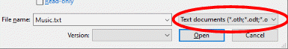Figure 2: Select text file type
- Click Open
- Text Import dialogue box opens. Mark Tab option in Separator Options. Unmark other Separator Options.
- Examine the preview in the Fields section.
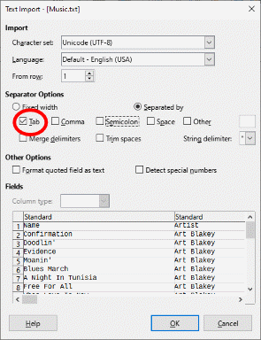Figure 3. Text Import dialog box
- Click OK

iTunes exports many data fields as table columns, and some of them are not useful or wanted. Since I am only interested in Name (song title), Artist, Album, Genre, Track Number and year, I delete all columns except for these. I also insert an ID field to be used as a primary key. (I will discuss the primary key in the database section of this article.)
To insert the ID field, I follow these steps:
- Insert a column in the first position, left of the name column.
Sheet > Insert Columns > Columns Left
- Label new column “ID”
- Leave cells in the ID column blank. (They will be automatically filled in LibreOffice Base.)
- Click Save
- I can optionally keep Calc open to cut & paste data later
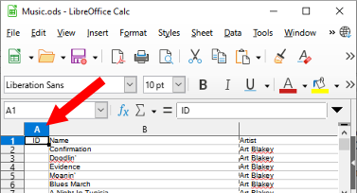Figure 4. Insert ID column
At this point, I have the data that I need to populate the database. I need to get that spreadsheet data into a database. LibreOffice Base can create, manage and edit flat and relational databases. The next section describes how I use LibreOffice Base to create my music database.

LibreOffice Base database
LibreOffice makes use of wizards in most of it’s applications. I find that wizards are very helpful in LibreOffice Base, especially users that are not expert in the SQL language. The first step is to create a new database. While LibreOffice Base is capable of importing data directly from a spreadsheet, I prefer to copy and paste the table data from Calc into a predefined template in Base using a wizard.
Create New Database
Next I create and register a new database as follows:
- Open LibreOffice Base (Database Wizard appears)
- Click Create a new database
- Click Next >
- Mark options:
  - Yes, register the database for me
  - Open the database for editing
  - Create tables using the table wizard
- Click Finish
- Click Save As MusicLibrary.odb
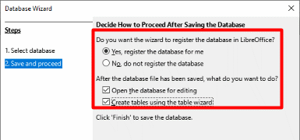Figure 5. Create database options
Note: Registering the database allows the database to be used by other LibreOffice components such as Writer. It is not required. You can use it at your own discretion.
After creating the database, Table Wizard (Figure 6) appears. When it appears, I follow these steps.
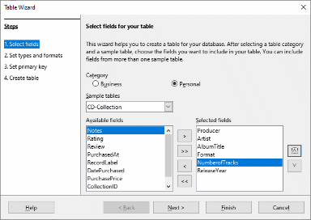Figure 6. Table Wizard
Step 1: Select fields
Select Personal Category option
Select CD-Collection from Sample tables
Select and Move the following fields from Available fields to Selected fields: Producer, Artist, AlbumTitle, Format, NumberofTracks, ReleaseYear (Note: Some of these field names will be modified)
Click Next >

Step 2: Set types and formats
Change Field names but keep corresponding Field type. For the song, artist, and album fields, set Length to 150. (Figure 7)
Change the Field names of the following fields: Producer to Song, AlbumTitle to Album, Format to Genre, NumberofTracks to Track, ReleaseYear to Year
Click Next >

Step 3: Set primary key
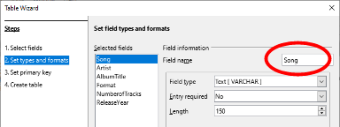Figure 7. Set types and formats
Mark the Create a primary key box if not marked already.
Select options: Create a primary key, Automatically add a primary key, Auto value
Click Next >

Step 4: Create table
Change name to MyTable
Select option Insert data immediately
Click Finish (Table Wizard closes. Table Data View opens. Confirm column labels and close the window. Base window appears with Database, Tasks, and Tables sections visible.)

Once the table is created in Base, open the Music.txt spreadsheet in Calc. Select and copy all data cells from A1 through the last cell. (That includes column label cells.) Switch back to Base and follow the steps below to paste the copied table data into MyTable in Base.

In Tables section
Select MyTable
Right-click and choose paste from the drop-down menu (Copy table window opens. See Figure 8.)
Select the Append data option
Mark Use first line as column name
Click Next > (Assign columns window)
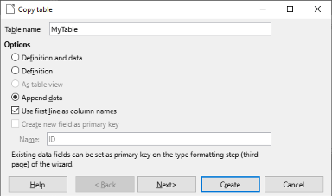Figure 8. Copy table from Calc into Base
Review to confirm that the Source table data aligns with the destination table labels, then click Create.

Double-click MyTable to open the Table Data View and confirm that data copied correctly. Set the width of the columns. (The width of the query result field is determined by the width of the table fields.) Unmark Automatic.

I now have the database ready to run SQL queries to find songs, artists, and album information from my music library. The next step is to set up and run queries on the database. LibreOffice Base provides three methods to create SQL queries:
- Create Query in Design View
- Use Wizard to Create Query
- Create Query in SQL View
I use the second method, Use Wizard to Create Query, to set up and run a query. As an example I first set up a query search for an all songs by a particular artist. Then, I use the Standard Filter on the query results to refine my searches.

Set up and run query
Click on Queries icon in Database section
Click on Use Wizard to Create Query (Query Wizard appears)

Step 1: Field selection
Select Song, Artist, and Album in the Available fields window then move them to the Fields in the Query window. Use up or down arrow to change the order if necessary. (Figure 9)
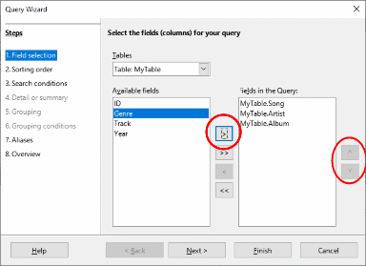Figure 9. Query Wizard
Step 2: Sorting order
Sort by Artist first, then Album, then by Song, all in ascending order
Step 3: Search conditions
Select MyTable.Artist in the Fields drop-down. (Figure 10) Select like from the Condition drop-down list. Enter Value %Herbie H%.
Note: In SQL, the % sign is used as a wild card character. The like function matches string patterns. The SQL view shows the SQL statement as:
SELECT "Artist" AS "Artist", "Song" FROM "MyTable" WHERE "Artist" LIKE '%Herbie H%'
(Skip Steps 5-6 since grouping will not be used.)
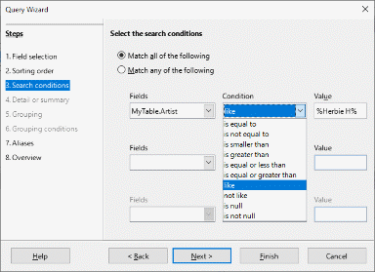Figure 10. Search conditions
Step 4: Aliases
Alias for MyTable.Artist defaults to Artist and MyTable.Song defaults to Song. I use the defaults. (Figure 11)
Step 5: Overview
In the Name of the query field, I change the default name Query_MyTable to Query_ArtistsAndSongs. Review contents in Overview window. Use default Display Query option.
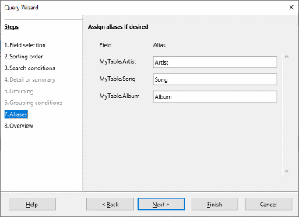Figure 11. Aliases
The results in the Data Table View list all songs and albums by Herbie Hancock in my music library. To narrow my search down to just songs in one of the three albums, I could create another query repeating the five steps above, but there is an easier way. I use the Standard Filter in the Data Table View from this query result.
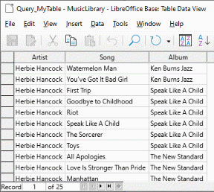Figure 12. Table Data View

Set up and run filter
- If the Table Data View is not already open, I can click on the Queries icon in the Database section
- Double-click Query_MyTable. The Table Data View opens. (Figure 12)
- Click Standard Filter in Toolbar (Figure 13)
- In Standard Filter, select Album in the Field Name drop-down list and select like in the Condition drop-down list.
Note: Using the like condition allows the use of wildcards to match partial strings in the Value field.
- Enter the artist name in the Value text box. The Value string is case sensitive and requires exact spelling. Again I use the SQL wildcard percent (%) character. e.g. %Speak% in place of the full album name “Speak Like A Child”.
- Other filter conditions can be applied to either the Artist, Song, or Album fields.

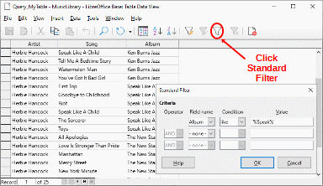Figure 13. Standard Filter

Filter result
As we can see from the six song tracks in Figure 14, the Standard Filter narrowed the album information to one album, “Speak Like A Child”.
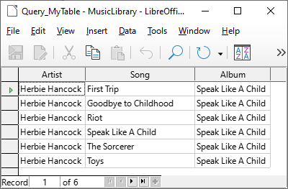
This was a simple example to illustrate that by following the process I’ve described, LibreOffice can easily be used to migrate music information from iTunes into a searchable database and perform simple to moderately complex database queries.
Figure 14. Filter result

Summary
To facilitate the database creation and query process for users that may have minimal familiarity with SQL, I used Wizards to create a database table and SQL query. More sophisticated SQL users could write more complex queries and table relationships. Those features are available in LibreOffice Base.
While I used the LibreOffice Base embedded database engine HSQLDB, Base can also connect to other popular SQL databases like MySQL, Maria, and PostgreSQL to name a few.
For users that need to create and manage one or more databases for personal, educational, or home office use, LibreOffice is faster to implement, simpler, has a built-in user interface, and achieves the same goals as the LAMP approach for simple to moderately complex database queries.

# Steps #

In iTunes
- Select all songs in library (approximately 650)
- File > Library > Export Playlist
- iTunes
(This saves as tab delimited txt file which can then be directly imported into Excel.)
Note: Export Playlist works for individual playlist or entire library. Export Library only exports xml.

In Excel
- File>Open
- Select “Files of type: Text Files (*.prn; *.txt; *.csv)” from drop-down menu.
- Select your_file.txt
- Click Open
- Text Import Wizard opens for step 1 of 3.
- Step 1: Check “Delimited” option.
- Step 2: Select Tab option. Examine Data preview window
- Step 3: Select General option in Column data format. Click Finish

In LibreOffice Calc
- File > Open
- Select “Files of type: Text documents” from drop-down menu. <Pic>
- Select your_file.txt
- Click Open
- Text Import dialogue box opens. <Pic> Select Tab option in Separator Options. Unselect other separator options.
- Examine the preview in the Fields section.
- Click OK
- Delete all columns except Name, Artist, Album, Genre, Track Number, and Year
- Insert a column in the first position, left of the name column. <Pic>
Sheet > Insert Columns > Columns Left
- Label new column ID
- Autofill ID column starting at 1
Sheet > Fill Cells > Series
- Click Save
- Keep Calc open to retrieve data later

In LibreOffice Base
- Open LibreOffice Base (Database Wizard appears)
- Click Create a new database
- Click Next >
- Select options: <Pic>
  - Yes, register the database for me
  - Open the database for editing
  - Create tables using the table wizard
- Finish
- Click Save As database_name
- Table Wizard appears

In Table Wizard <Pic>
Step 1: Select fields
Select Personal Category option
Select CD-Collection from Sample tables
Select and Move the following fields from Available fields to Selected fields: Producer, Artist, AlbumTitle, Format, NumberofTracks, ReleaseYear (Note: Some of these field names will be modified)
Click Next >

Step 2: Set types and formats <Pic>
Change Field names but keep corresponding Field type and Length.
Change the Field names of the following fields: Producer to Song, AlbumTitle to Album, Format to Genre, NumberofTracks to Track, ReleaseYear to Year
Click Next >

Step 3: Set primary key
Check the Create a primary key box if not marked already.
Select options: Create a primary key, Automatically add a primary key, Auto value
Click Next >

Step 4: Create table
Change name to MyTable
Select option Insert data immediately
Finish (Wizard closes. Base window appears with Database, Tasks, and Tables sections.)

Switch to open music spreadsheet in Calc
Copy all data cells except column labels
Switch to Base

In Tables section
Select MyTable
Right click > paste (Copy table window opens) <Pic>
Select Append data option
Unmark “Use first line as column name”
Click Next > (Assign columns window)

Review to confirm that the Source table data aligns with the Destination table labels.
Click Create

Open MyTable to confirm that data copied correctly.
Set the width of the columns. Unmark Automatic. Set column widths as follows: Song = 6 cm., Artist = 5 cm., Album = 6 cm., Genre = 3 cm., Track and Year = Automatic. (The width of the query result field is determined by the width of the table fields.

Setup and run query
Click on Query icon in Database section
Click on Use Wizard to Create Query (Query Wizard appears) <Pic>

Step 1 (Field selection): Select Song and Artist in the Available fields window then move them to the Fields in the Query window. (Use up or down arrow to change order if necessary.)
Step 2 (Sorting order): Sort by Artist first, then by Song, both in ascending order
Step 3 (Search conditions): Select MyTable.Artist in the Fields drop-down. <Pic> Select “like” from the Condition drop-down list. Enter Value %. (SQL: SELECT "Artist" AS "Artist", "Song" FROM "MyTable" WHERE "Artist" LIKE '%')
Skip Steps 4-6 since grouping will not be used.
Step 4 (Aliases): Alias for MyTable.Artist defaults to Artist and MyTable.Song defaults to Song. Use the defaults. <Pic>
Step 5 (Overview): In the Name of the query text box, change Query_MyTable to Query_ArtistsAndSongs. Review contents in Overview window. Use default Display Query option.

Setup and run filter
- Click on Query icon in Database section
- Run Query_ArtistsAndSongs (Table Data View opens) <Pic>
- Click Standard Filter in Toolbar <See BaseRunQuery pic>
- In Standard Filter, select Artist in Field Name drop-down list and select like in Condition drop-down list. (Note: Using the like condition allows the use of wildcards to match partial strings in the Value text box.) <Pic>
- Enter artist name in the Value text box. The Value string is case sensitive and requires exact spelling. You can enter a partial string by using enclosing the partial string in single quotes and using the SQL wildcard percent (%) character. e.g. ‘%Miles D%’ in place of the full artist name ‘Miles Davis’.
- Other filter conditions can be applied to either the Artist or Song field.

Background
(Elaborate on steps taken to create library database with MySQL and Wordpress.)

Statistics
Number of songs in library: 650
Apache Version 2.4.
LibreOffice version 6.4 & 7.2
MySQL Version 5.7.29
WordPress Version 5.3.2

Notes
1. If you often use the same basic query but with different values each time, queries with parameters can be used. In principle queries with parameters function just like queries for a subform.

Bibiliography for Notes
1. LibO Base Guide (LBG) p. 234

SQL
*Search by artist. Order by Album.
SELECT Artist,Album,Genre,RelYear FROM musict3 where Artist LIKE '%" . $artistname . "%' ORDER BY Album;
* All artists in database
SELECT DISTINCT Artist,Album FROM musict3 ORDER BY Artist;
*Search for album name. Order by track mumber.
SELECT Artist,Album,Track,TrkName FROM musict3 where Album LIKE '%" . $albumname . "%' ORDER BY Track;
*All albums in database. Order by Album.
SELECT DISTINCT Album,Artist FROM musict3 ORDER BY Album;
*All tracks on album.
SELECT TrkName,Artist,Album,Track FROM musict3 where TrkName LIKE '%" . $songname . "%' ORDER BY TrkName;

###

