Dota2 Competition

Table of Contents
== Results timings == 1
template Heroes- bow, Lobby – bow, time – pres 1
LogisticRegression Heroes- bow, Lobby – bow, time – here 01_02_03 2
Grad Bust: Heroes- bow, Lobby – bow, time – pres, Est =200, max-depth-6 3
Grad Bust: Heroes- bow, Lobby – bow, time – pres, Est =300, max-depth-8 4
LogisticRegression Heroes- bow, Lobby – bow, time – removed 5
LogisticRegression: Heroes- bow, Lobby – bow, time – pres 7
== Submissions == 9
Submissions 05 – with added results – 0.75735 – 0.00066. 143 место 9
Submission 04 11
Submission 03 12
Submission 02 12
Submission 01 13

== Results timings ==

template Heroes- bow, Lobby – bow, time – pres
&&&& parameters &&&&&&&&&

Heroes – ????
Lobby – ?????
Time - ?????

&&&& results &&&&&&&&&
?? 'C': 0.005
??? best score = 0.751887870551
??? /Volumes/fast64/My/MachineLearning/week07/Dota2_02/logreg_train.csv

&&&&&& code &&&&&&&&&
??????

&&&&&& rez &&&&&&&&&
??????

LogisticRegression Heroes- bow, Lobby – bow, time – here 01_02_03
&&&& parameters &&&&&&&&&

Heroes – bag of words
Lobby – bag of word
Time is Not removed
applied transformations:
01
02
03

&&&& results &&&&&&&&&
best param = {'C': 0.0080000000000000002} best score = 0.752667856313 (0.752028818385)

/Volumes/fast64/My/MachineLearning/week07/Dota2_02/logreg_train_01_02_03.csv
/Volumes/fast64/My/MachineLearning/week07/Dota2_02/logreg_test_01_02_03.csv

&&&&& code &&&&&&&&&&
&&&&& output &&&&&&&&&
modify_dayaframe_01 (Before). parDataFrame (97230, 108)
modify_dayaframe_01 (After). parDataFrame (97230, 105)
modify_dayaframe_02 (Before). parDataFrame (97230, 105)
modify_dayaframe_02 (After). rezDataFrame (97230, 115)
modify_dayaframe_03 (Before). parDataFrame (97230, 115)
modify_dayaframe_03 (After). rezDataFrame (97230, 117)
<class 'pandas.core.frame.DataFrame'>
Int64Index: 97230 entries, 0 to 114406
Columns: 117 entries, start_time to d_gold
dtypes: float64(21), int64(96)
memory usage: 87.5 MB
None
remove_result_columns (Before): shape (97230, 117)
remove_result_columns (After): shape (97230, 111)
(97230, 111) <class 'pandas.core.frame.DataFrame'>
(97230, 100) <class 'pandas.core.frame.DataFrame'>
Before
NaNs = 173534
not NaNs = 9549466
after
NaNs = 0
not NaNs = 9723000
<type 'numpy.ndarray'>
(97230, 113)
<type 'numpy.ndarray'>
(97230, 10)
(97230, 113) (97230, 10)
(97230, 123)
(97230, 100) <class 'pandas.core.frame.DataFrame'>
(97230, 123) <type 'numpy.ndarray'>
(97230, 223) <type 'numpy.ndarray'>
Done1
Done2
--- initial C calculation
{'C': [1e-11, 0.0001, 0.001, 0.01, 0.1, 1, 10, 100, 1000, 100000000]}
best param = {'C': 0.01} best score = 0.75266607169
mean: 0.51151, std: 0.00271, params: {'C': 1e-11}
mean: 0.74614, std: 0.00358, params: {'C': 0.0001}
mean: 0.75224, std: 0.00359, params: {'C': 0.001}
mean: 0.75267, std: 0.00357, params: {'C': 0.01}
mean: 0.75263, std: 0.00358, params: {'C': 0.1}
mean: 0.75262, std: 0.00358, params: {'C': 1}
mean: 0.75262, std: 0.00358, params: {'C': 10}
mean: 0.75262, std: 0.00358, params: {'C': 100}
mean: 0.75262, std: 0.00358, params: {'C': 1000}
mean: 0.75262, std: 0.00358, params: {'C': 100000000}
--- fine C tuning
{'C': array([ 0.005, 0.006, 0.007, 0.008, 0.009, 0.01 , 0.011, 0.012,
0.013, 0.014, 0.015])}
best param = {'C': 0.0080000000000000002} best score = 0.752667856313
mean: 0.75265, std: 0.00357, params: {'C': 0.0050000000000000001}
mean: 0.75266, std: 0.00356, params: {'C': 0.0060000000000000001}
mean: 0.75267, std: 0.00356, params: {'C': 0.0070000000000000001}
mean: 0.75267, std: 0.00357, params: {'C': 0.0080000000000000002}
mean: 0.75267, std: 0.00357, params: {'C': 0.0090000000000000011}
mean: 0.75267, std: 0.00357, params: {'C': 0.01}
mean: 0.75267, std: 0.00357, params: {'C': 0.010999999999999999}
mean: 0.75266, std: 0.00357, params: {'C': 0.012}
mean: 0.75266, std: 0.00357, params: {'C': 0.013000000000000001}
mean: 0.75266, std: 0.00357, params: {'C': 0.014}
mean: 0.75266, std: 0.00357, params: {'C': 0.014999999999999999}
Average time for single regression fit: 0:00:19.716209
Done3
Done4
Done5
Минимум предсказанных вероятностей = 0.000752490026246
Максимум предсказанных вероятностей = 0.999051758388
Done6 2016-04-23 00:00:19.931932

Grad Bust: Heroes- bow, Lobby – bow, time – pres, Est =200, max-depth-6
&&&& parameters &&&&&&&&&

Heroes – bag of words
Lobby – bag of words
Time – present
n_estimators in [200]
max_depth=6

&&&& results &&&&&&&&&

best score = 0.73496934060687025
No results

&&&&&& code &&&&&&&&&
# Считаем для 200 - max_depth=6
rez_scores_6 = list()
for n_estimators in [200]:
rez_scores_6.append((n_estimators, calculate_scores_for_estimators(n_estimators, x_bust , y_bust, max_depth=6)))
rez_scores_6
n_estimators = 200 max_depth= 6 Time elapsed: 0:50:03.578764
Out[86]:
[(200, (0.73496934060687025, 0.0034719373478807334))]

&&&&&& rez &&&&&&&&&
??????

Grad Bust: Heroes- bow, Lobby – bow, time – pres, Est =300, max-depth-8
&&&& parameters &&&&&&&&&

Heroes – bag of words
Lobby – bag of words
Time – present
n_estimators in [300]
max_depth=8

&&&& results &&&&&&&&&

best score = 0.730912764209 (200,6 0.73496934060687025)
/Volumes/fast64/My/MachineLearning/week07/Dota2_02/grad_bust_train_300_8.csv
grad_bust_test_300_8.csv
&&&&&& code &&&&&&&&&
rez_scores = crossvalidate_estimators([300], x_bust, y_bust, max_depth=8)
clf= get_best_GradientBoostingClassifier(rez_scores)
clf.fit(x_bust, y_bust)
rez_dataframe = store_predicted_probability(clf, x_bust, match_info, '/Volumes/fast64/My/MachineLearning/week07/Dota2_02/grad_bust_train_300_8.csv')
print 'Done'
​
score_mean= 0.730912764209 scores_std= 0.00295226870677 n_estimators = 300 max_depth= 8 Time: 2:22:47.397056
<type 'list'>
0.730912764209
max_score = 0.730912764209 max_index= 0 best_n_estimators= 300 best_max_depth= 8
Минимум предсказанных вероятностей = 0.00311487817964
Максимум предсказанных вероятностей = 0.996693682736
Done

&&&&&& rez &&&&&&&&&
??????

LogisticRegression Heroes- bow, Lobby – bow, time – removed
&&&& parameters &&&&&&&&&

Heroes – bag of words
Lobby – bag of word
Time is removed

&&&& results &&&&&&&&&
'C': 0.005
best score = 0.751887870551 (Strange – best score went down after time removal 0.752028818385)
/Volumes/fast64/My/MachineLearning/week07/Dota2_02/logreg_train.csv
???? /Volumes/fast64/My/MachineLearning/week07/Dota2_02/???????????

&&&&&&&&&&&&&&&

x_train, y_train, x_train_data_frame, = prepare_for_log_regr('/Volumes/fast64/My/MachineLearning/week07/Assignment01/data/features.csv', False)
ss = stdScaling_fit(x_train)
print 'Done1'
X_train_std_scal = stdScaling_transform( x_train ,ss)
print 'Done2'

log_reg_best_param = calculate_logreg_best_param(X_train_std_scal, y_train)
print 'Done3'

clf = LogisticRegression(penalty='l2', random_state=555, C=log_reg_best_param['C'])
print 'Done4'

clf.fit(X_train_std_scal, y_train)

print 'Done5'
rez_dataframe = store_predicted_probability(clf, X_train_std_scal, x_train_data_frame, '/Volumes/fast64/My/MachineLearning/week07/Dota2_02/logreg_train.csv')
print 'Done6'

&&&&&&&&&&&&&&&&&&&&&&&&&&&
<class 'pandas.core.frame.DataFrame'>
Int64Index: 97230 entries, 0 to 114406
Columns: 108 entries, start_time to barracks_status_dire
dtypes: float64(12), int64(96)
memory usage: 80.9 MB
None
(97230, 102) <class 'pandas.core.frame.DataFrame'>
(97230, 90) <class 'pandas.core.frame.DataFrame'>
Before
NaNs = 193087
not NaNs = 8557613
after
NaNs = 0
not NaNs = 8750700
<type 'numpy.ndarray'>
(97230, 113)
<type 'numpy.ndarray'>
(97230, 10)
(97230, 113) (97230, 10)
(97230, 123)
(97230, 90) <class 'pandas.core.frame.DataFrame'>
(97230, 123) <type 'numpy.ndarray'>
(97230, 213) <type 'numpy.ndarray'>
Done1
Done2
--- initial C calculation
{'C': [1e-11, 0.0001, 0.001, 0.01, 0.1, 1, 10, 100, 1000, 100000000]}
best param = {'C': 0.01} best score = 0.751873476501
mean: 0.50711, std: 0.00085, params: {'C': 1e-11}
mean: 0.74280, std: 0.00339, params: {'C': 0.0001}
mean: 0.75157, std: 0.00349, params: {'C': 0.001}
mean: 0.75187, std: 0.00349, params: {'C': 0.01}
mean: 0.75183, std: 0.00350, params: {'C': 0.1}
mean: 0.75182, std: 0.00350, params: {'C': 1}
mean: 0.75182, std: 0.00350, params: {'C': 10}
mean: 0.75182, std: 0.00350, params: {'C': 100}
mean: 0.75182, std: 0.00350, params: {'C': 1000}
mean: 0.75182, std: 0.00350, params: {'C': 100000000}
--- fine C tuning
{'C': array([ 0.005, 0.006, 0.007, 0.008, 0.009, 0.01 , 0.011, 0.012,
0.013, 0.014, 0.015])}
best param = {'C': 0.0050000000000000001} best score = 0.751887870551
mean: 0.75189, std: 0.00349, params: {'C': 0.0050000000000000001}
mean: 0.75188, std: 0.00349, params: {'C': 0.0060000000000000001}
mean: 0.75188, std: 0.00349, params: {'C': 0.0070000000000000001}
mean: 0.75188, std: 0.00349, params: {'C': 0.0080000000000000002}
mean: 0.75188, std: 0.00349, params: {'C': 0.0090000000000000011}
mean: 0.75187, std: 0.00349, params: {'C': 0.01}
mean: 0.75187, std: 0.00350, params: {'C': 0.010999999999999999}
mean: 0.75187, std: 0.00350, params: {'C': 0.012}
mean: 0.75186, std: 0.00350, params: {'C': 0.013000000000000001}
mean: 0.75186, std: 0.00350, params: {'C': 0.014}
mean: 0.75186, std: 0.00350, params: {'C': 0.014999999999999999}
Average time for single regression fit: 0:00:20.786627
Done3
Done4
Done5
Минимум предсказанных вероятностей = 0.00125251781433
Максимум предсказанных вероятностей = 0.998498987628
Done6

/Volumes/fast64/My/MachineLearning/week07/Dota2_01/dota2-kaggle-01.ipynb

LogisticRegression: Heroes- bow, Lobby – bow, time – pres
&&&& parameters &&&&&&&&&

Heroes – bag of words
Lobby – bag of words
Time – present

&&&& results &&&&&&&&&
'C': 0.0050000000000000001
best score = 0.752028818385
/Volumes/fast64/My/MachineLearning/week07/Dota2_02/logreg_train.csv
/Volumes/fast64/My/MachineLearning/week07/Dota2_02/logreg_test.csv

&&&&&& code &&&&&&&&&

x_train, y_train, x_train_data_frame, = prepare_for_log_regr('/Volumes/fast64/My/MachineLearning/week07/Assignment01/data/features.csv', False)
ss = stdScaling_fit(x_train)
print 'Done1'
X_train_std_scal = stdScaling_transform( x_train ,ss)
print 'Done2'

log_reg_best_param = calculate_logreg_best_param(X_train_std_scal, y_train)
print 'Done3'

clf = LogisticRegression(penalty='l2', random_state=555, C=log_reg_best_param['C']) # !! replace with log_reg_best_param
print 'Done4'

clf.fit(X_train_std_scal, y_train)

print 'Done5'
rez_dataframe = store_predicted_probability(clf, X_train_std_scal, x_train_data_frame, '/Volumes/fast64/My/MachineLearning/week07/Dota2_02/logreg_train.csv')
print 'Done6'

&&&&&& rez &&&&&&&&&
<class 'pandas.core.frame.DataFrame'>
Int64Index: 97230 entries, 0 to 114406
Columns: 108 entries, start_time to barracks_status_dire
dtypes: float64(12), int64(96)
memory usage: 80.9 MB
None
(97230, 102) <class 'pandas.core.frame.DataFrame'>
(97230, 91) <class 'pandas.core.frame.DataFrame'>
Before
NaNs = 193087
not NaNs = 8654843
after
NaNs = 0
not NaNs = 8847930
<type 'numpy.ndarray'>
(97230, 113)
<type 'numpy.ndarray'>
(97230, 10)
(97230, 113) (97230, 10)
(97230, 123)
(97230, 91) <class 'pandas.core.frame.DataFrame'>
(97230, 123) <type 'numpy.ndarray'>
(97230, 214) <type 'numpy.ndarray'>
Done1
Done2
--- initial C calculation
{'C': [1e-11, 0.0001, 0.001, 0.01, 0.1, 1, 10, 100, 1000, 100000000]}
best param = {'C': 0.01} best score = 0.752012765217
mean: 0.50815, std: 0.00173, params: {'C': 1e-11}
mean: 0.74291, std: 0.00337, params: {'C': 0.0001}
mean: 0.75172, std: 0.00349, params: {'C': 0.001}
mean: 0.75201, std: 0.00350, params: {'C': 0.01}
mean: 0.75197, std: 0.00351, params: {'C': 0.1}
mean: 0.75196, std: 0.00351, params: {'C': 1}
mean: 0.75196, std: 0.00351, params: {'C': 10}
mean: 0.75196, std: 0.00351, params: {'C': 100}
mean: 0.75196, std: 0.00351, params: {'C': 1000}
mean: 0.75196, std: 0.00351, params: {'C': 100000000}
--- fine C tuning
{'C': array([ 0.005, 0.006, 0.007, 0.008, 0.009, 0.01 , 0.011, 0.012,
0.013, 0.014, 0.015])}
best param = {'C': 0.0050000000000000001} best score = 0.752028818385
mean: 0.75203, std: 0.00350, params: {'C': 0.0050000000000000001}
mean: 0.75203, std: 0.00350, params: {'C': 0.0060000000000000001}
mean: 0.75202, std: 0.00350, params: {'C': 0.0070000000000000001}
mean: 0.75202, std: 0.00350, params: {'C': 0.0080000000000000002}
mean: 0.75202, std: 0.00350, params: {'C': 0.0090000000000000011}
mean: 0.75201, std: 0.00350, params: {'C': 0.01}
mean: 0.75201, std: 0.00350, params: {'C': 0.010999999999999999}
mean: 0.75201, std: 0.00350, params: {'C': 0.012}
mean: 0.75200, std: 0.00350, params: {'C': 0.013000000000000001}
mean: 0.75200, std: 0.00350, params: {'C': 0.014}
mean: 0.75200, std: 0.00350, params: {'C': 0.014999999999999999}
Average time for single regression fit: 0:00:18.811567
Done3
Done4
Done5
Минимум предсказанных вероятностей = 0.00115585751738
Максимум предсказанных вероятностей = 0.998548195379
Done6

&&&&&&&&&&&&& code test &&&&&&&&&&&&&
rez_dataframe = store_predicted_probability(clf, X_test_std_scal, X_test_data_frame, '/Volumes/fast64/My/MachineLearning/week07/Dota2_02/logreg_test.csv')
print 'Done'
Минимум предсказанных вероятностей = 0.00885013986788
Максимум предсказанных вероятностей = 0.996288227305
Done

== Submissions ==

Submissions 05 – with added results – 0.75735 – 0.00066. 143 место

{'C': array([1, 1, 1, 1, 1, 1, 1, 1, 1, 1, 1])}
best param = {'C': 1} best score = 0.863028850866
logreg_test_01_02_03_pow2_gb_120_6.csv

Your Best Entry ↑
Your submission scored 0.70151, which is not an improvement of your best score. Keep trying!

=========================

score_mean= 0.753566204425 scores_std= 0.00391650456146 n_estimators = 120 max_depth= 6 Time: 0:09:30.104000
C:/My/Dota2/04/Rez01/grad_boost_test_120_6_plus_logreg.csv

Your Best Entry ↑
Your submission scored 0.75443, which is not an improvement of your best score. Keep trying!

On Tue, May 3, 2016 at 5:34 PM, Gennadiy Kostyshin <docentmail@gmail.com> wrote:
try it

Gennadiy Kostyshin <docentmail@gmail.com>
8:40 pm (1 day ago)

to me
score_mean= 0.75497010374 scores_std= 0.00370295927146 n_estimators = 120 max_depth= 5 Time: 0:06:35.635000
C:/My/Dota2/04/Rez01/grad_boost_test_120_5_plus_logreg.csv

Your submission scored 0.75662, which is not an improvement of your best score. Keep trying!

============================================================================================================
score_mean= 0.755888467732 scores_std= 0.00350303576086 n_estimators = 120 max_depth= 4 Time: 0:04:35.792000
C:/My/Dota2/04/Rez01/grad_boost_train_120_4_plus_logreg.csv

143 ↑20 docentmail
0.75735
13 Wed, 04 May 2016 03:30:20
Your Best Entry ↑
You improved on your best score by 0.00066.
You just moved up 22 positions on the leaderboard. Tweet this!

============================================================================================================
score_mean= 0.755347929013 scores_std= 0.0037281910584 n_estimators = 10 max_depth= 2 Time: 0:00:17.219000
C:/My/Dota2/04/Rez01/grad_boost_test_10_2_plus_logreg.csv

Your submission scored 0.75562, which is not an improvement of your best score. Keep trying!

Submission 04
/Volumes/fast64/My/MachineLearning/week07/Dota2_03/ExportedRez
logreg_test_01_02_03_pow2.csv
162 ↑271; docentmail; 0.75669; 6; Sun, 24 Apr 2016 17:09:48
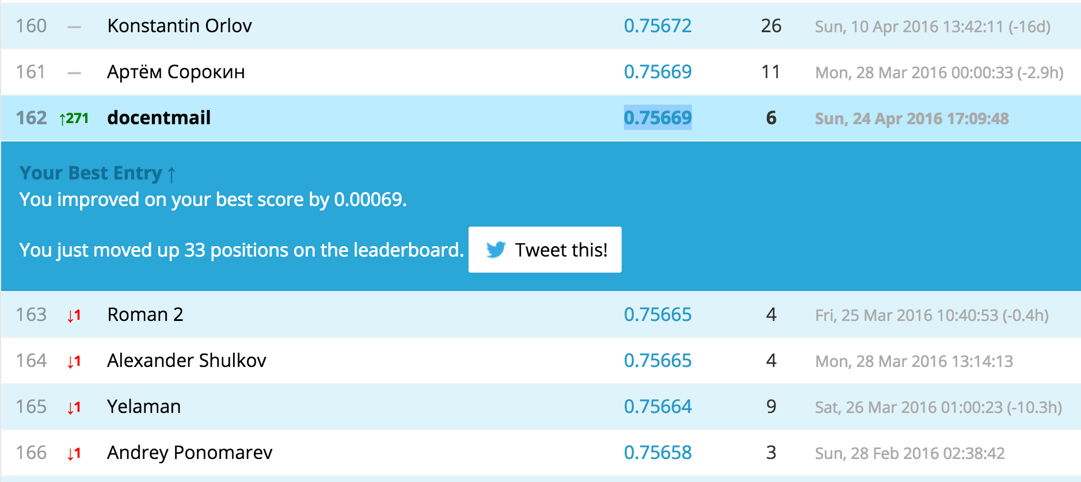

Submission 03

/Volumes/fast64/My/MachineLearning/week07/Dota2_02
logreg_test_01_02_03.csv
dota2-kaggle-02.ipynb
194 место; 0.75600; 23 апреля


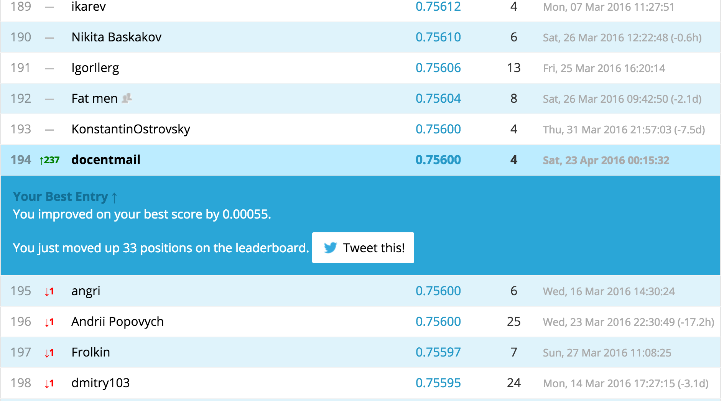

Submission 02

/Volumes/fast64/My/MachineLearning/week07/Dota2_01/dota2-kaggle-01.ipynb
226 место; 0.75545; 18 Апреля 2016

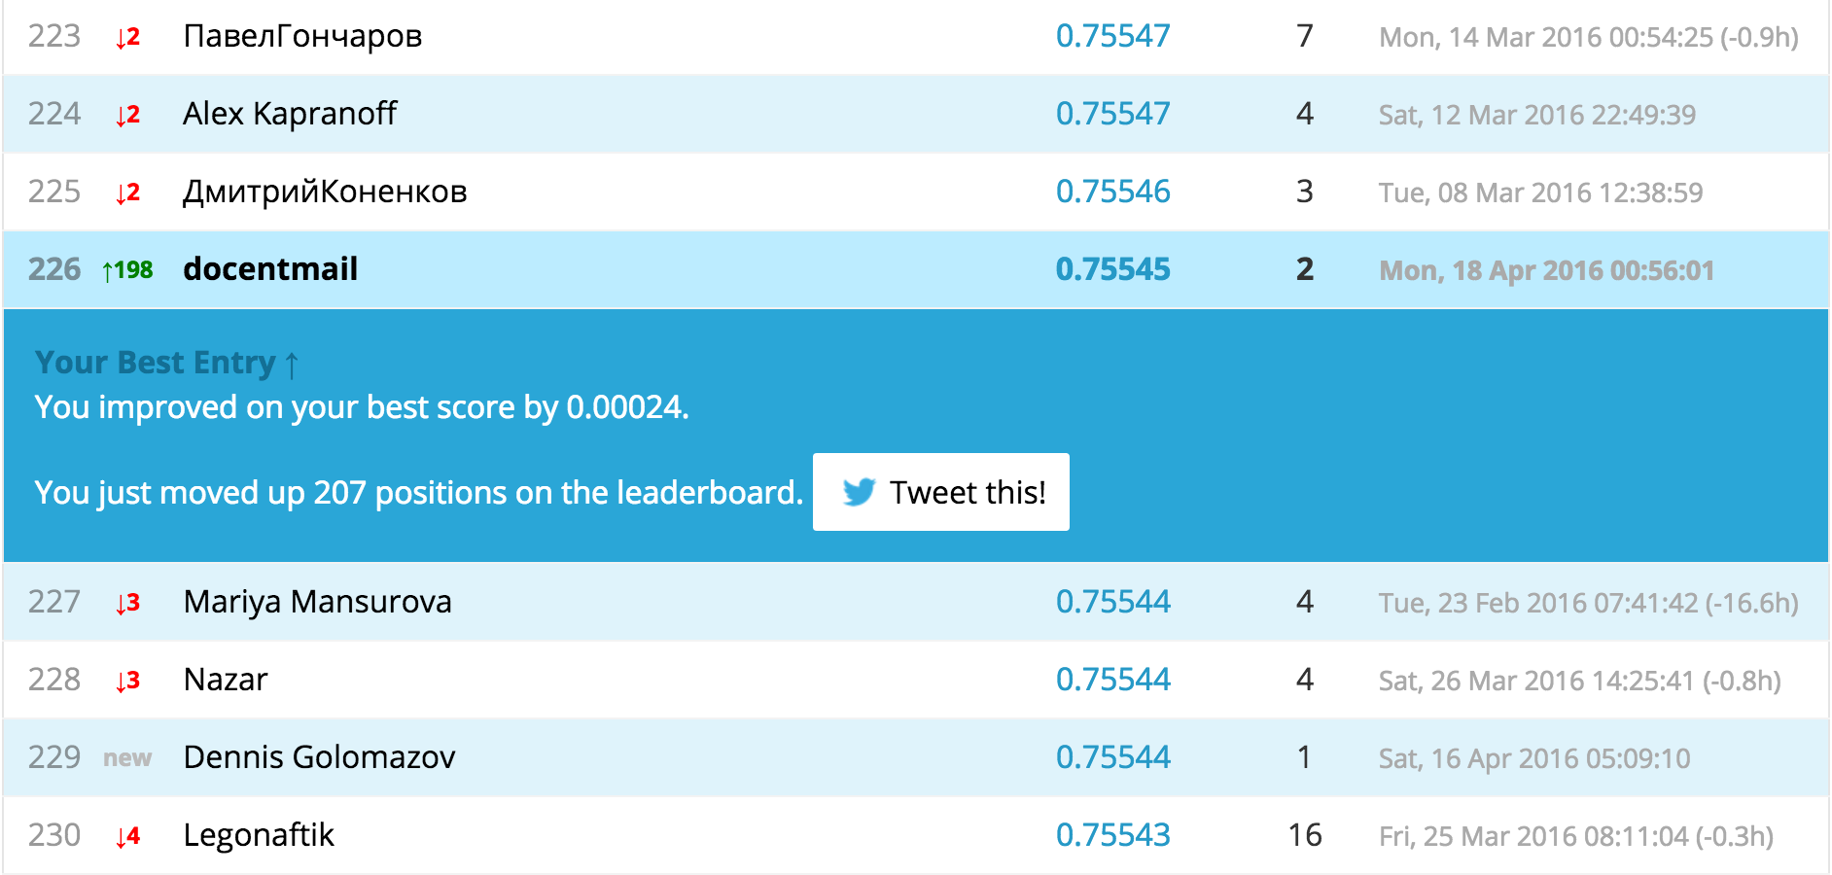

Submission 01
/Volumes/fast64/My/MachineLearning/week07/Assignment01/dota final.ipynb
433 место; 0.75521; 10 апреля 2016

