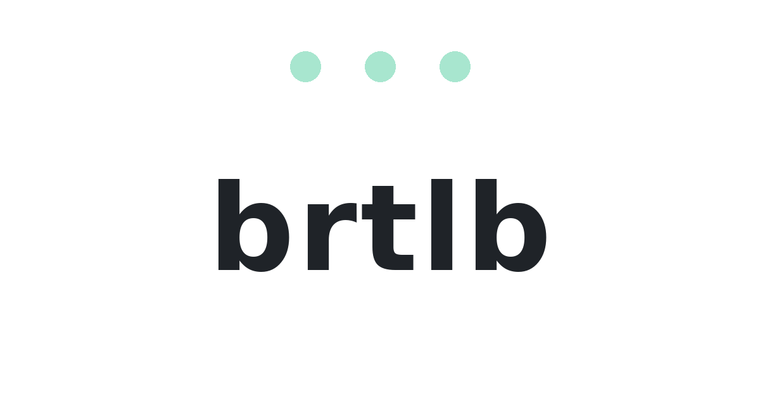
Brand Book v0.1
Developer handoff for pediatric AI scribe app
Core idea: BRTLB removes what gets in the way while preserving what matters.

1. Brand foundation
Decision area | Selected direction
Brand name | brtlb, all lowercase
Pronunciation | Bartleby
Category | Pediatric AI scribe / pediatric documentation assistant
Core idea | Removes what gets in the way while preserving what matters
Primary visual metaphor | Subtraction: the three dots represent removed friction, not missing meaning
Primary palette | Graphite / Seafoam / White
Wordmark direction | Soft grotesk; compact but legible; avoid overly tight l/b spacing

Positioning lines
Line | Use
Less noise. Same meaning. | Primary brand tagline
Pediatric documentation, compressed. | Category descriptor / product context
Chart less. Notice more. | Clinician-facing campaign or hero line

Brand should feel
- Modern, calm, precise, and useful
- Abstract rather than medical or pediatric-cute
- Trustworthy for clinicians and buyers
- Quietly intelligent, not flashy or magical

Avoid
- Stethoscopes, hearts, crosses, teddy bears, crayons, mascots, kid-coded illustration
- Robots, sparkle-heavy AI tropes, generic hospital blue
- Over-compressing the wordmark until the l and b merge

2. Logo system
Primary logo: three seafoam subtraction dots above the lowercase brtlb wordmark. The dots should be aligned in a straight row and centered above the wordmark.


Required variants
Variant | Usage guidance
Primary stacked lockup | Default brand usage: dots above brtlb
Wordmark only | Use when vertical space is limited or dots are repeated elsewhere
Dots only | App icon, favicon, loading state, small UI brand moments
Dark lockup | Use on graphite or dark surfaces
Light/reversed dots | Use on pale seafoam or light brand surfaces
Do not use | Compact horizontal dots + wordmark lockup has been removed from consideration

Spacing principles
- Dots sit above the wordmark, not beside it, for the primary lockup.
- The row of dots should feel intentionally aligned, not random.
- Keep enough letter spacing that brtlb reads clearly; the l and b must not blend.
- The dot row may be used alone as a unique mark.

3. Wordmark
Current shortlist: F1 or F2. Both are soft grotesk directions. The production font should be selected or customized by the designer/developer based on rendering in the app environment.
Option | Direction | Notes
F1 | Soft grotesk / current lead | More precise and premium. Recommended default unless it feels too cold in UI.
F2 | Rounded system grotesk | Warmer and more approachable. Good fallback if F1 feels too engineered.

Wordmark implementation notes
- Use lowercase: brtlb.
- Use a semibold weight as the starting point.
- Use slightly open tracking; avoid extreme negative tracking.
- Check small-size rendering in the app header, login screen, favicon, and mobile app icon context.
- Custom kerning may be needed around t-l-b.

Suggested CSS starting point
font-family: Inter, ui-sans-serif, system-ui, -apple-system, BlinkMacSystemFont, 'Segoe UI', sans-serif;
font-weight: 600;
letter-spacing: -0.035em;

4. Color palette
Primary palette: Graphite / Seafoam / White. This keeps the app sleek and health-tech without strong medical imagery.
Graphite  #1F2328 | Soft Graphite  #3D444D | Seafoam  #A8E6CF | Pale Seafoam  #E8FAF3 | White  #FFFFFF | Mist  #F6F8FA

Color tokens
Token | Hex | Use
--brtlb-graphite | #1F2328 | Primary text, dark surfaces, app icon background
--brtlb-soft-graphite | #3D444D | Secondary text, softer dark surfaces
--brtlb-seafoam | #A8E6CF | Primary accent, dots, selected states
--brtlb-pale-seafoam | #E8FAF3 | Soft accent backgrounds
--brtlb-white | #FFFFFF | Primary background
--brtlb-mist | #F6F8FA | Secondary background / app chrome

Accessibility notes
- Graphite on white is suitable for body text and interface labels.
- Seafoam should generally be used as an accent, not as small text on white.
- Use graphite text on pale seafoam for readable callouts.
- For buttons, prefer graphite background with white text and seafoam accents.

5. App icon
Selected app icon direction: I1 - three seafoam dots centered on graphite. Keep the icon flat, simple, and high-contrast.


App icon specification
Element | Guidance
Background | Graphite #1F2328
Dots | Seafoam #A8E6CF
Dot count | Three
Dot arrangement | Straight horizontal row, centered
Style | Flat; no gradients required
Corner radius | Use platform-appropriate squircle/corner radius
Do not | Do not randomize dot placement; do not add medical symbols

Small UI uses for dots
- Favicon and app icon
- Loading state or recording/processing indicator
- Section divider in marketing pages
- Subtle brand accent in onboarding

6. Motion concept
The motion concept explains the name without complicating the static logo. Use it for onboarding, a splash screen, website hero animation, or loading transition.

Storyboard
Step | Visual | Meaning
1 | bartleby, with a/e/y highlighted | Start with the literary reference
2 | b·rtl·b· | Vowels become dots
3 | Dots lift above the wordmark | Removed pieces become the subtraction mark
4 | brtlb resolves below the dots | Less noise, same meaning

Motion guidance
- Keep it subtle and quick: around 1.5-2.5 seconds for a full reveal.
- Avoid bouncy or playful motion; use calm easing.
- Do not make the static logo b·rtl·b·. That form is for animation/storytelling only.
- The final resting state should always be the three dots above brtlb.

Example implementation logic
bartleby -> b·rtl·b· -> dots rise -> brtlb compresses into final wordmark

7. Developer handoff notes

Recommended current lead
Decision | Recommendation
Font | F1 as starting point; test F2 if F1 feels too cold
Dot spacing | A or E remain open; start with A for visibility
Logo variants | Use L1-L5; do not implement L6
App icon | I1
Motion | Use only as optional brand reveal; static logo remains dots above brtlb

Implementation checklist
- Create SVG versions of primary logo, dots-only mark, dark lockup, and wordmark-only lockup.
- Add color tokens to the app theme.
- Use the dot mark for favicon/app icon/loading states.
- Confirm wordmark legibility at 16px, 24px, 32px, and header sizes.
- Check dark and light mode contrast.
- Avoid substituting generic ellipsis icons for the three-dot mark; use the custom mark assets.

Included assets in package
- brtlb_primary_logo.svg
- brtlb_dots_mark.svg
- logo_primary_light.png
- logo_primary_dark.png
- logo_dots_only_dark.png
- app_icon.png

