Data Science Capacity Building Initiative (DSCBI)

Report from the Kigali Retreat

Contents
Figures 2
Tables 2
1. Background and Context 3
2. Curriculum Coverage 3
3. Attendance and Participation 3
3.1. Overall attendance 3
3.2. Participation in the Data Use Case 4
4. Performance on Assessments 5
4.1. Evaluation and Assessment Framework 5
4.2. Performance Outcomes and Insights 5
4.3. Aggregate Performance on All Assessments 6
4.4. Detailed Performance per Assessment 7
5. Participant Feedback and Suggested Improvements 8
5.1. Key Takeaways from Participant Feedback 8
5.2. Participant Feedback in Detail 8
5.3. Overall Satisfaction 9
6. Confidence Gains 9

Figures
Figure 1. Aggregate Performance across all assessments 7
Figure 2. Performance by each assessment 8

Tables
Table 1. Attendance by each day 3
Table 2. List of data use cases 4

- Background and Context
The training in Kigali took place over 4 days, from September 15 to September 18. The structure was as follows:
- Monday to Thursday: Sessions ran from 9:15 a.m. to 5:00 p.m. However, participants came had breakfast from between 8:30 to 9:15. Each day consisted of approximately five hours of lectures and hands-on programming activities, followed by two hours of participant group discussions. Please refer to the detailed program for more information.
The rest of this report provides insights into what transpired, focusing on the extent of content covered, participant attendance, performance on assessments, and feedback on the training.
- Curriculum Coverage
Please refer to the course website for the full curriculum. During the Kigali training, the plan was to cover three to four modules: Databases and APIs, Introduction to Machine Learning, and Introduction to Large Language Models (LLMs). However, since some participants had not completed the required preparation—such as installing PostgreSQL and reviewing Python—the pace of the training was slower than anticipated. As a result, we were only able to complete one module: Databases and APIs.
It is also important to note that the Databases and APIs module effectively combines two modules. Covering it within the planned two days proved challenging, as it required sufficient time to ensure that participants fully understood the core concepts of databases and building APIs.
- Attendance and Participation
  - Overall attendance
Overall, participants were expected to engage in three main categories of activities in order to be considered as having fully participated in the course: attending lecture sessions led by instructors, actively contributing during group discussions, and completing the required assessments (including quizzes and submissions). Statistics on the completion of quizzes and assessments will be presented in the next section. The table below focuses specifically on class attendance across each day.
Table 1. Attendance by each day
Day | Date | Expected Number of Participants | Number Present | Percent Present
1 | September-15 | 50
2 | September-16 | 50
3 | September-17 | 50
4 | September-18 | 50

  - Participation in the Data Use Case
During the Kigali session, we did not allocate dedicated time for participants to present progress on their data use cases. This was intentional, as in the four weeks leading up to the in-person session, we had already scheduled two rounds of mandatory meetings for participants to report on their progress, as well as one round of office hours for them to consult with trainers regarding any challenges they needed assistance with.
However, during the session, we offered participants who were willing to discuss their data use cases the opportunity to consult with us. We also set aside a small amount of time during group discussions for teams to approach trainers with pressing needs. Through this arrangement, approximately three to five individual consultations were conducted.
- Performance on Assessments
  - Evaluation and Assessment Framework
To track participant performance and ensure completion of all course activities, the training included three types of graded assessments:
- Quizzes: Short assessments, typically lasting no more than 25 minutes, designed to test participants’ understanding of key concepts.
- Programming Assignments: Given that this is a hands-on, skills-based training program, programming assignments are essential for allowing participants to practice their skills while also enabling instructors to evaluate how well the concepts have been understood.
- Data Use Case: Serving as the capstone project of the training, this component contributes significantly to course completion and applies the skills learned in a practical context.
In this report, we will report on assessments which were assigned to participants during the recess period after the Nyagatare in-person training, this is between August 4 and September 14 well as the assessments in Kigali. The summary of these assesments is provided below:
- Assignment-2. Sent out on August 12 with submission on August 20. Thismis an ungraded assignment.
- Assignment-3. Sent out on August 25 with submission on September 6. This is a graded assignment.

For the Kigali session, the graded assessments included:
- One quiz
- One programming assignment. This assignment was distributed after the Kigali session, as the limited duration of the training did not allow sufficient time for participants to complete it during the session itself. It was sent out on September 20 and consists of a four-part programming exercise, with final submissions due on October 20, 2025.
  - Performance Outcomes and Insights
We now provide a summary of participation in the assessments conducted after the in-person session in Nyagatare:
- Assignment 2: As this was ungraded, participation rates are not reported.
- Assignment 3: Out of 50 participants, 28 submitted the assignment, representing a 56% participation rate. A total of 22 participants did not submit.
- Quiz 3: Three participants did not take this quiz.
- Assignment 4: This assignment is currently ongoing and is due on October 20.

  - Performance on the Quiz
Since Assignment-3 is still being graded and assignment-4 isnt due for submission until the end of October, we provde results of performance on the quiz in Kigali. These sort of quizzes attem pts t check learners grap of key theoretical concepts and slittle bit of practical programming cocnepts.
The bar chart below illustrates the distribution of participants across performance groups. As shown, the vast majority of participants (89.4%) achieved high-performing scores (≥80%), reflecting strong mastery of the material. A smaller proportion (8.5%) fell within the mid-performing range (60–79%), indicating that they were able to grasp many of the key concepts but may benefit from additional reinforcement. Only one participant (2.1%) remained in the low-performing group (≤60%), highlighting a limited need for targeted follow-up support.
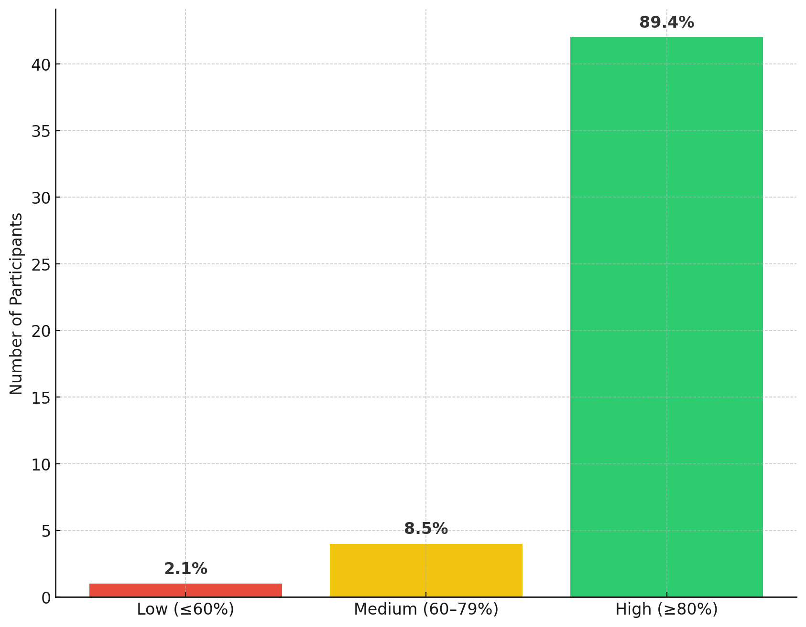
Figure 1. Quiz-4 (Databases and APIs)

  - Performance on Assignment-3

As indicated earlier, this assignment is still being graded. Once completed, the scores will be updated in this section.

- Participant Feedback and Suggested Improvements
  - Key Takeaways from Participant Feedback
Following the Kigali session on Databases and APIs, participants provided structured feedback through the evaluation survey. The key takeaways are summarized below:
- High Satisfaction and Relevance: Most participants rated the session as satisfactory and found the content on Databases and APIs to be very relevant to their work.
- Strong Intent to Apply Skills: The majority indicated that they will apply the skills (PostgreSQL, APIs, FastAPI) to their course projects.
- Pacing Remains a Concern: Several participants reported that the session was too fast, suggesting the need for pacing adjustments or additional time to practice.
- Valued Practical Components: The database practical with PostgreSQL and API exercises were consistently identified as the most useful parts of the training.
- Topics Requiring More Depth: Participants expressed the need for more time on APIs (theory and practice) and for follow-up coverage of topics like LLMs and Machine Learning that were not included due to time constraints.
- Project Discussions Desired: Many participants wished for dedicated time to discuss their projects during the session.
- Quiz Perceptions: The quiz was generally considered fair (“just right”), though some found it too easy, suggesting room to refine the assessment for differentiation.
- Suggestions for Improvement: Feedback emphasized more group practice sessions, additional days for content coverage, and structured time for peer-to-peer discussions.
- Confidence Gains: While some participants rated their confidence as “somewhat confident” in using PostgreSQL, APIs, and FastAPI, the responses indicate that confidence improved overall but further reinforcement is needed.
  - Participant Feedback in Detail
The detailed feedback from participants provides deeper insights into their learning experience. It highlights overall satisfaction with the training, changes in confidence levels, and the topics they found most valuable. It also captures areas where participants struggled, perceptions about the course pace, and their suggestions for improvement. Together, these insights point to what worked well and where adjustments may be needed in future iterations of the program.
  - Overall Satisfaction
Overall satisfaction with the course content was positive, with:
- 13% rating it as very satisfied.
- 70% rating it as satisfied
- 17% rating as neutral
- Confidence Gains
Participants reported clear improvements in their confidence levels across all three core technical areas:
- Working with APIs: The vast majority of participants (90%) rated themselves as "somewhat confident" or higher after the session, demonstrating a significant upward shift from their limited prior exposure to API concepts and implementation.
- Using PostgreSQL: Similar gains were observed, with nearly all participants (98%) reporting increased confidence in database setup, querying, and management. This aligns with PostgreSQL practicals being the most valued component of the training.
- Building simple apps with FastAPI: An overwhelming majority (86%) of participants expressed confidence after the session in building and running applications with FastAPI, indicating successful knowledge transfer despite this being new content for most learners.
These confidence gains across all three technical domains demonstrate that the session effectively achieved its learning objectives. The strong improvement in self-reported confidence—with 86-98% of participants feeling capable in areas where many had limited prior experience—provides clear evidence that participants not only engaged with the material but also acquired practical skills they feel prepared to apply. This widespread confidence building validates the session's impact and suggests participants are well-positioned to integrate these technologies into their project work.

A detailed breakdown of these confidence gains is presented in Figure 2 below.
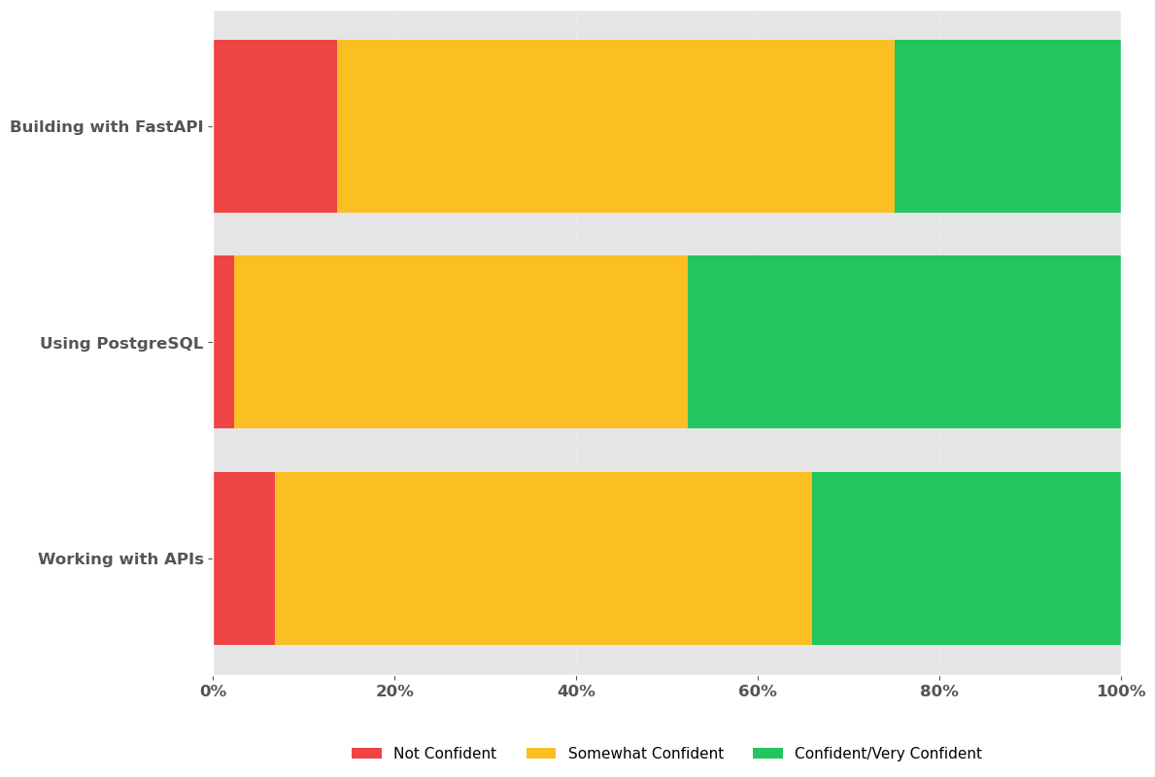
Figure 2: Gains from the session

- Valuable Topics
Participants were asked "Which part of this session was most useful to you?" and the results show a clear preference for hands-on learning. As illustrated in Figure 2, Databases Practical with PostgreSQL led at 76% as the most valued session element, followed by Building APIs at 57%. This demonstrates a consistent pattern: participants found practical exercises more useful than theoretical content. Theory sessions, while still appreciated by roughly half of participants (55% for Databases, 48% for APIs), were secondary to applied learning experiences. This reinforces that future sessions should continue to emphasize hands-on practice, particularly in database work, while maintaining theory as essential foundational support rather than the primary focus. sessions should continue to emphasize hands-on practice, while maintaining theory as essential foundational support rather than the primary focus.
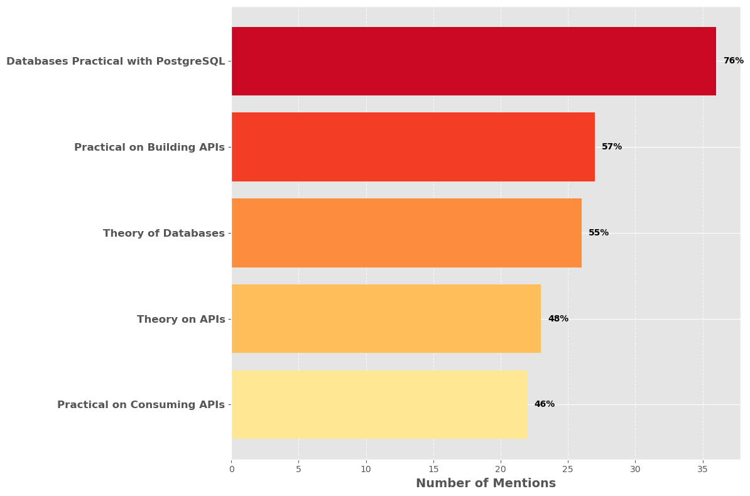
Figure 3: Most valuable topics
- Pace of the Course
Participant feedback on pacing was split almost evenly down the middle: 49% indicated the session moved too fast, while 51% rated it as just right. This distribution points to an opportunity for future sessions to incorporate differentiated learning approaches, such as extended hands-on practice periods, optional deep-dive segments, or asynchronous resources for continued learning after the session.

- Challenging Areas
Participants were asked "Which topics in this session do you feel need more time or explanation?" to identify areas where additional instruction would be beneficial. As illustrated in Figure 4. APIs emerged as the dominant topic requiring more attention, mentioned by over half (53%) of participants. This substantial demand reflects the complexity of API concepts and the need for extended practice time in both theory and application. The related topics of Building APIs (13%) and Consuming APIs (6%) together reinforce that API-related content needs significant expansion in future iterations. PostgreSQL (11%) and Machine Learning (9%) also received notable mentions, with participants expressing disappointment that Machine Learning topics were not covered due to time constraints. LLMs (6%) similarly reflect interest in emerging technologies that participants hoped to explore. The data strongly suggests that future sessions should allocate substantially more time to API-related content while also considering additional days to incorporate the Machine Learning and LLM topics that were originally planned but omitted.
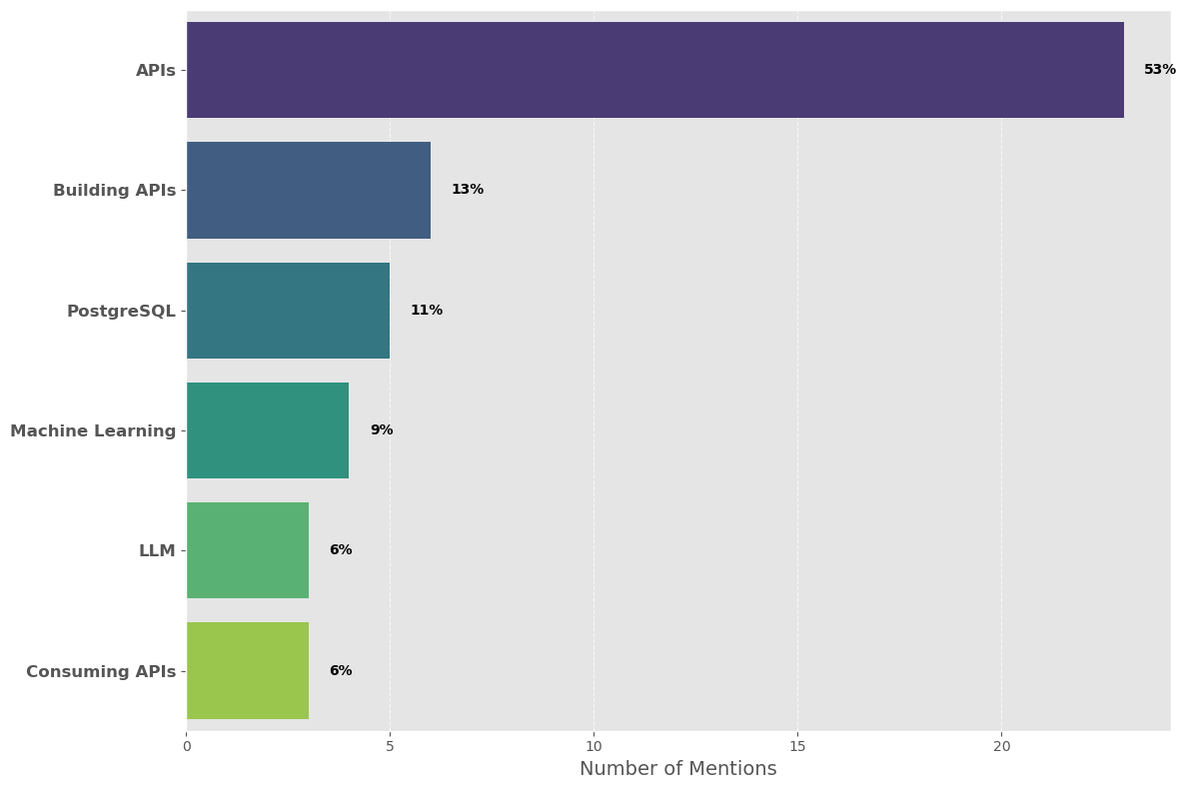
Figure 4: Topics requiring additional coverage
- Intent to Apply Skills to Course Work
Participants were asked "Do you believe you will apply the skills gained in this session to your work?" to assess the perceived practical value and relevance of the training. As shown in Figure 5, the responses indicate strong intent to apply the learned skills.

An overwhelming majority of participants plan to apply their new skills, with 53.2% expressing definite intent ("Yes") and 40.4% indicating probable application ("Maybe"). Combined, this represents 93.6% of participants who see direct applicability of the session content to their course projects. Only 6.4% indicated they would not apply the skills, suggesting the training successfully addressed relevant, practical needs. The substantial "Maybe" group (40.4%) may reflect participants who need additional practice or clarity on how to integrate these skills into their specific projects, reinforcing earlier feedback requesting more dedicated project discussion time.

Overall, the data demonstrates that the session effectively delivered content participants view as valuable and transferable to their academic work, validating the training's relevance and potential real-world impact.
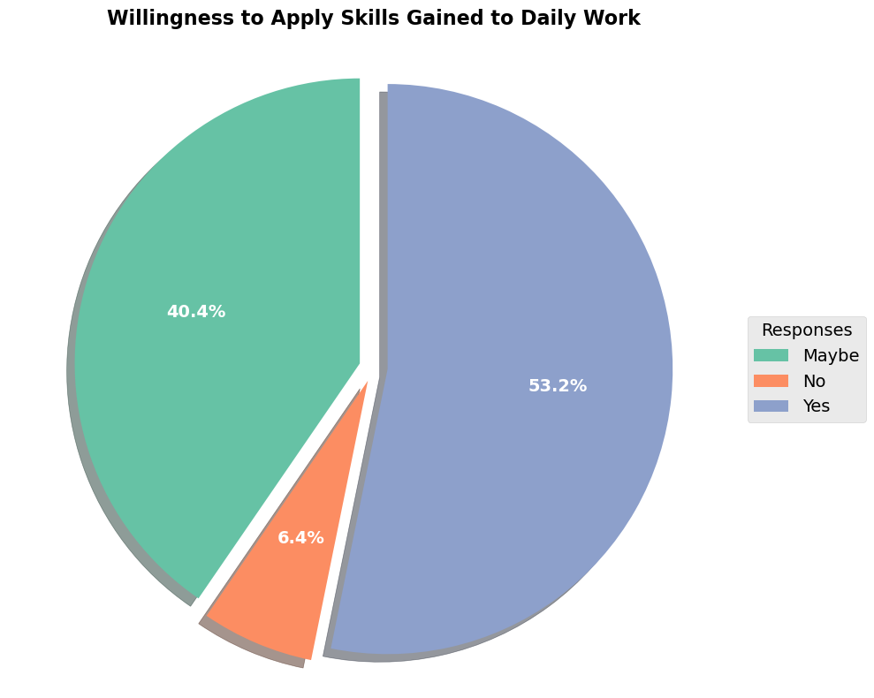
Figure 5: Intent to Apply Skills

- Suggestions for Improvement
Participants were asked "What changes or additions would make this session more effective next time?" to identify specific areas for improvement. Responses were categorized into thematic groups based on keywords and common suggestions. As shown in Figure 6, the feedback reveals clear priorities across multiple dimensions of the training experience.
- More Time & Slower Pace was the top concern at 62%, with participants requesting extended duration, additional days, or reduced teaching speed to better absorb material.
- Practice & Hands-on Activities ranked second at 34%, with requests for more group exercises and practical sessions—reinforcing that participants want more of what worked best.
- Learner Levels & Groups received 23% of mentions, suggesting the mixed-ability classroom created challenges and that separate beginner/advanced tracks or structured group discussions would be beneficial.
- Content & Materials appeared in 17% of responses, with suggestions to share materials beforehand or provide advance reading to maximize face-to-face learning time.
- Location & Environment concerns were noted by 9%, primarily requesting sessions outside Kigali to avoid traffic disruptions and improve concentration.
- Specific Topics were mentioned by 9%, with requests for deeper coverage of APIs, PostgreSQL, and the uncovered Machine Learning and LLM topics.
The feedback converges on three primary improvement areas: (1) extending session duration or slowing the pace to accommodate learning needs, (2) increasing hands-on practice time with more group activities, and (3) differentiating instruction for varied skill levels. Implementing these changes—particularly adding extra days, incorporating more structured practice sessions, and potentially offering beginner/advanced tracks—would significantly enhance the training's effectiveness. The strong emphasis on time and pacing (62%) indicates this should be the highest priority for future iterations.
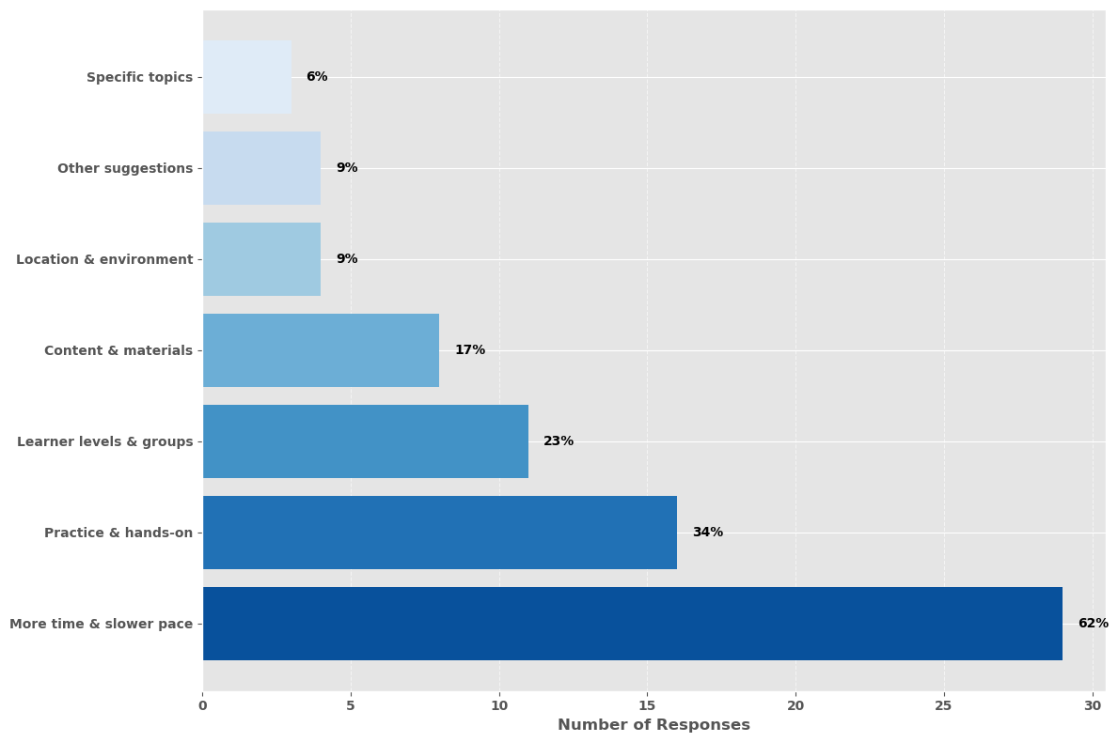
Figure 6: Suggestions for improvements

- Feedback from Instructors
Instructors contributed valuable feedback covering participant engagement during the Kigali session and the interim 6-8 week period (August 4 to September 14, 2025) following Nyagatare—when participants completed essential learning activities in preparation for Kigali. Their observations complement participant evaluations, providing a holistic view of the training experience and actionable recommendations for improvement.

- Participant Engagement During the Interim Learning Period
The interim period (August 4 to September 14, 2025) between the Nyagatare and Kigali in-person sessions was designed as a critical preparation phase. Participants were assigned two programming assignments and scheduled for mandatory project meetings and optional office hours. These activities aimed to maintain Python skills momentum and enable a faster learning pace during the Kigali session.
However, engagement during this period was significantly below expectations, as detailed in the following sections.
Assignment Completion Rates
Participants were assigned two programming assignments to practice and reinforce their Python skills. Completion rates were alarmingly low: Assignment-2 had only 28 out of 50 participants submit their work (56% completion rate), while Assignment-3 showed even worse engagement with just 15 out of 50 participants completing the assignment (30% completion rate). This meant that the majority of participants did not engage with the structured practice necessary to build their technical foundation for the Kigali session.
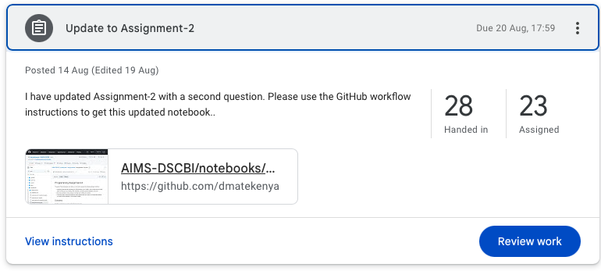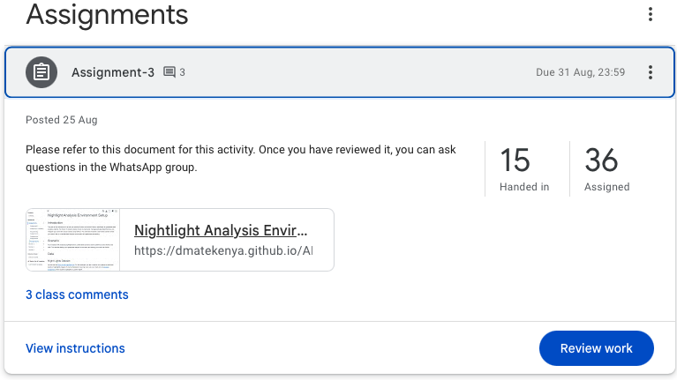

Project Meetings and Office Hours Attendance
Beyond assignments, two types of instructor-led support sessions were offered during the interim period:
- Mandatory Project Meetings were established as required checkpoints for students to report progress on their capstone projects and ask technical questions about Python and project-related challenges. Despite being mandatory, attendance rates were below 20%, indicating that most participants did not take advantage of this critical opportunity for personalized guidance and feedback on their projects.
- Optional Office Hours provided an additional opportunity for students to engage in deep dives into Python concepts and other technical topics. However, students made minimal use of these sessions, further limiting their opportunity to strengthen their skills and address knowledge gaps.
The combination of low assignment completion rates, poor attendance at mandatory project meetings, and minimal utilization of office hours resulted in a continued lack of preparation and prerequisite Python skills for most students. This insufficient engagement during the interim period directly undermined the intended learning progression, leaving participants inadequately prepared for the intensive Kigali session. Consequently, the pacing challenges reported by participants during the Kigali training were partially attributable to their own lack of preparation rather than solely the session's instructional design.

- Kigali Training Schedule and Duration
When designing the Kigali session, instructors planned for 8-hour training days to ensure adequate coverage of all planned modules. However, in practice, effective training time was reduced to only 6.5 to 7 hours per day due to two factors:
- Late Start Times: Instead of the planned 8:30 AM start, sessions typically began at 9:15-9:30 AM, resulting in a loss of 45 minutes to 1 hour of instruction time daily.
- Early Dismissals: On several days, sessions concluded at 4:30 PM rather than the scheduled end time, as participants requested early release to attend to family responsibilities such as spousal and childcare pickup.
The combination of late starts, early dismissals, and the slower instructional pace needed to accommodate varying participant skill levels resulted in insufficient time to cover all planned modules. This directly contributed to the omission of Machine Learning and LLM topics that participants later indicated they had hoped to learn. The compressed effective training time meant instructors had to prioritize foundational content (databases and APIs) at the expense of more advanced topics, leaving participants disappointed about the missing content they had anticipated.

- Participant Engagement and Preparation
Overall, attendance and participation levels were strong throughout the training. However, a key bottleneck and an important area for improvement is ensuring that participants complete the pre-session preparatory course material when it is provided. During the sessions themselves, participants are encouraged to carefully work through the programming notebooks step by step, paying close attention to the instructions in both the markdown text and code comments.

- Conclusion and Next Steps
The Kigali training session successfully strengthened participants' capabilities in databases and APIs, as evidenced by strong quiz performance (89% scoring ≥80%), high satisfaction ratings (83% satisfied or very satisfied), and significant confidence gains across all technical areas (86-98% reporting increased confidence). The session effectively achieved its core learning objectives, with participants demonstrating both theoretical understanding and practical application skills that they intend to transfer to their project work.
However, the training also revealed critical challenges that require attention in future iterations. The most significant issue was inadequate participant preparation during the interim learning period, with assignment completion rates as low as 30% and mandatory project meeting attendance below 20%. This lack of engagement directly contributed to the pacing difficulties reported by participants during the Kigali session. Additionally, compressed training time—due to late starts and early dismissals—resulted in covering only one module instead of the planned three, leaving participants disappointed about missing Machine Learning and LLM content.
Key Areas for Improvement:
- Enforce Preparatory Requirements: Implement accountability mechanisms to ensure participants complete interim assignments and attend mandatory meetings. Consider making preparatory work completion a prerequisite for attending in-person sessions.
- Extend Training Duration: Add at least one additional day to accommodate the slower pace needed for mixed-ability learners and to cover all planned modules, particularly Machine Learning and LLMs.
- Enhance Hands-on Practice: Increase structured practice time and group exercises, as these were identified as the most valuable components by 76% of participants.
- Differentiate Instruction: Consider offering separate tracks or supplementary sessions for beginners versus advanced learners to address the 49% who found the pace too fast.
- Strengthen Schedule Adherence: Establish clear expectations around start times and session duration, balancing family responsibilities with the need for adequate instruction time.
Looking Ahead:
The next training session presents an opportunity to build on these lessons learned. By incorporating participant and instructor feedback—particularly around preparation requirements, pacing, and content coverage—the program can enhance both learning outcomes and participant satisfaction. The flexible, project-responsive approach to module sequencing will ensure that training remains directly relevant to participants' immediate needs, while the emphasis on hands-on practice will continue to leverage what participants value most.
Continued collaboration with stakeholders including CENFRI and NISR will strengthen the program's relevance and sustainability. With targeted adjustments to address the identified challenges, the training is well-positioned to deliver even stronger results and better equip participants with the data science skills essential for their professional development and project success.

