**Example Voting App**

**Getting started**

Download [Docker](https://www.docker.com/products/overview). If you are on Mac or Windows, [Docker Compose](https://docs.docker.com/compose) will be automatically installed. On Linux, make sure you have the latest version of [Compose](https://docs.docker.com/compose/install/).

Run in this directory:

docker-compose up

The app will be running at [http://localhost:5000](http://localhost:5000/), and the results will be at [http://localhost:5001](http://localhost:5001/).

Alternately, if you want to run it on a [Docker Swarm](https://docs.docker.com/engine/swarm/), first make sure you have a swarm. If you don't, run:

docker swarm init

Once you have your swarm, in this directory run:

docker stack deploy --compose-file docker-stack.yml vote

**Architecture**

[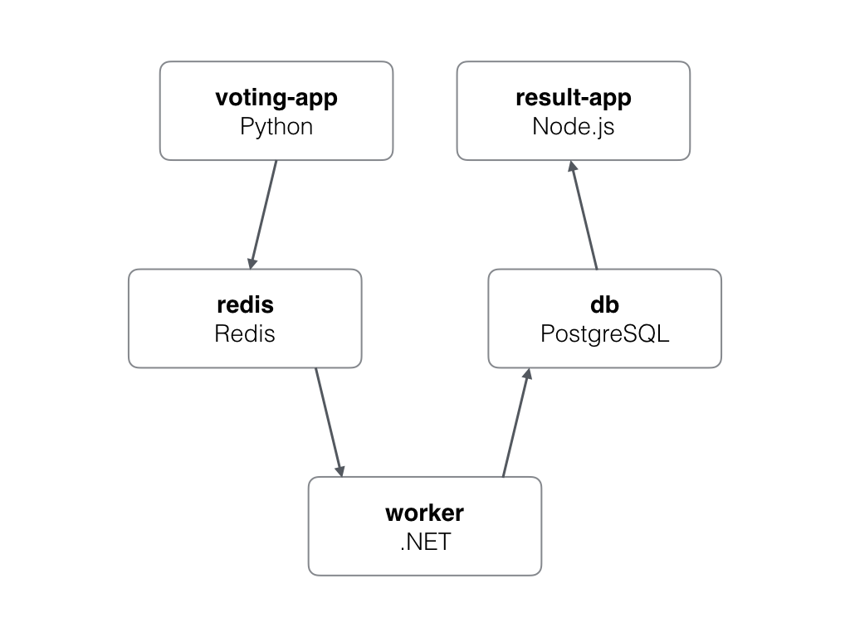](https://github.com/russmckendrick/mastering-docker/blob/master/chapter06/example-voting-app/architecture.png)

* A Python webapp which lets you vote between two options
* A Redis queue which collects new votes
* A .NET worker which consumes votes and stores them in…
* A Postgres database backed by a Docker volume
* A Node.js webapp which shows the results of the voting in real time

**Note**

The voting application only accepts one vote per client. It does not register votes if a vote has already been submitted from a client.