**Marketplace:-**

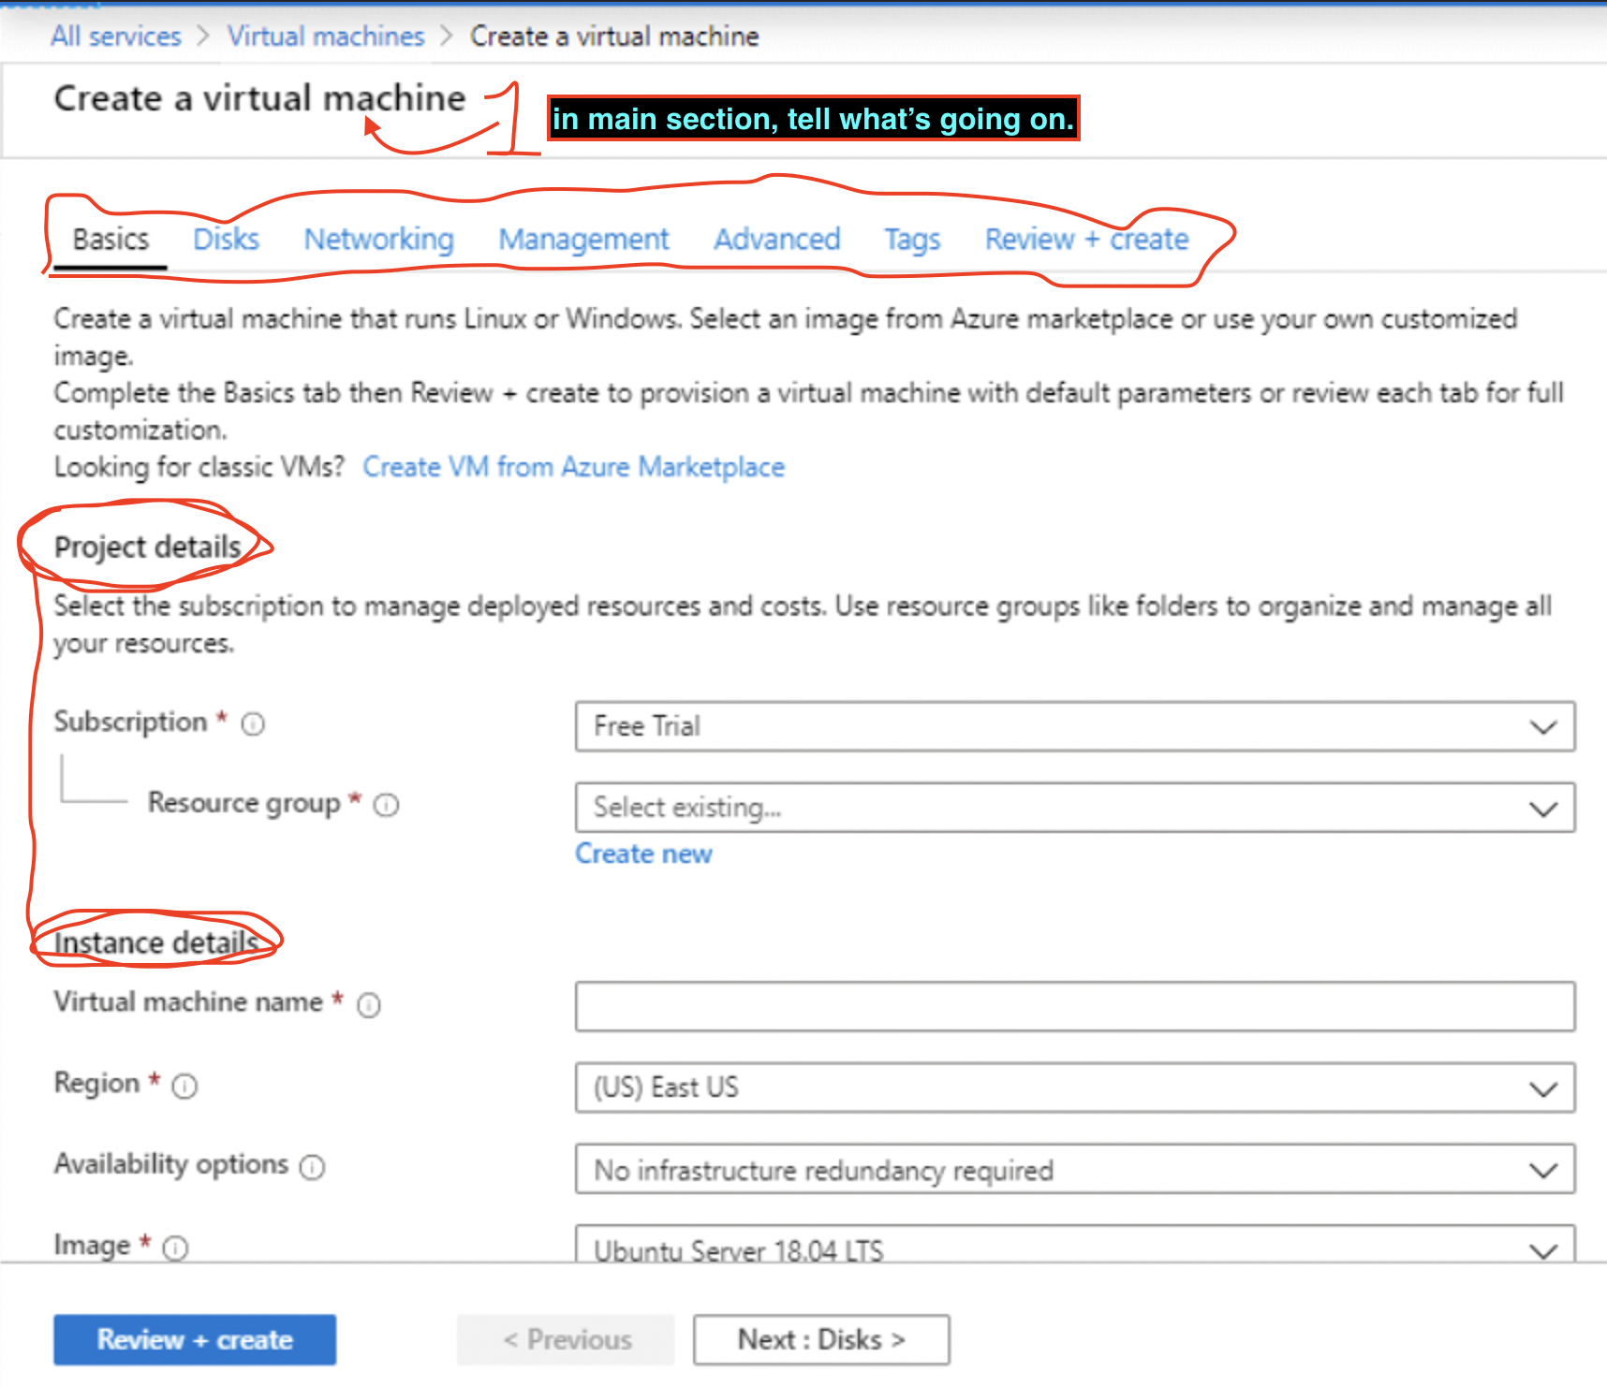

Instead of basic: it would be ***setup***

NOTE:- every app will have different fields or sometimes, no fields.

all fields should be having (i) options for better read.

**environment <section>**

environment: * prod/dev/**sandbox** (default sandbox selected)

**Server details:- <section>**

server name: "iam-postgres-dev" default is empty string – 20char, lower -,0-9

Admin username: ""

password: ""

confirm password: ""

version: [get the versions from backend]: 16,15,14,13 list *latest*

**size:- <section> *you can make slider if you want*.**

cpu: "1","250m" user will enter this *100m*

memory: user will enter this number and select MB or GB *4MiB*

Disk: user will select a disk size. we can make slider. *6GB*

storage class:- HDD/SSD_standard/SSD_premium. *HDD*

Scheduling: <section>

Node affinity: bool *false*

Node selector: if blank, not pass, provider key: value from backend. “*Blank”*

//

View/status page:- see things in this namespace.

Cpu,ram Metrics

no edit is required:- use blur and not blur option with helm upgrade, or ask them to reinstall with those settings, with clean setup. or reinstall with this dump or pvc. upgrade option.

//

Uninstall:-

Uninstall +

Delete data checkbox(complete)

Button of uninstall (immediately uninstall and show the status. Like uninstalling or stuck).

//

Networking:-

Certificate and DNS:-

1. If user will choose own DNS and certs:-

I have my own certificate and DNS pointing to this.

1. Configured by us:-
   1. servername-1.ddmarket.com

Default dns name for the application as per server-name.

Let’s Encrypt (default)

Self singed

Digicert wildcard

Routing: NOT required, path based ? or other ways?

Resiliency:-

Timeout imp

Retries imp

Advance retries imp

Circuit Breaking:- imp

Firewall & security:-

Allow from following ips only. imp

External authN and authZ

End-user authN authZ

Mtls with client?

CORS

CSRF

DLP

WAF <https://docs.solo.io/gloo-mesh-gateway/latest/security/waf/> imp

<https://docs.solo.io/gloo-mesh-gateway/latest/security/deny-traffic-default/>

VPN:-

// connect:

Connect details:-

Connection information for various applications

Tools to access:- gui tool(pgadmin), Pgpool pgbounce

// dbops

Operation and other operation

//

scale:-not all app will scale, and with all these options

hpa vpa

minimum / max scale value.

scale to zero when not in use.

golang + keda

connectors:-

cpu(90%),memory (80%), disk, network

http requests to the applications. http will not work for postgres. (Mean,stddev,variance)

Prometheus query, Advance.

Kafka. If number of MSGs are > 100 in a queue then scale

Elasticsearch

Cronjob(pre scale) 10am - 12am

Vulnerabilities:-

Latest vulnerabilities check as per news api and ai.

Gatekeeper

Kyverno

Istio

Trivy:- harbor data.

Others

Logging check the anonymous access

Or track the access from where(geoMap)?

Notifications:-

Notify something(can’t upgrade pvc or can etc), about this service, health, slow, iops not enough, cpu etc.

Number of malicious activities etc.

Communication:- slack connectors, teams mail, group etc.

Observability:- url for Grafana, trace, metrics etc.

Backup and restore etc:-

DR:-

DBOPS / Operation and other operation

Tags:-

Scheduling:-

prod, dev, specific labels, taint, kubefed, on-prem, azure etc from kubeconfig?

// Tonic.ai

Chat:-

Learn it:- integration, ai trained tools.

Sleep/stop:- Define when you want to shut it down. And start again options. In case of any danger, or to save any cost.

Owasp

Things decouple in helm or not?

Decouple will faster but might break in future(not immutable)

Upgrade something or how to change something.

Ex:- rename, size change etc.

Build orchestrator on top of it.

Rebuild whole marketplace from backup.

Suggestion page.