**Data Analysis – Results**

**Top 5 longest flights in 2019**

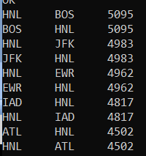

**Most popular flight**



**Most popular route**



**Most popular carrier used**



**Worst delay type – {carrier, weather, nas, security, aircraft}**



Aircraft is the worst delay type as it has caused the longest total delays. This would imply that difficulties with the actual plane causes the most minutes of delays.

**Carrier with worst departing delays**

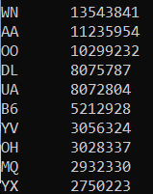It makes since that the most common airline used has the longest delays.

**What delay is most common for “WN” – {carrier, weather, nas, security, aircraft}**



Aircraft delay again is the main cause of delays for WN

**Carrier with worst self inflicted delays (total time)**

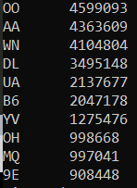

**Worst single departing delay – {carrier, flight_num, depature_delay}**

