**Computer Network project**

Group members

***F17 9433 Ahmed Waheed***

***F17 9428 Shaheer Rahi***

***F17 9436 Haroon Hamid***

Our project is under construction. Now only the connection between the peers and server works.

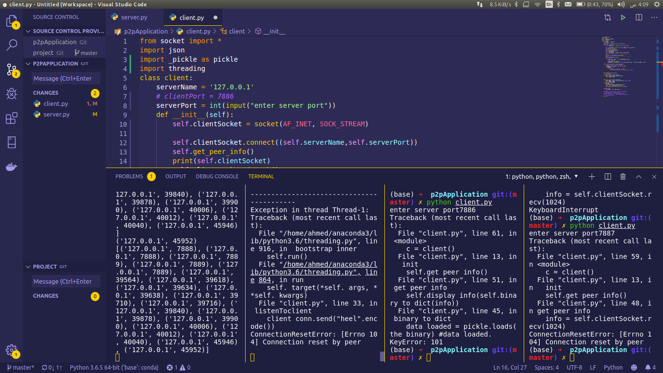Code files are attached.