Table of Contents
Table of Contents – update to populate

DocLang: Universal AI Document Format

Introduction and Overview

Foreword
This specification was prepared by
Name | Company | Email
Peter Staar | IBM | taa@zurich.ibm.com
Panos Vagenas | IBM | pva@zurich.ibm.com
Maksym Lysak | IBM | mly@zurich.ibm.com
Nikolaos Livathinos | IBM | nli@zurich.ibm.com
Christoph Auer | IBM | cau@zurich.ibm.com
Michele Dolfi | IBM | dol@zurich.ibm.com
Said Gürbüz | IBM | Said.Gurbuz@ibm.com
Marlene Wolfgruber | ABBYY | marlene.wolfgruber@abbyy.com
Maxime Vermeir | ABBYY | maxime.vermeir@abbyy.com
Morgan Logue | ABBYY | morgan.logue@abbyy.com
Andrew Pery | ABBYY | andrew.pery@abbyy.com
Christopher Giblin | IBM | cgi@zurich.ibm.com
Jehlum Vitasta Pandit | RedHat | jepandit@redhat.com
Ali Maredia | RedHat | amaredia@redhat.com
Santosh Borse | IBM | ssborse@us.ibm.com
Yousaf Shah | IBM | syshah@us.ibm.com
Maroun Touma | IBM | touma@us.ibm.com
This document specifies the DocLang format, a universal markup language for representing structured document content with semantic, geometric, and formatting information.

Introduction
The proliferation of digital documents across diverse formats (PDF, HTML, Word, etc.) has created significant challenges in document processing, conversion, and understanding. These were mainly designed for efficient rendering and often result in loss of semantic information, structural relationships, or geometric context during document conversion.
DocLang addresses these challenges by providing a minimalist, unambiguous markup format that:
- Preserves complete document structure and semantics
- Maintains geometric and layout information when appropriate
- Supports complex document components including tables, formulas, code, nested lists, and charts
- Enables lossless round-trip conversion between formats regarding content
- Maintains token efficiency by defining controlled vocabulary of tags and attributes
- Eliminates ambiguity by enforcing a well defined set of tags with restricted, non generic usage ( and preserves semantic clarity )
This standard builds upon research in document understanding and is intended to represent the content of a document as accurately as possible while maintaining implementation simplicity.

Scope
This standard specifies:
- The syntax and semantics of the DocLang markup language
- Rules for encoding document structure, content, and metadata
- Primitives for representing geometric layout and pagination
- Methods for expressing formatting and text direction
- Specifications for complex document components (tables, charts, formulas, code, forms)
- Requirements for conforming implementations

Motivation
The motivation for this new markup language is twofold,
- It is created from the ground up to be able to represent complex, multimodal content with visual grounding in plain text with markup
- It is created with the express purpose to be compatible with LLM tokenizers, i.e. use a markup structure that maps naturally and efficiently between DocLang elements and LLM tokens.
As a consequence of point 2, this standard ensures that there is a limited number or tags and attributes. In general, we intend that the number of syntax tokens should not exceed 1000. The latter is not a strong bound, but rather a direction.
There is an exception for meta-data markup. Meta-data is not intended to be heavily used or produced by LLMs, so it is in general possible to include an expanded set of protected markup tokens. Nevertheless, we do want to normalize as much as possible this representation.
Such requirements preclude us from using existing markup languages such as Markdown (incomplete scope), HTML (not concise enough), LaTeX (ambiguity of representation) etc.
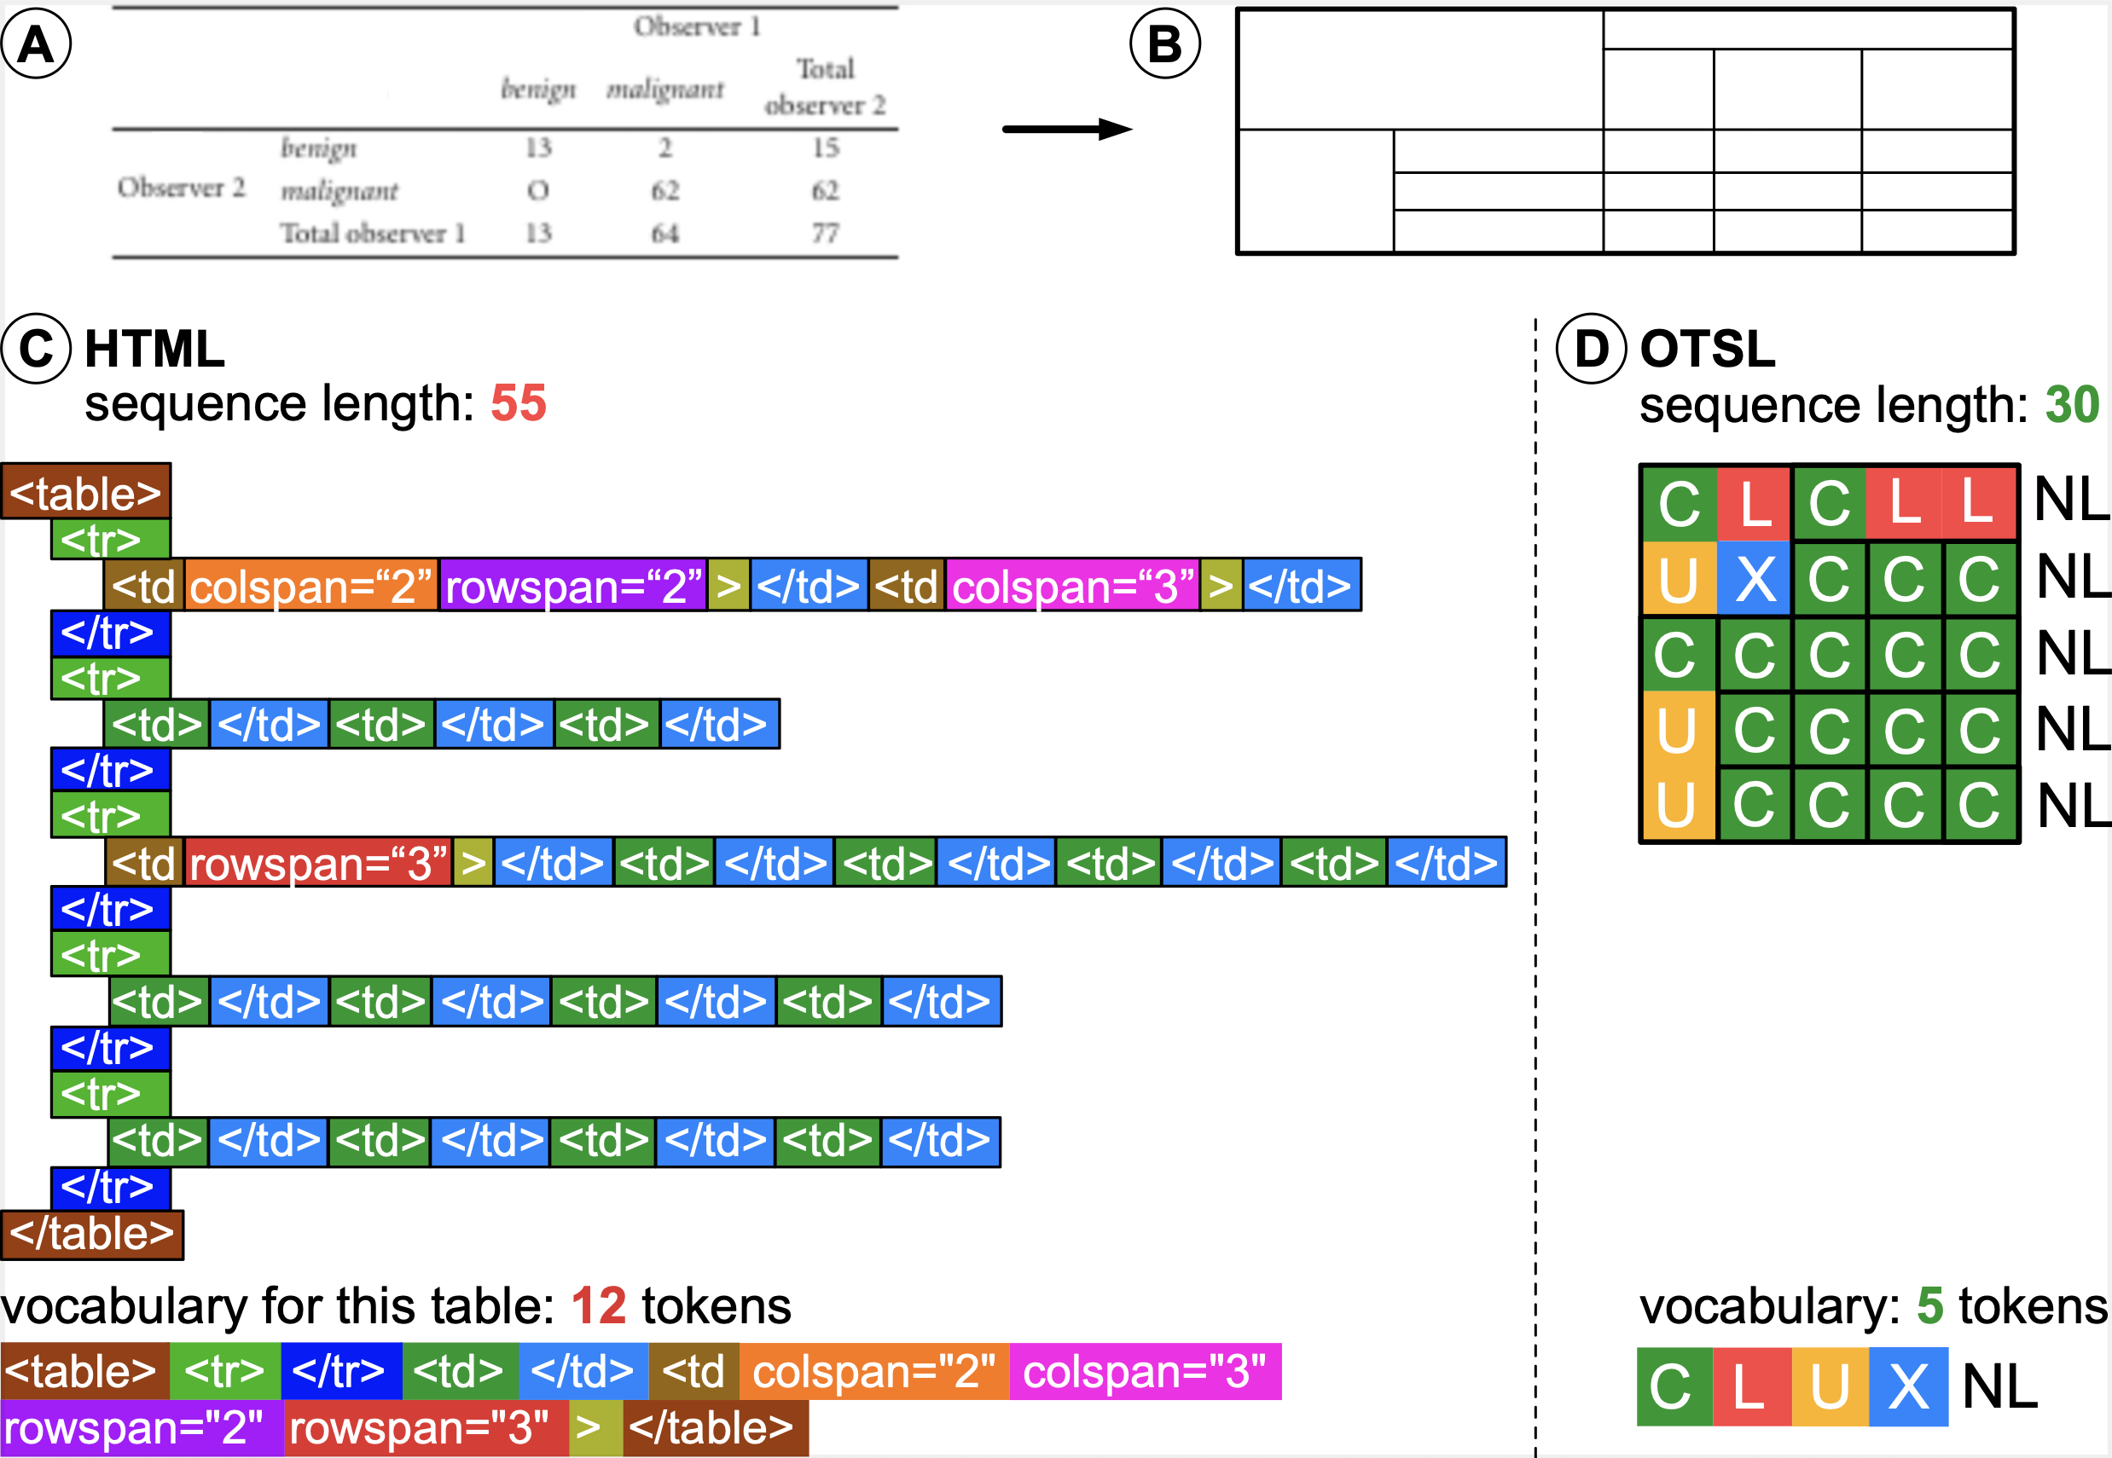
Example in pure table structure representation, omitting content of cells, when comparing HTML to DocLang (OTSL tags). HTML sequence is both longer and uses more tokens than DocLang
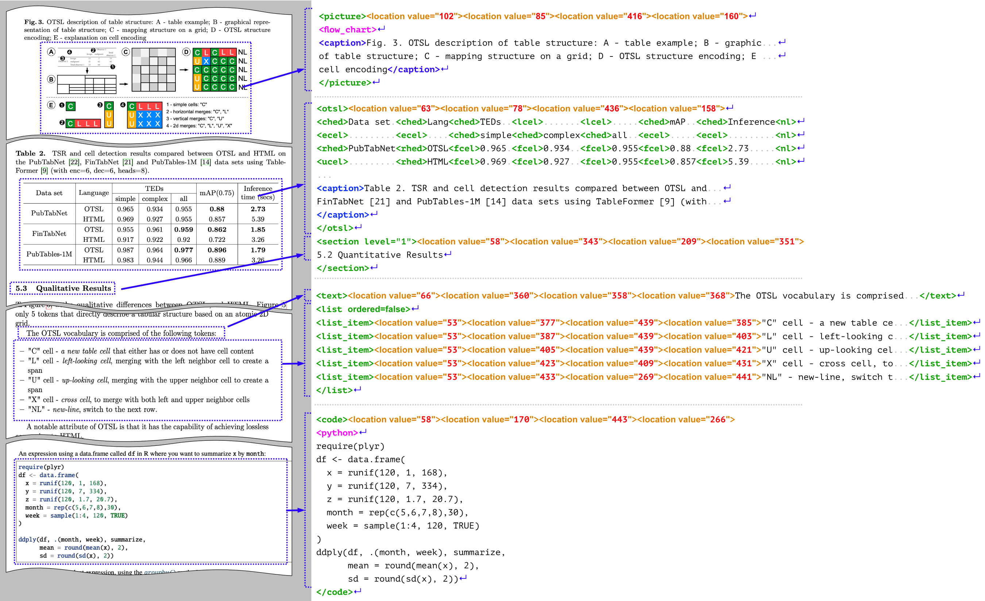
Examples of real-world document fragments and their DocLang representation
A specific class of related formats is the one operating on the OCR level, including PageXML, ALTO XML, and hOCR.
Beyond certain low-level similarities (e.g. presence of bounding box information), the DocLang format is significantly differentiated as it is designed to be AI-native:
- The above-mentioned formats focus on OCR processing, e.g. for archives, browser display, or other types of OCR/HTR pipelines, while DocLang is designed for LLM/VLM generation, with token efficiency in mind.
- Whereas these formats are primarily concerned with the geometric locations of the various spans of text, DocLang also places a strong focus on the semantic meaning and internal structure of the involved complex components, providing various native elements for headings, formulas, code, etc. and also rich table structure support (incl. table headings, spanned cells, etc.), this way capturing richer context for generative AI applications to leverage.

Language Design Principles

Terminology
Abstract concepts:
- document component: A cohesive and meaningful part of the document, e.g. a table, list item with a marker, a bold piece of text, etc.
Adopted from XML:
- element: An XML element.
- attribute: An XML attribute.
- tag: An XML tag: can be a start-tag, an end-tag, or an empty-element tag (a.k.a. self-closing tag).
Adopted from HTML:
- block-level element: An element that is meant to be interpreted or displayed as a block, i.e. starting on a new line, occupying the full width of its container, and typically with increased margin to any other neighboring block-level elements; a typical HTML example is the p element (paragraph).
- inline element: An element that can be used within a block element to shape its in-line structure; a typical HTML example is the span element.
Note that, whether block-level or inline, an element may contain explicit new lines.

Property Semantics
In XML, the attribute syntax allows explicitly separating an element's properties from its content. Let's consider the following example: <elem size="250" color="#ffeedd">foo</elem>. This denotes an elem element, including its properties (size and color) and its content (foo).
For an element with multiple possible property values, the attribute syntax can lead to an increased complexity of the respective possible tokenized representations. For instance, the following could all be valid variants of an elem start tag: <elem size="300" color="#aabbcc">, <elem size="42">, <elem color="#112233">, <elem>.
Aiming at LLM-friendliness, in such cases, the DocLang format often favors an alternative representation of property semantics, namely captured as respective elements leading the content. The example above could be represented as <elem><size>250</size><color>#ffeedd</color>foo</elem>. Depending on the specific properties, empty elements are used too.
This representation can reduce the number of tokens and streamline how XML is mapped to them, making it easier for language models to learn and predict.
For elements with a strictly limited set of possible property values, attributes are still used.

Content Encoding and Whitespace Handling
As DocLang is XML, standard XML encoding rules apply — for example:
- any provided XML prolog defines the encoding, otherwise UTF-8 is assumed
- special characters reserved by XML, such as <, can be represented either by escaping with the respective XML entities (e.g. < becomes &lt;) or by using CDATA section syntax (e.g. raw text <foo> can be represented as <![CDATA[<foo>]]>.)
DocLang generally allows applications to decide how to handle XML whitespace (i.e implicit xml:space="default" behavior). To address cases where preservation is required, DocLang provides a dedicated element for whitespace preservation (i.e. xml:space="preserve" behavior).

Head and Body Areas
Documents and their core components (as implemented via semantic elements) can have various properties associated with them. To separate between properties and actual content, DocLang follows a two-part scheme, both on the the component / element level and on the global document level.

Element Head
The XML content of a semantic element begins with an element head, which is a sequence of dedicated elements that establish the element's properties, namely in this order:
- <thread> (optional)
- <xref> or <href> (mutually exclusive, optional)
- sequence of 2*N <location>s, whereby values are interpreted in alternating axis order (x0, y0, ...) (optional)
- sequence of <timestamp>s (optional)
- <caption> (optional)
- <custom> (optional)

Element Body
The XML content after the element head is called the element body and contains the effective payload of the semantic element.

Document Head
Root element <doclang> begins with an optional document head, which encapsulates any global document properties in a dedicated <head> element.

Document Body
The remaining XML content after the optional document head is called the document body and contains the effective payload of the document.

Head and Body Example
While the details are specified in the sections further below, this snippet shows an example of this scheme:
<doclang>
<!-- document head: -->
<head>
<default_resolution width="1024" height="1024"/>
<!-- ... -->
</head>
<!-- document body: -->
<text>
<!-- element head: -->
<location value="60"/><location value="260"/>
<location value="440"/><location value="270"/>
<!-- element body: -->
<italic>Hello</italic>
<content> world!</content>
</text>
<text>
<!-- element body: -->
Headless paragraph
</text>
</doclang>

Version Management and Compatibility
DocLang documents define a version in MAJOR.MINOR format through the version attribute of the root <doclang> element. This indicates the specification version against which the document is intended to be validated.
The version of the present specification is 0.3.

Semantic Versioning Principles
The XSD schema used for validating DocLang XML documents defines the specification versions it supports based on Semantic Versioning principles, i.e. considering X >= 1, and Y < Z:
- A document with version X.Y is compatible with an XSD schema with version X.Z, i.e. a document that is valid against schema X.Y will also successfully validate against schema X.Z.
- A document with version X.Z is considered incompatible with an XSD schema with version X.Y, i.e. a document that is valid against schema X.Z need not be successfully validate against X.Y.
Example:
- A 1.0 document is compatible with a 1.1 schema
- A 1.1 document is considered incompatible with a 1.0 schema

Version 0.x Behavior
As per Semantic Versioning conventions, versions where MAJOR = 0 indicate initial development and always break backward compatibility. Therefore:
- A document of version 0.1 is considered incompatible with a 0.2 schema
- A document of version 0.2 is considered incompatible with a 0.1 schema
Each minor version increment in the 0.x series represents a breaking change.

XSD Schema Versioning
The XSD schema itself may additionally capture a patch version and internally define a full Semantic Versioning (SemVer) version string (e.g., 1.0.0, 1.0.1) to track schema-level changes that do not affect document compatibility.

Language Specification
The individual DocLang elements and attributes, as well as DocLang's contextual rules are specified in Appendix A: Reference.
Planned extensions are discussed in Appendix B: Planned Features.
Special validation rules are covered in Appendix C: Validation Rules.

Usage Examples

Simple Document Structure
In the simplest document example, document elements are in a flat list,
<doclang>
<heading level="1">Research Paper Title</heading>
<heading level="2">Abstract</heading>
<text>This paper presents...</text>
<heading level="2">Introduction</heading>
<text>In recent years...</text>
<heading level="3">Background</heading>
<text>Previous work has shown...</text>
</doclang>
In case of page-layout information, the coordinates are provided only at the semantic element level. Coordinates are not allowed at the group level.
<doclang>
<heading level="1">
<location value="10"/><location value="20"/><location value="30"/><location value="40"/>
Research Paper Title
</heading>
<heading level="2">
<location value="10"/><location value="20"/><location value="30"/><location value="40"/>
Abstract
</heading>
<text>
<location value="10"/><location value="20"/><location value="30"/><location value="40"/>
This paper presents...
</text>
<heading level="2">Introduction</heading>
<text>In recent years...</text>
<heading level="3">Background</heading>
<text>Previous work has shown...</text>
</doclang>

Code snippets
Code content is captured with <code>, either as a standalone block or inlined within a semantic element. The class attribute can be optionally used for classifying the programming language.
Whitespace can be retained by <content> and XML escape characters can be addressed using CDATA.
Inline code:
<text>
Check your version with <code>python --version</code>.
We can even have <code><bold>formatted code</bold></code>.
</text>
Code block with language classification and whitespace preservation:
<code class="python"><content>
def add(a, b):
return a + b
if __name__ == "__main__":
print(add(2, 3))</content>
</code>
Grouped code with caption and coordinates:
<group>
<caption>
<location value="10"/><location value="20"/><location value="400"/><location value="60"/>
Listing 1: Minimal HTTP server
</caption>
<code class="javascript">
<location value="10"/><location value="80"/><location value="400"/><location value="300"/>
<content><![CDATA[
// Minimal Node.js server
import http from 'node:http';
const server = http.createServer((req, res) => {
res.end('OK');
});
server.listen(3000);]]></content>
</code>
<footnote>Source: examples/code/server.js</footnote>
</group>
Long code blocks can be split across pages using continuation elements; keep <class> in the first fragment.
<code class="bash">
<thread thread_id="42"/>
<content>
# Part 1
seq 1 5 | while read n; do echo $n; done</content>
</code>
<page_footer>Foo</page_footer>
<page_break/>
<code>
<thread thread_id="42"/>
<content>
echo "done"</content>
</code>

Math and Equations
All math is authored as LaTeX inside <formula>, whether in standalone blocks or inlined within a semantic element (similar to code).
Inline formula:
<text>
The famous relation <formula>E = mc^2</formula> connects mass and energy.
For small x, <formula>\sin x \approx x - x^3/3!</formula> holds.
The binomial: <formula>(a+b)^n = \sum_{k=0}^n \binom{n}{k} a^{n-k} b^k</formula>.
</text>
Block Formula:
<formula>
\int_{-\infty}^{\infty} e^{-x^2}\,dx = \sqrt{\pi}
</formula>
Grouped formula with caption and coordinates:
<group>
<caption>
<location value="10"/><location value="20"/><location value="400"/><location value="60"/>
Equation for the normal distribution
</caption>
<marker>(2)</marker>
<formula>
<location value="10"/><location value="80"/><location value="400"/><location value="150"/>
f(x) = \frac{1}{\sigma\sqrt{2\pi}}\,\exp\!\left(-\frac{(x-\mu)^2}{2\sigma^2}\right)
</formula>
<footnote>Parameters: mean <formula>\mu</formula> and standard deviation <formula>\sigma</formula>.</footnote>
</group>
Multi-line LaTeX in a single formula:
<formula>
<content><![CDATA[
\begin{align}
\nabla\cdot\mathbf{E} &= \frac{\rho}{\varepsilon_0} \\
\nabla\cdot\mathbf{B} &= 0
\end{align}]]></content>
</formula>
Cross-page block formula with continuation:
<formula>
<content>
\begin{equation}
\mathbf{F}(t) = \int_0^t e^{A(t-\tau)}\,\mathbf{b}(\tau)\,d\tau
\end{equation}</content>
<thread thread_id="42"/>
</formula>
<page_footer>Foo</page_footer>
<page_break/>
<formula>
<thread thread_id="42"/>
<content>
% Optional tail content if the printed equation spans pages</content>
</formula>
Note: All math content is LaTeX; omit $...$ or \[...\] delimiters since the tag conveys math context.

Lists
A list can in principle can contain as list items any semantic element sequence. List items are namely introduced by <ldiv> elements, whereby an <ldiv> may optionally contain a marker.
To promote token efficiency within the repetitive context of a list, a list item may also comprise unwrapped text content. That case is called a *virtual <text>* and is to be handled exactly as if the whole list item (content between two sibling <ldiv>s or until </list>) were wrapped by <text> tags.
Basic list with virtual <text>
<list>
<ldiv/>First item
<ldiv/>Second item
<ldiv/>Third item
</list>
Unordered list with optional markers
<list class="unordered">
<ldiv><marker>•</marker></ldiv>
<text>First item with <bold>bold</bold> text</text>
<ldiv>
<!-- Marker with its own coordinates -->
<marker>
<location value="50"/><location value="110"/><location value="60"/><location value="120"/>
•
</marker>
</ldiv>
<text>Second item</text>
</list>
Ordered list; markers are optional and can hold the printed numbering
<list class="ordered">
<ldiv><marker>1.</marker></ldiv>
<text>Install dependencies</text>
<ldiv><marker>2.</marker></ldiv>
<text>Run tests</text>
<ldiv/>
<!-- No marker provided -->
<text>Ship release</text>
</list>
Checkbox items with selection state; markers optional
<list class="unordered">
<ldiv><marker><checkbox class="selected"/></marker></ldiv>
<text>Completed task</text>
<ldiv><marker><checkbox class="unselected"/></marker></ldiv>
<text>Pending task</text>
</list>
Nested lists (mixing ordered and unordered)
<list class="ordered">
<ldiv><marker>1.</marker></ldiv>
<text>Setup project</text>
<list class="unordered">
<ldiv><marker>•</marker></ldiv>
<text>Create virtual environment</text>
<ldiv><marker>•</marker></ldiv>
<text>Configure linter</text>
</list>
<ldiv><marker>2.</marker></ldiv>
<text>Implement features</text>
</list>
Page breaks and continuation
Lists can span multiple pages. Use <thread thread_id="..."/> to indicate continuation. You may thread the whole list and, if a particular component, e.g. a text is broken, also thread the component itself.
List split across pages
<list class="ordered">
<thread thread_id="L1"/>
<ldiv><marker>1.</marker></ldiv>
<text>First item</text>
<ldiv><marker>2.</marker></ldiv>
<text>Second item</text>
</list>
<page_break/>
<list class="ordered">
<thread thread_id="L1"/>
<ldiv><marker>3.</marker></ldiv>
<text>Third item</text>
</list>
Single list-item broken by a page break
<list class="unordered">
<thread thread_id="L2"/>
<ldiv><marker>•</marker></ldiv>
<text>
<thread thread_id="I7"/>
This item starts on page 1 and continues
</text>
</list>
<page_break/>
<list class="unordered">
<thread thread_id="L2"/>
<ldiv/>
<text>
<thread thread_id="I7"/>
on page 2 until it ends.
</text>
</list>
Notes
- <marker> is optional. Include it when the printed glyph/number is visible.
- <marker> can include its own location coordinates to pinpoint bullet/number placement.
- Lists can nest as shown above.
- When broken across pages, close items before the page_break, then re-open and continue with matching thread ids after the break.

Tables
A table is defined by a table element, that contains cells, as delimited by the respective structural elements (e.g., <fcel/>, <ched/>).
Similarly to lists above, while a cell can naturally contain any semantic element sequence, it may also comprise unwrapped text content too, i.e. constituting a virtual <text>.
Basic table with virtual <text>:
<table>
<ched/>Method<ched/>Accuracy<nl/>
<fcel/>Baseline<fcel/>0.8<nl/>
<fcel/>Proposed<fcel/>0.92<nl/>
</table>
Example with table location and semantic elements:
<table>
<location value="40"/><location value="130"/><location value="540"/><location value="320"/>
<ched/><text>Method</text><ched/><text>Accuracy</text><nl/>
<fcel/><text>Baseline</text><fcel/><text>0.85</text><nl/>
<fcel/><text>Proposed</text><fcel/><text>0.92</text><nl/>
</table>
Example with caption and footnote:
A group element can be employed for associating a table with other semantic elements, such as a caption or a footnote — for instance:
<group>
<caption>
<location value="40"/><location value="80"/><location value="540"/><location value="110"/>
Table 1: Experimental Results
</caption>
<table>
<location value="40"/><location value="130"/><location value="540"/><location value="320"/>
<ched/><text>Method</text><ched/><text>Accuracy</text><nl/>
<fcel/><text>Baseline</text><fcel/><text>0.85</text><nl/>
<fcel/><text>Proposed</text><fcel/><text>0.92</text><nl/>
</table>
<footnote>Accuracy reported on validation set.</footnote>
</group>
Document index example for table of contents:
<table class="index">
<ched/>Section<ched/>Page<nl/>
<fcel/>1. Introduction<fcel/>1<nl/>
<fcel/>2. Methodology<fcel/>5<nl/>
</table>
Immediately after a cell-creating element (e.g., <fcel/>, <ched/>), place the cell’s content, which may include text, list, even nested group elements like another table or picture.
<group>
<caption>Table 3: Rich Cells</caption>
<table>
<location value="40"/><location value="200"/><location value="560"/><location value="620"/>
<ched/><text>Description</text><ched/><text>Details</text><nl/>
<fcel/>
<text>Pipeline steps</text>
<fcel/>
<list class="unordered">
<ldiv><marker>•</marker></ldiv>
<text>Ingest</text>
<ldiv><marker>•</marker></ldiv>
<text>Process</text>
<ldiv><marker>•</marker></ldiv>
<text>Export</text>
</list>
<nl/>
<fcel/>
<text>Nested table</text>
<fcel/>
<group>
<caption>Inner table</caption>
<table>
<ched/>
<text>Key</text>
<ched/>
<text>Value</text>
<nl/>
<fcel/>
<text>A</text>
<fcel/>
<text>1</text>
<nl/>
<fcel/>
<text>B</text>
<fcel/>
<text>2</text>
<nl/>
</table>
</group>
<nl/>
<fcel/>
<text>Image</text>
<fcel/>
<picture>
<caption>Example image inside a cell</caption>
<src uri="assets/img/sample.png"/>
</picture>
<nl/>
</table>
</group>
Notes:
- OTSL follows the rectangular rule; ensure each row has the same number of structural elements up to <nl/>.
- A cell can include any valid DocLang semantic element sequence.

Fields
Fields provide a flexible structure for representing key-value data and structured content. The field elements allow for more flexible document structures where keys and values may be separated by other content or organized in complex layouts.
element | Description
<field_region> | Field region container; contains at least one field_item as descendant
<field_item> | Field item container; may contain 0-1 key and 0-many value elements as descendants
<field_heading> | Field heading within a field region; has an optional attribute level
<key> | Key of the field item: can be a descendant of field_item
<value> | Value of the field item: can be a descendant of field_item; optional class attribute with values read_only (default) or fillable
<hint> | Hint for a fillable value field; recommended to be used within the context of a field_item; can describe a format, example, or additional description

Field Structure Rules
- A field_region must contain at least one field_item as a descendant (not necessarily a direct child)
- A field_item may contain 0 or 1 key element as a descendant
- A field_item may contain 0 or more value elements as descendants
- Values within a field_item are implicitly associated with the key in that item
- A field_heading should have a field_region as an ancestor
- Field elements can contain any other DocLang elements (text, pictures, lists, etc.)
- The value element has an optional class attribute:
- class="read_only" (default): Indicates a pre-filled, non-editable value
- class="fillable": Indicates an empty or editable field that can be filled in
- The hint element is recommended to be used within a field_item context to provide guidance for fillable values
- <key> or <value> are not necessarily just textual and can contain pictures, multiline text, etc.

Field region examples
Basic field region with simple key-value pairs:
<field_region>
<field_item>
<key>Name:</key>
<value>John Smith</value>
</field_item>
<field_item>
<key>Date of Birth:</key>
<value>1985-03-15</value>
</field_item>
<field_item>
<key>Address:</key>
<value>123 Main Street, Anytown, USA</value>
</field_item>
</field_region>
Field region with headings and complex layout:
<field_region>
<field_heading level="1">Personal Information</field_heading>
<field_item>
<text><key>Full Name:</key></text>
<text><value>Jane Doe</value></text>
</field_item>
<field_item>
<text><key>Email:</key></text>
<text><value>jane.doe@example.com</value></text>
</field_item>
<field_heading level="2">Employment Details</field_heading>
<field_item>
<text><key>Company:</key></text>
<text><value>Acme Corporation</value></text>
</field_item>
<field_item>
<text><key>Position:</key></text>
<text><value>Senior Engineer</value></text>
</field_item>
</field_region>
Field item with multiple values:
<field_region>
<field_item>
<key>Phone Numbers:</key>
<value>+1-555-0100 (Home)</value>
<value>+1-555-0101 (Work)</value>
<value>+1-555-0102 (Mobile)</value>
</field_item>
</field_region>
Field item without a key (value-only):
<field_region>
<field_heading>Additional Notes</field_heading>
<field_item>
<value>This is a standalone value without an explicit key.</value>
<value>Multiple values can be provided.</value>
</field_item>
</field_region>
Fillable fields with hints:
<field_region>
<field_heading>Application Form</field_heading>
<field_item>
<key>Full Name:</key>
<value class="fillable"></value>
<hint>Enter your first and last name</hint>
</field_item>
<field_item>
<key>Date of Birth:</key>
<value class="fillable"></value>
<hint>Format: YYYY-MM-DD</hint>
</field_item>
<field_item>
<key>Email Address:</key>
<value class="fillable"></value>
<hint>example@domain.com</hint>
</field_item>
<field_item>
<key>Status:</key>
<value class="read_only">Pending Review</value>
</field_item>
</field_region>
Field region with mixed content:
<field_region>
<location value="50"/><location value="100"/>
<location value="500"/><location value="400"/>
<field_heading level="1">Product Specifications</field_heading>
<text>The following specifications apply to Model XYZ-2000:</text>
<field_item>
<key>Dimensions:</key>
<value>10cm × 15cm × 5cm</value>
</field_item>
<field_item>
<key>Weight:</key>
<value>250g</value>
</field_item>
<picture>
<src uri="assets/product-diagram.png"/>
<caption>Product diagram showing key components</caption>
</picture>
<field_item>
<key>Materials:</key>
<list class="unordered">
<ldiv><marker>•</marker></ldiv>
<text><value>Aluminum alloy frame</value></text>
<ldiv><marker>•</marker></ldiv>
<text><value>Tempered glass display</value></text>
<ldiv><marker>•</marker></ldiv>
<text><value>Silicone rubber grips</value></text>
</list>
</field_item>
</field_region>

Simple key-values
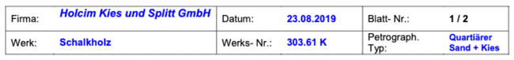
<field_region>
<field_item>
<key>Firma:</key>
<value>Holcim ... GmbH</value>
</field_item>
<field_item>
<key>Datum:</key>
<value>23.08.2019</value>
</field_item>
...
<field_item>
<key>Petrograph. Typ:</key>
<value>Quartiarer Sand + Kies</value>
</field_item>
</field_region>

Nesting forms and using form headings
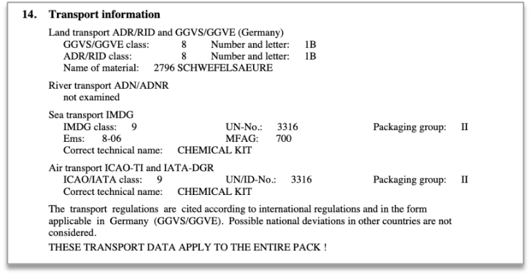
<field_region>
<field_heading>
<marker>14.</marker>
Transport Information
</field_heading>
<field_region>
<field_heading>
Land transport ... (Germany)
</field_heading>
<field_item>
<key>GGVS/GGVE class:</key>
<value>8</value>
</field_item>
<field_item>
<key>ADR/RID class:</key>
<value>8</value>
</field_item>
...
</field_region>
<field_item>
<key>River transport ADN/ADNR</key>
<value>not examined</value>
</field_item>
<field_region>
<field_heading>
Sea transport IMDG
</field_heading>
...
</field_region>
...
<text>
The transport ... considered.
</text>
<text>
THESE TRANSPORT ... PACK!
</text>
</field_region>

Fillable form
<table><tr><td>
<field_region>
<field_item>
<key>Description</key>
<value>A.A. Cat</value>
</field_item>
<field_item>
<key>Quant.</key>
<value></value>
</field_item>
<field_item>
<key>Un</key>
<value></value>
</field_item>
<field_item>
<key>Measure</key>
<value></value>
</field_item>
<field_item>
<key>Price (in currency)</key>
<value></value>
</field_item>
<field_item>
<key>Un</key>
<value></value>
</field_item>
<field_item>
<key>Total</key>
<value></value>
</field_item>
<text></text>
<field_region>
<field_item>
<key>Delivery Cost</key>
<value></value>
</field_item>
<field_item>
<key>Maintenance</key>
<value></value>
</field_item>
...
<field_region>
<field_region>
<field_item>
<key>Date and time of delivery:</key>
<value></value>
</field_item>
...
<field_item>
<key>Guarantee</key>
<value></value>
</field_item>
<text>
Delivery Suppl...Finance Department
</text>
</field_region>
...
</field_region>
</td><td style="vertical-align: top;">
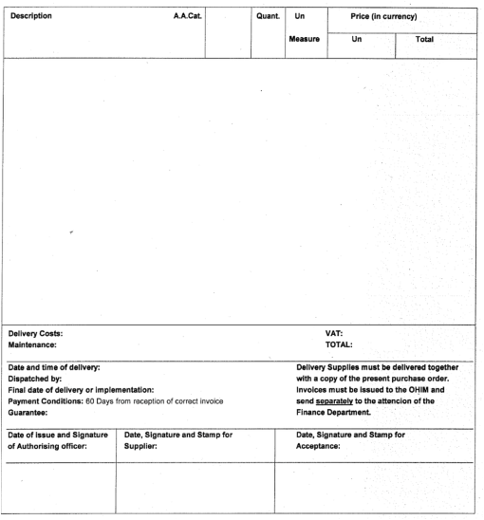
</td></tr></table>

Use of form headings
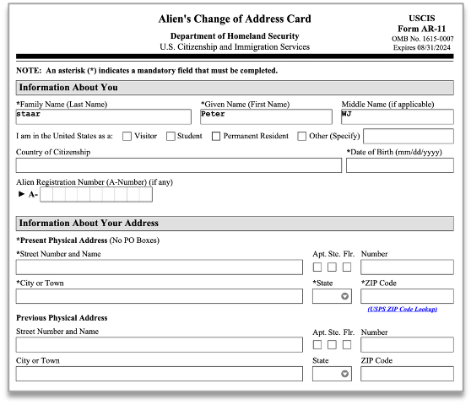
<field_region>
<field_heading>Information about you</field_heading>
<field_item>
<key>
\*Family Name (Last Name)
</key>
<value>staar</value>
</field_item>
<field_item>
<key>\*Given Name (First Name)</key>
<value>peter</value>
</field_item>
<field_item>
<key>\*Middle Name (if applicable)</key>
<value>WJ</value>
</field_item>
<field_item>
<key>I am in the United States as a:</key>
<text><checkbox class="unselected"/>Visitor</text>
<text><checkbox class="unselected"/>Student</text>
<text><checkbox class="unselected"/>Permanent Resident</text>
<text><checkbox class="unselected"/>Other (Specify)</text>
<value></value>
<field_item>
<field_item>
<key>Country of Citizenship</key>
<value></value>
</field_item>
<field_item>
<key>\*Date of Birth</key>
<value></value>
</field_item>
<field_item>
<key>Alien Registration Number (A-Number) (if any)</key>
<value>A-</value>
</field_item>
<field_heading>Information About Your Address</field_heading>
<text>\*Present Physical Address ()No Po Boxes</text>
<field_item>
<key>\*Street ... Name</key>
<value></value>
</field_item>
<field_item>
<key>Apt.</key>
<checkbox class="unselected"/>
</field_item>
<field_item>
<key>Ste.</key>
<checkbox class="unselected"/>
</field_item>
...
</field_region>

High density form
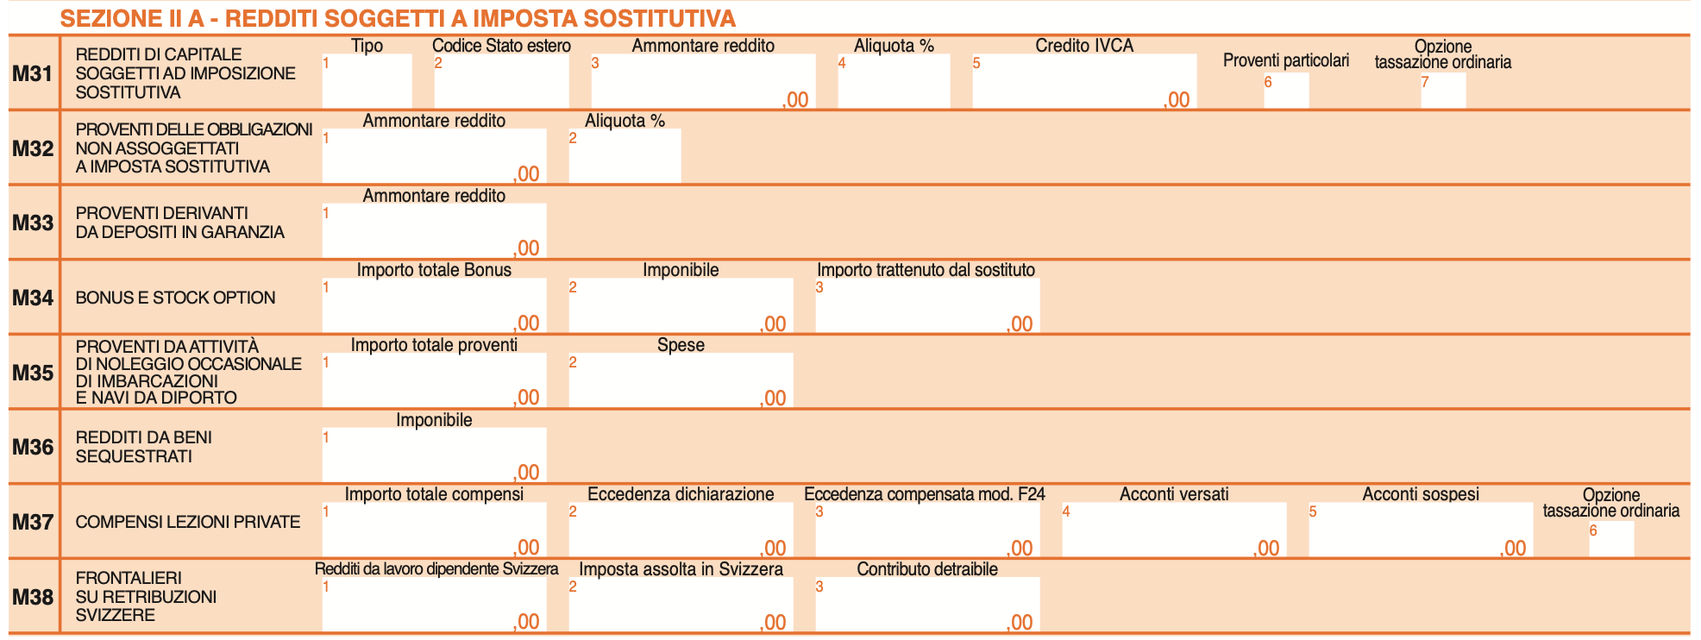
<field_region>
<form_heading level="1">M31</field_heading>
<form_heading level="2">REDDITI DI CAPITALE SOGGETTI AD IMPOSIZIONE SOSTITUTIVA</field_heading>
<field_item>
<marker>1</marker>
<key>Tipo</key>
<value></value>
</field_item>
<field_item>
<marker>2</marker>
<key>Codice Stato estero</key>
<value></value>
</field_item>
<field_item>
<marker>3</marker>
<key>Ammontare reddito</key>
<value>,00</value>
</field_item>
<field_item>
<marker>4</marker>
<key>Aliquota %</key>
<value></value>
</field_item>
<field_item>
<marker>5</marker>
<key>Credito IVCA</key>
<value>,00</value>
</field_item>
<field_item>
<marker>6</marker>
<key>Proventi particolari</key>
<value></value>
</field_item>
<field_item>
<marker>7</marker>
<key>Opzione tassazione ordinaria</key>
<value></value>
</field_item>
<form_heading level="1">M32</field_heading>
<form_heading level="2">PROVENTI DELLE OBBLIGAZIONI NON ASSOGGETTATI A IMPOSTA SOSTITUTIVA</field_heading>
<field_item>
<marker>1</marker>
<key>Ammontare reddito</key>
<value>,00</value>
</field_item>
<field_item>
<marker>2</marker>
<key>Aliquota %</key>
<value></value>
</field_item>
<form_heading level="1">M33</field_heading>
<form_heading level="2">PROVENTI DERIVANTI DA DEPOSITI IN GARANZIA</field_heading>
<field_item>
<marker>1</marker>
<key>Ammontare reddito</key>
<value>,00</value>
</field_item>
...
</field_region>

Classical duality between tables and explicit key-values
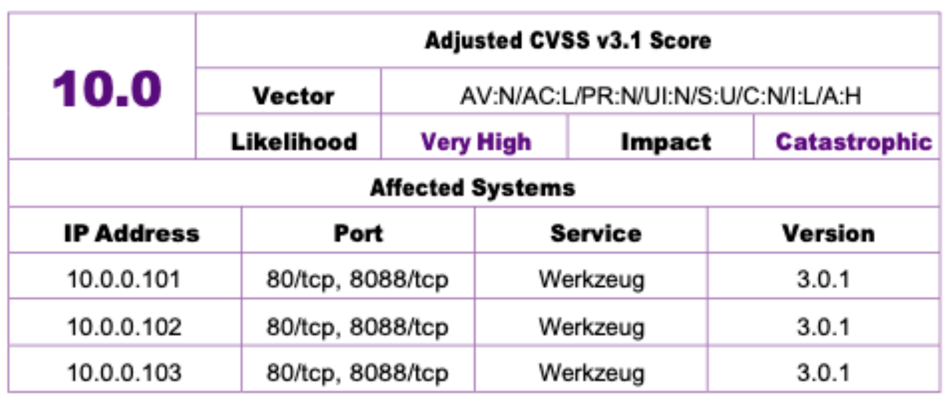
<field_region>
<field_item>
<key>Adjusted CVSS v3.1 Score</key>
<value>10.0</value>
</field_item>
<field_item>
<key>Vector</key>
<value>AV:N/AC:L/PR:N/UI:N/S:U/C:N/I:L/A:H</value>
</field_item>
<field_item>
<key>Likelihood</key>
<value>Very High</value>
</field_item>
<field_item>
<key>Impact</key>
<value>Catastrophic</value>
</field_item>
<field_heading>
Affected Systems
</field_heading>
<table>
<ched/><text>IP Address</text><ched/><text>Port</text><ched/><text>Service</text><ched/><text>Version</text><nl/>
<fcel/><text>10.0.0.101</text><fcel/><text>80/tcp, 8088/tcp</text><fcel/><text>Werkzeug</text><fcel/><text>3.0.1</text><nl/>
<fcel/><text>10.0.0.102</text><fcel/><text>80/tcp, 8088/tcp</text><fcel/><text>Werkzeug</text><fcel/><text>3.0.1</text><nl/>
<fcel/><text>10.0.0.103</text><fcel/><text>80/tcp, 8088/tcp</text><fcel/><text>Werkzeug</text><fcel/><text>3.0.1</text><nl/>
</table>
</field_region>

Values without Keys
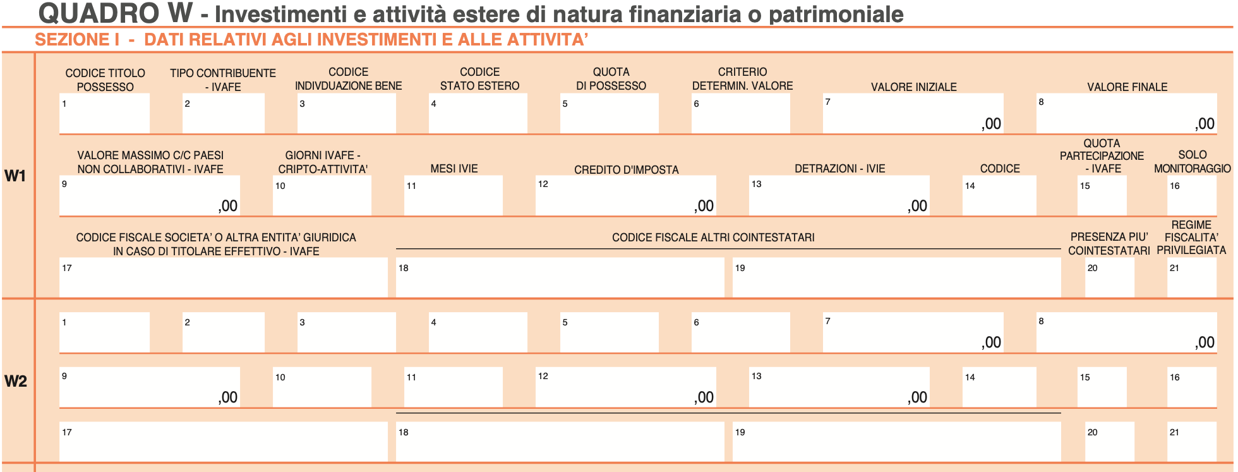
<heading level="1">QUADRO W - Investimenti e...</heading>
<heading level="2">SEZIONE I - DATI RELATIVI...</heading>
<field_region>
<form_heading level="1">W1</field_heading>
<field_item>
<marker>1</marker>
<key>CODICE TITOLO POSSESSO</key>
<value></value>
</field_item>
<field_item>
<marker>2</marker>
<key>TIPO CONTRIBUENTE - IVAFE</key>
<value></value>
</field_item>
...
<form_heading level="1">W2</field_heading>
<field_item>
<marker>1</marker>
<value></value>
</field_item>
<field_item>
<marker>2</marker>
<value></value>
</field_item>
<field_item>
<marker>3</marker>
<value></value>
</field_item>
...
</field_region>

Another complex form deconstructed into field items
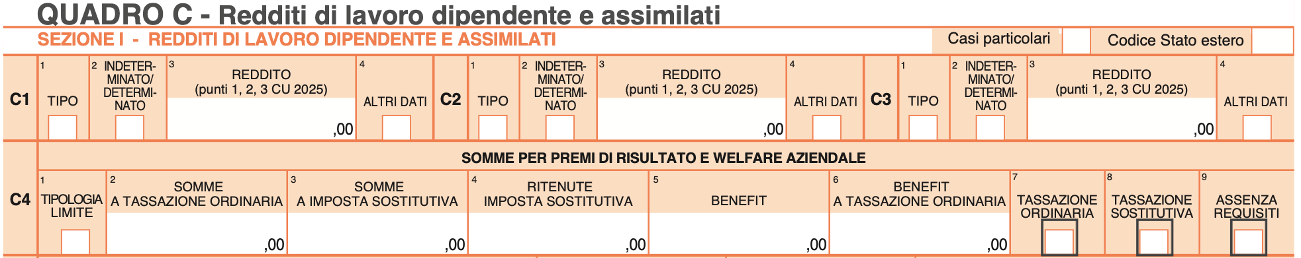
<table><tr><td>
<heading level="1">QUADRO C - Redditi di lavoro...</heading>
<field_region>
<form_heading level="1">SEZIONE I - RE...</field_heading>
<field_item>
<key>Casi particolari</key>
<checkbox class="unselected"/>
</field_item>
<field_item>
<key>Codice Stato estero</key>
<value></value>
</field_item>
<form_heading level="2">C1</field_heading>
<field_item>
<marker>1</marker>
<key>TIPO</key>
<value></value>
</field_item>
<field_item>
<marker>2</marker>
<key>INDETERMINATO/DETERMINATO</key>
<checkbox class="unselected"/>
</field_item>
<field_item>
<marker>3</marker>
<key>REDDITO (punti 1,2,3 CU 2025)</key>
<value>,00</value>
</field_item>
<field_item>
<marker>4</marker>
<key>ALTRI DATI</key>
<checkbox class="unselected"/>
</field_item>
<form_heading level="2">C2</field_heading>
<field_item>
<marker>1</marker>
<key>TIPO</key>
<value></value>
</field_item>
<field_item>
<marker>2</marker>
<key>INDETERMINATO/DETERMINATO</key>
<checkbox class="unselected"/>
</field_item>
<field_item>
<marker>3</marker>
<key>REDDITO (punti 1,2,3 CU 2025)</key>
<value>,00</value>
</field_item>
...
</td><td style="vertical-align: top;">
...
<field_item>
<marker>4</marker>
<key>ALTRI DATI</key>
<checkbox class="unselected"/>
</field_item>
<form_heading level="2">C3</field_heading>
<field_item>
<marker>1</marker>
<key>TIPO</key>
<value></value>
</field_item>
<field_item>
<marker>2</marker>
<key>INDETERMINATO/DETERMINATO</key>
<checkbox class="unselected"/>
</field_item>
<field_item>
<marker>3</marker>
<key>REDDITO (punti 1,2,3 CU 2025)</key>
<value>,00</value>
</field_item>
<field_item>
<marker>4</marker>
<key>ALTRI DATI</key>
<checkbox class="unselected"/>
</field_item>
<form_heading level="2">C4</field_heading>
<form_heading level="3">SOMME PER PREMI...
</field_heading>
<field_item>
<marker>1</marker>
<key>TIPOLOGIA LIMITE</key>
<checkbox class="unselected"/>
</field_item>
<field_item>
<marker>2</marker>
<key>SOMME A TASSAZIONE ORDINARIA</key>
<value>,00</value>
</field_item>
<field_item>
<marker>3</marker>
<key>SOMME A IMPOSTA SOSTITUTIVA</key>
<value>,00</value>
</field_item>
...
</field_region>
</td></tr></table>

Middle section of a form with A and B choices
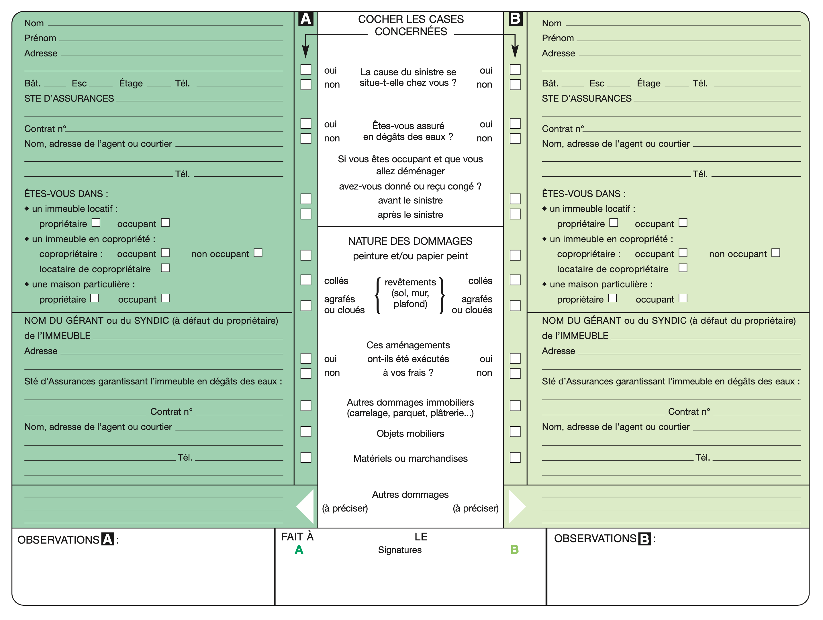
<field_region>
<field_heading>COCHER LES CASES CONCERNEES</field_heading>
<field_item>
<key>La cause du sinistre se situe-t-elle chez vous ?</key>
<text><checkbox class="unselected"/><marker>A</marker>oui</text>
<text><checkbox class="unselected"/><marker>A</marker>non</text>
<text><checkbox class="unselected"/><marker>B</marker>oui</text>
<text><checkbox class="unselected"/><marker>B</marker>non</text>
</field_item>
<field_item>
<key>Êtes-vous assuré en dégâts des eaux ?</key>
<text><checkbox class="unselected"/><marker>A</marker>oui</text>
<text><checkbox class="unselected"/><marker>A</marker>non</text>
<text><checkbox class="unselected"/><marker>B</marker>oui</text>
<text><checkbox class="unselected"/><marker>B</marker>non</text>
</field_item>
<field_item>
<key>Si vous êtes occupant et que vous allez déménager avez-vous donné ou reçu congé ?</key>
<text><checkbox class="unselected"/><marker>A</marker>avant le sinistre</text>
<text><checkbox class="unselected"/><marker>A</marker>après le sinistre</text>
<text><checkbox class="unselected"/><marker>B</marker>avant le sinistre</text>
<text><checkbox class="unselected"/><marker>B</marker>après le sinistre</text>
</field_item>
<field_heading>NATURE DES DOMMAGES peinture et/ou papier peint</field_heading>
<field_item>
<key>revêtements (sol, mur, plafond)</key>
<text><checkbox class="unselected"/><marker>A</marker>collés</text>
<text><checkbox class="unselected"/><marker>A</marker>agrafés ou cloués</text>
<text><checkbox class="unselected"/><marker>B</marker>collés</text>
<text><checkbox class="unselected"/><marker>B</marker>agrafés ou cloués</text>
</field_item>
<field_item>
<key>Ces aménagements ont-ils été exécutés à vos frais ?</key>
<text><checkbox class="unselected"/><marker>A</marker>oui</text>
<text><checkbox class="unselected"/><marker>A</marker>non</text>
<text><checkbox class="unselected"/><marker>B</marker>oui</text>
<text><checkbox class="unselected"/><marker>B</marker>non</text>
</field_item>
<field_item>
<key>Autres dommages immobiliers (carrelage, parquet, plâtrerie...)</key>
<text><checkbox class="unselected"/><marker>A</marker></text>
<text><checkbox class="unselected"/><marker>B</marker></text>
</field_item>
<field_item>
<key>Objets mobiliers</key>
<text><checkbox class="unselected"/><marker>A</marker></text>
<text><checkbox class="unselected"/><marker>B</marker></text>
</field_item>
<field_item>
<key>Matériels ou marchandises</key>
<text><checkbox class="unselected"/><marker>A</marker></text>
<text><checkbox class="unselected"/><marker>B</marker></text>
</field_item>
<field_item>
<key>Autres dommages</key>
<value><marker>A</marker><hint>(à préciser)</hint></value>
<value><marker>B</marker><hint>(à préciser)</hint></value>
</field_item>
</field_region>

Tabular form with strong 2D value relationship
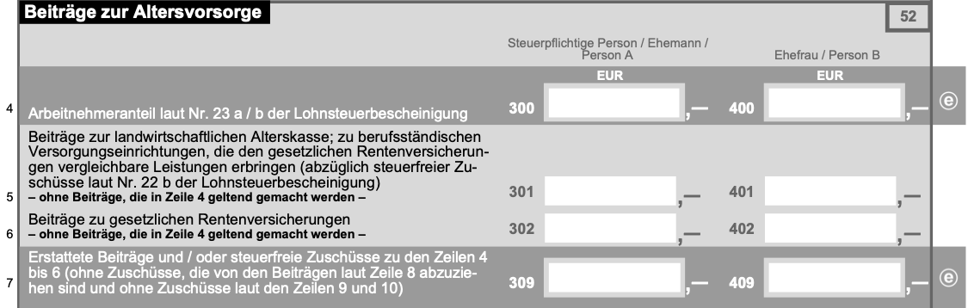
<field_region>
<table>
<srow/><text>Beiträge zur Altersvorsorge</text> <srow/> <srow/><text>52</text> <ecel/><nl>
<ecel/> <ched/><text>Steuerpflichtige Person / Ehemann / Person A</text> <ched/><text>Ehefrau / Person B</text> <ecel/><nl>
<fcel/><text>Arbeitnehmeranteil laut Nr. 23 a / b der Lohnsteuerbescheinigung</text> <fcel/><text>*FORM1*,-</text> <fcel/><text>*FORM2*,-</text> <fcel/><text>e</text><nl>
<fcel/><text>Beiträge zur landwirtschaftlichen Alterskasse; zu berufsständ...</text> <fcel/><text>*FORM3*,-</text> <fcel/><text>*FORM4*,-</text> <ecel/><nl>
<fcel/><text>Beiträge zu gesetzlichen Rentenversicherungen...</text> <fcel/><text>*FORM5*,-</text> <fcel/><text>*FORM6*,-</text> <ecel/><nl>
<fcel/><text>Erstattete Beiträge und / oder steuerfreie Zuschüsse zu den...</text> <fcel/><text>*FORM7*,-</text> <fcel/><text>*FORM8*,-</text> <fcel/><text>e</text><nl>
...
</table>
</field_region>
...
*FORMS referred above:
*FORM1*: <field_item><key>300</key><value></value><hint>EUR</hint></field_item>
*FORM2*: <field_item><key>400</key><value></value><hint>EUR</hint></field_item>
*FORM4*: <field_item><key>401</key><value></value></field_item>
*FORM5*: <field_item><key>302</key><value></value></field_item>
*FORM3*: <field_item><key>301</key><value></value></field_item>
*FORM6*: <field_item><key>402</key><value></value></field_item>
*FORM7*: <field_item><key>309</key><value></value></field_item>
*FORM8*: <field_item><key>409</key><value></value></field_item>

Mix table and form elements
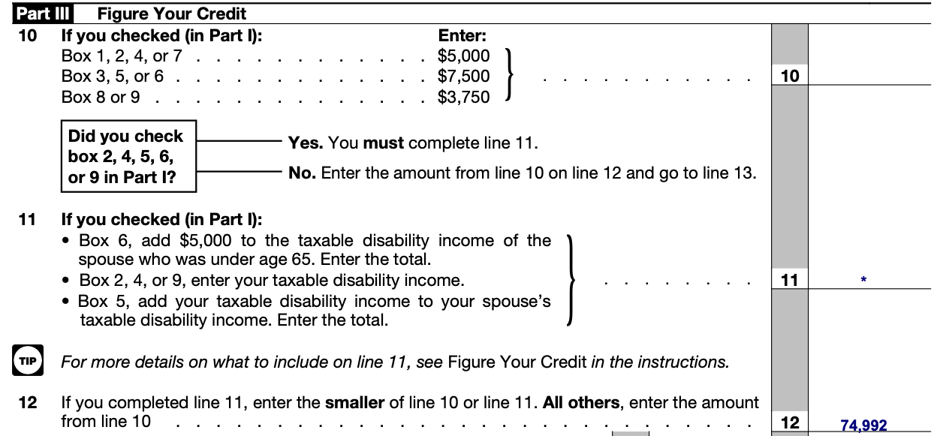
...
<heading>Part III</heading>
<text>Figure Your Credit</text>
<text>10</text>
<table>
<ched/><text>If you checked (in Part l):</text><ched/><text>Enter</text><nl>
<fcel/><text>Box 1, 2, 4, or 7</text><fcel/><text>$5,000</text><nl>
<fcel/><text>Box 3, 5, or 6</text><fcel/><text>$7,500</text><nl>
<fcel/><text>Box 8 or 9</text><fcel/><text>$3,750</text><nl>
</table>
<field_region><field_item><key>10</key><value></value></field_item></field_region>
<text>11 If you checked (in Part I):</text>
<list class="unordered">
<ldiv/>
<text>Box 6, add $5,000 to the taxable...</text>
<ldiv/>
<text>Box 2, 4, or 9, enter your taxable...</text>
<ldiv/>
<text>BBox 5, add your taxable disabilit...</text>
</list>
<field_region><field_item><key>11</key><value>.</value></field_item></field_region>
<picture><class>pictogram</class></picture>
<text>For more details on what to include on line 11...</text>
<text>12 If you completed line 11, enter the smaller...</text>
<field_region><field_item><key>12</key><value>74,992</value></field_item></field_region>
...

Key-value pair in the wild
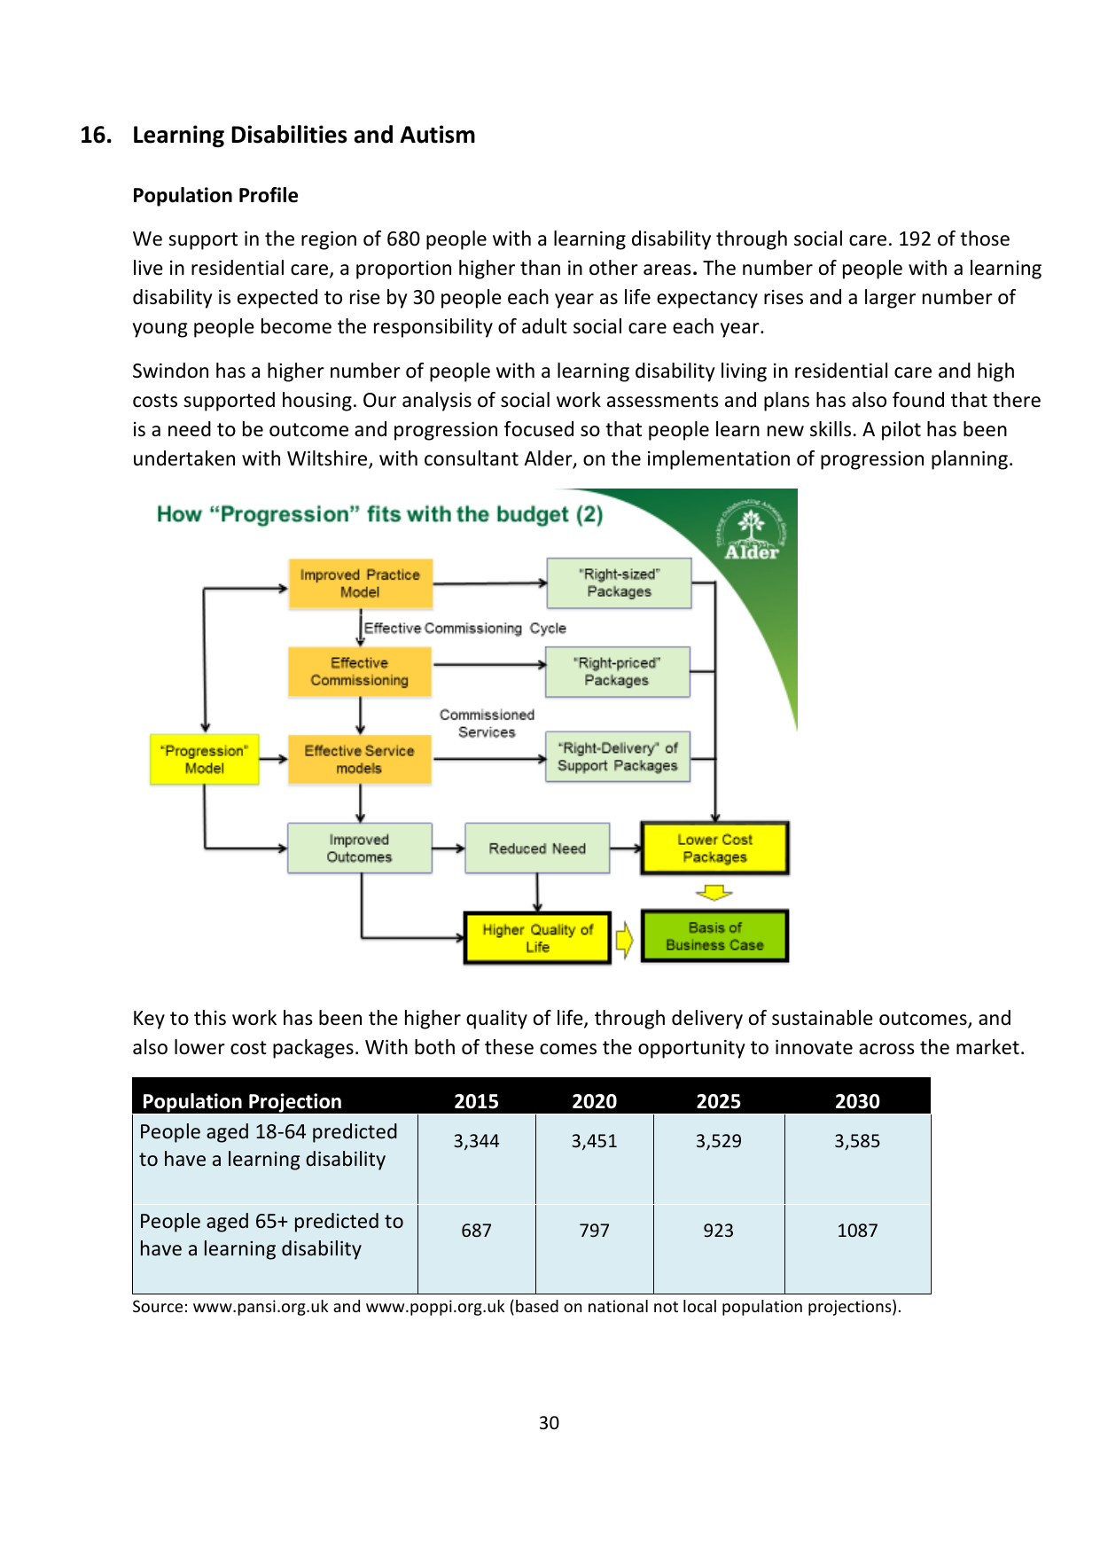
...
<field_region>
<field_item>
<key>Source</key>
<value>www.pansi.org.uk and ... projections).</value>
</field_item>
</field_region>
...
Detailed examples can be seen here: Form Examples

Split structure
We can capture content that is split (e.g. across columns or across pages) using the <thread thread_id="N"/> element, where N is a unique identifier.
The basic structure is shown below, e.g. for a text tag:
<text>
<thread thread_id="1"/>
This text item starts here
</text>
...
<text>
<thread thread_id="1"/>
and continues here.
</text>

Cross-column structure example
<img src="examples/cross_column/cross_column.png" width="700">
Each block that has location information is a top-level tag of the corresponding label, e.g. "text".
Elements which belong to the same document component should have the same thread ID.
<!-- ... -->
<text>
<thread thread_id="1"/>
<location value="10"/><location value="20"/>
<location value="30"/><location value="40"/>
where τ<subscript>x,y,z</subscript> are the Pauli matrices acting
on Nambu space. We consider a circular-shaped boundary, the nor-
</text>
<picture>
<caption>
<location value="20"/><location value="30"/>
<location value="40"/><location value="50"/>
FIG. 3. The modules of the inner product of two MES spinors
<formula><!-- ... --></formula>
<!-- ... -->
</caption>
<!-- ... -->
</picture>
<text>
<thread thread_id="1"/>
<location value="30"/><location value="40"/>
<location value="50"/><location value="60"/>
mal direction of the boundary tangent for arbitrary angle θ is
<formula><!-- ... --></formula>
<!-- ... -->
</text>

Cross-page structure example
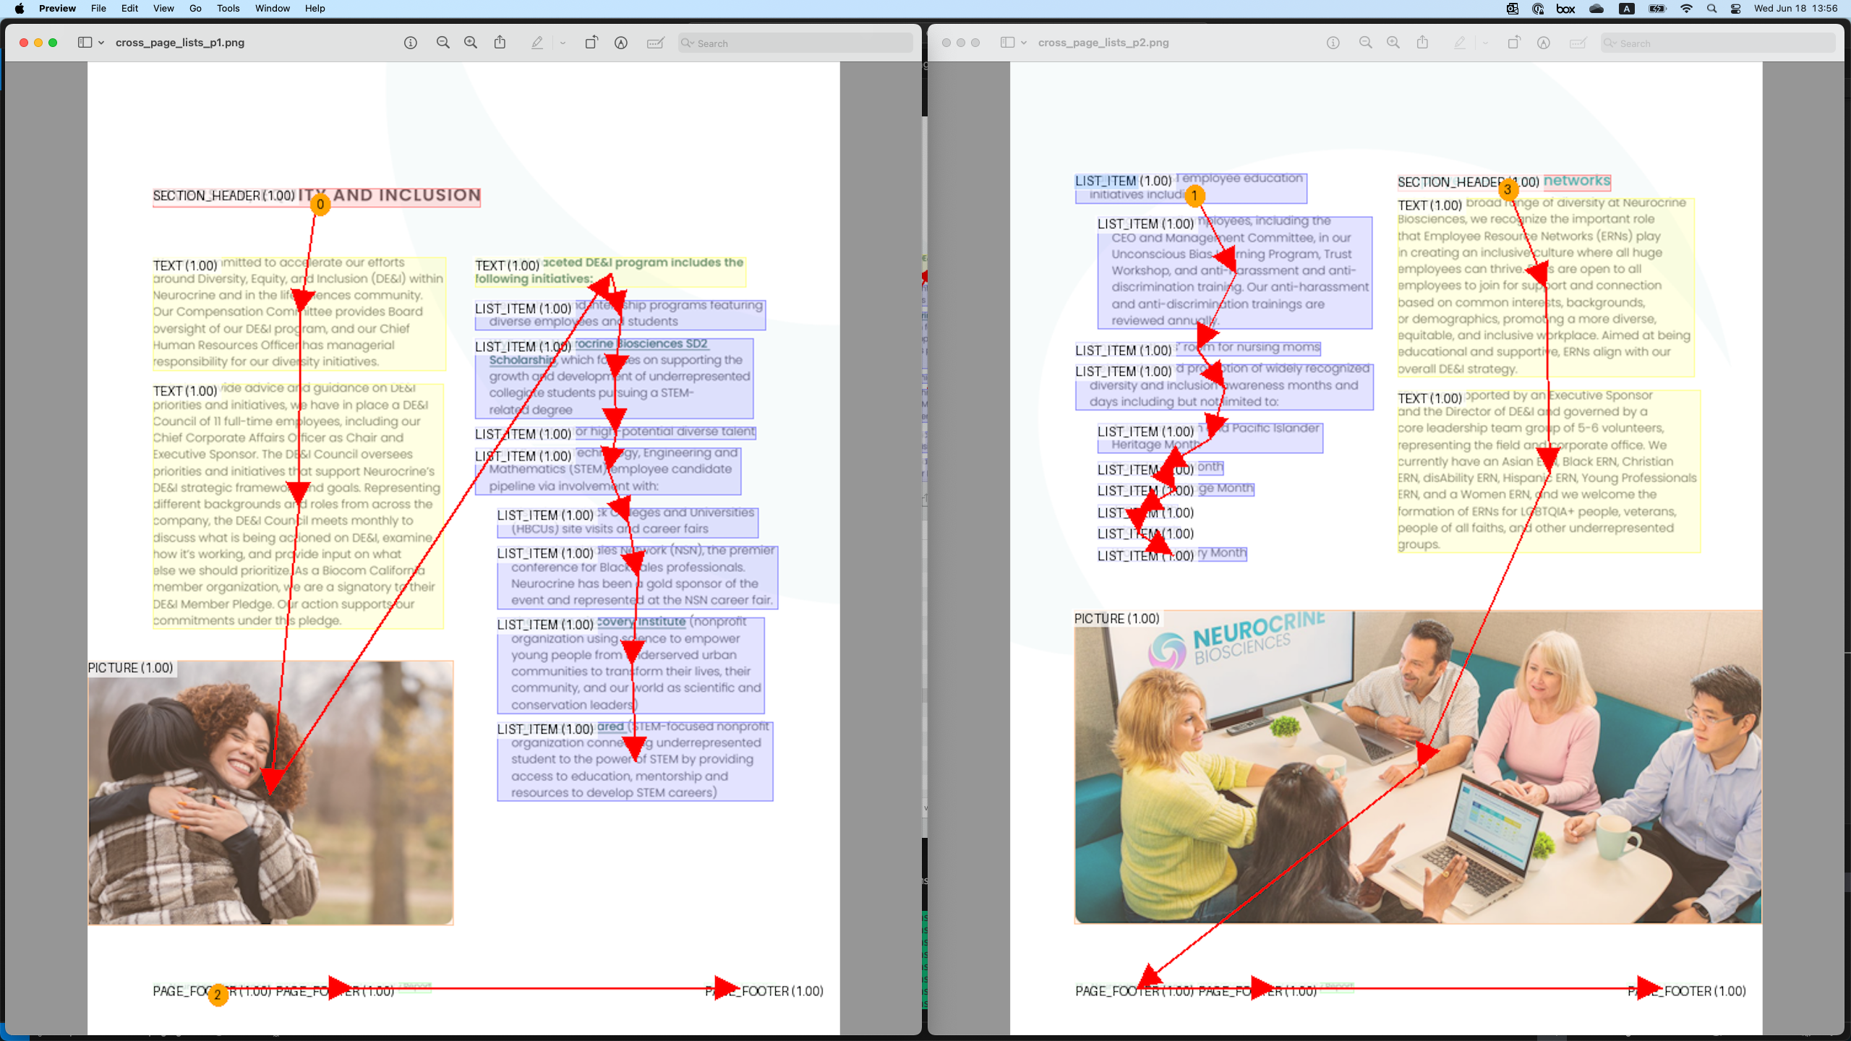
The scenario in the above figure is represented as follows:
...
<text>
<location value="10"/><location value="20"/>
<location value="30"/><location value="40"/>
<![CDATA[Our multi-faceted DE&I program includes the following initiatives:]]>
</text>
<list class="unordered">
<thread thread_id="1"/>
<ldiv/>
<text>
<location value="15"/><location value="25"/>
<location value="35"/><location value="45"/>
Mentorships and internship programs featuring diverse employees and students
</text>
...
<ldiv/>
<text>
<location value="20"/><location value="30"/>
<location value="40"/><location value="50"/>
Build Science, Technology, Engineering and Mathematics (STEM) employee candidate pipeline via involvement with:
<list class="unordered">
<ldiv/>
<text>
<location value="25"/><location value="35"/>
<location value="45"/><location value="55"/>
Historically Black Colleges and Universities (HBCUs) site visits and career fairs
</text>
...
<ldiv/>
<text>
<location value="30"/><location value="40"/>
<location value="50"/><location value="60"/>
San Diego Squared (STEM-focused nonprofit organization connecting underrepresented student to the power
of STEM by providing access to education, mentorship and resources to develop STEM careers)
</text>
<list>
</text>
<list>
<page_footer>
<location value="35"/><location value="45"/>
<location value="55"/><location value="65"/>
16 Neurocrine Biosciences
</page_footer>
<page_break/>
<list class="unordered">
<thread thread_id="1"/>
<ldiv/>
<text>
<location value="40"/><location value="50"/>
<location value="60"/><location value="70"/>
<![CDATA[Build upon DE&I employee education initiatives including: ...]]>
</text>
...
<list>
...

Split table example
The table shown on the left may be split across pages, e.g. as shown on the middle. The figure on the right visualizes the thread elements (more details further below):
<table style="min-width: 1800px"> <tr> <td> Original table:
<img src="./examples/split_tables/original_table.png" height="900" width="644" /> </td> <td> Table split across pages:
<img src="./examples/split_tables/split_table.png" height="900" width="644" /> </td> <td> Table threads:
<img src="./examples/split_tables/table_threads.png" height="900" width="644" /> </td> </tr> </table>
The scenario in the above figure is represented below.
- We introduce a new horizontal thread element, h_thread, which is used to capture table content that spans pages sidewise,
similarly to the usual thread elements thread.
- Only the content that is visible within the page is included in the table element (e.g. see "2025 d").
- When thread linking is resolvable through ucel/lcel or h_thread, the thread element is not used, as it would be redundant.
- When thread linking must be captured, we capture it the earliest possible, i.e. we don't wait for the bottom-most cell
to be reached to add the thread for "Europe" in the example above.
...
<!-- page 1: -->
<table>
<thread thread_id="1"/>
<h_thread h_thread_id="1"/>
<ecel/> <ecel/> <ecel/><nl/>
<ecel/> <ched/><text>Continent</text> <ched/><text>Country</text><nl/>
<rhed/><text><thread thread_id="2"/></text> <rhed/><text>Asia</text> <rhed/><text>Japan</text><nl/>
</table>
<page_break/>
<!-- page 2: -->
<table>
<thread thread_id="1"/>
<h_thread h_thread_id="2"/>
<rhed/><text><thread thread_id="2"/>G7 member</text> <rhed/><text><thread thread_id="3"/>Europe</text> <rhed/><text>France</text><nl/>
<ucel/> <ucel/> <rhed/><text>Germany</text><nl/>
<ucel/> <ucel/> <rhed/><text>Italy</text><nl/>
</table>
<page_break/>
<!-- page 3: -->
<table>
<thread thread_id="1"/>
<h_thread h_thread_id="3"/>
<rhed/><text><thread thread_id="2"/></text> <rhed/><text><thread thread_id="3"/></text> <rhed/><text>United Kingdom</text><nl/>
<ucel/> <rhed/><text>North America</text> <rhed/><text>Canada</text><nl/>
<ucel/> <ucel/> <rhed/><text>United States</text><nl/>
</table>
<page_break/>
<!-- page 4: -->
<table>
<h_thread h_thread_id="1"/>
<ched/><text><h_thread h_thread_id="4"/>2025 d<text> <lcel/> <lcel/><nl/>
<ched/><text>GDP (PPP) per capita in USD</text> <ched/><text>Currency</text> <ched/><text><h_thread h_thread_id="5"/>Key l</text><nl/>
<fcel/><text>46,097</text> <fcel/><text>Japanese yen (JPY)</text> <fcel/><text>Shigeru Ishiba</text><nl/>
</table>
<page_break/>
<!-- page 5: -->
<table>
<thread thread_id="1"/>
<h_thread h_thread_id="2"/>
<fcel/><text>54,465</text> <fcel/><text>Euro (EUR)</text> <fcel/><text>Emmanuel Macron</text><nl/>
<fcel/><text>62,830</text> <fcel/><text>Euro (EUR)</text> <fcel/><text>Friedrich Merz</text><nl/>
<fcel/><text>53,115</text> <fcel/><text>Euro (EUR)</text> <fcel/><text>Giorgia Meloni</text><nl/>
</table>
<page_break/>
<!-- page 6: -->
<table>
<thread thread_id="1"/>
<h_thread h_thread_id="3"/>
<fcel/><text>52,518</text> <fcel/><text>Pound sterling (GBP)</text> <fcel/><text>Keir Starmer</text><nl/>
<fcel/><text>62,830</text> <fcel/><text>Canadian dollar</text> <fcel/><text>Mark Carney</text><nl/>
<fcel/><text>53,115</text> <fcel/><text>United States dollar (USD)</text> <fcel/><text>Donald Trump</text><nl/>
</table>
<page_break/>
<!-- page 7: -->
<table>
<thread thread_id="1"/>
<h_thread h_thread_id="1"/>
<ched/><text><h_thread h_thread_id="4"/>etails</text> <lcel/> <lcel/><nl/>
<ched/><text><h_thread h_thread_id="5"/>eader</text> <ched/><text>Population in millions</text> <ched/><text>Area in km2</text><nl/>
<fcel/><text>Prime Minister</text> <fcel/><text>125.1</text> <fcel/><text>377,975</text><nl/>
</table>
<page_break/>
...

References

Cross-references
Cross-references can be captured using the <xref> element as part of the element head, for pointing to a thread based on the thread_id.

Cross-reference example
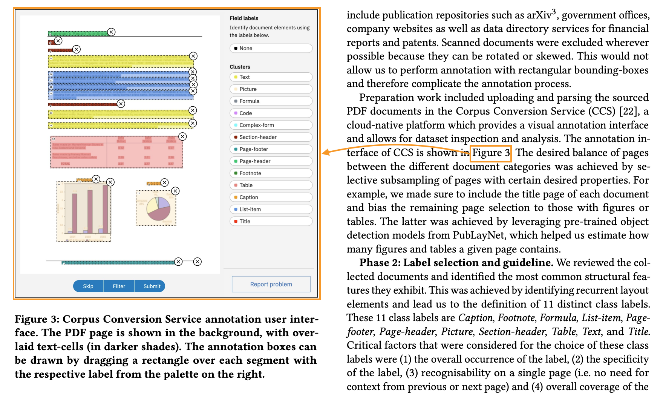
<picture>
<thread thread_id="1"/>
<!--...-->
</picture>
<!--...-->
<text>
<content>... is shown in <content/>
<text><xref thread_id="1"/>Figure 3</text>
. The desired balance...
</text>

Hyperlinks
Hyperlinks can be captured using the <href> element as part of the element head, for pointing to a URI.
Basic example:
<text>
<content>Visit our </content>
<text><href uri="https://www.example.com"/>website</text>
<content> for more information.</content>
</text>
Hyperink from a non-text element:
<text>Click on the image below:</text>
<picture>
<href uri="https://www.example.com"/> <!-- the target URI -->
<src uri="https://www.example.com/image.jpg"/> <!-- the image source URI -->
</picture>

Formatting
Formatting may be preserved through nested tags or escape sequences:
- Bold, italic, underline, strikethrough, handwriting
- Superscript, subscript
- Text direction markers
Examples of basic formatting:
<text>
This text contains <bold>bold</bold>, <italic>italic</italic>,
<underline>underlined</underline>, and <strikethrough>struck-through</strikethrough> text.
</text>
Nested formatting:
<text>
You can combine <bold><italic>bold and italic</italic></bold> or
<underline><bold>underlined and bold</bold></underline> text.
</text>
Handwriting formatting (for handwritten annotations or text):
<text>
The printed text says "Sign here:" followed by
<handwriting>John Smith</handwriting> in handwritten form.
</text>
Superscript and subscript:
<text>
The formula for water is H<subscript>2</subscript>O, and
Einstein's equation is E=mc<superscript>2</superscript>.
</text>

Page Break with Continuation
Page breaks are complex components that interrupt the flow of a document. They can interrupt paragraphs, tables, lists, etc. In general, we follow two rules,
- If content spans across one (or more) page breaks, add <thread thread_id="N"/> to the item and reuse the same id in the continuing item.
- For the follow up content of the page, we follow a reading order and close all open elements before the <page_break/> element is introduced.
An easy example is below,
<doclang>
<text><thread thread_id="1"/>This paragraph spans across</text>
<caption>Some caption</caption>
<page_break/>
<text><thread thread_id="1"/>multiple pages.</text>
</doclang>
Often, we have more complicated page breaks, in which a (nested) list is split across pages and further interrupted by other semantic elements (think page footers). In this case, we demand that all elements of the first page are added and/or closed before the page break and then opened again in the appropriate way after the page break, with the intent that the content in between the page breaks is a valid DocLang tree.
A more complicated example is shown below in which we break the content of a list-item,
<doclang>
<list class="ordered">
<thread thread_id="1"/>
<ldiv/>
<text>First item</text>
<ldiv/>
<text><thread thread_id="2"/>Second </text>
...
</list>
<page_footer>...</page_footer>
<page_break/>
<list class="ordered">
<thread thread_id="1"/>
<ldiv/>
<text><thread thread_id="2"/>item</text>
</list>
...
</doclang>
Above, <thread thread_id="1"/> captures that the list itself is split, while <thread thread_id="2"/> captures that a particular list item is split.

Bibliography
- SmolDocling: An ultra-compact vision-language model for end-to-end multi-modal document conversion
- Optimized Table Tokenization for Table Structure Recognition
- DoclingDocument API Specification
- W3C XML 1.0 Specification (Fifth Edition)
- W3C HTML5 Specification
- ISO 32000-2:2020 (PDF 2.0)
- ISO 8601
- Semantic Versioning 2.0.0 (semver.org)

Appendix A: Reference

Special Elements
This category comprises elements with specialized document-level function.

<doclang>
The document root element. Starts with an optional <head> followed by a sequence of applicable elements.

Allowed Context
Exists exactly once, as root element.

Attributes
Attribute | Required / Optional | Allowed Values | Description
xmlns | Optional; default: "https://www.doclang.ai/ns/v0" | {"https://www.doclang.ai/ns/v0"} | The DocLang specification version namespace.
version | Optional; default: "0.3" | {"0.3"} | The DocLang specification version the document is supposed to validate against, in "MAJOR.MINOR" format, i.e. first two positions of Semantic Verisoning.

Allowed Content Types
Content Type | Allowed / Not allowed
Element head | Not allowed
Raw text | Not allowed
Primary semantic elements | Not allowed

Example
<doclang>
<!-- content -->
</doclang>

<head>
Includes doc-level metadata.

Allowed Context
Can only be first child of <doclang>.

Attributes
None

Allowed Content Types
Content Type | Allowed / Not allowed
Element head | Not allowed
Raw text | Not allowed
Primary semantic elements | Not allowed

<page_break>
Indicates a page break. A paginated document may be divided into pages using the <page_break/> empty element. Any page content, as split by <page_break/>, forms a valid DocLang document body, i.e. would be a valid DocLang document if wrapped in a doclang root element.

Allowed Context
Can only be child of <doclang>.

Attributes
None

Allowed Content Types
None (empty element).

Example
<doclang>
<!-- first page content -->
<page_break/>
<!-- second page content -->
</doclang>

Semantic Elements
Semantic elements capture core components with specific meaning and functional role in the document (e.g. a paragraph, a table, a list etc.) and may optionally begin with a element head. They are generally meant to be interpreted as block-level elements (although they can also be inlined via nesting). Semantic elements that can appear on the top level within <doclang> are called primary, while those that can only appear within other semantic elements are called secondary.

<text>
Represents a piece of cohesive text as that would appear in a paragraph. Note: a special construct related to this element is the so-called "virtual <text>", which can occur only as a list item or a table cell — see <list> and <table> below for details.

Allowed Context
Any context that allows semantic elements.

Attributes
None

Allowed Content Types
Content Type | Allowed / Not allowed
Element head | Allowed
Raw text | Allowed
Primary semantic elements | Allowed

<heading>

Allowed Context
Any context that allows semantic elements.

Attributes
Attribute | Required / Optional | Allowed Values | Description
level | Optional; default "1" | Positive integer

Allowed Content Types
Content Type | Allowed / Not allowed
Element head | Allowed
Raw text | Allowed
Primary semantic elements | Allowed

<footnote>

Allowed Context
Any context that allows semantic elements.

Attributes
None

Allowed Content Types
Content Type | Allowed / Not allowed
Element head | Allowed
Raw text | Allowed
Primary semantic elements | Allowed

<page_header>

Allowed Context
Any context that allows semantic elements.

Attributes
None

Allowed Content Types
Content Type | Allowed / Not allowed
Element head | Allowed
Raw text | Allowed
Primary semantic elements | Allowed

<page_footer>

Allowed Context
Any context that allows semantic elements.

Attributes
None

Allowed Content Types
Content Type | Allowed / Not allowed
Element head | Allowed
Raw text | Allowed
Primary semantic elements | Allowed

<field_region>
Serves for scoping of field items, for example encapsulating a whole form.

Allowed Context
Any context that allows semantic elements.

Attributes
None

Allowed Content Types
Content Type | Allowed / Not allowed
Element head | Allowed
Raw text | Not allowed
Primary semantic elements | Allowed

<list>
Captures a list. List items are delimited by the respective structural elements. A list item can be defined without a wrapping tag, i.e. as pure (optional) element head followed by raw text; this is called an "virtual <text>" and is handled exactly like a regular <text> element.

Allowed Context
Any context that allows semantic elements.

Attributes
Attribute | Required / Optional | Allowed Values | Description
class | Optional; default: "unordered" | {"unordered", "ordered"}

Allowed Content Types
Content Type | Allowed / Not allowed
Element head | TRUE, also on cell level in case of virtual <text>
Raw text | Only on cell level, in case of virtual <text>
Primary semantic elements | Allowed

<table>
Captures a table, in a format inspired by OTSL. Table cells are delimited by the respective structural elements. A table cell can be defined without a wrapping tag, i.e. as pure (optional) element head followed by raw text; this is called an "virtual <text>" and is handled exactly like a regular <text> element.

Allowed Context
Any context that allows semantic elements.

Attributes
Attribute | Required / Optional | Allowed Values | Description
class | Optional; default: "data" | {"data", "index"} | A value of "index" denotes a document index as it would be used e.g. for a table of contents.

Allowed Content Types
Content Type | Allowed / Not allowed
Element head | TRUE, also on cell level in case of virtual <text>
Raw text | Only on cell level, in case of virtual <text>
Primary semantic elements | Allowed

<formula>

Allowed Context
Any context that allows semantic elements.

Attributes
None

Allowed Content Types
Content Type | Allowed / Not allowed
Element head | Allowed
Raw text | Allowed
Primary semantic elements | Not allowed

<code>

Allowed Context
Any context that allows semantic elements.

Attributes
None

Allowed Content Types
Content Type | Allowed / Not allowed
Element head | Allowed
Raw text | Allowed
Primary semantic elements | Not allowed

<picture>
Can contain specific semantic elements: <src>, <table>.

Allowed Context
Any context that allows semantic elements.

Attributes
None

Allowed Content Types
Content Type | Allowed / Not allowed
Element head | Allowed
Raw text | Not allowed
Primary semantic elements | Allowed

<marker>

Allowed Context
Any context that allows semantic elements.

Attributes
None

Allowed Content Types
Content Type | Allowed / Not allowed
Element head | Allowed
Raw text | Allowed
Primary semantic elements | Allowed

<group>
Container for encapsulating multiple semantic elements.

Allowed Context
Any context that allows semantic elements.

Attributes
None

Allowed Content Types
Content Type | Allowed / Not allowed
Element head | Allowed
Raw text | Not allowed
Primary semantic elements | Allowed

<field_heading>

Allowed Context
Can only be descendant of <field_region>.

Attributes
Attribute | Required / Optional | Allowed Values | Description
level | Optional; default "1" | Positive integer

Allowed Content Types
Content Type | Allowed / Not allowed
Element head | Allowed
Raw text | Allowed
Primary semantic elements | Allowed

<field_item>
Scoping of a field key (optional) and any corresponding values.

Allowed Context
Can only be descendant of <field_region>.

Attributes
None

Allowed Content Types
Content Type | Allowed / Not allowed
Element head | Allowed
Raw text | Not allowed
Primary semantic elements | Allowed

<key>
The key of a field (may correspond to 0-N field values).

Allowed Context
Can only be descendant of <field_item>.

Attributes
None

Allowed Content Types
Content Type | Allowed / Not allowed
Element head | Allowed
Raw text | Allowed
Primary semantic elements | Allowed

<value>
A value of a field (may correspond to 0 or 1 field key).

Allowed Context
Can only be descendant of <field_item>.

Attributes
Attribute | Required / Optional | Allowed Values | Description
class | Optional; default: "read_only" | {"read_only", "fillable"}

Allowed Content Types
Content Type | Allowed / Not allowed
Element head | Allowed
Raw text | Allowed
Primary semantic elements | Allowed

<hint>
A hint regarding a field.

Allowed Context
Can only be descendant of <field_region>.

Attributes
None

Allowed Content Types
Content Type | Allowed / Not allowed
Element head | Allowed
Raw text | Allowed
Primary semantic elements | Allowed

<caption>
Optional part of the element head for capturing an associated caption.

Allowed Context
Can only be part of the element head of a semantic element.

Attributes
None

Allowed Content Types
Content Type | Allowed / Not allowed
Element head | Allowed
Raw text | Allowed
Primary semantic elements | Allowed

Property Elements
Property elements are non-semantic elements that help define useful traits of a semantic element, forming the main building blocks of the element head. Property elements that can appear on the top level of the element head are called primary, while those that can only appear within other property elements are called secondary. The various property elements are further specified in the following subsections.

<thread>
Optional part of the element head; serves for establishing a logical document component. This can be useful for capturing fragmented components, e.g. spanning multiple bounding boxes (e.g. cross-column) or pages, or for defining anchors for cross references.
To capture a fragmented component, we define separate instances of the respective element and use a <thread> with the same thread_id attribute for all of them

Allowed Context
Can only be child of a semantic element.

Attributes
Attribute | Required / Optional | Allowed Values | Description
thread_id | Required | Positive integer | A string that identifies a thread.

Allowed Content Types
None (empty element).

<xref>
Optional part of the element head; serves for capturing an outgoing cross-reference from this component.

Allowed Context
Can only be child of a semantic element. Mutually exclusive with <href>.

Attributes
Attribute | Required / Optional | Allowed Values | Description
thread_id | Required | Positive integer | The ID of the referenced thread.

Allowed Content Types
None (empty element).

<href>
Optional part of the element head; serves for capturing a URI referenced by this component.

Allowed Context
Can only be child of a semantic element. Mutually exclusive with <xref>.

Attributes
Attribute | Required / Optional | Allowed Values | Description
uri | Required | URI | The URI of the referenced resource.

Allowed Content Types
Content Type | Allowed / Not allowed
Element head | Not allowed
Raw text | Allowed
Primary semantic elements | Not allowed

<custom>
Custom metadata, e.g. for application-specific purposes.

Allowed Context
Can only be child of a semantic element.

Attributes
None

Allowed Content Types
Content Type | Allowed / Not allowed
Element head | Not allowed
Raw text | Not allowed
Primary semantic elements | Not allowed

<location>
Coordinate system is the bottom-left corner of the page.

Allowed Context
Can only be child of a semantic element.

Attributes
Attribute | Required / Optional | Allowed Values | Description
resolution | Optional; defaults to default_resolution@width or default_resolution@height depending on whether location refers to x or y, otherwise "512" if respective default_resolution not explicitly specified | Positive integer | Axis boundary (exclusive) for the respective location@value.
value | Required | Integer within [0, location.resolution)

Allowed Content Types
None (empty element).

Payload Elements
Payload elements are low-level elements that help define the effective content of another element.

<src>
The image's source.

Allowed Context
Can only be child of <picture>.

Attributes
Attribute | Required / Optional | Allowed Values | Description
uri | Required | URI | The source URI.

Allowed Content Types
None (empty element).

<checkbox>

Allowed Context
Any context that allows raw text content.

Attributes
Attribute | Required / Optional | Allowed Values | Description
class | Optional; default: "unselected" | {"unselected", "selected"}

Allowed Content Types
None (empty element).

<content>

Allowed Context
Any context that allows raw text content.

Attributes
None

Allowed Content Types
Content Type | Allowed / Not allowed
Element head | Not allowed
Raw text | Allowed
Primary semantic elements | Not allowed

Formatting Elements
Formatting elements modify the styling and presentation within semantic or other formatting elements.

<bold>

Allowed Context
Any context that allows raw text content.

Attributes
None

Allowed Content Types
Content Type | Allowed / Not allowed
Element head | Not allowed
Raw text | Allowed
Primary semantic elements | Not allowed

<italic>

Allowed Context
Any context that allows raw text content.

Attributes
None

Allowed Content Types
Content Type | Allowed / Not allowed
Element head | Not allowed
Raw text | Allowed
Primary semantic elements | Not allowed

<underline>

Allowed Context
Any context that allows raw text content.

Attributes
None

Allowed Content Types
Content Type | Allowed / Not allowed
Element head | Not allowed
Raw text | Allowed
Primary semantic elements | Not allowed

<strikethrough>

Allowed Context
Any context that allows raw text content.

Attributes
None

Allowed Content Types
Content Type | Allowed / Not allowed
Element head | Not allowed
Raw text | Allowed
Primary semantic elements | Not allowed

<superscript>

Allowed Context
Any context that allows raw text content.

Attributes
None

Allowed Content Types
Content Type | Allowed / Not allowed
Element head | Not allowed
Raw text | Allowed
Primary semantic elements | Not allowed

<subscript>

Allowed Context
Any context that allows raw text content.

Attributes
None

Allowed Content Types
Content Type | Allowed / Not allowed
Element head | Not allowed
Raw text | Allowed
Primary semantic elements | Not allowed

<handwriting>

Allowed Context
Any context that allows raw text content.

Attributes
None

Allowed Content Types
Content Type | Allowed / Not allowed
Element head | Not allowed
Raw text | Allowed
Primary semantic elements | Not allowed

<rtl>
Indicates right-to-left direction.

Allowed Context
Any context that allows raw text content.

Attributes
None

Allowed Content Types
Content Type | Allowed / Not allowed
Element head | Not allowed
Raw text | Allowed
Primary semantic elements | Not allowed

Structural Elements
Structural elements define boundaries within explicitly structured components like tables and lists.

<fcel>
Indicates the beginning of a full / regular cell.

Allowed Context
Can only be child of <table>.

Attributes
None

Allowed Content Types
None (empty element).

<ecel>
Indicates the beginning of an empty cell.

Allowed Context
Can only be child of <table>.

Attributes
None

Allowed Content Types
None (empty element).

<ched>
Indicates the beginning of a column header cell.

Allowed Context
Can only be child of <table>.

Attributes
None

Allowed Content Types
None (empty element).

<rhed>
Indicates the beginning of a row header cell.

Allowed Context
Can only be child of <table>.

Attributes
None

Allowed Content Types
None (empty element).

<corn>
Indicates the beginning of a corner cell, typically the top-left header intersection.

Allowed Context
Can only be child of <table>.

Attributes
None

Allowed Content Types
None (empty element).

<srow>
Indicates the beginning of a section row header.

Allowed Context
Can only be child of <table>.

Attributes
None

Allowed Content Types
None (empty element).

<lcel>
Left-merge extension token; extends the previous cell horizontally (colspan continuation).

Allowed Context
Can only be child of <table>.

Attributes
None

Allowed Content Types
None (empty element).

<ucel>
Upward-merge extension token; extends the cell above vertically (rowspan continuation)

Allowed Context
Can only be child of <table>.

Attributes
None

Allowed Content Types
None (empty element).

<xcel>
Cross/combined span extension token; used where both horizontal and vertical spanning intersect.

Allowed Context
Can only be child of <table>.

Attributes
None

Allowed Content Types
None (empty element).

<nl>
New line / new table row.

Allowed Context
Can only be child of <table>.

Attributes
None

Allowed Content Types
None (empty element).

<ldiv>
Indicates the beginning of a list item. It can either be empty or contain a <marker>.

Allowed Context
Can only be child of <list>.

Attributes
None

Allowed Content Types
Content Type | Allowed / Not allowed
Element head | Not allowed
Raw text | Not allowed
Primary semantic elements | Only <marker>

Document Head Elements
This category comprises the document-level metadata elements that are the building blocks of <head>.

<default_resolution>
Defines the default resolution for the document.

Allowed Context
Can only be child of <head>.

Attributes
Attribute | Required / Optional | Allowed Values | Description
width | Optional; default "512" | Non-negative integer | Default document width in pixels.
height | Optional; default "512" | Non-negative integer | Default document height in pixels.

Allowed Content Types
None (empty element).

Appendix B: Planned Features
These features are considered for future versions of the standard.

Horizontal Threading
Horizontal threading enables linking related content across the horizontal axis in page or table layouts. The h_thread element supports this by explicitly connecting content (like table rows or columns) that spans multiple pages, ensuring these threads remain structured and traceable.

Layers
Layers enable separating the document's main content (such as text and images) from supplementary information (such as guides or decorations).

Metadata

<head>
Document-level metadata is contained in the optional <head> element.
Below we list the reserved core metadata elements to be used within <head>:
- title
- each author element can optionally begin with one or more affiliation elements
- date
- page_size, the actual page size. An element without the page_no attribute defines the default size for all pages, when page_no is specified it is counted from 1.
- language, Identifies the (human) language of the document, e.g., English, German, French, Spanish, Japanese. The content MUST be an ISO 639-3 language identifier. Optional attributes: classifier (the tool/method used, e.g., fastText) and score (confidence in [0, 1]). Multiple language entries MAY be provided.
- generated_by, upstream pipeline information, e.g. VLM ID
- topic, topic that the document is most likely to fall in such as Science and Technology, Legal, etc. The topics should preferrably come from some taxonomy. Classifier defines the classifier used for classifying into the given topic and score is the confidence score of classifier and 0<=Scores<=1. This can be one or more.
- summary, a summary of the document
- document_hash, Hash of the document, whereas hash_function defines the algorithm used to compute the hash, e.g., SHA2. This can be one or more.
Here is an example:
<doclang>
<head>
<!-- reserved elements -->
<title>My Company's Annual Report</title>
<author_info>
<author>Author 1 Name</author>
<author>
<affiliation>Affiliation A</affiliation>
<affiliation>Affiliation B</affiliation>
Author 2 Name
</author>
</author_info>
<date>2024-01-01</date>
<language classifier="fastText" score="0.7">eng</language>
<language classifier="fastText" score="0.2">spa</language>
<topic topic_taxonomy="taxonomy" score="0.5">Technology</topic>
<topic topic_taxonomy="taxonomy" score="0.5">Math</topic>
<document_hash hash_function="sha256sum"/>75f2db0c6124527bf6dd48440f95fc864a5108d28517633f937923a7d8199185</document_hash>
<summary>This is a summary of the document</summary>
<generated_by>example_vlm_org/example_vlm_name</generated_by>
<default_resolution width="512" height="512"/>
<page_size width="612" height="792"/>
<page_size page_no="4" width="792" height="612"/>
<!-- examples of custom elements -->
<my_company_hap_filter_hate/>0.1</my_company_hap_filter_hate>
<my_company_hap_filter_abuse/>0.1</my_company_hap_filter_abuse>
<my_company_hap_filter_profanity/>0.1</my_company_hap_filter_profanity>
</head>
<!-- document content -->
</doclang>

Governance and compliance metadata
In addition to the core metadata elements, publishers can optionally provide metadata pertaining to governance and compliance. These elements allow the communication of acceptable use, policy, licensing, contact information and compliance requirements.
Governance and compliance metadata MUST be expressed at the document level inside <head> and MAY be overridden at component level for finer-grained control.

Standards reference and interpretation
The standards referenced throughout this Governance and Compliance section are provided to support alignment, interpretation, and interoperability. They are informative, not normative, unless explicitly stated otherwise.
These references are intended to:
- Clarify regulatory or industry concepts reflected by the metadata elements
- Assist implementers in mapping DocLang governance signals to existing compliance programs
- Avoid re-defining legal or regulatory obligations within this standard
DocLang governance metadata does not claim conformance to any listed framework by itself. Rather, it provides structured, machine-readable signals that downstream systems MAY use to support compliance, risk management, and audit workflows.
The following standards and regulations are commonly referenced:
Standard / Regulation | Scope and relevance
GDPR (EU General Data Protection Regulation) | Governs processing of personal data, including lawful basis, purpose limitation, data minimization, retention, data subject rights, and cross-border transfer obligations.
EU AI Act | Establishes obligations related to AI system risk categories, data governance, transparency, and human oversight for AI systems placed on or used within the EU.
ISO/IEC 27001 | International standard for information security management systems (ISMS), covering access control, asset management, logging, and security controls.
ISO/IEC 27701 | Extension to ISO/IEC 27001 focused on privacy information management (PIMS), including controller/processor roles and personal data handling.
ISO/IEC 23894 | Guidance on AI risk management, including lifecycle governance, human oversight, and accountability for AI systems.
HIPAA | U.S. regulation governing protected health information (PHI), including privacy, security, and breach notification requirements.
PCI DSS | Security standard for handling payment card data, including storage, processing, and transmission controls.
FedRAMP | U.S. government program defining security requirements for cloud services used by federal agencies.
Where multiple standards are referenced for a single metadata element, the intent is to indicate conceptual alignment rather than impose cumulative obligations. Implementers SHOULD consult authoritative sources and legal counsel to determine applicability within their specific legal and regulatory context.

Governance narrative and flow
Governance metadata is intended to travel with the document and provide downstream systems with machine-readable constraints. The diagram below illustrates how the four governance areas map to common document-to-AI workflows.
flowchart LR
D["Document content<br/>(DocLang body)"] --> H["<head><br/>Governance metadata"]
H --> PII["Privacy & PII controls<br/>(pii_*)"]
H --> EXT["Extraction controls<br/>(extraction_*)"]
H --> RAG["RAG controls<br/>(rag_*)"]
H --> TRN["Training controls<br/>(training_*)"]
D --> X["Extraction pipeline"]
EXT --> X
PII --> X
X --> XD["Extracted dataset / fields"]
D --> I["Index/Embed pipeline"]
RAG --> I
PII --> I
I --> E["Embeddings / index"]
E --> Q["Retrieve"]
RAG --> Q
Q --> M["Model inference"]
M --> O["Output"]
RAG --> O
PII --> O
D --> T["Training / fine-tuning pipeline"]
TRN --> T
PII --> T
T --> TD["Training dataset"]
T --> TM["Trained model"]

Naming and terminology conventions
This section uses the following terminology consistently:
- RAG refers to retrieval-augmented generation workflows that embed/index content and retrieve it at inference time.
- Extraction refers to producing structured outputs (fields/records) derived from document content.
- Training refers to using content for model training, fine-tuning, evaluation, or benchmarking.
- Artifacts refers to derived outputs created by processing the document (e.g., extracted datasets, embeddings/indexes, caches, training datasets).
Where an element carries an enumerated value (e.g., pii_status, rag_embedding_scope), implementations SHOULD use a controlled vocabulary. Where an element carries a boolean, implementations SHOULD use explicit true / false values.

Governance overview
Governance metadata is intended to be machine-actionable: it should enable downstream systems (including AI systems) to determine what is permitted, under what constraints, and with what obligations.

Licensing and rights
- licenses Indicate one or more licenses covering use of the document.

Data classification and privacy posture
- data_classification One or more data classifications can be given for the document content.
In general, data classification is not globally standardized. Organizations usually define a classification system suitable for their respective mission. These elements allow an organization to classify document sensitivity in their own terms.

Acceptable use and purpose limitation
- acceptable_use Organizations may express acceptable use cases for the provided document data.

Stewardship and contact
- stewardship Provides the name of a person and/or organization with governance responsibility at the document owning organization.

Access control policy
- access_policy Provides the ability to express access policy as well as enumerate roles allowed to access the data.
Similar to data classification, there are no standards specifying role semantics. This element allows organizations to describe access policy and roles in their own terms.

Retention and deletion
- retention_policy Allows organizations to state retention objectives for the document data.

Compliance frameworks
- compliance_requirements States the compliance frameworks (regulatory or industrial) governing the lifecycle and use of the documents.

Privacy and PII controls
This subsection defines governance signals related to personal data detection, sensitivity, and permitted handling. Implementations SHOULD use these elements to drive privacy-aware processing (e.g., redaction, restricted access, minimization).
The following optional elements MAY be provided to describe personal data presence, sensitivity, permitted processing, and privacy-related obligations. Unless otherwise required by an implementation, these elements are intended to be expressed at the document level inside <head>.
Element | Purpose | Standards alignment (non-exhaustive)
pii_status | Indicates whether the document contains PII. | ISO 27701; ISO 27001 A.5/A.8; GDPR Art. 4(1), 5(1)
pii_sensitivity_level | Classifies the sensitivity level of detected PII. | ISO 27701; GDPR Art. 9–10
pii_source_type | Identifies the origin/source of PII (e.g., provided by user, derived, third-party). | GDPR Art. 13–14
controller_processor_role | Defines the organizational role for processing (controller/processor or equivalent). | GDPR Art. 24–28
pii_processing_purpose | Specifies the purpose of processing (purpose limitation). | GDPR Art. 5(1)(b), Art. 6
pii_lawful_basis | Records lawful basis for processing. | GDPR Art. 6(1)
special_category_condition | Condition for processing special-category data (if applicable). | GDPR Art. 9(2)
pii_minimisation_status | Indicates whether minimisation has been applied (data minimisation / privacy by design). | GDPR Art. 5(1)(c), Art. 25
pii_transformation_level | Indicates transformation applied to PII (e.g., redacted, masked, pseudonymized). | GDPR Recital 26; GDPR Art. 4(5)
reidentification_risk | Expresses assessed risk of re-identification where transformations are used. | ISO 27701; GDPR Recital 26
access_control_level | Required access tier/controls for handling this document. | ISO 27001 A.9; GDPR Art. 32
ai_use_restriction | Indicates allowed AI uses or prohibitions for this document’s content. | GDPR Art. 5(1)(b–c)
cross_border_transfer_status | Indicates whether cross-border transfers occur/are allowed. | GDPR Art. 44–49
transfer_mechanism | Indicates transfer mechanism where applicable (e.g., adequacy, SCCs). | GDPR Art. 45–47
retention_category | Indicates retention category for personal data contained in the document. | GDPR Art. 5(1)(e)
dsr_impact_flag | Signals potential impact on data subject rights (DSR handling implications). | GDPR Art. 12–23
dpia_required | Indicates whether a DPIA is required for intended processing. | GDPR Art. 35–36
children_pii_present | Flags whether children’s data is present. | GDPR Art. 8
automated_decisioning_relevance | Indicates whether automated decision-making/profiling obligations apply. | GDPR Art. 22
logging_monitoring_enabled | Indicates whether logging/monitoring is enabled for access and processing (accountability/auditability). | ISO 27001 A.12/A.16; GDPR Art. 5(2)
Implementations SHOULD define controlled vocabularies (and, where applicable, boolean conventions) for these elements. If an organization already has established internal taxonomies for classification, purpose, lawful basis, access tiers, or transfer mechanisms, those SHOULD be used consistently.

Data extraction controls
This subsection defines governance signals that constrain automated extraction, transformation, and downstream use of extracted fields. Implementations SHOULD use these elements to ensure purpose limitation and auditability of extraction.
The following optional elements MAY be provided to express constraints and obligations related to automated or manual data extraction from the document. These elements are intended to guide downstream systems that perform field extraction, transformation, enrichment, or export. Unless otherwise required by an implementation, these elements SHOULD be expressed at the document level inside <head>, and MAY be overridden at component level for finer-grained control.
Element | Purpose | Standards alignment (non-exhaustive)
extraction_permitted | Indicates whether automated data extraction is permitted at all. | GDPR Art. 5(1)(a,b); ISO 27701
extraction_scope | Defines which parts or components of the document may be extracted (e.g., full document, tables only, specific sections). | GDPR Art. 5(1)(b,c)
extraction_purpose | Specifies the allowed purpose(s) for extracted data. | GDPR Art. 5(1)(b); ISO 27701
extraction_granularity | Indicates permitted level of granularity (e.g., aggregate only, field-level, record-level). | GDPR Art. 5(1)(c)
pii_extraction_allowed | Indicates whether PII may be included in extracted outputs. | GDPR Art. 6; ISO 27701
sensitive_data_extraction_allowed | Indicates whether special-category or sensitive data may be extracted. | GDPR Art. 9–10
extraction_transformation_required | Specifies required transformations during extraction (e.g., redaction, masking, pseudonymization). | GDPR Art. 25; Recital 26
extraction_output_constraints | Constrains allowed output formats or destinations for extracted data. | ISO 27001 A.8; GDPR Art. 32
downstream_sharing_permitted | Indicates whether extracted data may be shared with downstream systems or third parties. | GDPR Art. 5(1)(a,b); Art. 28
downstream_usage_restrictions | Specifies restrictions on how extracted data may be used downstream. | GDPR Art. 5(1)(b)
extraction_audit_required | Indicates whether extraction activities must be logged and auditable. | GDPR Art. 5(2); ISO 27001 A.12
extraction_audit_retention | Specifies retention period for extraction audit logs. | GDPR Art. 5(1)(e)
human_in_the_loop_required | Indicates whether human review/approval is required before or after extraction. | ISO 23894; ISO 27701
automated_decisioning_dependency | Indicates whether extracted data feeds automated decision-making systems. | GDPR Art. 22
Implementations SHOULD define controlled vocabularies for scope, purpose, granularity, transformations, and output constraints. Where extraction interacts with PII, these elements SHOULD be interpreted in conjunction with the Privacy and PII controls defined above.

RAG and retrieval controls
This subsection defines governance signals that constrain whether and how document content may be embedded, indexed, chunked, retrieved, and presented to models during retrieval-augmented generation. Implementations SHOULD use these elements to control exposure, leakage risk, and attribution requirements.
The following optional elements MAY be provided to govern whether and how document content may be embedded, indexed, retrieved, and surfaced to models or users as part of retrieval-augmented generation (RAG) workflows. These elements are intended to control exposure risk, attribution, and downstream use of retrieved content. Unless otherwise required by an implementation, these elements SHOULD be expressed at the document level inside <head>, and MAY be overridden at component level for finer-grained control.
Element | Purpose | Standards alignment (non-exhaustive)
rag_permitted | Indicates whether the document may be used in RAG workflows at all. | GDPR Art. 5(1)(a,b); ISO 27701
rag_indexing_allowed | Indicates whether the document content may be indexed or embedded for retrieval. | GDPR Art. 5(1)(b,c); ISO 27001 A.8
rag_embedding_scope | Defines which parts or components of the document may be embedded (e.g., full document, summaries only, specific sections). | GDPR Art. 5(1)(b,c)
rag_chunking_constraints | Specifies constraints on chunking strategy (e.g., max size, boundaries, semantic-only). | ISO 23894; privacy-by-design principles
rag_query_restrictions | Defines restrictions on the types of queries that may retrieve this content. | GDPR Art. 5(1)(b)
rag_output_attribution_required | Indicates whether attribution or citation is required when content is retrieved or surfaced. | ISO 27001 A.18; copyright best practice
rag_output_transformation_required | Specifies required transformations on retrieved content (e.g., summarization, redaction). | GDPR Art. 25; Recital 26
rag_pii_exposure_allowed | Indicates whether retrieved content may expose PII. | GDPR Art. 6; Art. 32
rag_sensitive_data_exposure_allowed | Indicates whether special-category or sensitive data may be exposed via retrieval. | GDPR Art. 9–10
rag_downstream_sharing_permitted | Indicates whether retrieved content may be shared beyond the immediate RAG response. | GDPR Art. 5(1)(a,b); Art. 28
rag_caching_allowed | Indicates whether retrieved content may be cached for performance or reuse. | ISO 27001 A.8; GDPR Art. 5(1)(e)
rag_cache_retention | Specifies retention period for cached embeddings or retrieved content. | GDPR Art. 5(1)(e)
rag_audit_required | Indicates whether retrieval events must be logged and auditable. | GDPR Art. 5(2); ISO 27001 A.12
rag_audit_retention | Specifies retention period for RAG access and retrieval logs. | GDPR Art. 5(1)(e)
rag_model_scope | Restricts which models or model classes may access this content via RAG. | ISO 23894; internal governance
Implementations SHOULD define controlled vocabularies for embedding scope, chunking constraints, query restrictions, and model scope. Where RAG interacts with PII or sensitive data, these elements SHOULD be interpreted in conjunction with the Privacy and PII controls defined above.

Document training controls
This subsection defines governance signals that constrain whether and how document content may be used for training, fine-tuning, or evaluation of models. Implementations SHOULD use these elements to ensure licensing compliance, privacy protection, provenance tracking, and alignment with regulatory and contractual obligations.
The following optional elements MAY be provided to govern whether and how document content may be used for model training, fine-tuning, evaluation, or benchmarking. These elements are intended to ensure licensing compliance, privacy protection, provenance tracking, and alignment with regulatory and contractual obligations. Unless otherwise required by an implementation, these elements SHOULD be expressed at the document level inside <head>, and MAY be overridden at component level for finer-grained control.
Element | Purpose | Standards alignment (non-exhaustive)
training_permitted | Indicates whether the document may be used for any form of model training or fine-tuning. | GDPR Art. 5(1)(a,b); ISO 27701
training_scope | Defines which parts or components of the document may be used for training (e.g., full document, summaries only, specific sections). | GDPR Art. 5(1)(b,c)
training_purpose | Specifies the intended purpose of training (e.g., general models, domain-specific models, evaluation only). | GDPR Art. 5(1)(b)
training_model_type | Restricts the types or classes of models that may be trained using this content. | ISO 23894; internal governance
training_data_retention | Specifies retention period for training datasets derived from this document. | GDPR Art. 5(1)(e)
training_dataset_reuse_allowed | Indicates whether derived training datasets may be reused beyond the initial training purpose. | GDPR Art. 5(1)(b)
training_derivative_sharing_permitted | Indicates whether trained models or derivatives may be shared with third parties. | GDPR Art. 28; licensing obligations
training_pii_included | Indicates whether training data may include PII. | GDPR Art. 6; ISO 27701
training_sensitive_data_included | Indicates whether special-category or sensitive data may be included in training. | GDPR Art. 9–10
training_transformation_required | Specifies required transformations prior to training (e.g., anonymization, pseudonymization). | GDPR Art. 25; Recital 26
training_provenance_required | Indicates whether provenance metadata must be retained for training records. | ISO 27001 A.12; AI accountability best practice
training_audit_required | Indicates whether training usage must be logged and auditable. | GDPR Art. 5(2); ISO 27001 A.12
training_audit_retention | Specifies retention period for training-related audit logs. | GDPR Art. 5(1)(e)
model_output_usage_constraints | Specifies constraints on use of models trained on this content (e.g., internal-only, non-commercial). | Licensing and IP best practice
right_to_be_forgotten_applicability | Indicates whether erasure obligations apply to trained models or datasets. | GDPR Art. 17; emerging AI guidance
Implementations SHOULD define controlled vocabularies for training scope, purpose, model type, and transformation requirements. Where training involves personal or sensitive data, these elements SHOULD be interpreted in conjunction with the Privacy and PII controls defined above.

Minimal and full governance profiles
Implementations may adopt either a minimal governance profile (recommended baseline) or a full governance profile (richer control surface). These profiles are informative and provided to encourage consistent adoption.
Minimal profile (recommended baseline)
Area | Recommended elements
Licensing & compliance | licenses, compliance_requirements
Classification & access | data_classification, access_policy (or access_control_level where used), retention_policy
PII | pii_status, pii_sensitivity_level (when pii_status is present)
Extraction | extraction_permitted, pii_extraction_allowed
RAG | rag_permitted, rag_indexing_allowed, rag_pii_exposure_allowed
Training | training_permitted, training_pii_included
Full profile (expanded control surface)
The full profile includes the minimal profile plus additional elements from the PII, Extraction, RAG, and Training subsections to express:
- purpose limitation and lawful basis
- component-level scope constraints
- transformation requirements (redaction/masking/pseudonymization)
- caching/index retention and auditability
- model scope restrictions and provenance requirements
Producers SHOULD avoid emitting elements with ambiguous free-text values when a controlled vocabulary is available.

Example
Example use of the governance and compliance elements is shown below:
<doclang>
<head>
<!-- reserved elements -->
<title>My Company's Annual Report</title>
<author_info>
<author>Author 1 Name</author>
</author_info>
<date>2024-01-01</date>
<language classifier="fastText" score="0.7">eng</language>
<topic topic_taxonomy="taxonomy" score="0.5">Technology</topic>
<document_hash hash_function="sha256sum"/>75f2db0c6124527bf6dd48440f95fc864a5108d28517633f937923a7d8199185</document_hash>
<summary>This is a summary of the document</summary>
<generated_by>example_vlm_org/example_vlm_name</generated_by>
<licenses>
<license>https://www.apache.org/licenses/LICENSE-2.0</license>
</licenses>
<data_classification>
<data_class>confidential</data_class>
<data_class>personal information</data_class>
</data_classification>
<acceptable_use>
<purpose>General-purpose language models</purpose>
<purpose>Sales and marketing</purpose>
</acceptable_use>
<stewardship>
<steward>
<name>Charles Owens</name>
<contact>abc@some.org</contact>
<org>Dataset Organization</org>
</steward>
</stewardship>
<access_policy>
<policy>
<ref>http://www.some.org/policies/AC-2345</ref>
<roles>
<role>viewer</role>
<role>reader</role>
</roles>
</policy>
</access_policy>
<retention_policy>
<policy>
<ref>http://www.some.org/policies/AC-2345</ref>
<retention_period unit="year">5</retention_period>
<deletion_method>permanent secure deletion</deletion_method>
<documentation>record deletion event, date, method and personnel responsible</documentation>
</policy>
</retention_policy>
<compliance_requirements>
<compliance_req>GDPR</compliance_req>
<compliance_req>HIPAA</compliance_req>
<compliance_req>FedRAMP</compliance_req>
<compliance_req>PCI DSS</compliance_req>
<compliance_req>EU AI Act</compliance_req>
</compliance_requirements>
</head>
<!-- document content -->
</doclang>

Consolidated example (PII + extraction + RAG + training)
The following example illustrates a single <head> that combines Privacy and PII controls, Data extraction controls, RAG and retrieval controls, and Document training controls. Implementations MAY choose to interpret these as organization-wide defaults for the document, and MAY override at component level for finer-grained control.
<doclang>
<head>
<!-- core metadata (illustrative) -->
<title>Customer Support Case File</title>
<date>2025-01-15</date>
<language classifier="fastText" score="0.92">eng</language>
<generated_by>example_pipeline/doc_ingest_v2</generated_by>
<!-- licensing / classification / compliance (existing governance elements) -->
<licenses>
<license>https://www.apache.org/licenses/LICENSE-2.0</license>
</licenses>
<data_classification>
<data_class>confidential</data_class>
<data_class>personal information</data_class>
</data_classification>
<acceptable_use>
<purpose>Customer support automation</purpose>
<purpose>Internal analytics</purpose>
</acceptable_use>
<compliance_requirements>
<compliance_req>GDPR</compliance_req>
<compliance_req>ISO/IEC 27001</compliance_req>
<compliance_req>ISO/IEC 27701</compliance_req>
</compliance_requirements>
<!-- Privacy and PII controls -->
<pii_status>present</pii_status>
<pii_sensitivity_level>medium</pii_sensitivity_level>
<pii_source_type>user_provided</pii_source_type>
<controller_processor_role>controller</controller_processor_role>
<pii_processing_purpose>case_resolution</pii_processing_purpose>
<pii_lawful_basis>legitimate_interest</pii_lawful_basis>
<pii_minimisation_status>applied</pii_minimisation_status>
<pii_transformation_level>pseudonymized</pii_transformation_level>
<reidentification_risk>low</reidentification_risk>
<access_control_level>restricted</access_control_level>
<ai_use_restriction>no_general_training</ai_use_restriction>
<cross_border_transfer_status>not_permitted</cross_border_transfer_status>
<retention_category>support_case_records</retention_category>
<dsr_impact_flag>true</dsr_impact_flag>
<dpia_required>false</dpia_required>
<logging_monitoring_enabled>true</logging_monitoring_enabled>
<!-- Data extraction controls -->
<extraction_permitted>true</extraction_permitted>
<extraction_scope>tables_and_forms_only</extraction_scope>
<extraction_purpose>case_metrics</extraction_purpose>
<extraction_granularity>field_level</extraction_granularity>
<pii_extraction_allowed>false</pii_extraction_allowed>
<sensitive_data_extraction_allowed>false</sensitive_data_extraction_allowed>
<extraction_transformation_required>redact</extraction_transformation_required>
<extraction_output_constraints>internal_systems_only</extraction_output_constraints>
<downstream_sharing_permitted>false</downstream_sharing_permitted>
<extraction_audit_required>true</extraction_audit_required>
<extraction_audit_retention unit="day">90</extraction_audit_retention>
<human_in_the_loop_required>true</human_in_the_loop_required>
<!-- RAG and retrieval controls -->
<rag_permitted>true</rag_permitted>
<rag_indexing_allowed>true</rag_indexing_allowed>
<rag_embedding_scope>summaries_only</rag_embedding_scope>
<rag_chunking_constraints>max_512_tokens</rag_chunking_constraints>
<rag_query_restrictions>support_intent_only</rag_query_restrictions>
<rag_output_attribution_required>true</rag_output_attribution_required>
<rag_output_transformation_required>summarize_and_redact</rag_output_transformation_required>
<rag_pii_exposure_allowed>false</rag_pii_exposure_allowed>
<rag_sensitive_data_exposure_allowed>false</rag_sensitive_data_exposure_allowed>
<rag_downstream_sharing_permitted>false</rag_downstream_sharing_permitted>
<rag_caching_allowed>true</rag_caching_allowed>
<rag_cache_retention unit="day">30</rag_cache_retention>
<rag_audit_required>true</rag_audit_required>
<rag_audit_retention unit="day">90</rag_audit_retention>
<rag_model_scope>enterprise_internal_models</rag_model_scope>
<!-- Document training controls -->
<training_permitted>false</training_permitted>
<training_scope>none</training_scope>
<training_purpose>none</training_purpose>
<training_model_type>none</training_model_type>
<training_dataset_reuse_allowed>false</training_dataset_reuse_allowed>
<training_derivative_sharing_permitted>false</training_derivative_sharing_permitted>
<training_pii_included>false</training_pii_included>
<training_sensitive_data_included>false</training_sensitive_data_included>
<training_provenance_required>true</training_provenance_required>
<training_audit_required>true</training_audit_required>
<training_audit_retention unit="day">365</training_audit_retention>
<model_output_usage_constraints>internal_only</model_output_usage_constraints>
<right_to_be_forgotten_applicability>true</right_to_be_forgotten_applicability>
</head>
<!-- document content -->
</doclang>
Notes:
- The example uses illustrative values. Implementations SHOULD define controlled vocabularies for enums such as pii_status, pii_sensitivity_level, extraction_scope, rag_embedding_scope, and training_model_type.
- When training_permitted is false, implementations SHOULD treat training-related fields as either omitted or set to explicit "none" values.
- Where retention elements include a unit attribute, producers MUST use consistent units and pre-normalized values.

Component-level metadata

Appendix C: Validation Rules

Required Structure Validation
- Root element must be <doclang>
- List items must appear only within list groupings
- OTSL tokens must appear only within <table> elements
- Continuation tokens must be properly paired

Geometric Validation
- Origin: The coordinate origin is the bottom-left corner of the page.
- Normalization: Each location value is an integer within [0, resolution); location@resolution overrides respective axis limit of <default_resolution>, else use 512×512.
- Point: Exactly 2 consecutive location tokens are required (x, then y).
- Bounding box: Exactly 4 consecutive location tokens are required in order x0, y0, x1, y1, with x0 ≤ x1 and y0 ≤ y1.
- Rotated rectangle: Exactly 8 consecutive location tokens are required in order x0, y0, x1, y1, x2, y2, x3, y3; the segment (x0, y0)→(x1, y1) lies along the bottom edge in reading order.
- Geometric elements should appear in reading order when possible.

Temporal Validation
- Components: Timestamps with second-level precision are encoded with hour, minute, and second tokens in strict order. Timestamps with sub-second precision are encoded with hour, minute, second and centisecond tokens in strict order.
- Ranges: hour.value is an integer in [0, 99]; minute.value is an integer in [0, 59]; second.value is an integer in [0, 59]; centisecond.value is an integer in [0, 99].
- Point with second-level precision: Exactly 3 consecutive tokens are required (hour, then minute, then second).
- Point with sub-second precision: Exactly 4 consecutive tokens are required (hour, then minute, then second, then centisecond).
- Interval with second-level precision: Exactly 6 consecutive tokens are required: start triplet followed by end triplet.
- Interval with sub-second precision: Exactly 8 consecutive tokens are required: start quadruplet followed by end quadruplet.
- Normalization: Out-of-range carry is not allowed; producers MUST pre-normalize values (e.g., 61 minutes becomes 1 hour and 1 minute).
- Monotonicity (intervals): End time MUST be greater than or equal to start time when converted to total seconds.
- Placement: Timestamp tokens MAY only appear on block-level elements and MUST precede textual content and inline formatting when present.
- Coexistence: When both geometric and temporal tokens are present, both appear before content; relative order has no semantic effect.
- Interpretation: Values are relative to a media timeline (not wall-clock), so dates/time zones do not apply.

Content Validation
- Text content must be valid Unicode (excluding null character)
- Version strings must follow semantic versioning format
- Classification values should use standard vocabularies where applicable

