Table of Contents
Table of Contents – update to populate

ISO XXX - DocLang: Universal Document Markup Format (Revised)

Foreword
This document was prepared by
Name | Company | Email
Peter Staar | IBM | taa@zurich.ibm.com
Panos Vagenas | IBM | pva@zurich.ibm.com
Maksym Lysak | IBM | mly@zurich.ibm.com
Nikolaos Livathinos | IBM | nli@zurich.ibm.com
Christoph Auer | IBM | cau@zurich.ibm.com
Michele Dolfi | IBM | dol@zurich.ibm.com
Said Gürbüz | IBM | Said.Gurbuz@ibm.com
Marlene Wolfgruber | ABBY | marlene.wolfgruber@abbyy.com
Maxime Vermeir | ABBY | maxime.vermeir@abbyy.com
Morgan Logue | ABBY | morgan.logue@abbyy.com
Alexander Eremenko | ABBY | ???
Christopher Giblin | IBM | cgi@zurich.ibm.com
Jehlum Vitasta Pandit | RedHat | jepandit@redhat.com
Ali Maredia | RedHat | amaredia@redhat.com
Santosh Borse | IBM | ssborse@us.ibm.com
Yousaf Shah | IBM | syshah@us.ibm.com
Maroun Touma | IBM | touma@us.ibm.com
This International Standard specifies the DocLang format, a universal markup language for representing structured document content with semantic, geometric, and formatting information.

Introduction
The proliferation of digital documents across diverse formats (PDF, HTML, Word, etc.) has created significant challenges in document processing, conversion, and understanding. These were mainly designed for efficient rendering and often result in loss of semantic information, structural relationships, or geometric context during document conversion.
DocLang addresses these challenges by providing a minimalist, unambiguous markup format that:
- Preserves complete document structure and semantics
- Maintains geometric and layout information when appropriate
- Supports complex document components including tables, formulas, code, nested lists, and charts
- Enables lossless round-trip conversion between formats regarding content
- Maintains token efficiency by defining controlled vocabulary of tags and attributes
- Eliminates ambiguity by enforcing a well defined set of tags with restricted, non generic usage ( and preserves semantic clarity )
This standard builds upon research in document understanding and is intended to represent the content of a document as accurately as possible while maintaining implementation simplicity.

Scope
This standard specifies:
- The syntax and semantics of the DocLang markup language
- Rules for encoding document structure, content, and metadata
- Primitives for representing geometric layout and pagination
- Methods for expressing formatting and text direction
- Specifications for complex document components (tables, charts, formulas, code, forms)
- Requirements for conforming implementations

Motivation
The motivation for this new markup language is twofold,
- It is created from the ground up to be able to represent complex, multimodal content with visual grounding in plain text with markup
- It is created with the express purpose to be compatible with LLM tokenizers, i.e. use a markup structure that maps naturally (== a 1-to-1 mapping between DocLang tokens and LLM tokens) and efficiently (== minimal token count).
As a consequence of point 2, this standard ensures that there is a limited number or tags and attributes. In general, we intend that the number of syntax tokens should not exceed 1000. The latter is not a strong bound, but rather a direction.
There is an exception for meta-data markup. Meta-data is not intended to be heavily used or produced by LLMs, so it is in general possible to include an expanded set of protected markup tokens. Nevertheless, we do want to normalize as much as possible this representation.
Such requirements preclude us from using existing markup languages such as Markdown (incomplete scope), HTML (not concise enough), LaTeX (ambiguity of representation) etc.
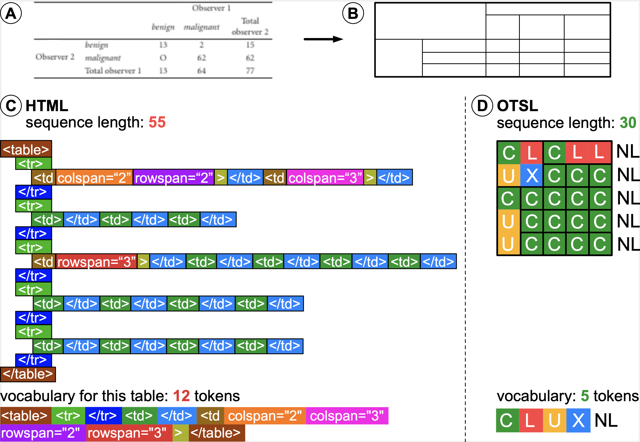
Example in pure table structure representation, omitting content of cells, when comparing HTML to DocLang (OTSL tags). HTML sequence is both longer and uses more tokens than DocLang/OTSL
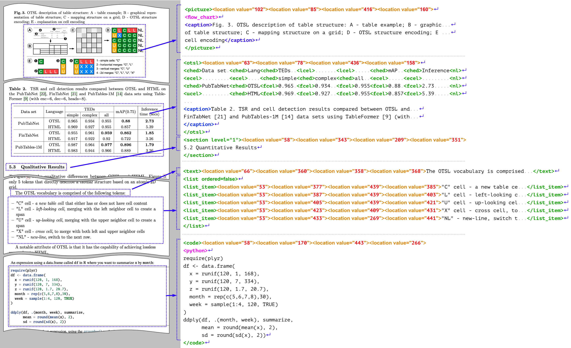
Examples of real-world document fragments and their DocLang representation
A specific class of related formats is the one operating on the OCR level, including PageXML, ALTO XML, and hOCR.
Beyond certain low-level similarities (e.g. presence of bounding box information), the DocLang format is significantly differentiated as it is designed to be AI-native:
- The above-mentioned formats focus on OCR processing, e.g. for archives, browser display, or other types of OCR/HTR pipelines, while DocLang is designed for LLM/VLM generation, with token efficiency in mind.
- Whereas these formats are primarily concerned with the geometric locations of the various spans of text, DocLang also places a strong focus on the semantic meaning and internal structure of the involved complex components, providing various native elements for headings, formulas, code, etc. and also rich table structure support (incl. table headings, spanned cells, etc.), this way capturing richer context for generative AI applications to leverage.

Terminology
Abstract concepts:
- document component: A cohesive and meaningful part of the document, e.g. a table, list item with a marker, a bold piece of text, etc.
Adopted from XML:
- element: An XML element.
- attribute: An XML attribute.
- tag: An XML tag: can be a start-tag, an end-tag, or an empty-element tag (a.k.a. self-closing tag).
Adopted from HTML:
- block-level element: An element that is meant to be interpreted or displayed as a block, i.e. starting on a new line, occupying the full width of its container, and typically with increased margin to any other neighboring block-level elements; a typical HTML example is the p element (paragraph).
- inline element: An element that can be used *within* a block element to shape its in-line structure; a typical HTML example is the span element.
Note that, whether block-level or inline, an element may contain *explicit* new lines.

Property Semantics
In XML, the attribute syntax allows explicitly separating an element's properties from its content. Let's consider the following example: <elem size="250" color="#ffeedd">foo</elem>. This denotes an elem element, including its properties (size and color) and its content (foo).
For an element with multiple possible property values, the attribute syntax can lead to an increased complexity of the respective possible tokenized representations. For instance, the following could all be valid variants of an elem start tag: <elem size="300" color="#aabbcc">, <elem size="42">, <elem color="#112233">, <elem>.
Aiming at LLM-friendliness, in such cases, the DocLang format often favors an alternative representation of property semantics, namely captured as respective elements leading the content. The example above could be represented as <elem><size>250</size><color>#ffeedd</color>foo</elem>. Depending on the specific properties, empty elements are used too.
This representation can reduce the number of tokens and streamline how XML is mapped to them, making it easier for language models to learn and predict.
For elements with a strictly limited set of possible property values, attributes are still used.

Content Encoding and Whitespace Handling
As DocLang is XML, standard XML encoding rules apply — for example:
- any provided XML prolog defines the encoding, otherwise UTF-8 is assumed
- special characters reserved by XML, such as <, can be represented either by escaping with the respective XML entities (e.g. < becomes &lt;) or by using CDATA section syntax (e.g. raw text <foo> can be represented as <![CDATA[<foo>]]>.)
DocLang generally allows applications to decide how to handle XML whitespace (i.e implicit xml:space="default" behavior). To address cases where preservation is required, DocLang provides a dedicated element for whitespace preservation (i.e. xml:space="preserve" behavior).

Head and Body Areas
Core document components such as paragraphs, tables, images etc., can have various properties associated with them. To separate between the component's properties and its actual content, respective DocLang elements follow a two-part scheme.
The element's XML content begins with an optional *component head*, which is a sequence of dedicated elements that establish the element's properties. The component's effective content, e.g. paragraph text, is then captured by the remaining of the XML content, an area which is called the *component body*.
The overall DocLang document follows a similar structure: Any global document properties are captured in the optional *global head* and the remaining content is called the *global body*. Unlike the component head, the global head is encapsulated in a dedicated <head> element — the body is still unwrapped.
While the details are specified in the sections further below, this snippet shows an example of this scheme:
<doclang>
<!-- document head: -->
<head>
<date>2020-01-01</date>
<topic>General</topic>
</head>
<!-- document body: -->
<text>
<!-- component body: -->
Headless paragraph
</text>
<text>
<!-- component head: -->
<meta><summary>A salutation.</summary></meta>
<location value="60"/><location value="260"/>
<location value="440"/><location value="270"/>
<!-- component body: -->
<italic>Hello</italic>
<content> world!</content>
</text>
</doclang>

DocLang Structure
DocLang is a constrained subset of XML with the following characteristics:
- Simplified syntax with a finite set of allowed tags
- Constrained use of attributes on most elements
- Character-based encoding using legal Unicode characters (except Null)
- Standard XML parsing rules apply for markup vs content distinction
The individual DocLang elements are specified in the reference.

Metadata Elements
Metadata elements are meant to capture information that is not directly part of the document *content*, but rather:
- deriveable from the document
- either directly, e.g. a summary of a certain component
- or in combination with other context, e.g. from external knowledge sources
- or reflects properties of the upstream pipeline, e.g. the VLM that generated the document.
As applications can have varying requirements, this standard defines a set of reserved metadata elements for common use cases, but also allows for custom metadata elements to be added. To avoid collisions, custom metadata SHOULD always be properly namespaced, as illustrated in the examples further below.
Document-level metadata is contained in the <head> element, while component-level metadata is contained in an <meta> element within the respective component element. We discuss the details in the subsections below.

The `head` Element
After the optional version element, the doclang element can continue with an optional <head> element. Below we list the reserved core metadata elements to be used within <head>:
- title
- each author element can optionally begin with one or more affiliation elements
- date
- default_resolution, containing attributes for the document-level default width and heigth resolution in pixels; if element is missing, 512x512 is considered the default resolution.
- page_size, the actual page size. An element without the page_no attribute defines the default size for all pages, when page_no is specified it is counted from 1.
- language, Identifies the (human) language of the document, e.g., English, German, French, Spanish, Japanese. The content MUST be an ISO 639-3 language identifier. Optional attributes: classifier (the tool/method used, e.g., fastText) and score (confidence in [0, 1]). Multiple language entries MAY be provided.
- generated_by, upstream pipeline information, e.g. VLM ID
- topic, topic that the document is most likely to fall in such as Science and Technology, Legal, etc. The topics should preferrably come from some taxonomy. Classifier defines the classifier used for classifying into the given topic and score is the confidence score of classifier and 0<=Scores<=1. This can be one or more.
- summary, a summary of the document
- document_hash, Hash of the document, whereas hash_function defines the algorithm used to compute the hash, e.g., SHA2. This can be one or more.
Here is an example:
<doclang>
<head>
<!-- reserved elements -->
<title>My Company's Annual Report</title>
<author_info>
<author>Author 1 Name</author>
<author>
<affiliation>Affiliation A</affiliation>
<affiliation>Affiliation B</affiliation>
Author 2 Name
</author>
</author_info>
<date>2024-01-01</date>
<language classifier="fastText" score="0.7">eng</language>
<language classifier="fastText" score="0.2">spa</language>
<topic topic_taxonomy="taxonomy" score="0.5">Technology</topic>
<topic topic_taxonomy="taxonomy" score="0.5">Math</topic>
<document_hash hash_function="sha256sum"/>75f2db0c6124527bf6dd48440f95fc864a5108d28517633f937923a7d8199185</document_hash>
<summary>This is a summary of the document</summary>
<generated_by>example_vlm_org/example_vlm_name</generated_by>
<default_resolution width="512" height="512"/>
<page_size width="612" height="792"/>
<page_size page_no="4" width="792" height="612"/>
<!-- examples of custom elements -->
<my_company_hap_filter_hate/>0.1</my_company_hap_filter_hate>
<my_company_hap_filter_abuse/>0.1</my_company_hap_filter_abuse>
<my_company_hap_filter_profanity/>0.1</my_company_hap_filter_profanity>
</head>
<!-- document content -->
</doclang>

Governance metadata
In addition to the core metadata elements, publishers can optionally provide metadata pertaining to document governance. These elements allow the communication of acceptable use, policy, licensing, contact information and compliance requirements.
- licenses Indicate one or more licenses covering use of the documents.
- data_classification One or more data classifications can be given for the document content. In general, data classification is not globally standardized. Organizations usually define a classification system suitable for their respective mission. These elements allow an organization to classify document sensitivity in their own terms.
- acceptable_use Organizations may express acceptable use cases for the provided document data.
- stewardship Provides the name of a person and/or organization with governance responsibility at the document owning organzation.
- access_policy Provides the ability to express access policy as well as enumerate roles allowed to access the data. Similar to data classification, there are no standards specifying role semantics. This element allows organizations to describe access policy and roles in their own terms.
- retention_policy Allows organizations to state retention objectives for the document data.
- compliance_requirements States the compliance frameworks - regulatory or industrial - governing the lifecycle and use of the documents.
Example use of these elements is shown below:
<doclang>
<head>
<!-- reserved elements -->
<title>My Company's Annual Report</title>
<author_info>
<author>Author 1 Name</author>
</author_info>
<date>2024-01-01</date>
<language classifier="fastText" score="0.7">eng</language>
<language classifier="fastText" score="0.2">spa</language>
<topic topic_taxonomy="taxonomy" score="0.5">Technology</topic>
<document_hash hash_function="sha256sum"/>75f2db0c6124527bf6dd48440f95fc864a5108d28517633f937923a7d8199185</document_hash>
<summary>This is a summary of the document</summary>
<generated_by>example_vlm_org/example_vlm_name</generated_by>
<licenses>
<license>https://www.apache.org/licenses/LICENSE-2.0</license>
</licenses>
<data_classification>
<data_class>confidential</data_class>
<data_class>personal information</data_class>
</data_classificiation>
<acceptable_use>
<purpose>General-purpose language models</purpose>
<purpose>Sales and marketing</purpose>
</acceptable_use>
<stewardship>
<steward>
<name>Charles Owens</name>
<contact>abc@some.org</contact>
<org>Dataset Organzation</org>
</steward>
<stewardship>
<access_policy>
<policy>
<ref>http://www.some.org/policies/AC-2345</ref>
<roles>
<role>viewer</role>
<role>reader</role>
</roles>
</policy>
</acess_policy>
<retention_policy>
<policy>
<ref>http://www.some.org/policies/AC-2345</ref>
<retention_period unit="year">5</retention_period>
<deletion_method>permamenent secure deletion</<deletion_method>>
<documentation>record deletion event, date, method and personnel responsible</documentation>
</policy>
</retention_policy>
<compliance_requirements>
<compliance_req>GDPR</compliance_req>
<compliance_req>HIPAA</compliance_req>
<compliance_req>FedRAMP</compliance_req>
<compliance_req>PCI DSS</compliance_req>
<compliance_req>EU AI Act</compliance_req>
</compliance_requirements>
</head>
<!-- document content -->
</doclang>

The `meta` Element
The meta element is used to contain metadata about a specific component of the document.
Below we list the reserved metadata elements to be used within <meta>:
- summary
- class
- language
Here is an example usage, for instance considering a picture:
<doclang>
<picture>
<meta>
<summary>This image shows the distribution of the various data points in the dataset</summary>
<class>pie_chart</class>
</meta>
<location value="50"/><location value="60"/><location value="450"/><location value="360"/>
<base64>iVBORw0KGgoAAAANSUhEUgAA...truncated...5ErkJggg==</base64>
</picture>
</doclang>

Grammar and Structure Rules

Simple Document Structure
In the simplest document example, document elements are in a flat list,
<doclang version="1.0.0">
<heading level="1">Research Paper Title</heading>
<heading level="2">Abstract</heading>
<text>This paper presents...</text>
<heading level="2">Introduction</heading>
<text>In recent years...</text>
<heading level="3">Background</heading>
<text>Previous work has shown...</text>
</doclang>
In case of page-layout information, the coordinates are provided only at the semantic element level. Coordinates are not allowed at the group level.
<doclang version="1.0.0">
<heading level="1">
<location value="10"/><location value="20"/><location value="30"/><location value="40"/>
Research Paper Title
</heading>
<heading level="2">
<location value="10"/><location value="20"/><location value="30"/><location value="40"/>
Abstract
</heading>
<text>
<location value="10"/><location value="20"/><location value="30"/><location value="40"/>
This paper presents...
</text>
<heading level="2">Introduction</heading>
<text>In recent years...</text>
<heading level="3">Background</heading>
<text>Previous work has shown...</text>
</doclang>

Code snippets
Code content can appear inline via inline class="code" or as block code via code. To classify the programming language of a block, include a <class>...</class> child inside code. When using groups, place coordinates only on semantic elements (e.g., caption, code), not on the group itself.
Basic inline code
<text>
Install with <inline class="code">pip install docling</inline> and run.
For environment checks, use <inline class="code">python --version</inline>.
Inline code preserves spacing and punctuation.
<br/>
Example path: <inline class="code">/usr/local/bin</inline>
<br/>
Variables like <inline class="code">API_KEY</inline> should not be committed.
<br/>
Use <inline class="code">Ctrl+C</inline> to stop the server.
<br/>
Command substitution: <inline class="code">$(echo hello)</inline>
<br/>
JSON snippet: <inline class="code">{"ok":true}</inline>
<br/>
Escaping: <inline class="code">&lt;tag&gt;value&lt;/tag&gt;</inline>
<br/>
Code fragments can mix with <bold>formatting</bold> seamlessly.
<br/>
Use backticks sparingly; DocLang uses explicit tokens instead.
<br/>
End of examples.
</text>
Basic block without language
<code>
echo "Hello, world!"
echo "Logs go to stdout by default"
</code>
Block with language classification via <class>
<code>
<class>python</class>
def add(a, b):
return a + b
if __name__ == "__main__":
print(add(2, 3))
</code>
Grouped code with caption and coordinates
<group>
<caption>
<location value="10"/><location value="20"/><location value="400"/><location value="60"/>
Listing 1: Minimal HTTP server
</caption>
<code>
<location value="10"/><location value="80"/><location value="400"/><location value="300"/>
<class>javascript</class>
// Minimal Node.js server
import http from 'node:http';
const server = http.createServer((req, res) => {
res.end('OK');
});
server.listen(3000);
</code>
<footnote>Source: examples/code/server.js</footnote>
</group>
Block with alternative language classification
<code>
<class>C++</class>
#include <iostream>
int main(){ std::cout << "hi"; }
</code>
Long code blocks can be split across pages using continuation tokens; keep <class> in the first fragment.
<code>
<class>bash</class>
# Part 1
seq 1 5 | while read n; do echo $n; done
<thread id="code-42"/>
</code>
<page_break/>
<code>
# Part 2 (continued)
<thread id="code-42"/>
echo "done"
</code>

Math and Equations
All math is authored as LaTeX inside inline class="formula" (inline) or formula (block). Do not use <class> for math; language classification is not applicable here. The optional <marker> child inside formula carries the printed equation number or label (e.g., “(1)”, “Eq. 3”). If present, include it as plain text within <marker>.
Inline math examples
<text>
The famous relation <inline class="formula">E = mc^2</inline> connects mass and energy.
For small x, <inline class="formula">\sin x \approx x - x^3/3!</inline> holds.
The binomial: <inline class="formula">(a+b)^n = \sum_{k=0}^n \binom{n}{k} a^{n-k} b^k</inline>.
</text>
Basic block formula (no numbering)
<formula>
\int_{-\infty}^{\infty} e^{-x^2}\,dx = \sqrt{\pi}
</formula>
Block formula with optional marker (numbering/label)
<formula>
<marker>(1)</marker>
a^2 + b^2 = c^2
</formula>
Grouped formula with caption and coordinates
<group>
<caption>
<location value="10"/><location value="20"/><location value="400"/><location value="60"/>
Equation for the normal distribution
</caption>
<formula>
<location value="10"/><location value="80"/><location value="400"/><location value="150"/>
<marker>(2)</marker>
f(x) = \frac{1}{\sigma\sqrt{2\pi}}\,\exp\!\left(-\frac{(x-\mu)^2}{2\sigma^2}\right)
</formula>
<footnote>Parameters: mean \mu and standard deviation \sigma.</footnote>
<!-- Note: Coordinates apply to semantic elements like caption/formula, not the group. -->
</group>
Multi-line LaTeX (align) in a single formula
<formula>
<marker>Eq. 3</marker>
\begin{align}
\nabla\cdot\mathbf{E} &= \frac{\rho}{\varepsilon_0} \\
\nabla\cdot\mathbf{B} &= 0
\end{align}
</formula>
Cross-page block formula with continuation
<formula>
<marker>(4)</marker>
\begin{equation}
\mathbf{F}(t) = \int_0^t e^{A(t-\tau)}\,\mathbf{b}(\tau)\,d\tau
\end{equation}
<thread id="eq-100"/>
</formula>
<page_break/>
<formula>
<thread id="eq-100"/>
% Optional tail content if the printed equation spans pages
</formula>
Notes
- All math content is LaTeX; omit $...$ or \[...\] delimiters since the tag conveys math context.
- <marker> is optional. Include it only when the page shows an equation number/label.
- Place coordinates on formula and caption as needed; never on the surrounding group.

Tables
DocLang separates the table’s structure from its surrounding semantics:
- group: Semantic container that may include caption, multiple footnote elements, and exactly one otsl child for the structure. Do not put coordinates on the group.
- otsl: The structural table token sequence. Put the table region’s coordinates on otsl for each page fragment. Cells are created by structural tokens (e.g., <fcel/>, <ched/>) and their content follows immediately after each cell token.
Basic example
<group>
<caption>
<location value="40"/><location value="80"/><location value="540"/><location value="110"/>
Table 1: Experimental Results
</caption>
<otsl>
<location value="40"/><location value="130"/><location value="540"/><location value="320"/>
<ched/>Method<ched/>Accuracy<nl/>
<fcel/>Baseline<fcel/>0.85<nl/>
<fcel/>Proposed<fcel/>0.92<nl/>
</otsl>
<footnote>Accuracy reported on validation set.</footnote>
</group>
Peculiarities and continuation
- Broken over rows (vertical split across pages)
Use <continue_row id="..."/> at the end of the first fragment and the start of the next fragment’s otsl.
<group>
<caption>Table 2: Long Results</caption>
<otsl>
<location value="40"/><location value="120"/><location value="540"/><location value="760"/>
<ched/>ID<ched/>Name<ched/>Score<nl/>
<fcel/>1<fcel/>Alice<fcel/>91<nl/>
<fcel/>2<fcel/>Bob<fcel/>88<nl/>
<continue_row id="T-rows"/>
</otsl>
</group>
<page_break/>
<group>
<otsl>
<location value="40"/><location value="80"/><location value="540"/><location value="300"/>
<continue_row id="T-rows"/>
<fcel/>3<fcel/>Cara<fcel/>95<nl/>
<fcel/>4<fcel/>Dan<fcel/>89<nl/>
</otsl>
</group>
- Broken over columns (horizontal split across facing pages)
Use <continue_col id="..."/> to indicate that columns continue on an adjacent page. Place it at the right edge of the left fragment and the left edge of the right fragment.
<!-- Left page -->
<group>
<otsl>
<location value="40"/><location value="120"/><location value="300"/><location value="760"/>
<ched/>Metric<ched/>Model A<nl/>
<fcel/>Accuracy<fcel/>0.92<nl/>
<fcel/>F1<fcel/>0.90<nl/>
<continue_col id="T-cols"/>
</otsl>
</group>
<!-- Right page -->
<group>
<otsl>
<location value="320"/><location value="120"/><location value="820"/><location value="760"/>
<continue_col id="T-cols"/>
<ched/>Model B<nl/>
<fcel/>0.93<nl/>
<fcel/>0.91<nl/>
</otsl>
</group>
- Rich cells (cells can contain arbitrary document content)
Immediately after a cell-creating token (e.g., <fcel/>, <ched/>), place the cell’s content, which may include text, list, even nested group elements like another table or picture.
<group>
<caption>Table 3: Rich Cells</caption>
<otsl>
<location value="40"/><location value="200"/><location value="560"/><location value="620"/>
<ched/>Description<ched/>Details<nl/>
<fcel/>
<text>Pipeline steps</text>
<fcel/>
<list class="unordered">
<list_text><marker>•</marker>Ingest</list_text>
<list_text><marker>•</marker>Process</list_text>
<list_text><marker>•</marker>Export</list_text>
</list>
<nl/>
<fcel/>
<text>Nested table</text>
<fcel/>
<group>
<caption>Inner table</caption>
<otsl>
<ched/>Key<ched/>Value<nl/>
<fcel/>A<fcel/>1<nl/>
<fcel/>B<fcel/>2<nl/>
</otsl>
</group>
<nl/>
<fcel/>
<text>Image</text>
<fcel/>
<picture>
<uri>assets/img/sample.png</uri>
<caption>Example image inside a cell</caption>
</picture>
<nl/>
</otsl>
</group>
Notes
- Coordinates go on otsl, caption, and other semantic children; never on the group.
- Row- and column-wise splits use continue_row and continue_col respectively; merge fragments by matching ids.
- OTSL follows the rectangular rule; ensure each row has the same number of structural tokens up to <nl/>.
- Rich cells can include any valid DocLang content; keep content immediately after the corresponding cell token.

Lists
Lists can in principle contain any children, with every new list item being introduced by a list_text element, which also contains any marker and checkbox information.
Unordered list with optional markers
<list class="unordered">
<list_text>
<marker>•</marker>
First item with <bold>bold</bold> text
</list_text>
<list_text>
<!-- Marker with its own coordinates -->
<marker>
<location value="50"/><location value="110"/><location value="60"/><location value="120"/>
•
</marker>
Second item
</list_text>
</list>
Ordered list; markers are optional and can hold the printed numbering
<list class="ordered">
<list_text>
<marker>1.</marker>
Install dependencies
</list_text>
<list_text>
<marker>2.</marker>
Run tests
</list_text>
<list_text>
<!-- No marker provided; numbering can be inferred from order -->
Ship release
</list_text>
</list>
Checkbox items with selection state; markers optional
<list class="unordered">
<list_text>
<checkbox class="selected"/>
Completed task
</list_text>
<list_text>
<checkbox class="unselected"/>
Pending task
</list_text>
</list>
Nested lists (mixing ordered and unordered)
<list class="ordered">
<list_text>
<marker>1.</marker>
Setup project
</list_text>
<list class="unordered">
<list_text>
<marker>•</marker>
Create virtual environment
</list_text>
<list_text>
<marker>•</marker>
Configure linter
</list_text>
</list>
<list_text>
<marker>2.</marker>
Implement features
</list_text>
</list>
Page breaks and continuation
Lists can span multiple pages. Use <thread id="..."/> to indicate continuation. You may thread the whole list and, if a particular component, e.g. a text is broken, also thread the component itself.
List split across pages
<list class="ordered">
<thread id="L1"/>
<list_text><marker>1.</marker>First item</list_text>
<list_text><marker>2.</marker>Second item</list_text>
</list>
<page_break/>
<list class="ordered">
<thread id="L1"/>
<list_text><marker>3.</marker>Third item</list_text>
</list>
Single list-item broken by a page break
<list class="unordered">
<thread id="L2"/>
<list_text>
<thread id="I7"/>
<marker>•</marker>
This item starts on page 1 and continues
</list_text>
</list>
<page_break/>
<list class="unordered">
<thread id="L2"/>
<list_text>
<thread id="I7"/>
on page 2 until it ends.
</list_text>
</list>
Notes
- <marker> is optional. Include it when the printed glyph/number is visible.
- <marker> can include its own location coordinates to pinpoint bullet/number placement.
- Lists can nest as shown above.
- When broken across pages, close items before the page_break, then re-open and continue with matching thread ids after the break.

Fields
Fields provide a flexible structure for representing key-value data and structured content. The field elements allow for more flexible document structures where keys and values may be separated by other content or organized in complex layouts.
Token | Description
<field_region> | Field region container; contains at least one field_item as descendant
<field_item> | Field item container; may contain 0-1 key and 0-many value elements as descendants
<field_heading> | Field heading within a field region; has an optional attribute level
<key> | Key of the field item: can be a descendant of field_item
<value> | Value of the field item: can be a descendant of field_item; optional class attribute with values read_only (default) or fillable
<hint> | Hint for a fillable value field; recommended to be used within the context of a field_item; can describe a format, example, or additional description

Field Structure Rules
- A field_region must contain at least one field_item as a descendant (not necessarily a direct child)
- A field_item may contain 0 or 1 key element as a descendant
- A field_item may contain 0 or more value elements as descendants
- Values within a field_item are implicitly associated with the key in that item
- A field_heading should have a field_region as an ancestor
- Field elements can contain any other DocLang elements (text, pictures, lists, etc.)
- The value element has an optional class attribute:
- class="read_only" (default): Indicates a pre-filled, non-editable value
- class="fillable": Indicates an empty or editable field that can be filled in
- The hint element is recommended to be used within a field_item context to provide guidance for fillable values
- <key> or <value> are not necessarily just textual and can contain pictures, multiline text, etc.

Field region examples

Simple key-values
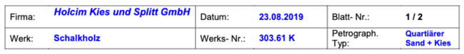
<field_region>
<field_item>
<key>Firma:</key>
<value>Holcim ... GmbH</value>
</field_item>
<field_item>
<key>Datum:</key>
<value>23.08.2019</value>
</field_item>
...
<field_item>
<key>Petrograph. Typ:</key>
<value>Quartiarer Sand + Kies</value>
</field_item>
</field_region>

Nesting forms and using form headings
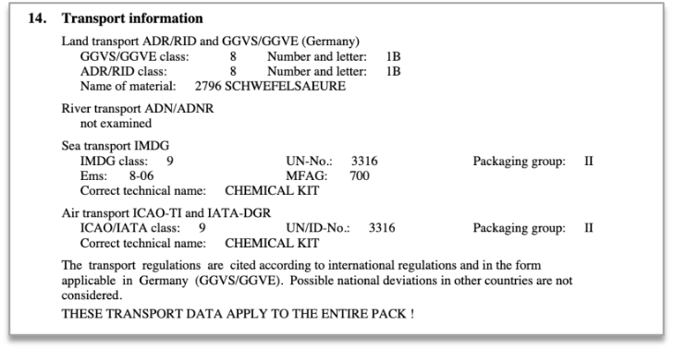
<field_region>
<field_heading>
<marker>14.</marker>
Transport Information
</field_heading>
<field_region>
<field_heading>
Land transport ... (Germany)
</field_heading>
<field_item>
<key>GGVS/GGVE class:</key>
<value>8</value>
</field_item>
<field_item>
<key>ADR/RID class:</key>
<value>8</value>
</field_item>
...
</field_region>
<field_item>
<key>River transport ADN/ADNR</key>
<value>not examined</value>
</field_item>
<field_region>
<field_heading>
Sea transport IMDG
</field_heading>
...
</field_region>
...
<text>
The transport ... considered.
</text>
<text>
THESE TRANSPORT ... PACK!
</text>
</field_region>

Fillable form
<table><tr><td>
<field_region>
<field_item>
<key>Description</key>
<value>A.A. Cat</value>
</field_item>
<field_item>
<key>Quant.</key>
<value></value>
</field_item>
<field_item>
<key>Un</key>
<value></value>
</field_item>
<field_item>
<key>Measure</key>
<value></value>
</field_item>
<field_item>
<key>Price (in currency)</key>
<value></value>
</field_item>
<field_item>
<key>Un</key>
<value></value>
</field_item>
<field_item>
<key>Total</key>
<value></value>
</field_item>
<text></text>
<field_region>
<field_item>
<key>Delivery Cost</key>
<value></value>
</field_item>
<field_item>
<key>Maintenance</key>
<value></value>
</field_item>
...
<field_region>
<field_region>
<field_item>
<key>Date and time of delivery:</key>
<value></value>
</field_item>
...
<field_item>
<key>Guarantee</key>
<value></value>
</field_item>
<text>
Delivery Suppl...Finance Department
</text>
</field_region>
...
</field_region>
</td><td style="vertical-align: top;">
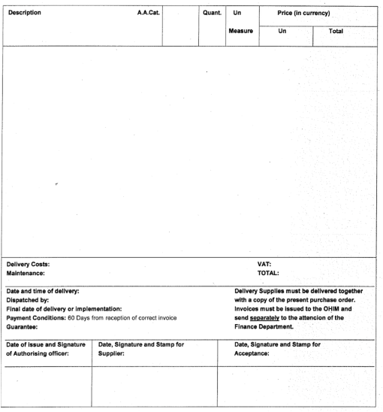
</td></tr></table>

Use of form headings
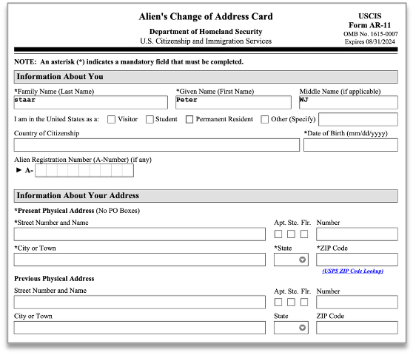
<field_region>
<field_heading>Information about you</field_heading>
<field_item>
<key>
\*Family Name (Last Name)
</key>
<value>staar</value>
</field_item>
<field_item>
<key>\*Given Name (First Name)</key>
<value>peter</value>
</field_item>
<field_item>
<key>\*Middle Name (if applicable)</key>
<value>WJ</value>
</field_item>
<field_item>
<key>I am in the United States as a:</key>
<text><checkbox class="unselected"/>Visitor</text>
<text><checkbox class="unselected"/>Student</text>
<text><checkbox class="unselected"/>Permanent Resident</text>
<text><checkbox class="unselected"/>Other (Specify)</text>
<value></value>
<field_item>
<field_item>
<key>Country of Citizenship</key>
<value></value>
</field_item>
<field_item>
<key>\*Date of Birth</key>
<value></value>
</field_item>
<field_item>
<key>Alien Registration Number (A-Number) (if any)</key>
<value>A-</value>
</field_item>
<field_heading>Information About Your Address</field_heading>
<text>\*Present Physical Address ()No Po Boxes</text>
<field_item>
<key>\*Street ... Name</key>
<value></value>
</field_item>
<field_item>
<key>Apt.</key>
<checkbox class="unselected"/>
</field_item>
<field_item>
<key>Ste.</key>
<checkbox class="unselected"/>
</field_item>
...
</field_region>

High density form
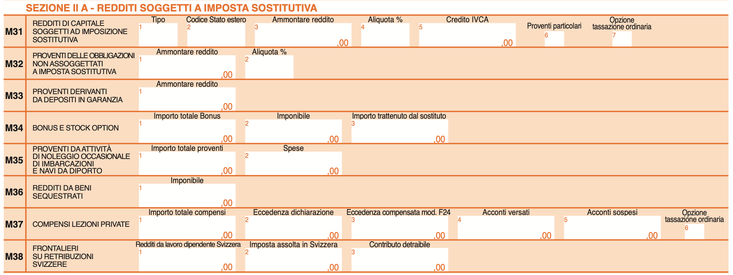
<field_region>
<form_heading level="1">M31</field_heading>
<form_heading level="2">REDDITI DI CAPITALE SOGGETTI AD IMPOSIZIONE SOSTITUTIVA</field_heading>
<field_item>
<marker>1</marker>
<key>Tipo</key>
<value></value>
</field_item>
<field_item>
<marker>2</marker>
<key>Codice Stato estero</key>
<value></value>
</field_item>
<field_item>
<marker>3</marker>
<key>Ammontare reddito</key>
<value>,00</value>
</field_item>
<field_item>
<marker>4</marker>
<key>Aliquota %</key>
<value></value>
</field_item>
<field_item>
<marker>5</marker>
<key>Credito IVCA</key>
<value>,00</value>
</field_item>
<field_item>
<marker>6</marker>
<key>Proventi particolari</key>
<value></value>
</field_item>
<field_item>
<marker>7</marker>
<key>Opzione tassazione ordinaria</key>
<value></value>
</field_item>
<form_heading level="1">M32</field_heading>
<form_heading level="2">PROVENTI DELLE OBBLIGAZIONI NON ASSOGGETTATI A IMPOSTA SOSTITUTIVA</field_heading>
<field_item>
<marker>1</marker>
<key>Ammontare reddito</key>
<value>,00</value>
</field_item>
<field_item>
<marker>2</marker>
<key>Aliquota %</key>
<value></value>
</field_item>
<form_heading level="1">M33</field_heading>
<form_heading level="2">PROVENTI DERIVANTI DA DEPOSITI IN GARANZIA</field_heading>
<field_item>
<marker>1</marker>
<key>Ammontare reddito</key>
<value>,00</value>
</field_item>
...
</field_region>

Classical duality between tables and explicit key-values
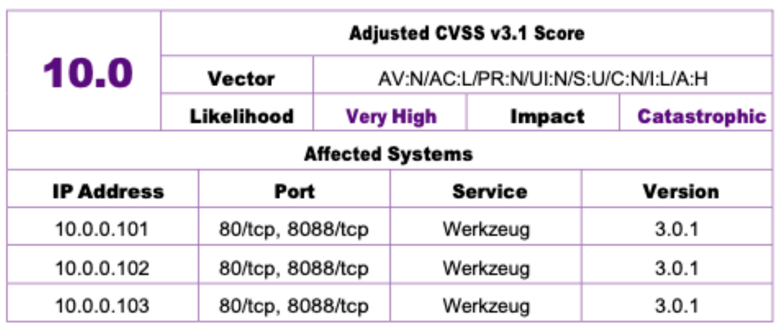
<field_region>
<field_item>
<key>Adjusted CVSS v3.1 Score</key>
<value>10.0</value>
</field_item>
<field_item>
<key>Vector</key>
<value>AV:N/AC:L/PR:N/UI:N/S:U/C:N/I:L/A:H</value>
</field_item>
<field_item>
<key>Likelihood</key>
<value>Very High</value>
</field_item>
<field_item>
<key>Impact</key>
<value>Catastrophic</value>
</field_item>
<field_heading>
Affected Systems
</field_heading>
<otsl>
<ched/>IP Address<ched/>Port<ched/>Service<ched/>Version<nl/>
<fcell/>10.0.0.101<fcell/>80/tcp, 8088/tcp<fcell/>Werkzeug<fcell/>3.0.1<nl/>
<fcell/>10.0.0.102<fcell/>80/tcp, 8088/tcp<fcell/>Werkzeug<fcell/>3.0.1<nl/>
<fcell/>10.0.0.103<fcell/>80/tcp, 8088/tcp<fcell/>Werkzeug<fcell/>3.0.1<nl/>
</otsl>
</field_region>

Values without Keys
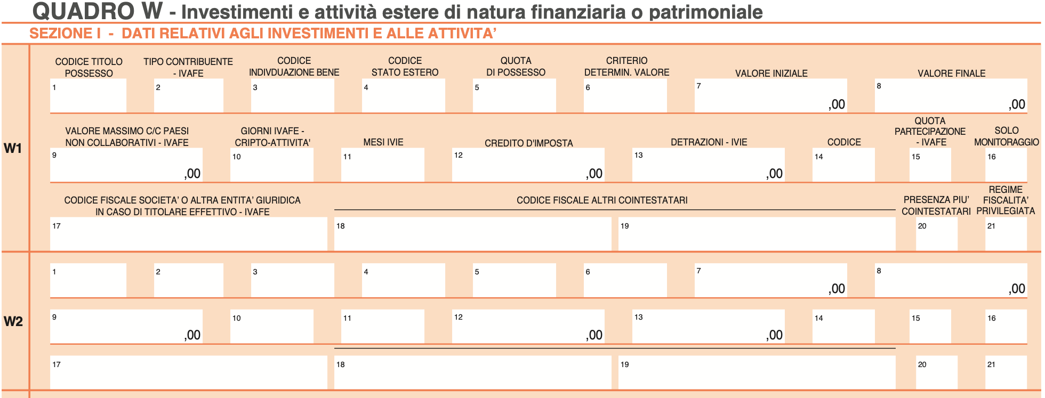
<heading level="1">QUADRO W - Investimenti e...</heading>
<heading level="2">SEZIONE I - DATI RELATIVI...</heading>
<field_region>
<form_heading level="1">W1</field_heading>
<field_item>
<marker>1</marker>
<key>CODICE TITOLO POSSESSO</key>
<value></value>
</field_item>
<field_item>
<marker>2</marker>
<key>TIPO CONTRIBUENTE - IVAFE</key>
<value></value>
</field_item>
...
<form_heading level="1">W2</field_heading>
<field_item>
<marker>1</marker>
<value></value>
</field_item>
<field_item>
<marker>2</marker>
<value></value>
</field_item>
<field_item>
<marker>3</marker>
<value></value>
</field_item>
...
</field_region>

Another complex form deconstructed into field items
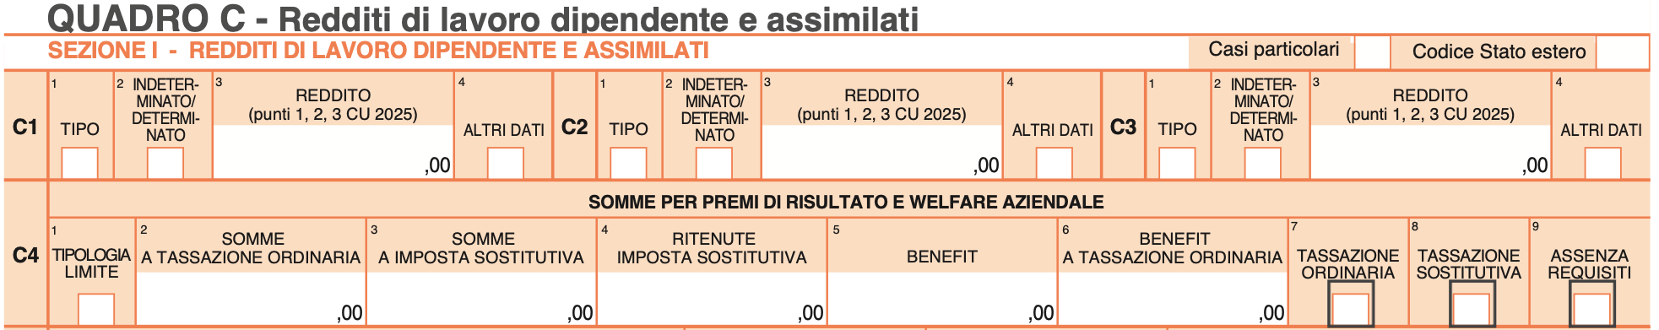
<table><tr><td>
<heading level="1">QUADRO C - Redditi di lavoro...</heading>
<field_region>
<form_heading level="1">SEZIONE I - RE...</field_heading>
<field_item>
<key>Casi particolari</key>
<checkbox class="unselected"/>
</field_item>
<field_item>
<key>Codice Stato estero</key>
<value></value>
</field_item>
<form_heading level="2">C1</field_heading>
<field_item>
<marker>1</marker>
<key>TIPO</key>
<value></value>
</field_item>
<field_item>
<marker>2</marker>
<key>INDETERMINATO/DETERMINATO</key>
<checkbox class="unselected"/>
</field_item>
<field_item>
<marker>3</marker>
<key>REDDITO (punti 1,2,3 CU 2025)</key>
<value>,00</value>
</field_item>
<field_item>
<marker>4</marker>
<key>ALTRI DATI</key>
<checkbox class="unselected"/>
</field_item>
<form_heading level="2">C2</field_heading>
<field_item>
<marker>1</marker>
<key>TIPO</key>
<value></value>
</field_item>
<field_item>
<marker>2</marker>
<key>INDETERMINATO/DETERMINATO</key>
<checkbox class="unselected"/>
</field_item>
<field_item>
<marker>3</marker>
<key>REDDITO (punti 1,2,3 CU 2025)</key>
<value>,00</value>
</field_item>
...
</td><td style="vertical-align: top;">
...
<field_item>
<marker>4</marker>
<key>ALTRI DATI</key>
<checkbox class="unselected"/>
</field_item>
<form_heading level="2">C3</field_heading>
<field_item>
<marker>1</marker>
<key>TIPO</key>
<value></value>
</field_item>
<field_item>
<marker>2</marker>
<key>INDETERMINATO/DETERMINATO</key>
<checkbox class="unselected"/>
</field_item>
<field_item>
<marker>3</marker>
<key>REDDITO (punti 1,2,3 CU 2025)</key>
<value>,00</value>
</field_item>
<field_item>
<marker>4</marker>
<key>ALTRI DATI</key>
<checkbox class="unselected"/>
</field_item>
<form_heading level="2">C4</field_heading>
<form_heading level="3">SOMME PER PREMI...
</field_heading>
<field_item>
<marker>1</marker>
<key>TIPOLOGIA LIMITE</key>
<checkbox class="unselected"/>
</field_item>
<field_item>
<marker>2</marker>
<key>SOMME A TASSAZIONE ORDINARIA</key>
<value>,00</value>
</field_item>
<field_item>
<marker>3</marker>
<key>SOMME A IMPOSTA SOSTITUTIVA</key>
<value>,00</value>
</field_item>
...
</field_region>
</td></tr></table>

Middle section of a form with A and B choices
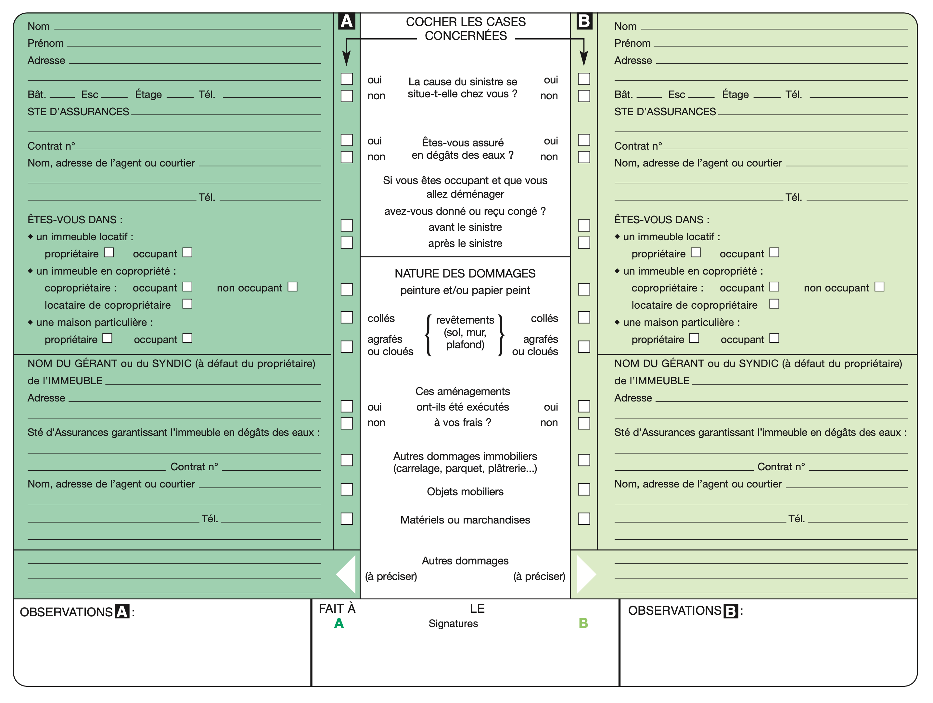
<field_region>
<field_heading>COCHER LES CASES CONCERNEES</field_heading>
<field_item>
<key>La cause du sinistre se situe-t-elle chez vous ?</key>
<text><checkbox class="unselected"/><marker>A</marker>oui</text>
<text><checkbox class="unselected"/><marker>A</marker>non</text>
<text><checkbox class="unselected"/><marker>B</marker>oui</text>
<text><checkbox class="unselected"/><marker>B</marker>non</text>
</field_item>
<field_item>
<key>Êtes-vous assuré en dégâts des eaux ?</key>
<text><checkbox class="unselected"/><marker>A</marker>oui</text>
<text><checkbox class="unselected"/><marker>A</marker>non</text>
<text><checkbox class="unselected"/><marker>B</marker>oui</text>
<text><checkbox class="unselected"/><marker>B</marker>non</text>
</field_item>
<field_item>
<key>Si vous êtes occupant et que vous allez déménager avez-vous donné ou reçu congé ?</key>
<text><checkbox class="unselected"/><marker>A</marker>avant le sinistre</text>
<text><checkbox class="unselected"/><marker>A</marker>après le sinistre</text>
<text><checkbox class="unselected"/><marker>B</marker>avant le sinistre</text>
<text><checkbox class="unselected"/><marker>B</marker>après le sinistre</text>
</field_item>
<field_heading>NATURE DES DOMMAGES peinture et/ou papier peint</field_heading>
<field_item>
<key>revêtements (sol, mur, plafond)</key>
<text><checkbox class="unselected"/><marker>A</marker>collés</text>
<text><checkbox class="unselected"/><marker>A</marker>agrafés ou cloués</text>
<text><checkbox class="unselected"/><marker>B</marker>collés</text>
<text><checkbox class="unselected"/><marker>B</marker>agrafés ou cloués</text>
</field_item>
<field_item>
<key>Ces aménagements ont-ils été exécutés à vos frais ?</key>
<text><checkbox class="unselected"/><marker>A</marker>oui</text>
<text><checkbox class="unselected"/><marker>A</marker>non</text>
<text><checkbox class="unselected"/><marker>B</marker>oui</text>
<text><checkbox class="unselected"/><marker>B</marker>non</text>
</field_item>
<field_item>
<key>Autres dommages immobiliers (carrelage, parquet, plâtrerie...)</key>
<text><checkbox class="unselected"/><marker>A</marker></text>
<text><checkbox class="unselected"/><marker>B</marker></text>
</field_item>
<field_item>
<key>Objets mobiliers</key>
<text><checkbox class="unselected"/><marker>A</marker></text>
<text><checkbox class="unselected"/><marker>B</marker></text>
</field_item>
<field_item>
<key>Matériels ou marchandises</key>
<text><checkbox class="unselected"/><marker>A</marker></text>
<text><checkbox class="unselected"/><marker>B</marker></text>
</field_item>
<field_item>
<key>Autres dommages</key>
<value><marker>A</marker><hint>(à préciser)</hint></value>
<value><marker>B</marker><hint>(à préciser)</hint></value>
</field_item>
</field_region>

Tabular form with strong 2D value relationship
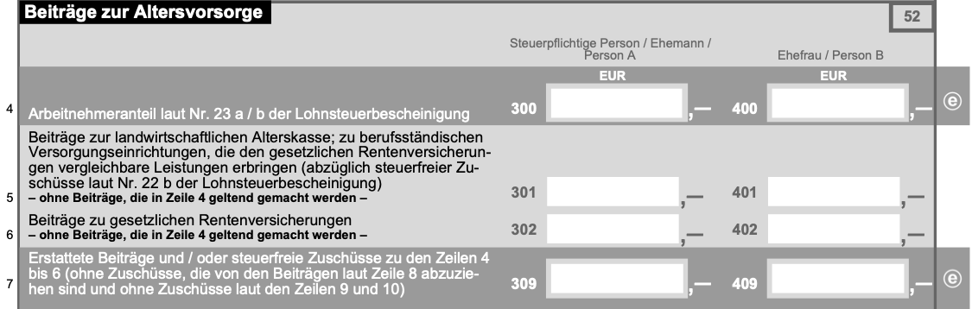
<otsl>
<srow>Beiträge zur Altersvorsorge<srow>52</lcel></srow><nl>
<fcel/><ched/>Steuerpflichtige Person / Ehemann / Person A<ched/>Ehefrau / Person B<fcel/> <nl>
<fcel/>Arbeitnehmeranteil laut Nr. 23 a / b der Lohnsteuerbescheinigung<fcel/>*FORM1*,-<fcel/>*FORM2*,-<fcel/>@<nl>
<fcel/>Beiträge zur landwirtschaftlichen Alterskasse; zu berufsständ...<fcel/>*FORM3*,-<fcel/>*FORM4*,-<fcel/> <nl>
<fcel/>Beiträge zu gesetzlichen Rentenversicherungen...<fcel/>*FORM5*,-<fcel/>*FORM6*,-<fcel/> <nl>
<fcel/>Erstattete Beiträge und / oder steuerfreie Zuschüsse zu den...<fcel/>*FORM7*,-<fcel/>*FORM8*,-<fcel/>@<nl>
...
</otsl>
...
*FORMS referred above:
*FORM1*: <field_item><key>300</key><value></value><hint>EUR</hint></field_item>
*FORM2*: <field_item><key>400</key><value></value><hint>EUR</hint></field_item>
*FORM4*: <field_item><key>401</key><value></value></field_item>
*FORM5*: <field_item><key>302</key><value></value></field_item>
*FORM3*: <field_item><key>301</key><value></value></field_item>
*FORM6*: <field_item><key>402</key><value></value></field_item>
*FORM7*: <field_item><key>309</key><value></value></field_item>
*FORM8*: <field_item><key>409</key><value></value></field_item>

Mix table and form elements
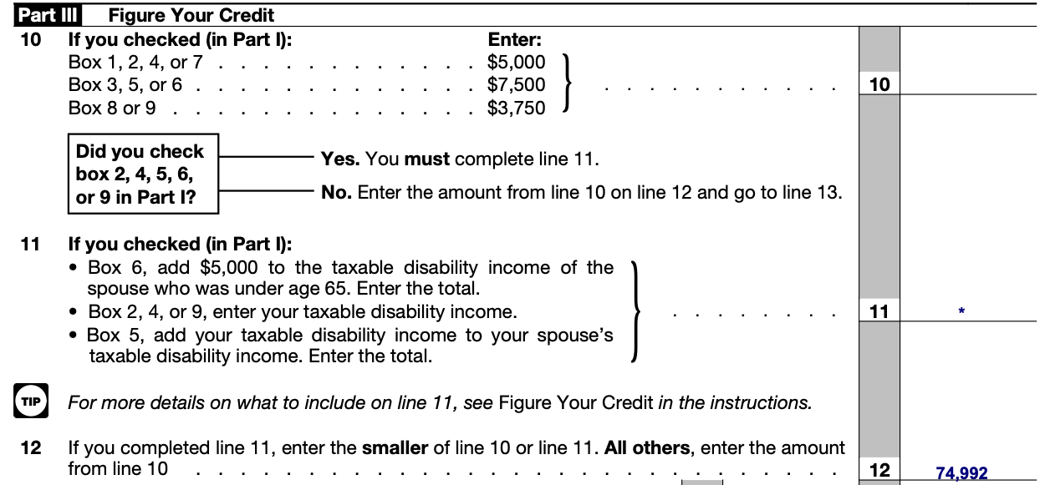
...
<heading>Part III</heading>
<text>Figure Your Credit</text>
<text>10</text>
<otsl>
<ched/>If you checked (in Part l):<ched/>Enter<nl>
<fcel/>Box 1, 2, 4, or 7<fcel/>$5,000<nl>
<fcel/>Box 3, 5, or 6<fcel/>$7,500<nl>
<fcel/>Box 8 or 9<fcel/>$3,750<nl>
</otsl>
<field_item><key>10</key><value></value></field_item>
<text>11 If you checked (in Part I):</text>
<list class="unordered">
<list_text>Box 6, add $5,000 to the taxable...</list_text>
<list_text>Box 2, 4, or 9, enter your taxable...</list_text>
<list_text>BBox 5, add your taxable disabilit...</list_text>
</list>
<field_item><key>11</key><value>.</value></field_item>
<picture><class>pictogram</class></picture>
<text>For more details on what to include on line 11...</text>
<text>12 If you completed line 11, enter the smaller...</text>
<field_item><key>12</key><value>74,992</value></field_item>
...

Key-value pair in the wild
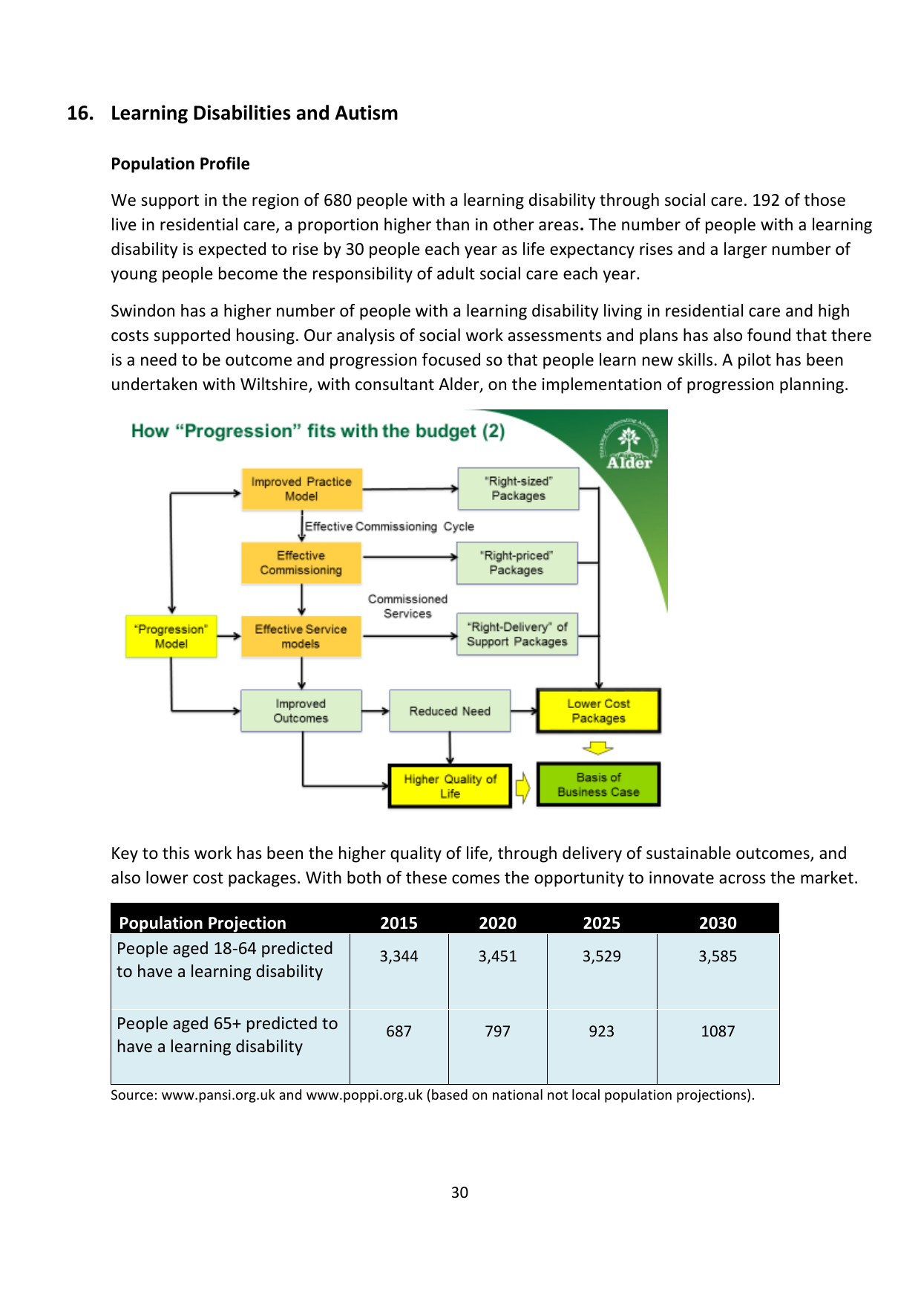
...
<field_region>
<field_item>
<key>Source</key>
<value>www.pansi.org.uk and ... projections).</value>
</field_item>
</field_region>
...
Detailed examples can be seen here: Form Examples

Fields
Fields can be used for representing key-value data in a flexible structure where keys and values may be separated by other content or organized in complex layouts.

Field Elements
Element | Description
field_region | Container for a region containing field items and related content
field_item | Container that associates keys with values; may contain 0-1 key and 0-many value elements as descendants
field_heading | Heading within a field region, with optional level N ≥ 1

Field Structure Rules
- A field_region must contain at least one field_item as a descendant (not necessarily a direct child)
- A field_item may contain 0 or 1 key element as a descendant
- A field_item may contain 0 or more value elements as descendants
- Values within a field_item are implicitly associated with the key in that item
- A field_heading should have a field_region as an ancestor
- Field elements can contain any other DocLang elements (text, pictures, lists, etc.)

Field Examples
Basic field region with simple key-value pairs:
<field_region>
<field_item>
<key>Name:</key>
<value>John Smith</value>
</field_item>
<field_item>
<key>Date of Birth:</key>
<value>1985-03-15</value>
</field_item>
<field_item>
<key>Address:</key>
<value>123 Main Street, Anytown, USA</value>
</field_item>
</field_region>
Field region with headings and complex layout:
<field_region>
<field_heading level="1">Personal Information</field_heading>
<field_item>
<text><key>Full Name:</key></text>
<text><value>Jane Doe</value></text>
</field_item>
<field_item>
<text><key>Email:</key></text>
<text><value>jane.doe@example.com</value></text>
</field_item>
<field_heading level="2">Employment Details</field_heading>
<field_item>
<text><key>Company:</key></text>
<text><value>Acme Corporation</value></text>
</field_item>
<field_item>
<text><key>Position:</key></text>
<text><value>Senior Engineer</value></text>
</field_item>
</field_region>
Field item with multiple values:
<field_region>
<field_item>
<key>Phone Numbers:</key>
<value>+1-555-0100 (Home)</value>
<value>+1-555-0101 (Work)</value>
<value>+1-555-0102 (Mobile)</value>
</field_item>
</field_region>
Field item without a key (value-only):
<field_region>
<field_heading>Additional Notes</field_heading>
<field_item>
<value>This is a standalone value without an explicit key.</value>
<value>Multiple values can be provided.</value>
</field_item>
</field_region>
Fillable fields with hints:
<field_region>
<field_heading>Application Form</field_heading>
<field_item>
<key>Full Name:</key>
<value class="fillable"></value>
<hint>Enter your first and last name</hint>
</field_item>
<field_item>
<key>Date of Birth:</key>
<value class="fillable"></value>
<hint>Format: YYYY-MM-DD</hint>
</field_item>
<field_item>
<key>Email Address:</key>
<value class="fillable"></value>
<hint>example@domain.com</hint>
</field_item>
<field_item>
<key>Status:</key>
<value class="read_only">Pending Review</value>
</field_item>
</field_region>
Field region with mixed content:
<field_region>
<location value="50"/><location value="100"/>
<location value="500"/><location value="400"/>
<field_heading level="1">Product Specifications</field_heading>
<text>The following specifications apply to Model XYZ-2000:</text>
<field_item>
<key>Dimensions:</key>
<value>10cm × 15cm × 5cm</value>
</field_item>
<field_item>
<key>Weight:</key>
<value>250g</value>
</field_item>
<picture>
<uri>assets/product-diagram.png</uri>
<caption>Product diagram showing key components</caption>
</picture>
<field_item>
<key>Materials:</key>
<list class="unordered">
<list_text><marker>•</marker><value>Aluminum alloy frame</value></list_text>
<list_text><marker>•</marker><value>Tempered glass display</value></list_text>
<list_text><marker>•</marker><value>Silicone rubber grips</value></list_text>
</list>
</field_item>
</field_region>

Split structure
We can capture content that is split (e.g. across columns or across pages) using the <thread id="N"/> token, where N is a unique identifier.
The basic structure is shown below, e.g. for a text tag:
<text>
<thread id="1"/>
This text item starts here
</text>
...
<text>
<thread id="1"/>
and continues here.
</text>

Cross-column structure example
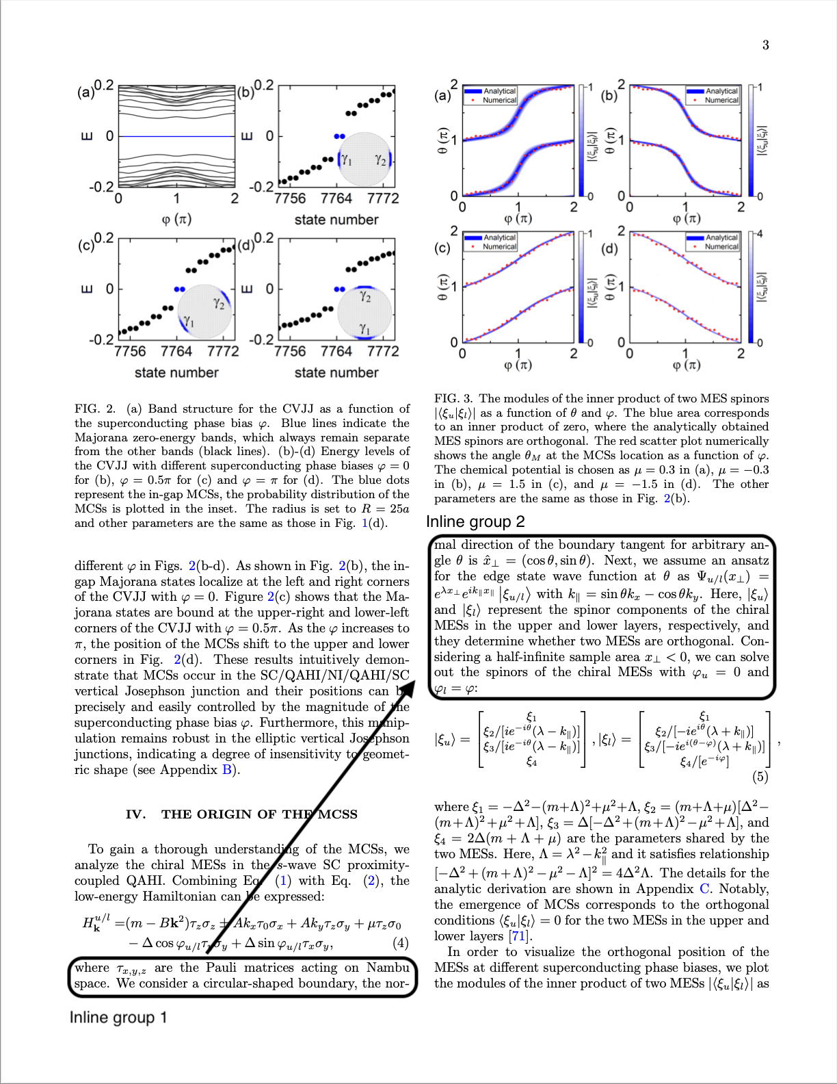
Each block that has location information is a top-level tag of the corresponding label, e.g. "text".
Top-level tags which belong to the same item should have the same thread token.
<text>
<loc_10/><loc_20/><loc_30/><loc_40/>
<thread id="1"/>
where τ<subscript>x,y,z</subscript> are the Pauli matrices acting
on Nambu space. We consider a circular-shaped boundary, the nor-
</text>
<caption>
<loc_15/><loc_25/><loc_35/><loc_45/>
FIG. 3. The modules of the inner product of two MES spinors
<formula>...<formula/>
...
</caption>
<text>
<loc_20/><loc_30/><loc_40/><loc_50/>
<thread id="1"/>
mal direction of the boundary tangent for arbitrary angle θ is
<formula>ˆx⊥ = (cos θ, sin θ)</formula>
. Next, we assume an ansatz for the edge state wave function at θ as
<formula>Ψu/l(x⊥) =eλx⊥ eik∥ x∥ ξu/l </formula>
with
<formula>k∥ = sin θkx − cos θky</formula>
Here, |ξu⟩ and |ξl⟩ represent the spinors ... of the chiral MESs with
<formula>φu = 0</formula>
and
<formula>φl = φ:</formula>
</text>

Cross-page structure example
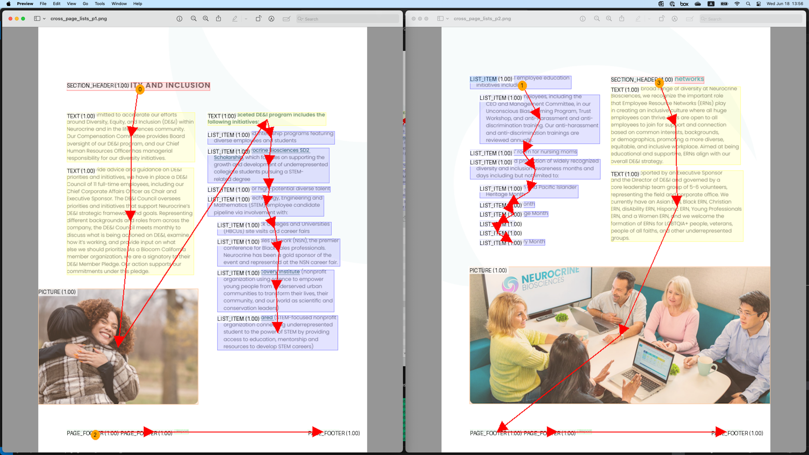
The scenario in the above figure is represented as follows:
...
<text>
<loc_10/><loc_20/><loc_30/><loc_40/>
Our multi-faceted DE&I program includes the following initiatives:
</text>
<list class="unordered">
<thread id="1"/>
<list_text>
<loc_15/><loc_25/><loc_35/><loc_45/>
Mentorships and internship programs featuring diverse employees and students
</list_text>
...
<list_text>
<loc_20/><loc_30/><loc_40/><loc_50/>
Build Science, Technology, Engineering and Mathematics (STEM) employee candidate pipeline via involvement with:
<list class="unordered">
<list_text>
<loc_25/><loc_35/><loc_45/><loc_55/>
Historically Black Colleges and Universities (HBCUs) site visits and career fairs
</list_text>
...
<list_text>
<loc_30/><loc_40/><loc_50/><loc_60/>
San Diego Squared (STEM-focused nonprofit organization connecting underrepresented student to the power
of STEM by providing access to education, mentorship and resources to develop STEM careers)
</list_text>
<list>
</list_text>
<list>
<page_footer><loc_35/><loc_45/><loc_55/><loc_65/>16 Neurocrine Biosciences</page_footer>
<page_break/>
<list class="unordered">
<thread id="1"/>
<list_text>
<loc_40/><loc_50/><loc_60/><loc_70/>
Build upon DE&I employee education initiatives including:
...
</list_text>
...
<list>
...

Split table example
The table shown on the left may be split across pages, e.g. as shown on the middle. The figure on the right visualizes the thread elements (more details further below):
<table style="min-width: 1800px"> <tr> <td> Original table: <br /> <img src="./examples/split_tables/original_table.png" height="900" width="644" /> </td> <td> Table split across pages: <br /> <img src="./examples/split_tables/split_table.png" height="900" width="644" /> </td> <td> Table threads: <br /> <img src="./examples/split_tables/table_threads.png" height="900" width="644" /> </td> </tr> </table>
The scenario in the above figure is represented below.
- We introduce a new horizontal thread token, h_thread, which is used to capture table content that spans pages sidewise,
similarly to the usual thread tokens thread.
- Only the content that is visible within the page is included in the OTSL token (e.g. see "2025 d").
- When thread linking is resolvable through ucel/lcel or h_thread, the thread token is not used, as it would be redundant.
- When thread linking must be captured, we capture it the earliest possible, i.e. we don't wait for the bottom-most cell
to be reached to add the thread for "Europe" in the example above.
...
<!-- page 1: -->
<table>
<otsl><loc_x0/><loc_y0/><loc_x1/><loc_y1/>
<thread id="1"/>
<h_thread id="1"/>
<ecel/> <ecel/> <ecel/><nl/>
<ecel/> <ched/>Continent <ched/>Country<nl/>
<rhed/><thread id="2"/> <rhed/>Asia <rhed/>Japan<nl/>
</otsl>
</table>
<page_break/>
<!-- page 2: -->
<table>
<otsl><loc_x0/><loc_y0/><loc_x1/><loc_y1/>
<thread id="1"/>
<h_thread id="2"/>
<rhed/><thread id="2"/>G7 member <rhed/><thread id="3"/>Europe <rhed/>France<nl/>
<ucel/> <ucel/> <rhed/>Germany<nl/>
<ucel/> <ucel/> <rhed/>Italy<nl/>
</otsl>
</table>
<page_break/>
<!-- page 3: -->
<table>
<otsl><loc_x0/><loc_y0/><loc_x1/><loc_y1/>
<thread id="1"/>
<h_thread id="3"/>
<rhed/><thread id="2"/> <rhed/><thread id="3"/> <rhed/>United Kingdom<nl/>
<ucel/> <rhed/>North America <rhed/>Canada<nl/>
<ucel/> <ucel/> <rhed/>United States<nl/>
</otsl>
</table>
<page_break/>
<!-- page 4: -->
<table>
<otsl><loc_x0/><loc_y0/><loc_x1/><loc_y1/>
<h_thread id="1"/>
<ched/><h_thread id="4"/>2025 d <lcel/> <lcel/><nl/>
<ched/>GDP (PPP) per capita in USD <ched/>Currency <ched/><h_thread id="5"/>Key l<nl/>
<fcel/>46,097 <fcel/>Japanese yen (JPY) <fcel/>Shigeru Ishiba<nl/>
</otsl>
</table>
<page_break/>
<!-- page 5: -->
<table>
<otsl><loc_x0/><loc_y0/><loc_x1/><loc_y1/>
<h_thread id="2"/>
<fcel/>54,465 <fcel/>Euro (EUR) <fcel/>Emmanuel Macron<nl/>
<fcel/>62,830 <fcel/>Euro (EUR) <fcel/>Friedrich Merz<nl/>
<fcel/>53,115 <fcel/>Euro (EUR) <fcel/>Giorgia Meloni<nl/>
</otsl>
</table>
<page_break/>
<!-- page 6: -->
<table>
<otsl><loc_x0/><loc_y0/><loc_x1/><loc_y1/>
<h_thread id="3"/>
<fcel/>52,518 <fcel/>Pound sterling (GBP) <fcel/>Keir Starmer<nl/>
<fcel/>62,830 <fcel/>Canadian dollar <fcel/>Mark Carney<nl/>
<fcel/>53,115 <fcel/>United States dollar (USD) <fcel/>Donald Trump<nl/>
</otsl>
</table>
<page_break/>
<!-- page 7: -->
<table>
<otsl><loc_x0/><loc_y0/><loc_x1/><loc_y1/>
<h_thread id="1"/>
<ched/><h_thread id="4"/>etails <lcel/> <lcel/><nl/>
<ched/><h_thread id="5"/>eader <ched/>Population in millions <ched/>Area in km2<nl/>
<fcel/>Prime Minister <fcel/>125.1 <fcel/>377,975<nl/>
</otsl>
</table>
<page_break/>
...

Formatting
Formatting may be preserved through nested tags or escape sequences:
- Bold, italic, underline, strikethrough, handwriting
- Superscript, subscript
- Hyperlinks
- Text direction markers
Examples of basic formatting:
<text>
This text contains <bold>bold</bold>, <italic>italic</italic>,
<underline>underlined</underline>, and <strikethrough>struck-through</strikethrough> text.
</text>
Nested formatting:
<text>
You can combine <bold><italic>bold and italic</italic></bold> or
<underline><bold>underlined and bold</bold></underline> text.
</text>
Handwriting formatting (for handwritten annotations or text):
<text>
The printed text says "Sign here:" followed by
<handwriting>John Smith</handwriting> in handwritten form.
</text>
Superscript and subscript:
<text>
The formula for water is H<subscript>2</subscript>O, and
Einstein's equation is E=mc<superscript>2</superscript>.
</text>
Hyperlinks with URI and optional formatted content:
<text>
Visit our <hyperlink><uri>https://www.example.com</uri>website</hyperlink> for more information.
</text>
<text>
For details, see the <hyperlink><uri>https://docs.example.com/api</uri><bold>API documentation</bold></hyperlink>.
</text>
<text>
Email us at <hyperlink><uri>mailto:info@example.com</uri>info@example.com</hyperlink>.
</text>
The hyperlink element contains:
- A required uri child element with the link target
- Optional text content and/or formatting elements that represent the visible link text
If no text content is provided after the uri, implementations should display the URI itself as the link text.
Right-to-left text direction:
<text>
This sentence contains <rtl>نص عربي</rtl> (Arabic text) within it.
</text>

Page Break with Continuation
Page breaks are complex components that interrupt the flow of a document. They can interrupt paragraphs, tables, lists, etc. In general, we follow two rules,
- If content spans across one (or more) page breaks, add <thread id="N"/> to the item and reuse the same id in the continuing item.
- For the follow up content of the page, we follow a reading order and close all open tokens before the <page_break/> token is introduced.
An easy example is below,
<doclang>
<text><thread id="1"/>This paragraph spans across</text>
<caption>Some caption</caption>
<page_break/>
<text><thread id="1"/>multiple pages.</text>
</doclang>
Often, we have more complicated page breaks, in which a (nested) list is split across pages and further interrupted by other semantic elements (think page footers). In this case, we demand that all elements of the first page are added and/or closed before the page break and then opened again in the appropriate way after the page break, with the intent that the content in between the page breaks is a valid DocLang tree.
A more complicated example is shown below in which we break the content of a list-item,
<doclang>
<list class="ordered">
<thread id="1"/>
<list_text>First item</list_text>
<list_text><thread id="2"/>Second </list_text>
...
</list>
<page_footer>...</page_footer>
<page_break/>
<list class="ordered">
<thread id="1"/>
<list_text><thread id="2"/>item</list_text>
</list>
...
</doclang>
Above, <thread id="1"/> captures that the list itself is split, while <thread id="2"/> captures that a particular list item is split.
For tables that are broken across pages, we need to introduce two differnt tokens, namely the <continue_col id=.../> and <continue_row id="..."/>. Same principle applies, if the OTSL starts/ends with any of these tokens, we know the the tables needs to be merged.

Implementation Requirements

Parser Requirements
A conforming DocLang parser SHALL:
- Syntax Validation: Recognize all tokens defined in this standard
- Geometric Processing: Handle coordinate and bounding box elements correctly
- Version Support: Process version information and apply appropriate parsing rules
- Hierarchy Validation: Enforce parent-child relationship rules
- Continuation Handling: Correctly link continued content across page breaks
- Error Reporting: Provide meaningful error messages for invalid documents

Serializer Requirements
A conforming DocLang serializer SHALL:
- Valid Output: Generate syntactically correct DocLang documents
- Coordinate Normalization: Ensure coordinates fit within specified resolution
- Structure Preservation: Maintain element hierarchy and relationships
- Version Specification: Include appropriate version information
- Continuation Integrity: Ensure continuation tokens are properly paired

Validation Rules

Required Structure Validation
- Root element must be <doclang>
- List items must appear only within list groupings
- OTSL tokens must appear only within <otsl> elements
- Continuation tokens must be properly paired

Geometric Validation
- Origin: The coordinate origin is the bottom-left corner of the page.
- Normalization: Each location value is an integer within [0, resolution]; per-token resolution overrides metadata.default_resolution, else use 512×512.
- Point: Exactly 2 consecutive location tokens are required (x, then y).
- Bounding box: Exactly 4 consecutive location tokens are required in order x0, y0, x1, y1, with x0 ≤ x1 and y0 ≤ y1.
- Rotated rectangle: Exactly 8 consecutive location tokens are required in order x0, y0, x1, y1, x2, y2, x3, y3; the segment (x0, y0)→(x1, y1) lies along the bottom edge in reading order.
- Geometric elements should appear in reading order when possible.

Temporal Validation
- Components: Timestamps with second-level precision are encoded with hour, minute, and second tokens in strict order. Timestamps with sub-second precision are encoded with hour, minute, second and centisecond tokens in strict order.
- Ranges: hour.value is an integer in [0, 99]; minute.value is an integer in [0, 59]; second.value is an integer in [0, 59]; centisecond.value is an integer in [0, 99].
- Point with second-level precision: Exactly 3 consecutive tokens are required (hour, then minute, then second).
- Point with sub-second precision: Exactly 4 consecutive tokens are required (hour, then minute, then second, then centisecond).
- Interval with second-level precision: Exactly 6 consecutive tokens are required: start triplet followed by end triplet.
- Interval with sub-second precision: Exactly 8 consecutive tokens are required: start quadruplet followed by end quadruplet.
- Normalization: Out-of-range carry is not allowed; producers MUST pre-normalize values (e.g., 61 minutes becomes 1 hour and 1 minute).
- Monotonicity (intervals): End time MUST be greater than or equal to start time when converted to total seconds.
- Placement: Timestamp tokens MAY only appear on block-level elements and MUST precede textual content and inline formatting when present.
- Coexistence: When both geometric and temporal tokens are present, both appear before content; relative order has no semantic effect.
- Interpretation: Values are relative to a media timeline (not wall-clock), so dates/time zones do not apply.

Content Validation
- Text content must be valid Unicode (excluding null character)
- Version strings must follow semantic versioning format
- Classification values should use standard vocabularies where applicable

Extensibility

Future Token Addition
New tokens may be added in minor version updates following these rules:
- New semantic tokens must specify content type (text or structural)
- New grouping tokens must define allowed children
- New structural tokens must specify usage context
- Backward compatibility must be maintained

Custom Classifications
The <class> token supports extensible vocabularies:
- Programming languages: Python, JavaScript, C++, etc.
- Chart types: bar_chart, pie_chart, line_chart, scatter_plot, etc.
- Image types: photograph, diagram, screenshot, icon, logo, etc.

Bibliography
- SmolDocling: An ultra-compact vision-language model for end-to-end multi-modal document conversion
- Optimized Table Tokenization for Table Structure Recognition
- DoclingDocument API Specification
- W3C XML 1.0 Specification (Fifth Edition)
- W3C HTML5 Specification
- ISO 32000-2:2020 (PDF 2.0)
- ISO 8601
- Semantic Versioning 2.0.0 (semver.org)

Appendix A: Reference

Special Elements
This category comprises elements with specialized document-level function.

`<doclang>`
The document root element. Starts with an optional [<head>](#head) followed by a sequence of applicable elements.

Allowed context
Exists exactly once, as root element.

Attributes
Attribute | Required / Optional | Allowed Values | Description
xmlns | Optional; default: "https://www.doclang.ai/ns/v1" | {"https://www.doclang.ai/ns/v1"} | The DocLang specification version namespace.
version | Optional; default: "1.0.0" | In format "x.y.z" as per Semantic Versioning | The DocLang specification version the document was produced against.

Content Types
XML content | Component head | Raw text | Semantic / grouping elements
Allowed | Not allowed | Not allowed | Not allowed

Example
<doclang xmlns="https://www.doclang.ai/ns/v1">
<!-- content -->
</doclang>

`<head>`
Includes doc-level metadata.

Allowed context
Can only be first child of [<doclang>](#doclang).

Attributes
None

Content Types
XML content | Component head | Raw text | Semantic / grouping elements
Allowed | Not allowed | Not allowed | Not allowed

`<page_break>`
Indicates a page break. A paginated document may be divided into pages using the <page_break/> empty element. Any page content, as split by <page_break/>, forms a valid DocLang document body, i.e. would be a valid DocLang document if wrapped in a doclang root element.

Allowed context
Can only be child of [<doclang>](#doclang).

Attributes
None

Content Types
XML content | Component head | Raw text | Semantic / grouping elements
Not allowed | Not allowed | Not allowed | Not allowed

Example
<doclang xmlns="https://www.doclang.ai/ns/v1">
<!-- first page content -->
<page_break/>
<!-- second page content -->
</doclang>

Semantic Elements
Semantic elements capture core components with specific meaning and functional role in the document, for example, a paragraph, a table, a list, and more. Any semantic element may optionally begin with a component head. Semantic elements are generally meant to be interpreted as block-level elements (although they can also be inlined via nesting).

`<text>`
Represents a piece of cohesive text as that would appear in a paragraph.

Allowed context
Any context that allows semantic elements.

Attributes
None

Content Types
XML content | Component head | Raw text | Semantic / grouping elements
Allowed | Allowed | Allowed | Allowed

`<title>`
TBD

Allowed context
TBD

Attributes
None

Content Types
XML content | Component head | Raw text | Semantic / grouping elements
TBD | TBD | TBD | TBD

`<heading>`

Allowed context
Any context that allows semantic elements.

Attributes
None

Content Types
XML content | Component head | Raw text | Semantic / grouping elements
Allowed | Allowed | Allowed | Allowed

`<caption>`

Allowed context
Any context that allows semantic elements.

Attributes
None

Content Types
XML content | Component head | Raw text | Semantic / grouping elements
Allowed | Allowed | Allowed | Allowed

`<footnote>`

Allowed context
Any context that allows semantic elements.

Attributes
None

Content Types
XML content | Component head | Raw text | Semantic / grouping elements
Allowed | Allowed | Allowed | Allowed

`<page_header>`

Allowed context
Any context that allows semantic elements.

Attributes
None

Content Types
XML content | Component head | Raw text | Semantic / grouping elements
Allowed | Allowed | Allowed | Allowed

`<page_footer>`

Allowed context
Any context that allows semantic elements.

Attributes
None

Content Types
XML content | Component head | Raw text | Semantic / grouping elements
Allowed | Allowed | Allowed | Allowed

`<field_region>`
Serves for scoping of field items, for example encapsulating a whole form.

Allowed context
Any context that allows semantic elements.

Attributes
None

Content Types
XML content | Component head | Raw text | Semantic / grouping elements
Allowed | Allowed | Not allowed | Allowed

`<otsl>`
Captures a table using OTSL format. A table cell, as delimited by the respective structural elements, can be defined either by normal semantic / grouping elements or by an optional component head followed by raw or formatted text, which is to be interpreted as an "implicit [<text>](#text)" (i.e. without the wrapping tags).

Allowed context
Any context that allows semantic elements.

Attributes
None

Content Types
XML content | Component head | Raw text | Semantic / grouping elements
Allowed | Allowed | Allowed | Allowed

`<list>`

Allowed context
Any context that allows semantic elements.

Attributes
Attribute | Required / Optional | Allowed Values | Description
class | Optional; default: "unordered" | {"unordered", "ordered"}

Content Types
XML content | Component head | Raw text | Semantic / grouping elements
Allowed | Allowed | Not allowed | Allowed

`<formula>`

Allowed context
Any context that allows semantic elements.

Attributes
None

Content Types
XML content | Component head | Raw text | Semantic / grouping elements
Allowed | Allowed | Allowed | Not allowed

`<code>`

Allowed context
Any context that allows semantic elements.

Attributes
None

Content Types
XML content | Component head | Raw text | Semantic / grouping elements
Allowed | Allowed | Allowed | Not allowed

`<picture>`

Allowed context
Any context that allows semantic elements.

Attributes
None

Content Types
XML content | Component head | Raw text | Semantic / grouping elements
Allowed | Allowed | Not allowed | Allowed

`<marker>`

Allowed context
Any context that allows semantic elements.

Attributes
None

Content Types
XML content | Component head | Raw text | Semantic / grouping elements
Allowed | Allowed | Allowed | Allowed

`<list_text>`

Allowed context
Can only be child of [<list>](#list).

Attributes
None

Content Types
XML content | Component head | Raw text | Semantic / grouping elements
Allowed | Allowed | Allowed | Allowed

`<field_heading>`

Allowed context
Can only be descendant of [<field_region>](#field_region).

Attributes
None

Content Types
XML content | Component head | Raw text | Semantic / grouping elements
Allowed | Allowed | Allowed | Allowed

`<field_item>`
Scoping of a field key (optional) & any corresponding values.

Allowed context
Can only be descendant of [<field_region>](#field_region).

Attributes
None

Content Types
XML content | Component head | Raw text | Semantic / grouping elements
Allowed | Allowed | Not allowed | Allowed

`<key>`
The key of a field (may correspond to 0-N field values).

Allowed context
Can only be descendant of [<field_item>](#field_item).

Attributes
None

Content Types
XML content | Component head | Raw text | Semantic / grouping elements
Allowed | Allowed | Allowed | Allowed

`<value>`
A value of a field (may correspond to 0 or 1 field key).

Allowed context
Can only be descendant of [<field_item>](#field_item).

Attributes
Attribute | Required / Optional | Allowed Values | Description
class | Optional; default: "read_only" | {"read_only", "fillable"}

Content Types
XML content | Component head | Raw text | Semantic / grouping elements
Allowed | Allowed | Allowed | Allowed

`<hint>`
A hint regarding a field.

Allowed context
Can only be descendant of [<field_region>](#field_region).

Attributes
None

Content Types
XML content | Component head | Raw text | Semantic / grouping elements
Allowed | Allowed | Allowed | Allowed

Grouping Elements
Grouping elements enable the encapsulation of semantic elements or other grouping elements. Any grouping element may optionally begin with a component head.

`<group>`
[TODO: revise] Generic container to be used for grouping mixed-type components.

Allowed context
Any context that allows grouping elements.

Attributes
None

Content Types
XML content | Component head | Raw text | Semantic / grouping elements
Allowed | Allowed | Not allowed | Allowed

`<floating_group>`
[TODO: revise] Container that groups a floating component with its caption, footnotes etc.

Allowed context
Any context that allows grouping elements.

Attributes
Attribute | Required / Optional | Allowed Values | Description
class | Required | {"table", "picture", "code", "formula"}

Content Types
XML content | Component head | Raw text | Semantic / grouping elements
Allowed | Allowed | Not allowed | Allowed

Component Head Elements
The component head is a sequence comprising the following elements in this order, whereby all elements are optional:<br /><ul><li><thread></li><li><h_thread></li><li><meta></li><li>sequence of 2*N <location>s (N>1)</li><li>sequence of <timestamp>s</li><li><layer></li></ul> A component head can only appear as the leading content of a semantic or grouping element, or also of <otsl> in the context of "implicit <text>s".<br/> The various component head elements are further specified in the following subsections.

`<thread>`
Optional part of the component head; serves for capturing a component spanning multiple bounding boxes (e.g. cross-column) or pages.<br/> To capture such a component, we define separate instances of the respective element and use a [<thread>](#thread) with the same thread_id attribute for all of them.

Allowed context
Can only be child of a semantic or a grouping element (or of [<otsl>](#otsl) in the context of "implicit [<text>](#text)s").

Attributes
Attribute | Required / Optional | Allowed Values | Description
thread_id | Required | Postive integer | A string that identifies a thread.

Content Types
XML content | Component head | Raw text | Semantic / grouping elements
Not allowed | Not allowed | Not allowed | Not allowed

Example

Show document picture
<img src="../input/examples/thread.png" width="700">
<doclang xmlns="https://www.doclang.ai/ns/v1">
<!-- ... -->
<text>
<thread thread_id="1"/>
<location value="10"/><location value="20"/>
<location value="30"/><location value="40"/>
where τ<subscript>x,y,z</subscript> are the Pauli matrices acting
on Nambu space. We consider a circular-shaped boundary, the nor-
</text>
<caption>
<location value="20"/><location value="30"/>
<location value="40"/><location value="50"/>
FIG. 3. The modules of the inner product of two MES spinors
<formula><!-- ... --></formula>
<!-- ... -->
</caption>
<text>
<thread thread_id="1"/>
<location value="30"/><location value="40"/>
<location value="50"/><location value="60"/>
mal direction of the boundary tangent for arbitrary angle θ is
<formula><!-- ... --></formula>
<!-- ... -->
</text>
</doclang>

`<h_thread>`
Optional part of the component head; serves for capturing a component crossing horizontal boundaries (e.g. table verically split between multiple pages).

Allowed context
Can only be child of a semantic or a grouping element (or of [<otsl>](#otsl) in the context of "implicit [<text>](#text)s").

Attributes
Attribute | Required / Optional | Allowed Values | Description
h_thread_id | Required | Postive integer

Content Types
XML content | Component head | Raw text | Semantic / grouping elements
Not allowed | Not allowed | Not allowed | Not allowed

`<meta>`
Used to store additional or derived information regarding the respective component.

Allowed context
Can only be child of a semantic or a grouping element (or of [<otsl>](#otsl) in the context of "implicit [<text>](#text)s").

Attributes
None

Content Types
XML content | Component head | Raw text | Semantic / grouping elements
Allowed | Not allowed | Not allowed | Not allowed

`<custom_meta>`
Custom metadata, e.g. for application-specific purposes.

Allowed context
Can only be child of a semantic or a grouping element (or of [<otsl>](#otsl) in the context of "implicit [<text>](#text)s").

Attributes
None

Content Types
XML content | Component head | Raw text | Semantic / grouping elements
Allowed | Not allowed | Not allowed | Not allowed

`<location>`
Coordinate system is the bottom-left corner of the page.

Allowed context
Can only be child of a semantic or a grouping element (or of [<otsl>](#otsl) in the context of "implicit [<text>](#text)s").

Attributes
Attribute | Required / Optional | Allowed Values | Description
value | Required | Integer within [0, resolution)
resolution | Optional; defaults to head metadata [<default_resolution>](#default_resolution), otherwise "512" | Postive integer

Content Types
XML content | Component head | Raw text | Semantic / grouping elements
Not allowed | Not allowed | Not allowed | Not allowed

`<timestamp>`
needed? Yes, if the individual hour/minute/etc are not all required (else cannot unambiguously interpret <hour>0</hour><minute>2</minute><second>3</second>)

Allowed context
Can only be child of a semantic or a grouping element (or of [<otsl>](#otsl) in the context of "implicit [<text>](#text)s").

Attributes
None

Content Types
XML content | Component head | Raw text | Semantic / grouping elements
Allowed | Not allowed | Not allowed | Not allowed

`<hour>`

Allowed context
Can only be child of a semantic or a grouping element (or of [<otsl>](#otsl) in the context of "implicit [<text>](#text)s").

Attributes
Attribute | Required / Optional | Allowed Values | Description
value | Required | Non-negative integer

Content Types
XML content | Component head | Raw text | Semantic / grouping elements
Not allowed | Not allowed | Not allowed | Not allowed

`<minute>`

Allowed context
Can only be child of a semantic or a grouping element (or of [<otsl>](#otsl) in the context of "implicit [<text>](#text)s").

Attributes
Attribute | Required / Optional | Allowed Values | Description
value | Required | Non-negative integer

Content Types
XML content | Component head | Raw text | Semantic / grouping elements
Not allowed | Not allowed | Not allowed | Not allowed

`<second>`

Allowed context
Can only be child of a semantic or a grouping element (or of [<otsl>](#otsl) in the context of "implicit [<text>](#text)s").

Attributes
Attribute | Required / Optional | Allowed Values | Description
value | Required | Non-negative integer

Content Types
XML content | Component head | Raw text | Semantic / grouping elements
Not allowed | Not allowed | Not allowed | Not allowed

`<centisecond>`

Allowed context
Can only be child of a semantic or a grouping element (or of [<otsl>](#otsl) in the context of "implicit [<text>](#text)s").

Attributes
Attribute | Required / Optional | Allowed Values | Description
value | Required | Non-negative integer

Content Types
XML content | Component head | Raw text | Semantic / grouping elements
Not allowed | Not allowed | Not allowed | Not allowed

`<layer>`

Allowed context
Can only be child of a semantic or a grouping element (or of [<otsl>](#otsl) in the context of "implicit [<text>](#text)s").

Attributes
Attribute | Required / Optional | Allowed Values | Description
class | Optional; default: "body" | {"body", "furniture", "background", "invisible", "notes"}

Content Types
XML content | Component head | Raw text | Semantic / grouping elements
Not allowed | Not allowed | Not allowed | Not allowed

`<summary>`
TBD

Allowed context
TBD

Attributes
None

Content Types
XML content | Component head | Raw text | Semantic / grouping elements
TBD | TBD | TBD | TBD

`<classification>`

Allowed context
Can only be child of [<meta>](#meta).

Attributes
None

Content Types
XML content | Component head | Raw text | Semantic / grouping elements
Allowed | Not allowed | Allowed | Not allowed

Payload Elements
Payload elements are low-level elements that help define the effective content of another element.

`<uri>`
Textual content must be a URI.

Allowed context
Can only be child of [<picture>](#picture) or first child of [<hyperlink>](#hyperlink).

Attributes
None

Content Types
XML content | Component head | Raw text | Semantic / grouping elements
Allowed | Not allowed | Allowed | Not allowed

`<checkbox>`

Allowed context
Any context that allows raw text content.

Attributes
Attribute | Required / Optional | Allowed Values | Description
selected | Optional;default: "false" | {"false", "true"}

Content Types
XML content | Component head | Raw text | Semantic / grouping elements
Not allowed | Not allowed | Not allowed | Not allowed

`<content>`

Allowed context
Any context that allows raw text content.

Attributes
None

Content Types
XML content | Component head | Raw text | Semantic / grouping elements
Allowed | Not allowed | Allowed | Not allowed

Formatting Elements
Formatting elements modify the styling and presentation within semantic or other formatting elements.

`<bold>`

Allowed context
Any context that allows raw text content.

Attributes
None

Content Types
XML content | Component head | Raw text | Semantic / grouping elements
Allowed | Not allowed | Allowed | Allowed

`<italic>`

Allowed context
Any context that allows raw text content.

Attributes
None

Content Types
XML content | Component head | Raw text | Semantic / grouping elements
Allowed | Not allowed | Allowed | Allowed

`<underline>`

Allowed context
Any context that allows raw text content.

Attributes
None

Content Types
XML content | Component head | Raw text | Semantic / grouping elements
Allowed | Not allowed | Allowed | Allowed

`<strikethrough>`

Allowed context
Any context that allows raw text content.

Attributes
None

Content Types
XML content | Component head | Raw text | Semantic / grouping elements
Allowed | Not allowed | Allowed | Allowed

`<superscript>`

Allowed context
Any context that allows raw text content.

Attributes
None

Content Types
XML content | Component head | Raw text | Semantic / grouping elements
Allowed | Not allowed | Allowed | Allowed

`<subscript>`

Allowed context
Any context that allows raw text content.

Attributes
None

Content Types
XML content | Component head | Raw text | Semantic / grouping elements
Allowed | Not allowed | Allowed | Allowed

`<handwriting>`

Allowed context
Any context that allows raw text content.

Attributes
None

Content Types
XML content | Component head | Raw text | Semantic / grouping elements
Allowed | Not allowed | Allowed | Allowed

`<rtl>`
Indicates right-to-left direction.

Allowed context
Any context that allows raw text content.

Attributes
None

Content Types
XML content | Component head | Raw text | Semantic / grouping elements
Allowed | Not allowed | Allowed | Allowed

`<hyperlink>`
Contains a [<uri>](#uri) and then optionally raw or formatted text data.

Allowed context
Any context that allows raw text content.

Attributes
None

Content Types
XML content | Component head | Raw text | Semantic / grouping elements
Allowed | Not allowed | Allowed | Allowed

Structural Elements
Structural elements define boundaries within tabular content (<otsl>).

`<fcel>`

Allowed context
Can only be child of [<otsl>](#otsl).

Attributes
None

Content Types
XML content | Component head | Raw text | Semantic / grouping elements
Not allowed | Not allowed | Not allowed | Not allowed

`<ecel>`

Allowed context
Can only be child of [<otsl>](#otsl).

Attributes
None

Content Types
XML content | Component head | Raw text | Semantic / grouping elements
Not allowed | Not allowed | Not allowed | Not allowed

`<ched>`

Allowed context
Can only be child of [<otsl>](#otsl).

Attributes
None

Content Types
XML content | Component head | Raw text | Semantic / grouping elements
Not allowed | Not allowed | Not allowed | Not allowed

`<rhed>`

Allowed context
Can only be child of [<otsl>](#otsl).

Attributes
None

Content Types
XML content | Component head | Raw text | Semantic / grouping elements
Not allowed | Not allowed | Not allowed | Not allowed

`<corn>`

Allowed context
Can only be child of [<otsl>](#otsl).

Attributes
None

Content Types
XML content | Component head | Raw text | Semantic / grouping elements
Not allowed | Not allowed | Not allowed | Not allowed

`<srow>`

Allowed context
Can only be child of [<otsl>](#otsl).

Attributes
None

Content Types
XML content | Component head | Raw text | Semantic / grouping elements
Not allowed | Not allowed | Not allowed | Not allowed

`<lcel>`

Allowed context
Can only be child of [<otsl>](#otsl).

Attributes
None

Content Types
XML content | Component head | Raw text | Semantic / grouping elements
Not allowed | Not allowed | Not allowed | Not allowed

`<ucel>`

Allowed context
Can only be child of [<otsl>](#otsl).

Attributes
None

Content Types
XML content | Component head | Raw text | Semantic / grouping elements
Not allowed | Not allowed | Not allowed | Not allowed

`<xcel>`

Allowed context
Can only be child of [<otsl>](#otsl).

Attributes
None

Content Types
XML content | Component head | Raw text | Semantic / grouping elements
Not allowed | Not allowed | Not allowed | Not allowed

`<nl>`

Allowed context
Can only be child of [<otsl>](#otsl).

Attributes
None

Content Types
XML content | Component head | Raw text | Semantic / grouping elements
Not allowed | Not allowed | Not allowed | Not allowed

Document Head Elements
This category comprises the document-level metadata elements that are the building blocks of <head>.

`<title>`
TBD

Allowed context
TBD

Attributes
None

Content Types
XML content | Component head | Raw text | Semantic / grouping elements
TBD | TBD | TBD | TBD

`<author>`
TBD

Allowed context
TBD

Attributes
None

Content Types
XML content | Component head | Raw text | Semantic / grouping elements
TBD | TBD | TBD | TBD

`<date>`
TBD

Allowed context
TBD

Attributes
None

Content Types
XML content | Component head | Raw text | Semantic / grouping elements
TBD | TBD | TBD | TBD

`<default_resolution>`
TBD

Allowed context
TBD

Attributes
None

Content Types
XML content | Component head | Raw text | Semantic / grouping elements
TBD | TBD | TBD | TBD

`<page_size>`
TBD

Allowed context
TBD

Attributes
None

Content Types
XML content | Component head | Raw text | Semantic / grouping elements
TBD | TBD | TBD | TBD

`<language>`
TBD

Allowed context
TBD

Attributes
None

Content Types
XML content | Component head | Raw text | Semantic / grouping elements
TBD | TBD | TBD | TBD

`<generated_by>`
TBD

Allowed context
TBD

Attributes
None

Content Types
XML content | Component head | Raw text | Semantic / grouping elements
TBD | TBD | TBD | TBD

`<topic>`
TBD

Allowed context
TBD

Attributes
None

Content Types
XML content | Component head | Raw text | Semantic / grouping elements
TBD | TBD | TBD | TBD

`<summary>`
TBD

Allowed context
TBD

Attributes
None

Content Types
XML content | Component head | Raw text | Semantic / grouping elements
TBD | TBD | TBD | TBD

`<document_hash>`
TBD

Allowed context
TBD

Attributes
None

Content Types
XML content | Component head | Raw text | Semantic / grouping elements
TBD | TBD | TBD | TBD

`<licenses>`
TBD

Allowed context
TBD

Attributes
None

Content Types
XML content | Component head | Raw text | Semantic / grouping elements
TBD | TBD | TBD | TBD

`<data_classification>`
TBD

Allowed context
TBD

Attributes
None

Content Types
XML content | Component head | Raw text | Semantic / grouping elements
TBD | TBD | TBD | TBD

`<acceptable_use>`
TBD

Allowed context
TBD

Attributes
None

Content Types
XML content | Component head | Raw text | Semantic / grouping elements
TBD | TBD | TBD | TBD

`<stewardship>`
TBD

Allowed context
TBD

Attributes
None

Content Types
XML content | Component head | Raw text | Semantic / grouping elements
TBD | TBD | TBD | TBD

`<access_policy>`
TBD

Allowed context
TBD

Attributes
None

Content Types
XML content | Component head | Raw text | Semantic / grouping elements
TBD | TBD | TBD | TBD

`<retention_policy>`
TBD

Allowed context
TBD

Attributes
None

Content Types
XML content | Component head | Raw text | Semantic / grouping elements
TBD | TBD | TBD | TBD

`<compliance_requirements>`
TBD

Allowed context
TBD

Attributes
None

Content Types
XML content | Component head | Raw text | Semantic / grouping elements
TBD | TBD | TBD | TBD

