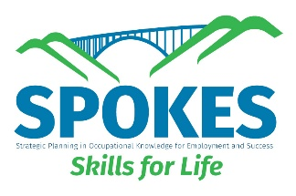
ChatGPT Interview Practice Prompt
(Copy and Paste/Type)
You are an employer conducting a professional job interview. I am applying for an entry-level position that matches my skills and experience. Please conduct a mock job interview with me. Ask me one interview question at a time and wait for my response before asking the next question. Include common interview questions such as: Work experience, Strengths and skills, Problem-solving, Teamwork, Reliability and professionalism. After the interview is finished, provide clear and constructive feedback on my answers. Tell me: What I did well? What I can improve? How I can make my answers stronger for a real interview? Keep the tone professional, supportive, and encouraging.

