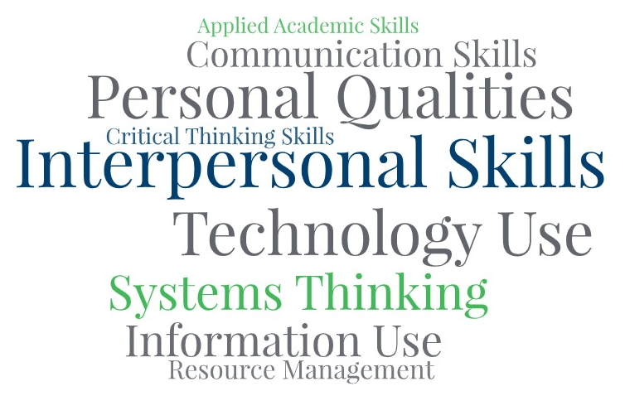

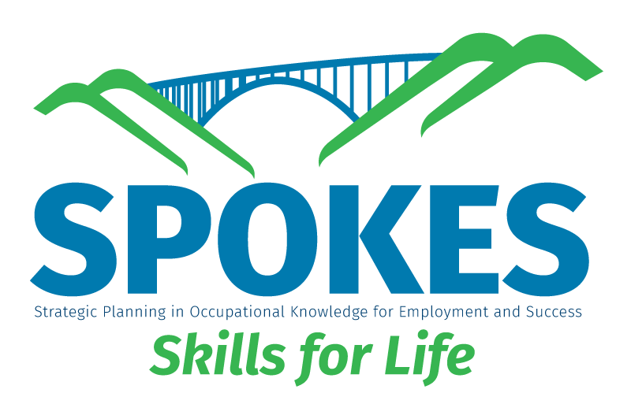
Interview Skills
Copyright 2026
Goal Setting

All rights reserved worldwide under International and Pan-American copyright agreements. No part of this document can be reproduced, stored in a retrieval system, or transmitted in any form or by any means, electronic, mechanical, photocopying, recording, or otherwise without the prior written permission of WV Adult Basic Education.

Courseware Version: 1.0 and subsequent updates

Interviewing Skills

LESSON BASICS
Lesson Topic
Interviewing Skills
Standards (CCRS, GED Standard, Employability Skills Framework)
ER.PQ: Adapts and Shows Flexibility
ER.PQ: Takes Responsibility for Professional Growth
WS.CS: Communicates Verbally

1. Applied Knowledge

a. Communication Skills

Key Alignment: Interviewing relies heavily on effective verbal communication, tone, clarity, and professionalism.

Teaching Focus: Practicing concise and professional speaking, active listening, and responding appropriately to questions.

b. Critical Thinking Skills

Key Alignment: Job seekers must analyze interview questions, think critically, and tailor responses.

Teaching Focus: Interpreting behavioral questions, developing STAR (Situation, Task, Action, Result) responses, and adapting on the spot.

2. Effective Relationships

a. Interpersonal Skills

Key Alignment: Interviewing involves relationship-building, reading body language, and demonstrating teamwork and respect.

Teaching Focus: Building rapport, maintaining positive body language, demonstrating empathy and confidence.

b. Personal Qualities

Key Alignment: Employers look for dependability, integrity, and self-management during interviews.

Teaching Focus: Self-awareness, confidence, enthusiasm, and professionalism in personal presentation.

3. Workplace Skills

a. Information Use

Key Alignment: Applicants must gather and apply information about the company and position.

Teaching Focus: Researching employers, analyzing job descriptions, and aligning personal strengths with company needs.

b. Systems Thinking

Key Alignment: Understanding how personal roles fit within an organization.

Teaching Focus: Connecting personal goals to the mission and values of the employer.

c. Technology Use

Key Alignment: Many interviews today are virtual or involve digital applications.

Teaching Focus: Using video conferencing tools (Zoom, Teams), ensuring digital professionalism.

Summary of Alignment
Employability Framework Standard Interview Skills Application
Communication Skills Responding to interview questions clearly and professionally
Interpersonal Skills Building rapport and demonstrating emotional intelligence
Personal Qualities Showing confidence, responsibility, and integrity
Critical Thinking Skills Answering scenario or behavioral questions strategically
Information Use Researching the company and tailoring responses

Objectives (Audience Behavior Condition Degree)
Pre-interview preparation
- Explain the purpose of an interview to understand its role in securing employment.
- Define and research key aspects of potential employers, including their mission, values, and company culture.
- Analyze job descriptions to understand key responsibilities and required skills.
- Identify the importance of making a strong first impression, including professional dress and proper etiquette.
- Prepare a list of references for potential employers.

During the interview
- Develop effective verbal and nonverbal communication skills, including active listening, maintaining eye contact, and projecting a confident demeanor.
- Practice answering common interview questions, such as "Tell me about yourself" and "What are your strengths and weaknesses?".
- Master specific techniques like the STAR method to provide clear and compelling answers to behavioral questions.
- Learn to frame negative experiences positively, turning weaknesses into learning opportunities and never speaking poorly of previous employers.
- Develop a list of thoughtful questions to ask the interviewer about the role, team, or company.
- Gain experience through role-play and mock interviews to build confidence.

Post-interview follow-up
- Review the importance of following up after an interview.
- Learn to write a professional thank-you email to reiterate interest and appreciation.
Establish proper follow-up etiquette, such as requesting a timeframe for a hiring decision and adhering to it.
Assessment
Module Rubric

LESSON MATERIALS
Handouts Needed
- STAR Behavioral Question Handout
- ChatGPT Mock Interview Prompt
Online Resources
- What Should I wear to an Interview: https://www.youtube.com/watch?v=YzqFqzpUm6M
- 7 Tips for Interview Body Language: https://www.youtube.com/watch?v=PCWVi5pAa30
- ChatGPT: https://chatgpt.com/

Other Materials or Equipment
[list of other materials needed]

ACTIVITY PLAN
 | Time | Activity | Materials
Warm-up | 10 Minutes | Sell an Object Activity | Student Option
Introduction | 10 Minutes | The Interview Process | Introductory Slides  (3 slides)
Presentation | 40 Minutes | Interview Skills | PowerPoint Presentation  STARS Worksheet
Practice | 20 Minutes | ChatGPT Mock Interview | ChatGPT Interview Prompt Sheet  PowerPoint Slide
Evaluation | 10 Minutes | Module Rubric Worksheet | Module Rubric Worksheet
Application | Varies | Answers to ChatGPT Mock Interview Review/Discussion | www.chatgpt.com

Other Resources or Alternative Resources

