Quarterly report
The budget workbook is embedded below.
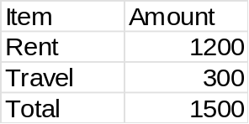
The roadmap slide is embedded below.
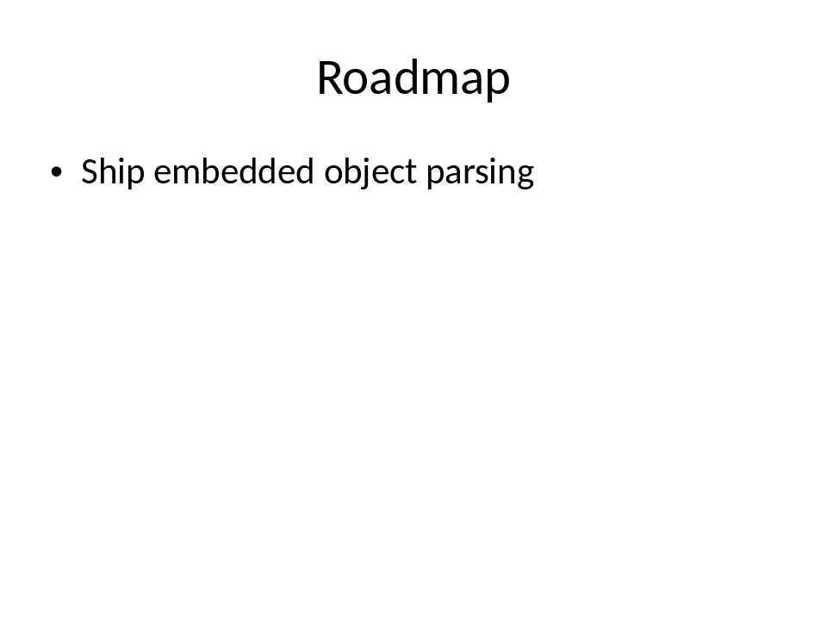
The meeting notes document is embedded below.
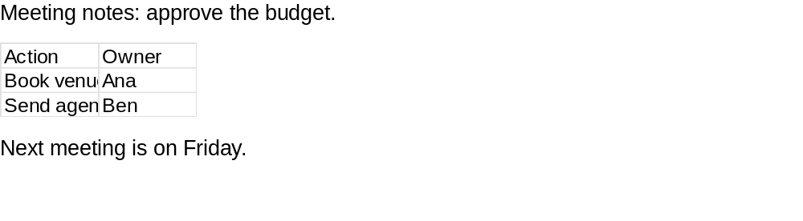
A text file is embedded as a package.
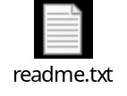
End of report.

