$$s{}_{+}^{}τ\left\{max\right\}= A × B$$

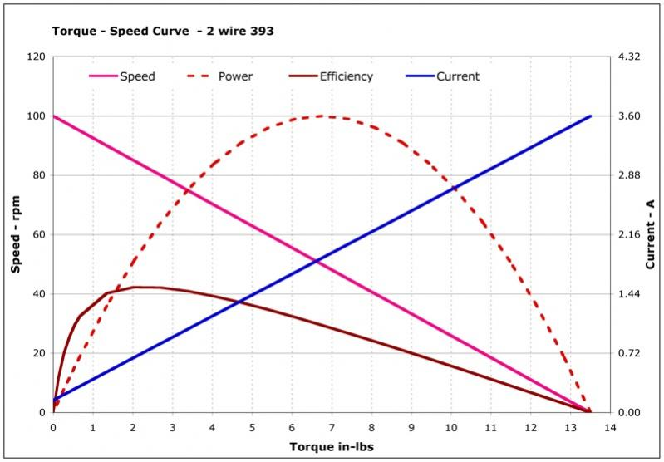
Fig – Torque v/s Speed characteristics

