**Impact assessment of 370 Jay Street development**

The following report outlines four components of New York City's Environmental Quality Review, providing initial assessments for each. Additionally, we explore some ideas for how to improve impact analysis process by making use of new data or analytical methods. The four topics assessed are transportation, noise, energy, and solid waste.

The original building at 370 Jay Street was opened in 1951 and home to the NYC Board of Transportation (now the Metropolitan Transit Authority). As the local economy in the surrounding neighborhood of DUMBO struggled retailers closed shop, and in 1990 the MTA also relocated leaving 370 Jay empty for over 25 years.

Today, the neighborhood of DUMBO is characterized primarily by explosive economic growth: from 2002 to 2013 the number of employees in the neighborhood nearly doubled, from 636 thousand to 1.19 million (LEHD Workplace Area Characteristics). While much less prevalent, there are also a fair number of residents of varied diversity: of the 37 thousand residents 43% are White, 23% Hispanic or Latino, and 22% African American (ACS 2013).

The renovation of 370 Jay – as well as other current and expected growth across DUMBO and surrounding neighborhoods – is expected to add to Brooklyn's rapid changes, especially in terms of economic activity.

**Chapter** ϕ **- Transportation**

**Current Conditions**

The area around 370 Jay Street is currently serviced by a number of transportation options.

**Subway**

For subway trips, there are 13 different lines which go through the area and a number of stations. Table ϕ-1 lists the closest stations which encompass all of the lines which stop in the area. For example, Hoyt St along the Eastern Parkway Line is not included because the Borough Hall stop along the same line is closer so the new trips coming from the further stop will be negligible.

**Table ϕ-1**

|  |  |  |  |  |  |
| --- | --- | --- | --- | --- | --- |
| Current Conditions | | | | Impact Estimates | |
| Station | Lines | Daily Traffic | Distance | AM Trips | PM Trips |
| Jay St Metrotech | NYCS-bull-trans-A.svgNYCS-bull-trans-C.svgNYCS-bull-trans-F.svgNYCS-bull-trans-R.svg | 59862 | 1 minute | 230 | 327 |
| Borough Hall | NYCS-bull-trans-2.svgNYCS-bull-trans-3.svgNYCS-bull-trans-4.svgNYCS-bull-trans-5.svg | 54622 | 4 minutes | 209 | 298 |
| Hoyt Schermerhorn | NYCS-bull-trans-A.svgNYCS-bull-trans-C.svgNYCS-bull-trans-G.svg | 16331 | 8 minutes | 29 | 41 |
| Dekalb Avenue | NYCS-bull-trans-B.svgNYCS-bull-trans-Q.svgNYCS-bull-trans-R.svg | 39138 | 7 minutes | 69 | 99 |
| Atlantic Av-Barclays Center | NYCS-bull-trans-B.svgNYCS-bull-trans-Q.svgNYCS-bull-trans-2.svgNYCS-bull-trans-3.svgNYCS-bull-trans-4.svgNYCS-bull-trans-5.svgNYCS-bull-trans-D.svgNYCS-bull-trans-N.svgNYCS-bull-trans-R.svg | 78121 | 16 minutes | 46 | 66 |

Average daily traffic is the average combination of the total number of people entering and leaving a station. This number does not account for any traffic that doesn’t enter or leave, such as transfers. Walking distance is the time in minutes it would take to walk to 370 Jay Street from that station according to Google Maps walking directions. The Estimated AM and PM trips are discussed in the impact analysis section.

We analyzed current usage of these stations by using the MTA turnstile data for a week in October 2015. The turnstile data published by the MTA has counts of entries and exits through each turnstile in a station combined into four hour blocks – 12AM, 4AM, 8AM, 12PM, 4PM and 8PM. The count at 12PM, for example, is the number of entries and exits through the turnstile between 8AM and 12PM. Due to granularity of the data, we can’t precisely assess current traffic during the peak hours.

**Bus**

**Table ϕ-2**

|  |  |  |  |  |  |  |
| --- | --- | --- | --- | --- | --- | --- |
| Current Conditions | | | Impact Estimates | | | |
| Bus Line | Avg Weekday Ridership | Peak Buses per Hour | AM | | PM | |
| Rides | Rides per Bus | Rides | Rides per Bus |
| B25 | 10603 | 6 | 12 | .667 | 18 | 1.00 |
| B26 | 10290 | 11 | 12 | .364 | 18 | .545 |
| B38 | 20222 | 13 | 23 | .590 | 35 | .897 |
| B41 | 30701 | 12 | 35 | .972 | 53 | 1.47 |
| B45 | 6745 | 6 | 8 | .444 | 12 | .667 |
| B52 | 12523 | 12 | 14 | .389 | 22 | .611 |
| B54 | 11501 | 8 | 13 | .542 | 20 | .833 |
| B57 | 7054 | 5 | 8 | .533 | 12 | .800 |
| B61 | 10433 | 7 | 12 | .571 | 18 | .857 |
| B62 | 9587 | 7 | 11 | .524 | 17 | .810 |
| B63 | 12187 | 7 | 14 | 21 | .667 | 1.00 |
| B67 | 4554 | 5 | 5 | 8 | .333 | .533 |
| B103 | 13788 | 8 | 16 | 24 | .667 | 1.00 |

Table ϕ-2 shows the 13 bus lines which service the area. Average Weekday ridership is taken from the MTA’s 2014 statistics[1] [2]. Peak buses per hour is the roughly the number of buses on that line per hour during the AM and PM peak hours according to the published timetables[3]. The impact estimates are discussed in the impact analysis section.

**Other**

Other options include the Atlantic Branch of the Long Island Railroad (LIRR), which terminates at Atlantic Terminal; biking, including Citibike which has one station around the corner from 370 Jay and another 3 stations within a couple of blocks; private automobiles; and taxis.

**Impact Analysis**

The work at 370 Jay will include 450,000 square feet of new space – including 27,000 sqft of ground floor retail, 150,000 sqft of space for CUSP, 40,000 sqft of incubator space, and the rest mixed use by NYU[4]. To calculate trips generated and types of trips, Table 16-2 was used from the CEQR manual[5], and Table 12-6 from the East Midtown environmental review[6]. Where statistics for academic settings were not available, office space was used as a proxy.

Without being sure of the exact makeup of the usage for the space, we generated a range of daily trips for different usage. We varied the retail space from all local retail to all destination retail, and the upper floors from all office to all academic, and all combinations of the two at 1% increments for a total of 10,000 building configurations. Graph ϕ-1 is histogram of the results, showing the expected daily trips generated range from a low of about 10,000 to a high of 15,000 with an average of 12,500. To get a better sense of the traffic, Graph ϕ-2 breaks down the average trips generated at the peak hours (AM rush hour, lunch time and PM rush hour) and 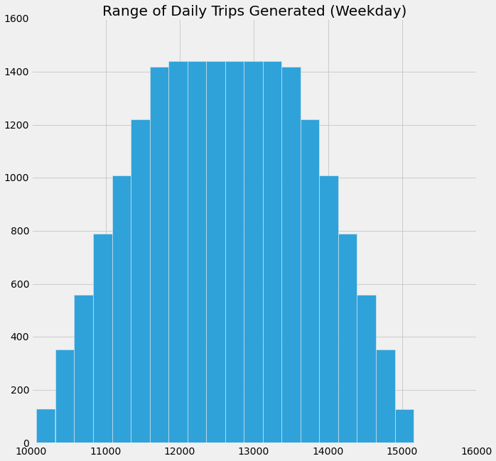mode of transportation.

**Graph ϕ-1**

As shown in graph ϕ-2, we expect there to be 1366 new trips during AM, 2220 during PM rush hour and 2370 during midday. The large amount of foot traffic during midday is mostly caused by the foot traffic to retail. The biggest impacts during AM and PM rush hours are to the subways. We expect that the automobile, taxi and railroad estimates are all over estimates due to using the modal splits of office space where academic modal splits were unavailable. Thus based on the CEQR requirements of 50 peak hour car trips, a level 2 assessment of traffic is probably unnecessary, but based on a 200 peak hour pedestrian or transit trips a level 2 assessment for pedestrians and transit would be required. Fortunately for this author and the reader, a full level 2 assessment is outside of the scope and budget of this environmental review.

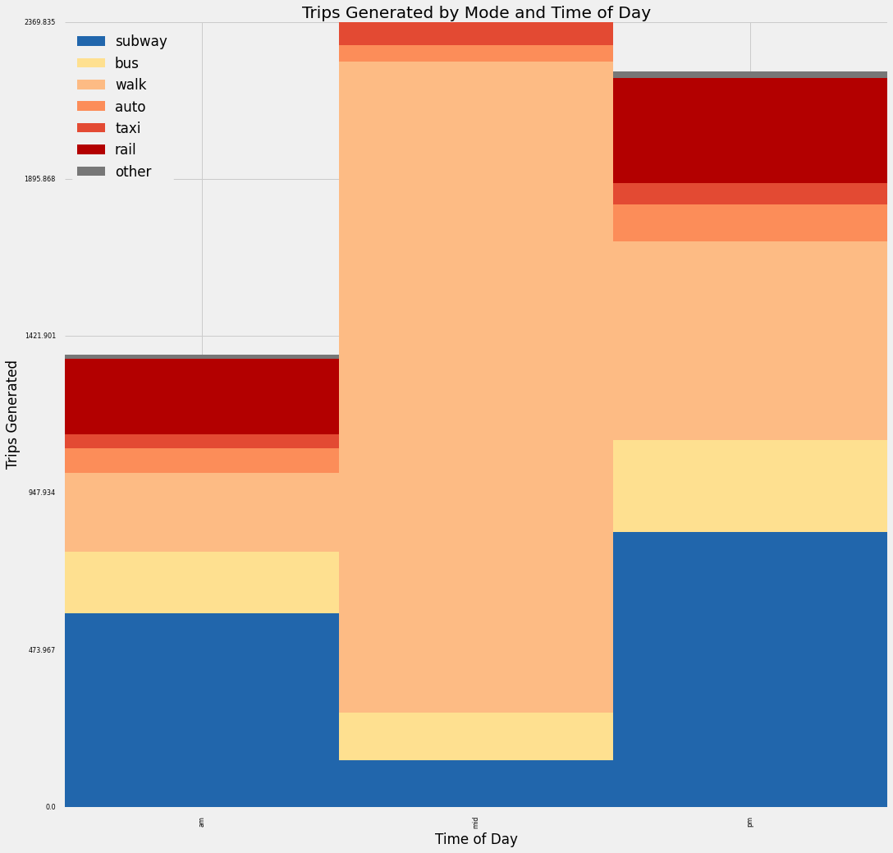**Graph ϕ-2**

**Subway Trip Assignment**

We estimated 585 subway trips generated during AM rush hour and 831 in the PM. We don’t have any usage statistics for subway lines themselves so we can’t assign trips to lines, only to the stations as a whole. We distributed the trips based on current station usage and distance from 370 Jay Street, weighing the closer stations more heavily. The results are shown in estimated AM and PM trips in table ϕ-1. Both Jay Street Metrotech and Borough Hall look to get a significant increase in traffic during peak hours. Our escalator expert[7] has identified the Jay Street escalators in particular as potential problem points.

**Bus Trip Assignment**

We estimated 185 bus trips generated during AM rush hour and 276 in the PM. To assign these trips to the bus lines we proportioned them according to current usage by the bus lines and then calculated the average additional rider per bus during peak hours. The results are shown in table ϕ-2. Only for the B41 during PM rush hour do we expect more than one extra rider per bus on average. For all other bus lines during peak hours we project one or less than one additional rider per bus. We don’t have statistics on current load but based on the estimates the impact to any one bus line does not seem major.

**New Methods**

The current method for doing transportation impact analysis is quite crude – it involves using static tables of questionable applicability to calculate how many people will frequent a new building and how they might commute. We first need to improve the quality of our model of how many and what type of trips are generated by new development. To do that we need to get a sense of the people who commute to similar buildings in the area – where they come from and how they get there. This would require fine grained data of origin and destination, data which is currently impossible to discern from either subways or buses. Citibike and taxi trips data are examples of transportation which does allow for us to determine origin and destination. But even with that, we miss what happens before, how they go between, and where they go after.

Data which could give us a fairly complete picture of where people come from, where they go and how they go there is cell tower pings, which, for obvious privacy reasons would probably be unavailable to planners. Similarly wifi pings could give insight into movement patterns, given a big enough wifi network – possibly linkNYC once rolled out could be used responsibly for this sort of analysis.

With a model of how people currently commute to a location, we could then simulate the addition of new people commuting to and in the area and see whether any modes, streets, intersections, etc. are stressed too far by the additional load.

**Chapter *e* – Noise**

**Current Conditions**

As of 2015, most of the evaluation of noise conditions in New York is realized for Final Environment Impact Studies (FEIS), which are mandatory in case of a rezoning proposal. Close to 370 Jay Street, the most recent FEIS was written for the Downtown Brooklyn Development proposal.[8] As the report was written in 2004, before a major revitalization of the neighborhood, it is fair to assume that the activity in the neighborhood has increased, and thus its noise level, especially on Jay Street (near the MetroTech Center).

In the absence of any other data, the current conditions were assessed using Decibel 10th, an iPhone application developed by SkyPaw Co., Ltd. The noise was evaluated on Wednesday, October 28, 2015 during 10 minutes for each peak-hour period (Table *e*-1):

|  |  |  |
| --- | --- | --- |
| **Table e-1: Current Noise (dBA)** | **Leq(1)** | **L10** |
| **AM** | 76.2 | 79 |
| **Mid** | 74.1 | 77 |
| **PM** | 74.8 | 78 |

In noise evaluations, Leq(1) is the constant noise level (in dBA) that, over an hour, carries the same sound energy as the actual fluctuating noise level. L10 corresponds to the noise level attained (or surpassed) only 10% of the time.

To better assess the current situation, we used the 311 Complaints Data[9]. Between 2010 and 2015, 23 calls were made to 311 to complain about noise on Jay Street (extending beyond the borders of Map *e*-1) during the day and 3 during the night. Those complaints are represented as a heat map (Map *e*-1).

**Map *e*-1. 311 Noise complaints around Jay Street, 2010-2015**

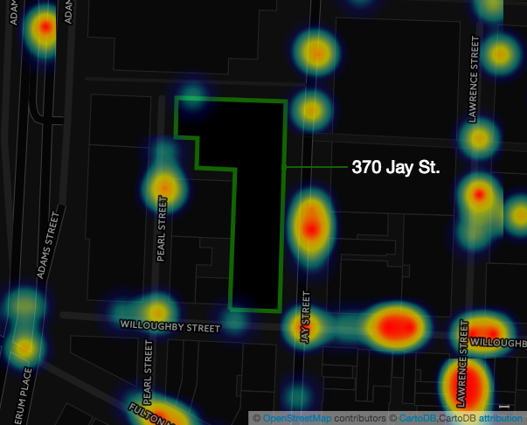

**Impact Analysis**

In New York, the evaluation of the impact of a building on the noise situation follows the PCE method exposed in the chapter 19 of the *CEQR Technical Manual*. Being located on a two-way street in Downtown Brooklyn, the impact of the building on the noise level would be mainly caused by the traffic generated. Other noise sources (for an educational/office building) are thus ignored.

In the PCE method, peak-hour existing, and future projected traffic volumes are converted to Noise PCE. The change in noise level is calculated based on the logarithmic ratio of Noise PCE values. This change is then added to the existing noise level to get the future projected noise level.

**Current traffic**

There is currently no traffic evaluation on Jay Street openly available. However, the Department of Transportation has measured the traffic on Smith Street, between Hamilton Street and Fulton Street, in April 2011[10]. Willoughby Street being a smaller street, we assumed that the measures on Smith Street could be used as approximations of the traffic on Jay Street.

Each car equals one PCE, and each bus equals 18 PCE. To get the current car traffic, we subtracted from the traffic count the number of buses driving on Jay Street during each peak-hour period (MTA lines 26, 57, 62, and 67).[11]

**Future traffic**

The detail of the calculation for the future projected incremental rides is laid out in the traffic portion of this document. To compute the incremental traffic, we multiplied the projected additional car rides by the average vehicle occupancy (1.13 persons by car) from the National Household Travel Survey (2009, New York Metropolitan Transportation Council area)[12], and we assumed that all incremental car traffic would pass through Jay Street.

|  |  |  |  |  |  |  |  |  |  |  |
| --- | --- | --- | --- | --- | --- | --- | --- | --- | --- | --- |
| **Time** | **Existing traffic & PCE** | | | | **Future traffic & PCE** | | | | | |
| **Incremental** | | | | | **Total** |
|  | Total | Bus | Car | PCE | Taxi | Auto | (Bus) | PCE |  | PCE |
| **AM** | 318 | 73 | 245 | **1559** | 41 | 54 | (185) | 107 |  | **1666** |
| **Mid** | 283 | 48 | 235 | **1099** | 71 | 34 | (142) | 113 |  | **1212** |
| **PM** | 272 | 67 | 205 | **1411** | 68 | 79 | (276) | 166 |  | **1577** |

We finally assumed that, although the building will generate bus rides, no new bus line would be created because of it. We thus assumed that no additional bus traffic would be generated by the building.

**Future predicted Noise Levels & Conclusion**

The Noise PCEs are finally converted to future noise levels through the following formula: Future noise level = 10*log(Future PCE/ Existing PCE) + Existing noise level. The changes for all peak-hour periods are inferior to 2 dBA, the lower threshold for the “barely perceptible” CEQR category. There is thus no ground to worry about the impact of 370 Jay Street on the noise level.

|  |  |  |  |  |  |
| --- | --- | --- | --- | --- | --- |
| **Time** | **Existing Noise Levels** | | **Future Noise Levels** | | |
|  | **Leq(1)** | **L10** | **Leq(1)** | **L10** | **Change (Leq)** |
| **AM** | 76.2 | 79 | 76.5 | 79.3 | 0.3 |
| **Mid** | 74.1 | 77 | 74.5 | 77.4 | 0.4 |
| **PM** | 74.8 | 78 | 75.3 | 78.5 | 0.5 |

**New Methods**

The current method to evaluate the impact of a building on noise levels presents two main features: (1) It relies heavily on the generated traffic estimates; (2) It depends on the current noise levels estimates.

Although there is no doubt that the methodology has been already carefully tested, its implementation does not enable an easy ex-post verification of its robustness, as the current and future estimates are not gathered and published in one database. It would be too expensive for the City itself to measure the noise levels in all areas of the city, but the non-random few points measured in the FEIS would already provide insights, especially on the relationship between traffic and noise levels.

Moreover, noise levels and traffic estimates are computed at different times: we used noise estimates from October 2015, along with traffic counts from April 2011 and average occupancy rates from 2009. Collecting all the data in the meantime would provide much more robust estimates.

The future of sensors such as the PlaceMeter is thus maybe not only at the windows of individuals, but in the hands of contractors or city agencies. The low cost of those sensors (provided that they are reliable enough) would render thinkable the obligation to use one of them to measure the current situation, to provide a more reliable basis for the impact analysis.

**Note**

We focused here on the impact of the future building on noise levels. We thus ignored the study of the required noise attenuation capacities of the building, given the projected noise levels, although this study is usually mandatory in any FEIS realized in New York City.

**Chapter π - Energy**

**Current Conditions**

370 Jay Street is currently being remodeled and converted into office, lab, classroom, and incubator space. Currently, Con Edison delivers electricity to almost all of New York City, including the neighborhood around 370 Jay Street. In 2014, Con Edison delivered 61.972 million megawatt-hours of electricity, and 181 million dekatherms of gas.[13] Electrical as gas connection are readily available in the area around 370 Jay Street.

370 Jay Street has 460,000 square feet of floor area. It has a capacity of about 2.3 people per 1000 square feet, for about 1058 people total. It is 14 stories, and will operate Monday through Saturday, 9 am to 9 pm.

**Impact Analysis**

The CEQR technical manual estimates that an institutional building requires 250,700 Btus (British thermal units) per square foot, or 73,473 watt-hours.[14] For a building the size of 370 Jay Street, this implies a requirement of 33,798 megawatt-hours. However, the CEQR estimates do not account for features other than type of building and size, so a more complex model would likely be more accurate.

An alternative methodology for estimating building energy consumption was developed by Dr. Constantine Kontokosta at New York University in 2012.[15] He developed a linear regression to estimate Source EUI (energy use intensity) for office buildings based on data available from PLTUO and Local Law 84. This report states that this model can be used for estimating energy consumption in buildings where actual energy consumption data is not available.

370 Jay Street was first constructed in 1951, making it about 64 years old. It was renovated 0 years ago. It has 14 floors. For the purpose of this analysis, I will assume it has 0% non-office space, because no other category of PLUTO data better matches the intended use of 370 Jay Street. It is not in a historic district. It is detached. The lot area for the building, based on PLUTO data, is approximately 39,233 square feet. It has 14 floors, and 460,000 square feet, so the floor plate size is 460000/14 = 35,386 square feet. Lo coverage, defined as footprint divided by lot area, equals 0.902. This is not an inside lot. Weekly operating hours total 72 hours. Worker density equals 2.3. Assessed value for this building was not available; however, NYU paid the city $60 million for it, which will be used as an estimate.[16]

Based on this model, the estimated building EUI is 244.712. EUI is measured in kBtus per gross square foot, so we estimate 112567520 kBtus, or 32,990 megawatt-hours. As the referenced report describes, the accuracy of the model is good, and within a 15-20% range. We use the same metrics as this model. This model includes most of the publicly available, quantifiable data about 370 Jay Street, so we believe it is better than the CEQR model. However, because 370 Jay Street does not report LL84 data that the model was created with, this is a possible source of bias, if buildings that release their energy data under LL84 are more or less efficient than those that do not.

According to the New York Independent System Operator 2015 Load & Capacity Data report, annual energy requirements for 2025 will be 54,925 GWh for New York City.[17] The energy consumed by 370 Jay Street represents about 0.06% of total energy used at that time, or about 2% of the increase in energy consumption between now and 2025.

The construction at 370 Jay Street will also feature sustainability improvements including high efficiency glazing, a one-megawatt microturbine, efficient lights, and a thermal ice storage system that will produce insulation and cooling, and use more power during off-peak hours. NYU estimates the performance upgrades will reduce energy source consumption by 37%.[18] The project will also be LEED Silver compliant, although one study found that LEED compliance does not significantly reduce energy consumption.[19] Historic energy usage information from 370 Jay Street was not available, but would be useful to this analysis. This data could be collected by the building operators or Con Edison.

Based on the above information, no significant adverse energy impacts will result from the opening of 370 Jay Street.

**New Methods**

EUI only measures the energy consumed over a year. However, energy usage during peak demand times has a higher cost, because it puts more strain on the grid and may require Con Edison to turn on backup generators powered by fossil fuels. Data which showed energy consumption by hour, during different seasons, would let us measure a building’s effect on peak demand. This would require smart meters which could report this data automatically.

**Chapter** *i* **– Solid Waste**

**Current Conditions**

As 370 Jay Street has been vacant over two decades[20], we assume zero solid waste generated at its location before construction began. As per the City's Environmental Quality Review (QECR) manual[21], the construction phase is considered separately so in this section we are only considering expected waste generation once the building is occupied (expected 2017).

**Impact Analysis**

The city's technical manual on new development impact assessment for solid waste[22] states that a detailed assessment may be necessary if the development is expected to generate more than 50 tons of solid waste. For preliminary estimates to determine if a more detailed assessment may be necessary, the technical manual includes a table of expected waste per person by use type. Table *i*-1 below shows the three use types that will exist at 370 Jay Street upon completion.

|  |  |
| --- | --- |
| **Use type** | **Waste generation rate (pounds per week)** |
| College | 1 per pupil |
| Office building | 13 per employee |
| General retail | 79 per employee |

**Table *i*-1:** Waste generation by occupancy

In order to assess the number of occupants by use we used the assumed number of 2.3 per 1,000 Gross Square Feet (GSF) for both office and retail. For classroom space in the new building we used NYU's guidelines on 20 students per 750 Assignable Square Feet (ASF)[23]. The same document also provides a guideline of GSF = ASF*2, so the total ASF given the estimated 235,000 GSF of classroom space is 117,500 (235,000/2). Based on the expected breakdown of “classroom and other academic space”[24] we assume a 50/50 split and that non-classroom space will have 2.3 people per 1,000 sq-ft. Table *i*-2 summarizes expected occupancy, which totals 2,200 people.

|  |  |  |
| --- | --- | --- |
| Use type | Calculation | Expected number of occupants |
| College | (2.3*117.5/2) + (117500/2*20/750) | 1702 |
| Office | 2.3 * 190 | 437 |
| Retail | 2.3 * 27 | 62 |

**Table *i*-2:** Estimate of people per building use type

Based on this estimate of occupancy we can simply multiple the rate of waste generation from table *i*-1 against pupils (for college use type) or employees (for office and retail space), resulting in an expected weekly output of 6.1 tons which is well below the required 50 ton per week estimate required for further impact analysis. Table *i*-3 summarizes waste generation by use type.

|  |  |  |
| --- | --- | --- |
| Use type | Occupants * waste rate | Total waste per week (pounds) |
| College | 1702 * 1 | 1702 |
| Office | 437 * 13 | 5,681 |
| Retail | 62 * 79 | 4,906 |

**Table *i*-3:** Estimated waste per building use type by week

**Limitations of CEQR waste assessment and proposed new methods**

The biggest limitation of the current approach to estimating expected building waste generation is the reliance on very general use types and occupant based averages. Given historic difficulty in collecting, storing, and analyzing data this approach was likely OK to get a first pass, general sense of waste generation, there is potential to get more detailed and targeted with estimates as outlined below. A secondary factor is the general guide of 50 tons per week as the cutoff for more detailed analysis, which does not take into account differences among neighborhoods or locations in terms of existing waste. Again, with current data collection and analytical techniques there is potential to front load the analysis to better inform the Department of Sanitation or private haulers of upcoming, location specific changes in waste generation.

The first recommendation is to collect information on property level waste collected. Over time, such a dataset would enable much more detailed analysis on the differences in waste generation not only between different building use types, but amongst the same use types that may have very different operating procedures. For example, restaurants of different cuisines or office buildings in different industries or neighborhoods may prove to generate different amounts of waste. A second idea is to enable building developers to assess how future occupants will fit into DSNY or private haulers waste collection scheme. For example, by providing more detailed information on when and where waste is currently collected plus truck capacity an automated assessment could be generated which would inform both the building developer and DSNY or other haulers could handle additional waste with minimal or no change to their collection schedule.

**Conclusion**

The completion of 370 Jay Street does not appear likely to significantly impact traffic, noise, energy, or waste. For each analysis, finding a reliable method of prediction was difficult. Most commonly used methods rely on a small number of variables, and in most cases it is difficult to measure their accuracy. While some data is available for each problem, more granular data would be useful. For example, to model pedestrian traffic, cell phone tower and wifi pings would be helpful. Sound sensors can measure noise, but would require installation. For energy, it is currently modeled using EUI, which measures energy use over a whole year. If it were measured hourly, we could also measure energy use during times of peak demand, when there is a higher social cost to energy use. This would require smart meters or similar technology which could report energy reading remotely.

1. http://web.mta.info/nyct/facts/ridership/ridership_busMTA.htm
2. http://web.mta.info/nyct/facts/ridership/ridership_bus.htm
3. http://web.mta.info/nyct/service/bus/bklnsch.htm
4. https://www.nyu.edu/content/dam/nyu/govCommunAffairs/documents/nyu-in-nyc/brooklyn/2014-07-29-370-Jay-St-Presentation-Downloadable.pdf
5. http://www.nyc.gov/html/oec/downloads/pdf/2014_ceqr_tm/16_Transportation_2014.pdf
6. http://www.nyc.gov/html/dcp/pdf/env_review/east_midtown/12_feis.pdf
7. Clayton Hunter Esq.
8. http://www.nyc.gov/html/oer/downloads/pdf/e-des_documents/E-124.2004-06-08.FEIS_Noise_Report_03DME016K.pdf
9. https://data.cityofnewyork.us/Social-Services/311-Service-Requests-from-2010-to-Present/erm2-nwe9
10. http://ftp.dot.ny.gov/tdv/YR2011/R11/02_Kings/02_2070.pdf
11. http://web.mta.info/nyct/bus/schedule/bkln
12. https://www.dot.ny.gov/divisions/policy-and-strategy/darb/dai-unit/ttss/repository/nhts09.pdf
13. "Con Edison Facts, 2014". http://www.coned.com/documents/Facts-2014.pdf
14. CEQR Technical Manual, 2014 Edition
15. Kontokosta, Constantine. (2012) "LOCAL LAW 84 ENERGY BENCHMARKING DATA: REPORT TO THE NEW YORK CITY MAYOR’S OFFICE OF LONG-TERM PLANNING AND SUSTAINABILITY" http://www.nyc.gov/html/gbee/downloads/pdf/ll84_kontoska_report.pdf
16. Kabak, Benjamin (2012). "NYU, NYC, MTA reach deal for 370 Jay Street". http://secondavenuesagas.com/2012/04/24/nyu-nyc-mta-reach-deal-for-370-jay-street/ Retrieved October 28, 2015.
17. "2015 Load & Capacity Data". The New York Independent System Operator, Inc. http://www.nyiso.com/public/webdocs/markets_operations/services/planning/Documents_and_Resources/Planning_Data_and_Reference_Docs/Data_and_Reference_Docs/2015%20Load%20and%20Capacity%20Data%20Report.pdf.
18. "370 Jay Street: Breathing New Life Into 370 Jay Street." New York University. https://www.nyu.edu/community/nyu-in-nyc/nyu-in-brooklyn/370-jay-street.html. Retrieved October 28, 2015.
19. Scofield, John H. (2009). ["Do LEED-certified buildings save energy? Not really.."](http://www.sciencedirect.com/science/article/pii/S037877880900187X). *Energy and Buildings* 41 (12): 1386–1390. [doi](https://en.wikipedia.org/wiki/Digital_object_identifier):[10.1016/j.enbuild.2009.08.006](https://dx.doi.org/10.1016%2Fj.enbuild.2009.08.006).
20. https://www.nyu.edu/community/nyu-in-nyc/nyu-in-brooklyn/370-jay-street.html
21. http://www.nyc.gov/html/oec/html/ceqr/technical_manual_2014.shtml
22. http://www.nyc.gov/html/oec/downloads/pdf/2014_ceqr_tm/14_Solid_Waste_2014.pdf
23. https://www.nyu.edu/content/dam/nyu/spacePriorities/documents/13-1008%20USPWG%20Classrooms%20FINAL.pdf
24. https://www.nyu.edu/content/dam/nyu/govCommunAffairs/documents/nyu-in-nyc/brooklyn/2014-07-29-370-Jay-St-Presentation-Downloadable.pdf