**Chapter π - Transportation**

**Current Condition**s

The area around 370 Jay street is currently serviced by a number of transportation options.

For subway trips, there are 13 different lines which go through the area and a number of stations. These are the closest stations which encompass all of the lines. For example, Hoyt St along the Eastern Parkway Line is not included because the Borough Hall stop along the same line is closer so the new trips generated at the further stop will be negligible.

* Jay St Metrotech - NYCS-bull-trans-A.svgNYCS-bull-trans-C.svgNYCS-bull-trans-F.svgNYCS-bull-trans-R.svg
* Borough Hall - NYCS-bull-trans-2.svgNYCS-bull-trans-3.svgNYCS-bull-trans-4.svgNYCS-bull-trans-5.svg
* Hoyt Schermerhorn - NYCS-bull-trans-A.svgNYCS-bull-trans-C.svgNYCS-bull-trans-G.svg
* Dekalb Avenue - NYCS-bull-trans-B.svgNYCS-bull-trans-Q.svgNYCS-bull-trans-R.svg
* Atlantic Av-Barclays Center - NYCS-bull-trans-B.svgNYCS-bull-trans-Q.svgNYCS-bull-trans-2.svgNYCS-bull-trans-3.svgNYCS-bull-trans-4.svgNYCS-bull-trans-5.svgNYCS-bull-trans-D.svgNYCS-bull-trans-N.svgNYCS-bull-trans-R.svg

We analyzed current usage of these stations by using the MTA turnstile data for a week in October 2015. The turnstile data has counts of entries and exits through each turnstile in four hour blocks. For example, the average number of daily entries and exits throughout the day at the Jay St Metrotech station are shown below. The count is the number of entries/exits between the previous time and that time. So about an average of 15,000 people exit and enter the station between 8AM and 12PM daily.

|  |  |  |
| --- | --- | --- |
|  |  |  |
|  |  |  |
|  |  |  |
|  |  |  |
|  |  |  |

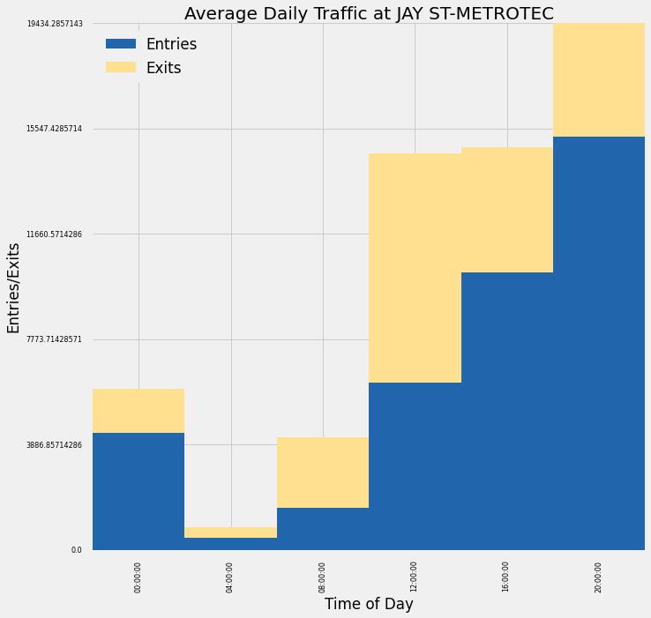

There are <x> bus lines which service the area:

* BPoop
* BShit

Other options include the Atlantic Branch of the Long Island Railroad (LIRR), which terminates at Atlantic Terminal; biking, including Citibike with one station around the corner from 370 Jay and another 3 stations within a couple of blocks.

**Impact Analysis**

The work at 370 Jay will include 450,000 square feet of new space – including 27,000 sqft of ground floor retail, 150,000 sqft of space for CUSP, 40,000 sqft of incubator space, and the rest mixed use by NYU[1]. To calculate trips generated and types of trips, Table 16-2 was used from the CEQR manual[2], and Table 12-6 from the East Midtown environmental review[3]. Where statistics for academic settings were not available, office space was used as a proxy.

Without being sure of the exact makeup of the usage for the space, we generated a range of daily trips for different usage. We varied the retail space from all local retail to all destination retail, and the upper floors from all office to all academic, and all combinations of the two at 1% increments. Below is a histogram of the results, showing daily trips generated range from about 10,000 to 15,000 with an average of 12,500.

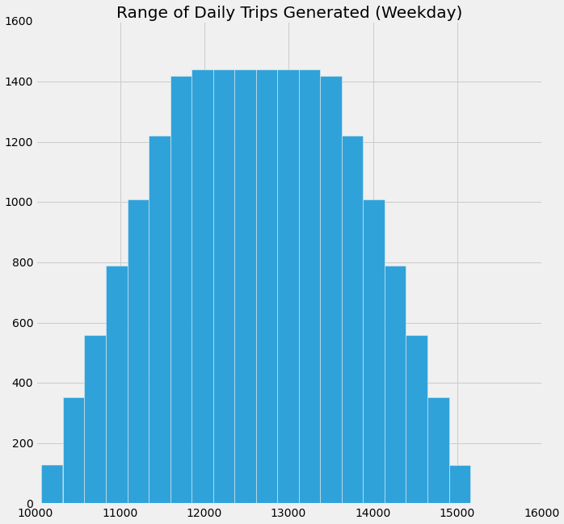

The next chart breaks down the average trips generated at the peak hours (AM rush hour, lunch time and PM rush hour) and mode of transportation. As shown, we expect there to be about 1400 new trips during AM rush hour, 2200 during PM rush hour and 2300 during midday, mostly caused by the foot traffic to local retail.

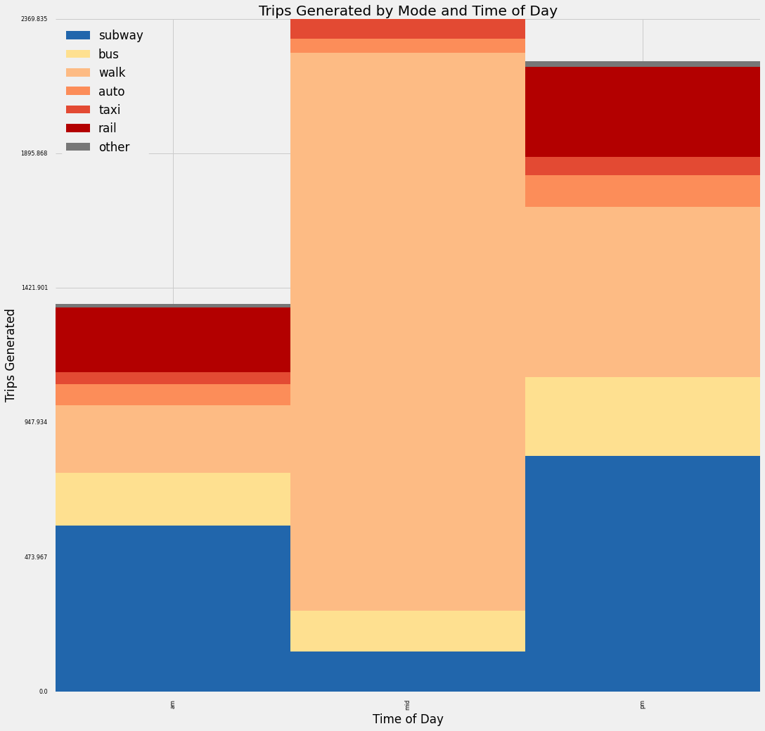

New Methods

1. https://www.nyu.edu/content/dam/nyu/govCommunAffairs/documents/nyu-in-nyc/brooklyn/2014-07-29-370-Jay-St-Presentation-Downloadable.pdf
2. http://www.nyc.gov/html/oec/downloads/pdf/2014_ceqr_tm/16_Transportation_2014.pdf
3. Citation Needed