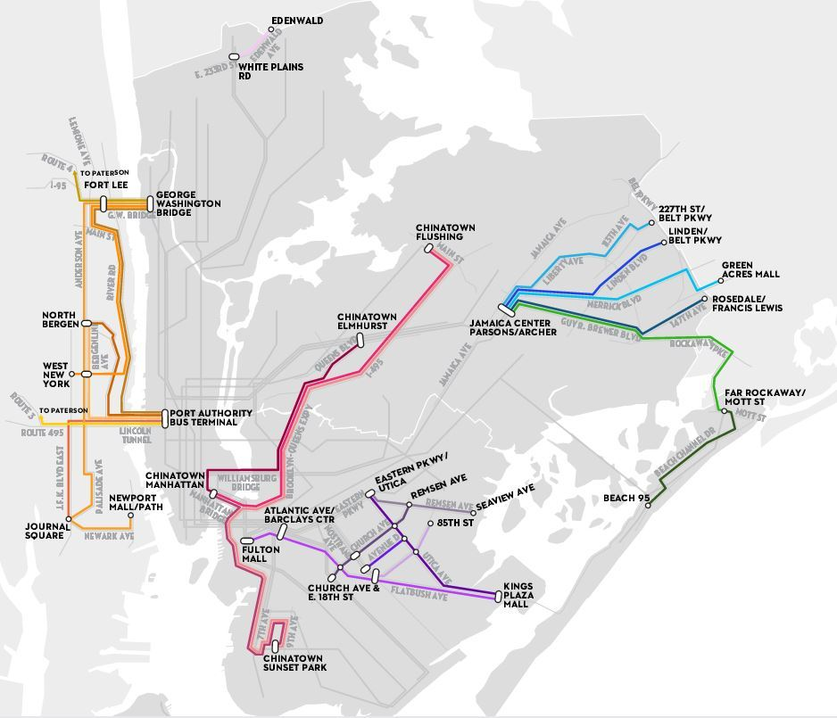

Executive Summary

Jeremy Neiman

Every day more than 100,000 New Yorkers take “dollar vans” – an informal transit method providing service somewhere between buses and taxis. Yet the city doesn’t have a good understanding of where and when they run; or why people choose them over the formal public transit infrastructure provided by the MTA.

The Taxi & Limousine Commission (TLC) and Department of Transportation (DOT) jointly run a commuter van program responsible for regulating this industry. Yet this lack of understanding makes administering this program difficult. Van operators specify areas of service when they apply for licenses, and the TLC and DOT have to evaluate whether the proposed area is in need of commuter van service. But at this time, they don’t have a reliable way to do the evaluation. The goal of this report is to provide these agencies a better understanding of what drives demand for dollar vans so they can better run the program.

This report attempts to quantify the demand for dollar vans across the city and determine which are the characteristics of an area drive that demand. This was done by comparing locations which currently have dollar vans to areas without to determine salient features which set those areas apart. The features considered were demographic information and commute times via formal public transit. Using the salient features, a predictive model was built to indentify other locations in New York City which are similar to places already served by dollar vans and which could be good places to introduce service. The major findings are:

* For the three major dollar van locations in New York City – Chinatown, Flatush and Eastern Queens - there are no universal characteristics driving demand, but there are some common features. Usage is more common among non-white and non-English speaking communities.
* The only place where demand appaers to be driven overwhelmingly by the MTA’s failure to proide transit is in Eastern Queens. Elsewhere it appears to be more culturally driven.
* A large swath running from Eastern Brooklyn through Western Queens where currently no dollar van serwas exists was identified as a place where there could be demand for it.