New York City government employs almost 400,000 people. For many of us, civil service is a defining factor of our lives in NYC. What civil servants do in the background keep the city running and impacts what life in NYC is like.

I'd like to capture what government employees do - from the mundane tasks no one notices to the innovative new programs, such as the open data initiative.

I took the jobs postings dataset (<https://data.cityofnewyork.us/City-Government/NYC-Jobs/kpav-sd4t/data>) and created an algorithm to generate (somewhat silly) haikus from the job descriptions. A working proof of concept can be found here: <https://github.com/docmarionum1/new_york_city_seeks/blob/master/Generate%20Haikus.ipynb>

The algorithm will break the postings down by job title or civil service title and then create appropriate haikus using the job descriptions.

The resulting title and haikus will be displayed on a webpage one at a time that will cycle through each one.

Screenshot of the webpage:

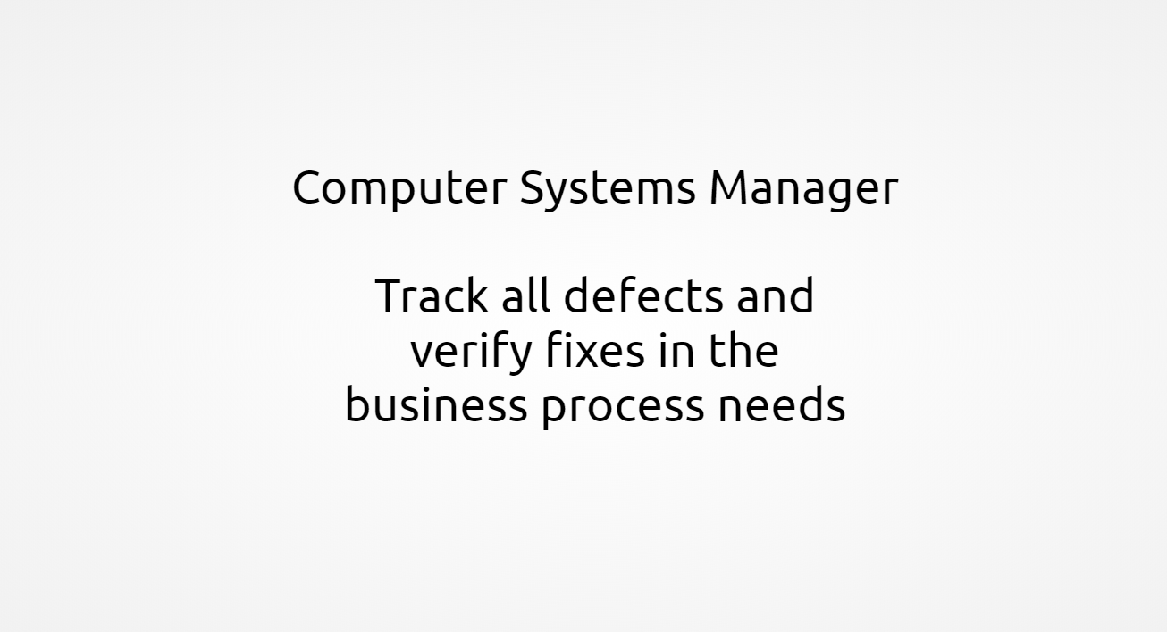

This idea for presenting the haikus is just a first thought and I’m more than open to suggestions to improve it. To begin with, I was more focused on creating the haiku generating algorithm.

Some examples of Haikus created for the job “Computer Systems Manager” are:

Track all defects and

verify fixes in the

business process needs

Maintain the software

development best practice

database systems

Plan and schedule for

project program management

security risks