Jeremy Neiman

Mexico City and the Pesero Horde

Mexico City

Mexico City is one of the largest and wealthiest cities in the world. But it is also incredibly vulnerable. It is susceptible to earthquakes, flood and rockslides; has outdated infrastructure; and has employment and inequality challenges. With the help of The Rockefeller Foundation, the city is hoping to address these issues.

Rockefeller’s 100 Resilient Cities Model

The Rockefeller Foundation’s 100 Resilience Cities program (100RC) has the goal of supporting the resilience efforts of 100 cities across the world, 67 of which have already been chosen. 100RC defines resilience as a city’s ability to survive and grow in the face of not just disasters, but chronic everyday stresses. Rockefeller picks cities based on the resilience challenges they face, of course, but as important is that cities have demonstrated the ability to innovate, work with a wide range of stakeholders and engage in partnership with other cities.

Rockefeller assists each of the cities in a few ways. First, they fund the creation of a new position in the city government called the Chief Resilience Officer (CRO). The CRO is responsible for leading the creation of the city’s resilience strategy and coordinating all of the players across different parts of government in realizing that strategy[1]. Funding the CRO is the only direct monetary support Rockefeller provides the cities. The rest of their assistance is in the form of expertise, guidance and partners. While each city differs in its challenges and goals, 100RC has a framework to help cities think about how to develop their own resilience strategy[2]. 100RC also hopes to bring together the cities so they can share knowledge and expertise, as well as build a platform of private, non-profit and academic partners to facilitate that knowledge sharing[3].

Mexico City used the Rockefeller framework to define its resiliency strategy around six pillars: future; land use and planning; water; infrastructure; economy and mobility.

Barriers

Under the 100RC model, the CRO is responsible for bringing together city leaders and stakeholders to create the resilience strategy; for facilitating communication across city government and agencies and ensuring project synergy; for ensuring that resilience is factored in to new projects; for connecting the city with external partners who can help tackle the city’s resilience challenges. Compared to the Bloomberg innovation model where there is a whole innovation team, the CRO is just a single person and the responsibilities possibly too great for a sole individual.

Mexico City is a complex city, with many different administrative boundaries. The city itself is divided into 16 semi-autonomous municipalities. And Mexico City is just one part of the much larger metropolitan area consisting of another 60 municipalities. Given the number of different players, getting buy-in for large resilience initiatives will be difficult. And, again, make the lone CRO’s job even more difficult.

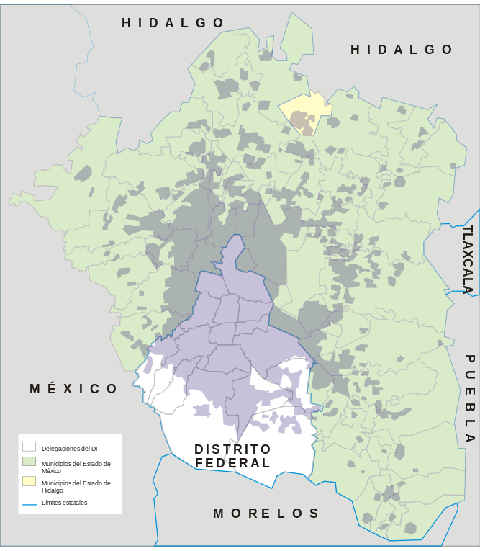

*A map of Mexico City (Distrito Federal) and the greater metropolitan region.*

Peseros and The Mapathon

Of the resilience challenges that Mexico City identified, this paper will focus on mobility, and specifically the form of transport known as “peseros.” Peseros are a form of informal public transit servicing the greater Mexico City region. They are generally small buses seating about 20 people. They run fixed routes, but being privately owned without any central organization, the government has had little understanding of where and when they run. There are an estimated 29,000 of them in the city and they carry 60% of Mexico City’s daily trips, about 14 million trips – millions more than the busiest subway systems in the world[4] [5].

Earlier this year the Laboratorio Para La Cuidad, in collaboration with the city and other partners, ran the Mapathon, a crowdsourced data collection event to map out the pesero routes. They created a mobile app which allowed riders to record their trips and offered prizes for the top mappers. Over the month long event, they recorded over 1500 different routes, which the organizers believe covers most of the routes in the city. The pesero network turns out to be vast – extending far past city boundaries. This data will help inform passengers, as well as city operations and planning.

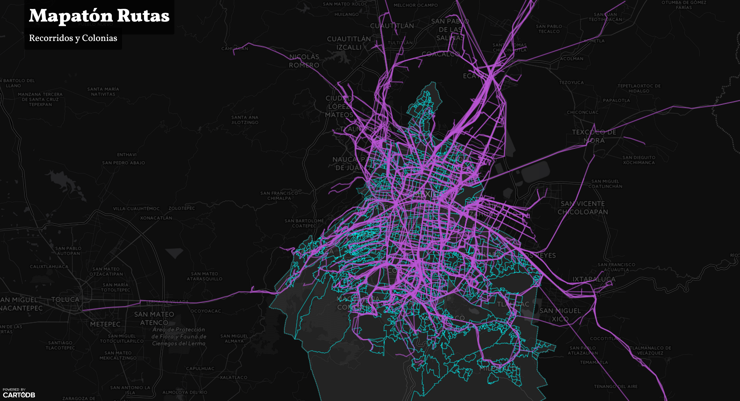

*A map of the pesero routes collected during the Mapathon*

Currently the Peseros are seen as a nuisance – the sheer number of them, as well as the way they drive, contribute to the congestion problem that the city is hoping to address as part of mobility resilience. The city has started trying to replace Peseros with formal transit infrastructure such as bus rapid transit which can carry more passengers more efficiently. But being such an important part of the city’s transportation network they are clearly not going anywhere anytime soon. So what if instead of seeing the peseros as an obstacle, we thought of them as a resource we could take advantage of?

Coordination of Peseros in the Event of a Disaster

When disaster strikes is the time when it is most important that vehicles, people and supplies can move easily throughout the city. But it is precisely at these times that road conditions are at their worst. Obstructed roads make it difficult for large vehicles such as buses or trucks to navigate the city. In 2012, after Hurricane Sandy hit New York most public transit was shut down – subway tunnels were flooded and buses couldn’t move around debris and downed trees. And while most people were best staying at home, some critical individuals such as nurses still needed to get to their jobs and New York’s own form of peseros – the dollar vans – stepped in to save the day[6]. Whiles buses couldn’t navigate the obstructed streets, the dollar vans were small and flexible enough to do so. Inspired by the role dollar vans played after Hurricane Sandy, I’d like to propose how peseros can be seen as an important player in Mexico City’s resilience strategy rather than just an obstacle to resilience.

The goal is to be able to coordinate peseros in the event of a disaster. From simply getting peseros cleared off of a stretch of road to make way for emergency vehicles, to having them move people or supplies around the city. With 29,000 peseros on the road – a fleet as large as the NYPD – coordination certainly poses a huge challenge, but also a great opportunity.

Challenge: Technical

There are two key pieces to be able to coordinate a fleet of vehicles: tracking and communications on the vehicles; and an operations center to monitor and direct the fleet. This is extremely timely because both of those pieces are already being thought about by Mexico City in some form. The Mapathon was a quick and dirty way for the city to start to understand the pesero network, but the government has already approved installing GPS tracking units in peseros over the next five years to have a more sustainable way of understanding the system. If, instead of equipping each pesero with just GPS, they were instead given a simple and cheap smartphone – which has GPS, cameras, communications and more all built in – that would provide sufficient capability to track and communicate with peseros, as well as providing all the other benefits that come with a smartphone. Furthermore, the government has already approved the creation of a mobility command center, even though they don’t yet know what to do with it. Taking advantage of two existing initiatives, finding the synergy between them, and capitalizing on it to support resilience speaks directly to the difference that 100RC expects a CRO to be able to make in a city.

Challenge: Engagement with Pesero Operators and Drivers

This plan necessarily hinges on the support of the pesero operators and drivers. Merely mandating pesero operators install these devices and then fully cooperate during a disaster wouldn’t suffice – unwilling participants couldn’t be trusted during these critical moments. Instead, they should *want* to participate. Nigel Jacob, of Boston’s New Urban Mechanics suggested that the best way to engage private partners is to appeal to their pathos – show them how their cooperation can help people. Maybe it’s cynicism, but I don’t believe that’s enough.

Instead, I’d like to take a page from the Behavioral Insights Team and think about how to make it easy and attractive and mutually beneficial for pesero operators to collaborate with the city. Pesero drivers are notoriously reckless[7]. The compensation model encourages drivers to compete for fares, leading to peseros swerving across lanes of traffic to pick up passengers. The operators have an interest in keeping tabs on their fleet and the city could use the onboard phones to offer them a service such as Zendrive[8] – a service which allows operators to monitor where their vehicles are located and how safely their drivers are driving. Besides the primary use case of disaster coordination, this would also address the of every-day mobility resilience challenge Mexico City faces by reducing reckless driving and traffic accidents.

By engaging pesero operators directly, the city could potentially avoid the complex administrative situation discussed in the barriers section. The city’s central mobility department could spearhead the effort and avoid the sort of buy-in that would be required for city wide transit infrastructure projects.

Conclusion

Propose to enable coordination of peseros

Take a cue from the Mapathon and engage drivers/citizens directly

Resilience isn’t just about efficiency, it’s also about redundancy.

It doesn’t need to be perfect right off the bat. It just needs to be better than it currently is. If that means some sort of coordination, that’s better than complete autonomy and chaos.

1. http://www.100resilientcities.org/blog/entry/what-is-a-chief-resilience-officer1#/-_/
2. http://www.100resilientcities.org/resilience#/-_/
3. http://www.100resilientcities.org/blog/entry/what-is-the-100-resilient-cities-platform-of-partners#/-_/
4. http://www.fastcoexist.com/3058475/mapping-mexico-citys-vast-informal-transit-system
5. https://nextcity.org/daily/entry/big-data-mexico-city-mapathon-gamifies-crowdsourcing
6. https://www.youtube.com/watch?v=7PI7tJ3GS1E
7. http://www.tomechangosubanana.com/2008/peseros-in-mexico-city-the-spawn-from-hell/
8. https://www.zendrive.com/