Jeremy Neiman

New York City Dollar Vans

New York City has an extensive public transportation network – subways, buses, trains, ferries, bikeshare, among others modes. But New York is a large and diverse city and despite having so much infrastructure, public transit doesn’t meet the needs of all New Yorkers, evident by the number of private cars and taxis on our streets. Another mode that helps fill this transportation gap is known as “dollar vans.” Dollar vans are an informal public transit system hallway between a taxi and a bus. They are privately owned vehicles which offer shared rides along somewhat fixed routes, mostly catering to immigrant communities or areas with poor alternative transit options. Dollar vans are unique in that they are not centrally planned like subways or buses but instead grew organically to meet demand. Can we learn from this organic growth and apply lessons to our formal, planned transit infrastructure?

Public transit is the lifeblood of New York City. Unlike most of the United States where people use personal automobiles, a majority of New Yorkers rely on public transportation to get around. On April 1st, 1980, for only the second time in New York’s history[1], the Transport Workers Union went on strike, effectively shutting down all the subways and buses in the city and threatening to grind the city to a halt. The strike lasted 11 days and during that time mandatory carpooling was put into effect, and hundreds of thousands of people took to walking and biking to work.

It’s estimated that the strike cost workers and companies up to $100 million a day, and the city lost $3 million a day. But not everyone fared so poorly. Prices for gas, taxis and hotels soared. Residents of Manhattan rented out their couches to people who didn’t want to commute back to work each day. The population of Manhattan is said to have increased by half a million people during the strike due to people staying in the city.

Among the entrepreneurs were those who saw an opportunity to provide alternate transportation by using their own cars to pick people up and drive them to their destinations, charging a dollar for the trip. But even after the strike ended, these drivers continued to find demand for their services across the city.

Today there are a number of routes throughout the city that are frequented by these vans. In total they serve over hundred thousand people daily. They largely serve immigrant communities or locations where the formal transit infrastructure is lacking. This is an unofficial transportation system with varying degrees of legitimacy – some vans being completely unlicensed and others having gentleman’s agreements with city agencies to allow their activities, even if not strictly legal.

There have been attempts to regulate the dollar van industry over the years and in 2014 The Taxi and Limousine Commission started to license dollar vans, but under the designation of “commuter vans.” This allows them to offer pre-arranged services in designated areas. Pre-arranged means that they can only pick up passengers that have requested the service ahead of time – they can’t just pick people up off the street, either at specific “stops” or by being hailed. But under these rules the dollar vans wouldn’t be able to operate as intended and thus none of them actually follow the laws. And while they are technically operating illegally, the NYPD rarely enforces these laws, instead allowing to dollar vans to continue to operate as they are as long as they follow some rules such as staying out of bus stops and not driving recklessly.

Information about dollar vans spreads throughout the community by word of mouth – there are no official websites, timetables or maps describing when and where operate; no uniform branding to help you recognize the vans; no standard fare. Figure 1 shows a map that was hand-compiled by Aaron Reiss in 2014 by riding the vans and documenting their routes, although it is incomplete and now out of date. There are several main sets of dollar van routes in New York City: Chinatown, Flatbush, Eastern Queens, each with their own reasons for existing.

The Chinatown vans provide service between the different Chinatowns of the city – Manhattan Chinatown, Sunset Park Chinatown, Elmhurst Chinatown and Flushing Chinatown. Despite being physically apart, there are a lot of ties between the Chinese community across the four Chinatowns. All of these places are served by Subways, so traveling between them is possible without the van service. But while possible, it is not that convenient due to the time it takes or number of transfers necessary. The vans generally make one, or few stops at the origin, and then run nonstop along highways to the destination where they will make stops as requested. They won’t stop precisely at a passenger’s destination, but passengers can request to be dropped off as close to their destination as possible along a predefined route. The route is based on where the NYPD will and will not allow them to operate. For example, in Sunset Park Chinatown, the police won’t harass the drivers as long as they keep to 7th and 9th Avenues, where there is lighter traffic and no bus routes. But if they were to go onto 8th Avenue the police will ticket them for the same laws they are breaking on the other streets.

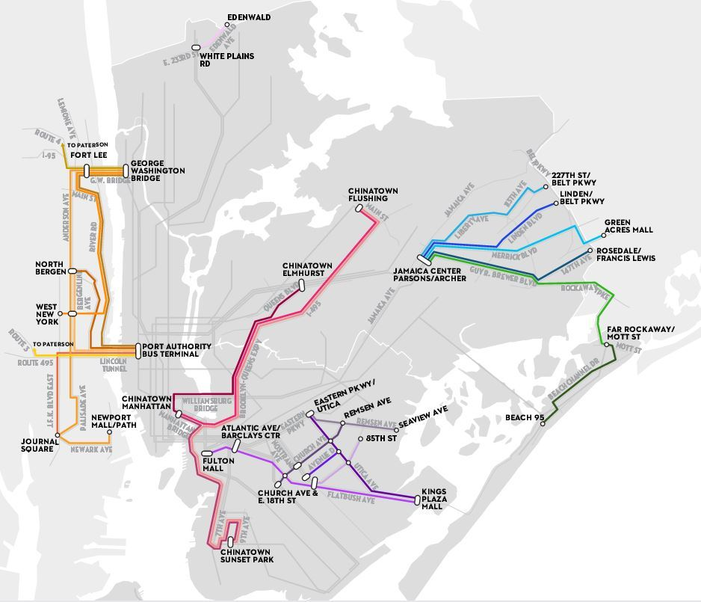

Figure 1: A map of major dollar van routes (<http://projects.newyorker.com/story/nyc-dollar-vans/>)

Besides offering shorter commutes between the Chinatowns, the vans also offer a higher frequency of service. The vans generally run every few minutes, even out of rush hours. One passenger stated he took the subway into Manhattan in the morning because during rush hour the subway runs frequently. Yet he took the dollar van home to Sunset Park because during the midday train service is infrequent while the vans maintain frequent service[2]. Another aspect is that vans provide a familiar environment, language and community. New York City’s transit system can be daunting to anyone new to the city, let alone newcomers who don’t speak English, so this provides a lower barrier to use for those who don’t speak English.

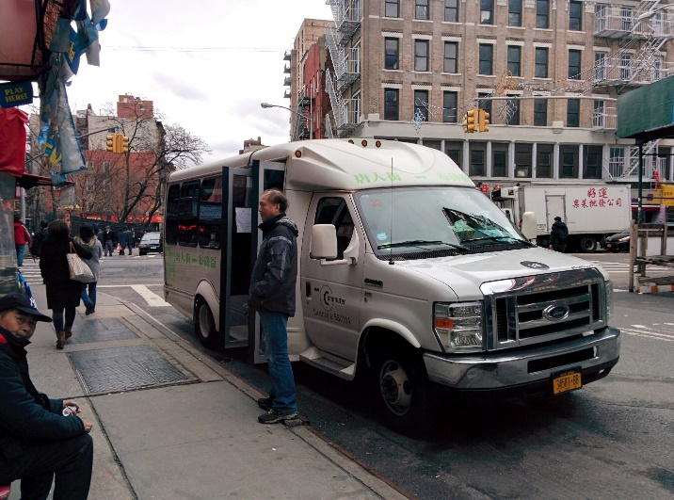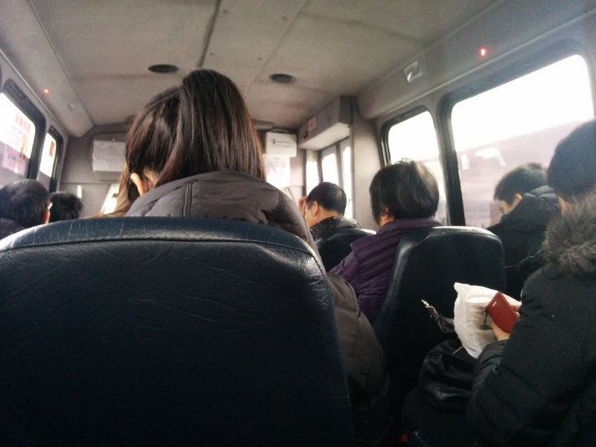

A Sunset Park Chinatown dollar van waiting to depart Manhattan and the inside of the van.

In Eastern Queens a whole number of dollar van lines connect Jamaica Center, the terminus of a number of subway lines, to the rest of Queens, Rockaway and further into Long Island. In some cases, the vans provide alternative transportation to buses and in others they go where no buses run. Most passengers are using the vans only as the first/final leg of their journey and then transferring to a subway. And many still choose to take the vans over buses and forfeit their free transfer because the vans offer such a superior service, thus spending more on transportation. Similar to the Chinatown vans, the Queens vans are largely licensed by the TLC and have “official” stops that they are allowed to operate from.

The Flatbush vans are the odd ones out, being largely unlicensed and having frequent problems with the police. They are run by and serve the Caribbean populations in central, southern and eastern Brooklyn. Their main routes are in areas which lack Subway access – along Flatbush Avenue to Downtown Brooklyn, up Utica Avenue to the 2 and 5 subways at Eastern Parkway, and east/west between these two streets. These vans are in direct competition with official bus lines, and often the drivers will pick up passengers from bus stops. But dollar vans are often much more frequent than the buses and commuters might just go with whichever comes first, even at the cost of the free transfer. Jitneys are also a familiar mode of transportation to many recent immigrants from the Caribbean, making it more comfortable for them than the buses.

In all cases, these dollar vans popped up in places where the official transit options were not meeting the needs of the communities. But in each case, the vans are serving a different need. The Chinatown routes connect places where there is large flow between specific endpoints, and while there is official subway service between them, there is enough demand to support an “express” service between them. In Flatbush, the dollar vans operate along heavily trafficked routes, often in direct competition with the buses, and can thrive by offering service that is familiar, cheaper and more frequent. And in Eastern Queens, the vans provide service from places which lack reliable official options just to first get to the subway.

This topic is timely because there are now attempts to bring this system out of the shadows and legitimatize it. There are currently several bills under discussion in the New York City Council regarding dollar vans. Most importantly, there is a bill to remove the pre-arrangement and passenger manifest requirements, which would allow the vans to legally operate as they currently do. Another bill proposes making dollar van applications demonstrate the need for their service, as well as designate specific stops they would use. Finally, there is a bill which would increase penalties for illegal dollar vans or dollar van violations.

But why should the city want to continue to support this informal transit system when it also is responsible for providing public transit itself? Are dollar vans a critical part of our transportation ecosystem that the city should make sure not to destroy, intentionally through outlawing them, or unintentionally through onerous regulation? That there is demand is self-evident by the fact that the vans exist. But what isn’t clear is whether dollar vans are the right tool to meet that demand.

To understand how to best meet the demand, we need to understand why people take dollar vans. Examining the routes that exist, there are a few primary reasons why people take dollar vans: chief among them are shorter commutes and more frequent service; in some cases, familiarity, ease of use and personalize service; and possibly the price.

In places where there isn’t currently bus service (express service between Chinatowns) or there is infrequent service (Flatbush Avenue), the MTA probably could probably introduce or increase bus service and find demand. But the MTA isn’t just a business. Public transportation is a social good and can’t just be thought of in terms of providing service where it’s profitable. The midnight buses on the outskirts of Queens where per-trip subsidies are high are paid for by fares along well-trafficked lines. In fact, it’s clear that dollar vans can only operate along highly trafficked routes, the same places that the MTA does plenty of business as well. Along Flatbush Avenue the dollar vans don’t provide service to those who have none, but instead cannibalize MTA bus business. The dollar vans could very well be helping those with poor transit options at the expense of hurting those with even worse options.

As for the price argument, despite being called “dollar vans” they no longer cost a dollar – usually $2-3 – and despite the emphasis on “dollar” it’s clear that the price is often not the primary consideration for the passengers. This is made clear by the fact that many people will opt to take a van, costing them at least $2, even when the van is only a part of their journey. By taking a bus instead of a dollar van, they would get a free transfer and the whole trip would cost just $2.75. Yet many people forfeit that transfer and pay twice as much for the trip for the better service they can get from the dollar vans.

As for the intangibles such as comfort, culture or personalized service, dollar vans may offer what other public transit may not. For example, many vans will, for an extra fee (25 cents to a dollar), go slightly off their route to drop passengers off at their final destination, providing an added benefit for the elderly, or someone without a car to get back from the supermarket. And maybe because this is a community operated and used service, the rest of the passengers accept those delays. But it wouldn’t be acceptable for your MTA bus to take twice as long meandering residential streets to drop people at their front doors. There are other intangibles pointing to the importance of dollar vans. For instance, dollar vans were crucial after Hurricane Sandy. Where buses couldn’t run because they were too large to get around debris, the smaller dollar vans could continue to move essential people around, such as nurses. But this is less of an argument that dollar vans in particular are crucial, and more that the city needs to diversify its transit fleet to be resilient.

It’s hard to argue definitively for or against dollar vans existing as part of the transportation ecosystem. But it is clear that the city has a responsibility to regulate the industry to at least ensure passengers are safe and not taken advantage of. There are stories of vans veering across four lanes of traffic to pick up fares, of drivers stopping midtrip to fill up on gas, or forcing everyone out of the van before the expected destination. Dealing with the illegal van problem and getting the vans under the regulatory umbrella would at least be a start in dealing with those problems.

But why is it that so many vans are currently illegal? Primarily it’s lack of enforcement. The NYPD only very occasionally pulls over and tickets vans, so there isn’t a large risk to operating illegally. Yet, by registering your business, your vans, and your drivers there are additional costs that may make the business not viable anymore. And if the city determines that the dollar vans are an important part of the transportation system that should be maintained, it needs to be careful that the changes to the legislation doesn’t destroy that system.

New York City isn’t alone in wanting to better understand and control its informal bus system. Several cities in the United States have tried to formalize their dollar van systems but haven’t been successful in doing so – notably Miami and Los Angeles. Both created programs to establish fixed routes for vans, essentially turning them into privately run buses. New York City also tried a similar pilot program where former bus routes were allowed to have dollar vans. In all cases the programs failed – indicating that what may work for buses run by the government won’t necessarily be viable for vans operated by private businesses.

Nowhere in the United States are dollar vans a major component of a city’s transportation, but several international cities provide examples of where they are the primary mode of transportation. In Mexico City the private buses, called peseros, are the mode of transportation for 60% of commuters and in Nairobi, where they are called matatus, were the only mode of public transit until a few years ago. Like New York City, both of these cities have an interest in understanding and regulating their informal bus systems, but as the primary transit option, the cities have a whole different set of considerations when approaching regulation. Just as the MTA’s subways and buses are the lifeblood of New York City, Mexico City and Nairobi run on peseros and matatus, so they surely can’t just be replaced by official transit options.

Both Mexico City and Nairobi have been taking similar approaches. They’ve started to license and regulate their vans, primarily around ensuring safety. Both cities are in the process of increasing their understanding the of the vans by leveraging technology to crowdsource route data – Mapaton CDMX in Mexico City, and Digital Matatus in Nairobi[3]. Both of these programs created mobile applications where commuters riding the vans could record the routes via GPS. Interestingly, as the cities have started mapping their informal, organically grown transportation networks, the routes appeared to be fairly orderly as if they were planned, for instance with the route density reflecting the population density of the city. And while the van systems have shown to exhibit some amount of order and efficiency, both cities are working to replace or supplement them with official transit options. Mexico City, for instance, faces congestion and air pollution problems, and are starting to roll out BRT systems to replace peseros and the city has even used major pesero routes to inform where there is demand for BRT.

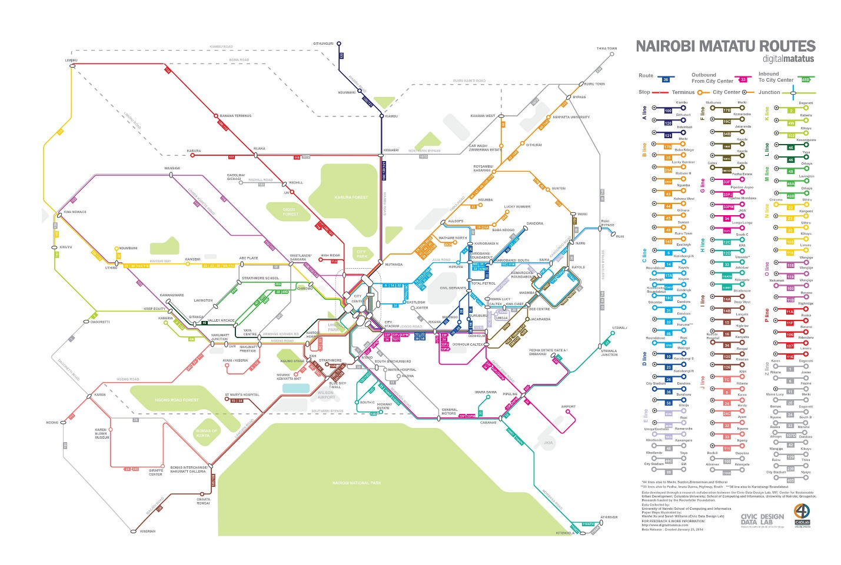

Figure 2: Crowdsourced map of Nairobi's Matatu routes (http://www.digitalmatatus.com/map.html)

New York’s dollar vans are very low tech, but they offer an interesting comparison to the emerging ridesharing tech space, such as Via[4]. Both are operating in a similar space – offering transit options which are frequent, faster than buses, can pick you up and drop you off closer to your endpoints, but at a lower price than taxis. When considering the importance of dollar vans in the greater transit ecosystem, their greatest strength is their flexibility and ability to respond to demand swiftly versus the years it might take the MTA to rollout a new bus service. But long term, a technological solution such as Via offers to do that more efficiently. Of course, the price-point might not make it an equitable solution.

Dollar vans are an interesting part of our public transportation network, operating on the fringes, yet serving such a significant portion of the population. But despite the number of people they currently serve, it’s not clear whether they are transit we want to support and encourage. Even the question of whether we need to ensure that all vans are licensed and regulated, which may seem obvious, isn’t so clear. If those regulations cost the operators too much money, without knowledge of their profitability, it’s impossible to say whether it could put them out of business, defeating the whole purpose. The public subsidizes the MTA – should we also subsidize dollar van registrations to make sure we don’t inadvertently put an important transportation option out of business? If the existence of dollar vans demonstrates need, should we be putting greater official resources into those areas to ensure that we can offer transit which is cleaner and doesn’t cause as much congestion? Or would it be better to pull MTA resources out of places well service by dollar vans so they could focus their efforts elsewhere? At this point, the future of dollar vans in New York City is very unclear.

Bibliography

1. Reiss, Aaron. "New York's Shadow Transit." The New Yorker. Web. 27 Feb. 2016.
2. Feinman, Mark S. "The New York Transit Authority in the 1980s." Www.nycsubway.org. Web. 27 Feb. 2016.
3. Chan, Sewell. "25 Years Ago, Subways and Buses Stopped Running." New York Times. 4 Apr. 2005. Web. 27 Feb. 2016.
4. "NYC Taxi & Limousine Commission - Commuter Vans." NYC Taxi & Limousine Commission. Web. 28 Feb. 2016.
5. Larson, Eric. "Dollar Vans: Inside NYC's Huge, Hidden Transit Network." Mashable. 10 Apr. 2014. Web. 01 Mar. 2016.
6. "Committee on Transportation -." The New York City Council. 22 Oct. 2015. Web. <http://legistar.council.nyc.gov/MeetingDetail.aspx?ID=435938&GUID=94AF0775-DA80-4C10-A18A-204797E19333&Options=&Search=>.
7. Keating, Alexander (Director, Special Projects Unit NYC Department of Transportation), Personal Interview, 2 Mar 2016.
8. Grandoni, Dino. "Brooklyn's Dollar Vans Will Not Yield." Bklynr. 3 Apr. 2014. Web. 04 Mar. 2016.
9. "MAPATÓN CDMX." PIDES Social Innovation. Web. 04 Mar. 2016. <http://www.pidesinnovation.org/initiatives/mapaton-cdmx/>.
10. Patinkin, Jason. "These Digital Maps Could Revolutionize Nairobi’s Minibus Taxi System." Next City. 11 Feb. 2014. Web. 04 Mar. 2016.
11. King, David A., and Eric Goldwyn. "Why Do Regulated Jitney Services Often Fail? Evidence from the New York City Group Ride Vehicle Project." Transport Policy 35 (2014): 186-92. Web.

1. And the only strike until the 2005 transit strike during which this author happily enjoyed a several day vacation from school.
2. Based on a conversation the author had with a fellow passenger while riding the Manhattan Chinatown to Sunset Park van.
3. <http://www.mapatoncd.mx/>

   <http://www.digitalmatatus.com/intro_full.html>
4. <http://ridewithvia.com/>