Table of Contents
- DocNexus Feature Validation Suite
- 1. New Features (v1.2.6)
- 1.1 GitHub Alerts
- 1.2 WikiLinks
- 1.3 CriticMarkup (Review)
- 1.4 Smarty & Emoji
- 2. Standard Extended Features
- 2.1 Tabbed Interface
- 2.2 Collapsible Details
- 2.3 Math (Arithmatex)
- 2.4 Task Lists
- 2.5 Keyboard Keys
- 2.6 Highlights & formatting
- 2.7 Definition Lists
- 2.8 Footnotes
- 2.9 Abbreviations
- 2.10 Attributes
- 3. Diagrams (Mermaid)
- 4. Standard Tables
- 5. Magic Links

DocNexus Feature Validation Suite
This document validates ALL Markdown features currently supported by the DocNexus renderer (v1.2.6).

1. New Features (v1.2.6)

1.1 GitHub Alerts
Note
This is a Note alert.

Tip
This is a Tip alert.

Important
This is an Important alert.

Warning
This is a Warning alert.

Caution
This is a Caution alert.

1.2 WikiLinks
Link to an internal page: feature_test_v1.2.6

1.3 CriticMarkup (Review)
- Addition: Added
- Deletion: Deleted
- Substitution: OldNew
- Comment: Comment
- Highlight: MarkedWith Comment

1.4 Smarty & Emoji
- Smart Punctuation: “Smart Quotes”, – En-dash, — Em-dash, … Ellipsis.
- Emoji: [🚀] [🎉] [🐍] [❤️]

2. Standard Extended Features

2.1 Tabbed Interface

Python
def hello():
print("Hello World")

JavaScript
console.log("Hello World");

2.2 Collapsible Details
▶ Click to Expand
Here is some hidden content!
It supports multiline text.

2.3 Math (Arithmatex)
- Inline:
Equation: E=mc^2
- Block:
Equation: \frac{n!}{k!(n-k)!} = \binom{n}{k}

2.4 Task Lists
- [x] Completed task
- [ ] Incomplete task
- [ ] Working on it

2.5 Keyboard Keys
To save, press Ctrl+S or Cmd+S.

2.6 Highlights & formatting
- Mark: Highlighted Text
- Insert: Inserted Text
- Delete: Strikethrough
- Subscript: H₂O
- Superscript: X²

2.7 Definition Lists
Term 1
Definition 1
Term 2
Definition 2a
Definition 2b

2.8 Footnotes
Here is a footnote reference.1

2.9 Abbreviations
The HTML specification is maintained by the W3C.

2.10 Attributes
This paragraph has a custom class.

3. Diagrams (Mermaid)
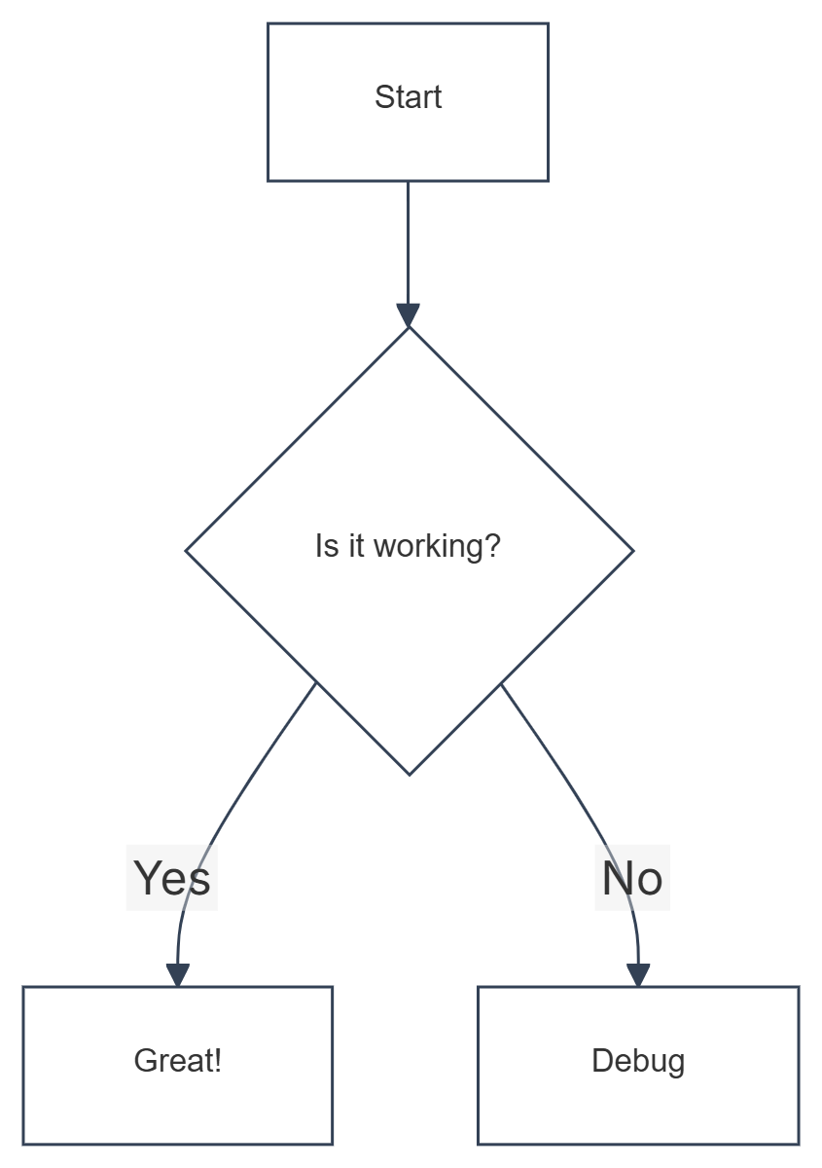
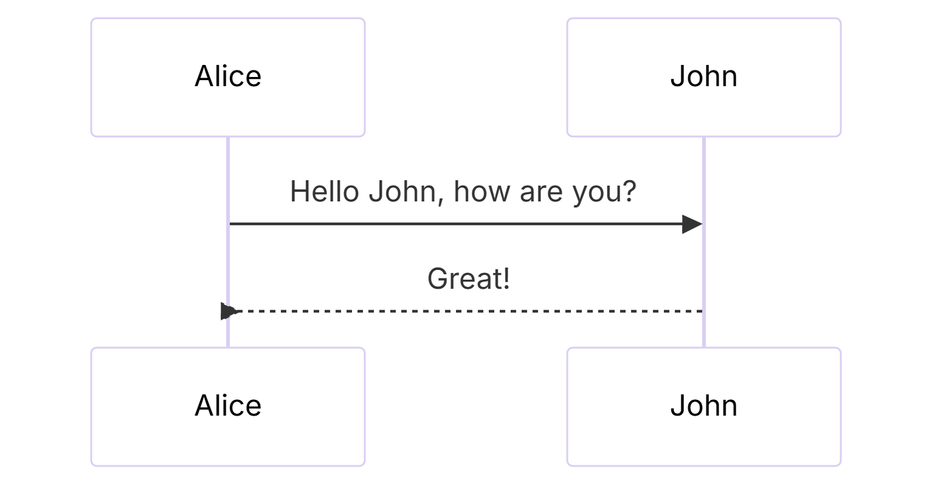

4. Standard Tables
Item | Value | Qty
Computer | $1600 | 5
Phone | $12 | 12
Pipe | $1 | 234

5. Magic Links
- Auto-link: https://google.com
- Mailto: contact@example.com

This is the footnote content. ↩

