**TLH**

**VFX DELIVERABLES**

**FOOTAGE**

FILE FORMAT FOR VFX : DPX - 10Bit Or EXR 16Bit Float(zip) ( to decide)

SOURCE RESOLUTION : 2880*1620

SOURCE ASPECT RATIO : 16:9

FRAME RATE : 24

* Please provide unprocessed log footage at full resolution and aspect ratio (no letterbox) for VFX
* Maintain camera generated clip name and in and out TC Leave filename as assigned by camera (e.g. A001_C001)
  + Parent folders can be renamed sequentially in case of similar clip names.
  + Getting rid of clip names will cause trouble later in the process.
  + A version number should be padded every time.(should be done while exporting from resolve.)
  + EXAMPLE: B001C007_180426_R21D_**v001**.00571012
  + Resubmitting a same shot to vfx will have newer version number.
* If time remapping is required please specify the final shot duration and speed change percentage in the shot list.

**FILE** **NAMING**

Folders containing DPX Files should follow this naming convention

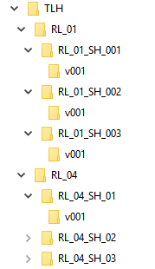TLH

* RL_01
  + RL_01_SH_01
    - V001
      * B001C007_180426_R21D.00571012
  + RL_01_SH_02
    - V001
      * B001C015_180426_R21D.00794017
  + RL_01_SH_03
    - V001
* RL_04
  + RL_04_SH_01
  + RL_04_SH_02
  + RL_04_SH_03

Short project name (TLH), reel # shot # , frames # space with underscores: **RL_01_SH_03**

Please exclude spaces, slashes, or other strange characters from file and folder names ([{!@#$%^&*/\=+•<>’:;”,?`~}]) are not acceptable characters