Cat-Sandra

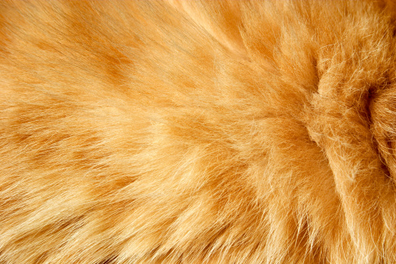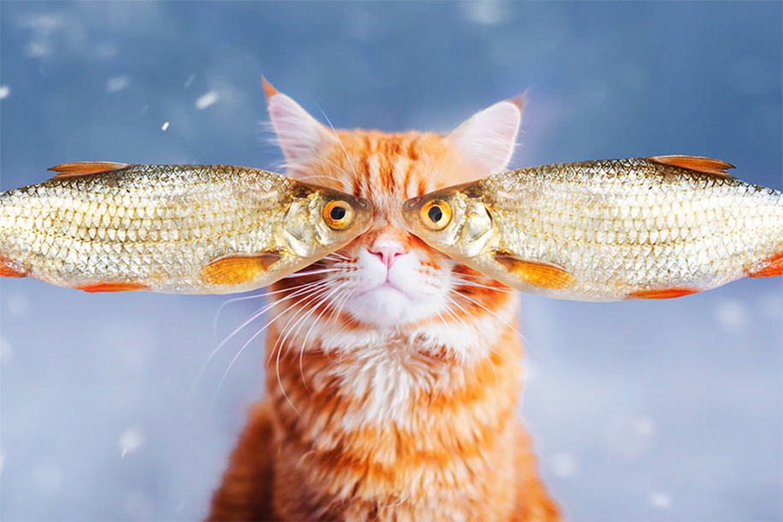

<https://www.demilked.com/professional-cat-photography-kotleta-cutlet-kristina-makeeva-hobopeeba/>

