# Title page

## Working title

Mortality among deteriorating ward patients referred to critical care: a prospective observational cohort study in 48 NHS hospitals

## Authors

* Steve Harris
* Mervyn Singer
* Colin Sanderson
* David Harrison
* Kathy Rowan

# Abstract

## Background

Identifying and responding to deterioration among ward patients includes early access to critical care. However, critical care provision in the NHS is constrained, delay to admission is thought likely, and patient outcomes are poorly understood.

## Methods

We conducted a prospective cohort study of consecutive deteriorating ward patients referred to critical care in 48 NHS hospitals (1 November 2010 — 31 December 2011). We recorded both the assessor’s recommendation for critical care, and the decision to admit. Admissions to critical care within one week, and deaths within one year were defined by linking to national registries. Incidence models were stratified by the NHS National Early Warning Score (NEWS) risk class, and used generalised estimating equations. Decision making and survival were modelled with random effects for the hospital using logistic regression and proportional hazards models respectively.

## Findings

Critical care teams assessed 15158 patients of whom 6759 (45%) were in the highest NEWS risk class giving an incidence of 17 high risk patients (95%CI 17–18) per hospital per month. 5164 (34%) patients were in established organ failure with only 870 patients (6%) already on organ support. Sepsis was reported in 9296 (61%) patients.

2141 (14%) patients with treatment limitation orders were refused critical care with 7-day, 90-day, and 1-year mortalities of 41%, 65%, and 76% respectively. They were not considered further.

The bedside assessor recommended 4976 (38%) of the remainder to critical care of whom 3375 (68%) were initally accepted. The median delay between asssessment and admission was 2 hours (IQR 1 to 4). Patients over 80 years were less likely to be accepted (OR 0.60 95%CI 0.53–0.69). Despite adjustment for patient specific risk factors, decision making varied markedly between hospitals (median interhospital OR 2.11, 95%1.81–2.42).

Of the 1601 (32%) patients recommended but initially refused, 1021 (64%) were admitted later with a median additional delay of 6 hours (IQR 5–7). A further 179 (11.2%) patients recommended and refused died without admission.

Without treatment limits, 7-day, 90-day, and 1-year mortalities were 14%, 30%, and 39% respectively. Even within the first week, mortality was front-loaded with 964 (53%) within two days. Survival also varied between hospitals with a median interhospital hazard ratio of 1.29 (95%CI, 1.22–1.35).

The critical care unit was full at the time of 1198 (8%) assessments. These patients were less likely to be accepted to critical care (OR 0.72 [95%CI 0.59–0.88]), and less likely to be admitted promptly (OR 0.27 [95%CI 0.19–.27]). Increasing occupancy was associated with greater physiological deterioration pending admission (Cochran-Armitage test for trend p=0.01). We could not exclude an effect of occupancy on 90-day survival (HR 1.07, 95%CI 1.00–1.15).

## Conclusion

Deteriorating ward patients referred to critical care are vulnerable with a high initial mortality. Despite clinical recommendation for admission a substantial minority die without admission, and high critical care occupancy both predujices and delays admission.

## Funding

Wellcome Trust, NIHR Service Support Costs, and the Intensive Care National Audit & Research Centre

# Introduction

There are more than 160 acute hospitals in England that care for more than 11 million overnight hospital admissions per annum. Each patient spends a mean of 5 days on a hospital ward where they undergo a process of continual triage, and those who deteriorate are referred to critical care.[@Anonymous:tc] This interface between the ward and critical care has been a priority area for the English National Health Service (NHS), but available data derive from qualitative work, small retrospective studies, or voluntary reporting systems [@Luettel:2007va; @McQuillan:1998uj; @Cullinane:2005vg].

Recent international reports suggest that critical care capacity affects decision making for these patients.[@Chen:2012hu; @Stelfox:2012iy; @Robert:2012ep] The last significant funding increase for critical care in the NHS was in 2000, and in 2010 the United Kingdom (UK) was still ranked 24 out of 28 European countries in terms of critical care provision.[@Rhodes:2012kb] Similar results are found when the comparison is with North American health care systems.[@Wunsch:2008kk] This implies that access to critical care here will be correspondingly constrained, and admissions may be delayed or refused.

Ward patients affected by this are likely to be among the most vulnerable in the hospital. Hospital mortality for these patients is probably two to three times the 9% overall inpatient mortality recently reported in Scottish NHS hospitals.[@Simchen:2007bn; @Buist:2002kc; @Clark:2014hu]

We set out to investigate the severity of, and circumstances surrounding delay to admission to critical care. Previous studies typically limit themselves to comparisons of early versus late admissions, and exclude by design those never admitted. This introduces a survivor bias (those who die before late admission), and an exclusion bias (those who survive without admission). We have instead prospectively followed all patients referred to critical care, traced any admission within the first week after referral (the ‘efferent limb’ of a rapid response system), and performed survival follow-up to one-year.

# Methods

## Study design and participants

The (SPOT)light study was a prospective observational cohort study of the deteriorating ward patient referred to critical care. The physiological status of the patient at the time of the first bedside assessment by critical care was prospectively recorded along with the recommendation made at the end of the assessment. By linking the records generated at the time of the bedside assessment, to the Intensive Care National Audit & Research Centre’s Case Mix Programme Database (ICNARC CMPD), the fact and timing of admission to critical care was identified. Similarly, by linking to the NHS Information Service then vital status up to one year was recorded.

Patients were eligible if they were inpatients on general hospital wards who had been referred to, and assessed by, critical care. The assessment had to be performed at the bedside by a member of the critical care team. This was defined broadly to include members of the critical care outreach service, or members of the critical care medical or nursing staff. Only the first assessment for a given episode of illness was eligible. Cardiac arrests, planned admissions, and visits that were retrievals of patients where a decision to admit had already been made were excluded.

Demographics, and the date, time and location of the visit were recorded, along with the level of care at the time of the visit.[@Eddleston:2009wy] Available patient physiology (vital signs, arterial blood gas and laboratory measurements) at the time of, or immediately preceding, the visit was abstracted along with organ support, antibiotic therapy, and a subjective assessment of the likelihood of sepsis, and its source. The assessor was then asked to report the level of care recommended, and the outcome of the decision to admit to critical care. Treatment limitation orders were recorded for those not admitted.

## Procedures

The study was registered on the National Institute of Health Research (NIHR) research portfolio, and hospitals were eligible if they participated in the CMP. Research teams at each hospital attended a Dataset Familiarisation Course, and a data collection manual containing definitions of items to be collected was provided. The Clinical Trials Unit at ICNARC provided support for research queries during the study.

Hospitals were asked to report all consecutive ward referrals to the critical care team. Data collection was to be contemporaneous, but hospitals were also requested to identify and submit missed referrals. We used the proportion of emergency ward admissions in the ICNARC CMP successfully linked to the (SPOT)light database to quality control the study. Data quality was judged on a monthly basis, and all data from individual months falling below a minimum standard of 80% data linkage were excluded. Reporting was via a secure online web portal which performed real-time field and record level validation. Further on-line validation reports were completed by all hospitals before the database was locked in September 2012. Fact and date of death were then requested from the NHS Information Service. CCOT provision was reported by participating hospitals, and contemporaneous CMP data and Hospital Episode Statistics (HES) were used to define critical care provision, occupancy, and hospital characteristics.

## Statistical analysis

Survival was evaluated at 90-days. Sample size was calculated to evaluate mortality increases from delay to admission using estimates from 2007 ICNARC CMP data. The target sample size was 12,075–20,125 patients referred to critical care which allowed for delays to occur in 10–40% of admissions and mortality effect sizes of 5–10%.

Physiology measurements at the time of the ward assessment were abstracted. From these, the ICNARC physiology score, the NHS National Early Warning Score (NEWS) and the Sequential Organ Failure Assessment (SOFA) score were calculated with missing values given zero weights as recommended.[@Anonymous:2012un; @Harrison:2007jt; @Vincent:1996vs] The NEWS score additionally defines three risk classes (Low, Medium, and High) designed to trigger an escalating clinical response.

The bedside recommendation for critical care, along with the decision to admit were recorded. Prompt admission was defined as one occuring within four hours of ward assessment.[@Anonymous:2013up]

The indicator of critical care unit occupancy was the difference between the maximum number of beds reported to ICNARC, and the number of actively treated patients occupying those beds at the time the ward patient was assessed. Bed pressure (occupancy) was defined as being high (zero or fewer beds), medium (one or two beds), or low (three or more beds).

Incidence models were stratified by NEWS risk class. The unit of analysis was a study day so that daily fluctuations in lagged critical care occupancy could be examined. Estimation was via generalised estimating equations (GEE) with hospitals as clusters, and day-by-day correlations modelled using a first order autoregressive structure. Decision to admit, and prompt delivery of that decison, were modelled using multi-level logistic regression with patients nested within hospitals. Cox proportional hazards were used to model survival with a shared frailty for hospitals. The proportional hazards assumption was checked by inspecting plots of smoothed exponentiated standardised Schoënfeld residuals, and re-entering terms using time-varying co-efficients where necessary. We reported random effects using the Median Odds Ratio (MOR), and the Median Hazard Ratio (MHR) using the bootstrap to generate 95% confidence intervals. These statistics represent the median difference when comparing patient outcomes from any two randomly selected hospitals.[@Bengtsson:2010ib]

Categorical data were reported as counts and percentages, and continuous data as mean (SD) or median (IQR) values. Effect measures are reported with their 95% confidence intervals.

## Role of the funding source

The study was centrally funded by the Wellcome Trust, sponsored by ICNARC, and supported at NHS hospitals through the National Institute of Health Research service support costs. The funders of the study had no role in the study design; gathering, analysis, and interpretation of the data; writing of the report; and decision to submit the report for publication. The corresponding author had full access to all the data (including statistical reports and tables); takes responsibility for the integrity of the data and the accuracy of the data analysis; and takes final responsibility for the decision to submit for publication.

# Results

48 hospitals reported 20893 visits over 435 months. 2694 visits (12.9%) did not meet the inclusion criteria including 1860 (8.9%) repeat visits, and 586 (2.8%) patients recently discharged from critical care. Data linkage was incomplete (< 80%) for 66 (15%) study-months excluding a further 2440 (11.7%) visits. Therefore 15759 patients were recruited to the study, of which 15158 (96.1%) completed follow-up without error and were available for analysis (Figure 1). Final data linkage (ward visits to critical care admissions) was 93% complete.

## Participating hospitals

The participating hospitals comprised 10 teaching and 38 general hospitals that each collected data between September 2010 and December 2011 for a median of 8 months (IQR 5 to 9 months). Each hospital contributed a median of 252 patients (IQR 162 to 380). Critical Care Outreach Teams (CCOT) operated 24 hours/day and 7 days/week in 14 (29%) hospitals, less than 24 hours/day in 19 (40%) hospitals, and less than 7 days/week in 13 (27%) hospitals. Two hospitals had no CCOT.

There was a median of 12 (IQR 9 to 18) critical care beds per hospital (mixed Level 2 [typically intensive monitoring or single organ support], and Level 3 [ventilated or multiple organ support]), most often co-located in a single physical location (45 hospitals).

Bed pressure was high (zero or fewer beds) for 1198 (8%) assessments, medium (one or two beds available) for 3757 (25%) assessments, and low (three or more beds available) for the remaining 10197 (67%) assessments. Critical care occupancy fluctuated with time of the day, day of the week, and season of the year (supplementary Figure 1).

## Incidence of critical care referrals

We estimated the mean baseline (non-teaching hospital with 60,000 admissions per year and 24/7 CCOT provision) incidence of referrals to critical care at 46 (95% confidence interval 50 to 54) patients per month of which 17 (95%CI 17 to 18) patients met the NEWS high risk criteria at assessment. This is equivalent to 8 unselected referrals or 3 NEWS high risk referrals per 1,000 overnight admissions. As critical care outreach provision decreased then the number of patients assessed fell (supplementary Table 1). Winter was busier (IRR 1.22, 95%CI 1.14 to 1.31), and weekends quieter (IRR 0.87, 95%CI 0.82 to 0.92) than the rest of year. When we included a measure of case finding in the models (cases assessed per 1000 overnight hospital admissions), referral incidence increased initially but may have begun to plateau for the hospitals with referral rates in the highest quartile (supplementary Figure 2).

## Patient characteristics

Table 1 shows the baseline data for all ward patients assessed. Sepsis was reported in 9296 patients (61%). Of these, the respiratory system was considered to be the source in half (4772, 51%). Organ failure, defined as a SOFA score greater than or equal to two, was present in 5164 of patients (34%). 1427 patients (9%) were in respiratory failure, 2931 (19%) were in renal failure, and 4636 (31%) were shocked. Organ support at the time of assessment was uncommon (870 patients, 6%).

2708 (18%) patients died during the 7-days following ward assessment. Mortality was heavily front-loaded with 1539 (57%) of these deaths occuring in the first 48 hours (supplementary Figure 3). There was a clear correlation between physiological severity and early (7-day) mortality using either ward based (NEWS) or critical care scoring systems (SOFA, ICNARC) (supplementary Figure 3). For example, the 7-day mortality was 9% (328 deaths), 15% (629 deaths), and 26% (1734 deaths)for NEWS low, medium and high risk classes respectively.

The critical care assessor judged that 5321 patients (35%) required critical care. These patients had a higher physiological severity of illness (ICNARC physiology score 17.6 versus 14.3, 95% confidence interval for difference 3.0 to 3.5), and a greater 7-day mortality (19.6% versus 17.0%, difference 1.3% to 4.0%). There was a clear correlation between measured severity and the assessors judgement of need (supplementary Figure 5).

Overall mortality at 90-days was 35% (5337 patients), and at one year was 39% (5068 patients) respectively.

## Patient pathways following ward assessment

Patients were classified into three groups following the ward assessment: those refused admission with treatment limits (pre-existing or otherwise); those refused admission without treatment limits (active ward care); and, those offered immediate critical care (Figure 1).

There were 2141 patients (14%) refused with treatment limits, 9471 patients (62%) assigned to active ward-care, and 3546 patients (23%) immediately offered critical care.

### Refused critical care with treatment limits

The 2141 patients with treatment limits had a 7-day mortality of 41% (881 deaths). The initial decision to refuse admission was reversed in just 76 patients (4%) of whom 26 (34%) died within the week. Although the final 90-day mortality was substantial 65% (1402 deaths), 506 patients (24%) survived a year despite the decision.

Patients refused with treatment limits were older (77 versus 66 years, 95%CI for difference 11 to 12 years), and more acutely unwell (17.1 vs 13.9 ICNARC points, difference 2.8 to 3.6) than those assigned active ward care. Critical care occupancy did not affect the proportion of patients refused admission with treatment limits (Table 2).

### Active ward care

The 9471 patients for active ward care had a 7-day mortality of 12% (1102 deaths). Most deaths (799 deaths 73%) occured on the ward but 303 deaths (27%) followed delayed critical care admission. The initial decision to refuse critical care was reversed for 1745 patients (18%), so a total of 2544 (27%) patients died or were admitted to critical care.

The active ward care group included 1601 (17%) patients who had been recommended critical care on assessment. These patients had a higher 7-day mortality (18% versus 10%, 95% confidence interval for difference 5% to 9%), and were more likely to have the initial refusal reversed (36% versus 15%, risk difference 19% to 24%).

### Immediate critical care

The 3546 patients immediately accepted to critical care had a 7-day mortality of 20% (725 deaths). Just 42 (6%) of those deaths occurred before admission was arranged, but a further 254 patients (9%) were never admitted but survived nonetheless.

Those offered immediate admission were marginally younger (64.1 versus 65.6 years, 95%CI 0.8 to 2.2 years), but distinctly more unwell (18.1 versus 13.9 ICNARC physiology points, 95%CI 3.9 to 4.5) than the active ward care group. As critical care occupancy at the time of the ward assessment increased, patients were less likely to be immediately accepted (Table 2, Cochran-Armitage test for trend p<0.0001).

## Delay to admission to critical care

The median delay between assessment and admission for patients immediately accepted was 2 hours (IQR 1 to 4) compared to 12 hours (IQR 5 to 29) for late admissions from the active ward care group (median additional delay 9 hours, IQR 9 to 10) (Figure 2a). This meant that 2277 (74%) admissions were achieved within 4 hours for those immediately accepted versus 256 (16%) for those initially refused (risk difference 58%, 95%CI 56% to 60%). For the subgroup recommended to critical care whose initial refusal was later reversed, the median delay to admission was 8 hours (IQR 3 to 22).

Increasing occupancy at assessment increased the median delay from 3 (low bed pressure), to 4 (medium pressure), to 6 hours (high pressure, Figure 2b, Cochran-Armitage test for trend p<0.0001).

## Determinants of a decision to admit

We built a multi-level (patients nested within hospitals) logistic regression model to examine factors associated with a decision to admit for patients without treatment limits (Table 3). As with the univariate comparisons above, older patients were less likely to be admitted (patients over 80 years: odds ratio 0.60, 0.53 to 0.69), and more acutely unwell patients were more likely to be admitted (OR 1.07 per ICNARC physiology point, 95% confidence interval 1.06 to 1.07). Similarly, patients already receiving organ support (1.83, 1.55 to 2.16), or clinically judged to be peri-arrest (6.32, 5.18 to 7.70) were also more likely to be admitted.

Patients referred out-of-hours (7pm-7am), during the weekend, or during the winter were more likely to be offered critical care (odds ratios between 1.04 to 1.33), but those assessed when bed pressure was high (OR 0.70, 0.57 to 0.86), or medium (0.87, 0.77 to 0.98) were less likely to be accepted. We estimated that in this sample had there been no limitations on capacity then an additional 122 patients (95%CI 53 to 186) would have been immediately accepted.

The model also demonstrated significant hospital level variation with a Median Odds Ratio (MOR) of 2.11 (95% confidence interval 1.81 to 2.42) which differed little to that estimated excluding patient predictors (MOR 2.18, 1.82 to 2.60). The MOR summarises the differences when comparing decision making for similar patients from any two randomly selected hospitals, and consistency when excluding patient level predictors suggests that it is a true hospital level difference.

## Determinants of prompt admission

The modelling was repeated but now with the delivery of admission to critical care within 4 hours (a prompt admission) as the outcome, and the decision to admit as an additional predictor (Table 3). We excluded an additional 358 (2.4%) patients where surgery between assessment and admission inevitably delayed that admission.

The associations between prompt admission and patient level predictors were broadly similar with younger and sicker patients being admitted more promptly. However, patients assessed during the winter, while being more likely to be offered critical care, were now less likely to be admitted promptly (odds ratio 0.76, 0.64 to 0.90). The strongest predictor of prompt admission was a decision to admit at the initial bedside assessment (odds ratio 69, 59 to 81). Even though the decision to admit was included in the model, bed pressure still had a marked effect (high pressure: 0.27, 0.19 to 0.37) and hospital level variation persisted (MOR 1.89, 1.63 to 2.21).

## Determinants of 90-day mortality

Amongst patients without treatment limits, there were 372 deaths (3%) by the end of the first day, 1742 (13%) by the end of the first week, 3130 (24%) by the end of the first month, and 3946(30%) by 90 days (proportions from Kaplan-Meier failure function).

A series of models were fitted with 90-day survival as the dependent variable for patients without treatment limits. The final best model (Table 4) incorporated a time-varying effect for measured physiological severity and reported peri-arrest status such that their effects were attenuated after the first week (supplementary Figure 6).

Other patient level risk factors were consistent with the existing literature on outcomes in similar patients: older patients, and those with sepsis (other than genito-urinary) had worse survival.[@Harrison:2004brb] Patients assessed during the winter months, over the weekend, and out-of-hours did not have a significantly worse adjusted survival than baseline.

Critical care occupancy did not affect adjusted mortality in the multi-level model (high pressure: hazard ratio 1.03, 95% confidence interval 0.90 to 1.17). A single level model (supplementary Table 2), constructed in case occupancy was mediated through rather than confounded by the effect of the hospital, similarly could not exclude a null effect (hazard ratio 1.07, 1.00 to 1.15, p=0.06).

The full multi-level model demonstrated significant hospital level variation in survival (median hazard ratio 1.28, 1.22 to 1.34) which was little altered by adjustment for patient level risk factors (MHR 1.29, 1.22 to 1.35).

Repeating the survival model in the subgroup recommended to critical care at the initial assessment produced similar effects albeit with less precision (supplementary Table 2).

# Discussion

## Main findings

We describe the events following bedside assessment by critical care of more than 15000 ward patients in 48 acute NHS hospitals. Nearly half (45%) of these patients were defined as being at high risk by current guidelines[@Anonymous:2012un], and one-third (33%) were assessed when the critical care unit was under-strain (two or fewer beds available). One in twelve (8%) were assessed when the unit was completely full.

The strain on capacity affected decision making at the bedside, and, despite adjustment for major patient specific risk factors, this decision making also varied between hospitals regardless of strain. There was additional evidence of rationing of critical care in that we also observed a bias against admitting the elderly.

The consequences of critical care strain, and inter-hospital variation in decision making were two-fold. Firstly, affected patients were less likely to be cared for during their acute illness in critical care, and correspondingly more likely to die on the ward without critical care. This was true even for the cohort of patients for whom the bedside assessor thought critical care was justified. Secondly, patients who did eventually receive critical care had their admission delayed — both directly (prompt admission was simply less likely), and indirectly (refusing immediate admission incurred a period of ward care before that refusal was reviewed).

With an immediate decision to admit, one-quarter of patients were still not admitted within the recommended four hour window. Moreover, the three-quarters admitted promptly represented only half of those assessed as requiring critical care. It is also worth noting that compared to the international literature this four hour target is not strict.[@Stelfox:2012iy; @Robert:2012ep]

The delivery of prompt critical care depends on a chain of events. A patient would need to find themselves in the right hospital, and to deteriorate at a time when critical care capacity was not limited. The ward team needs to refer appropriately, and the critical care team to judge accurately the patient’s need. In our model, the most important of these events was the decision to admit, but both through that decision, and in addition to it, critical care capacity, and wider hospital factors affect the delivery of prompt critical care.

The mortality rate in these patients is high. Around one in three patients assessed die within 90-days, and nearly one half do not survive a year. Because patients with treatment limits were in a minority, excluding them only mildly improves these statistics. The mortality rate is double that reported in a recent national study of all hospital inpatients in Scotland.[@Clark:2014hu] It is, in fact, not dissimilar to that seen in the unselected critical care population even though only a minority of these of these patients are admitted.[@Harrison:2014ei; @Harrison:2007jt]

Importantly, early (7-day) mortality is still elevated either for patients defined as objectively low risk by NEWS class, or subjectively low risk by the bedside assessor (recommended ward care only). In other words, mere referral for ward assessment by critical care is already effectively identifying high risk popoulation. The bedside assessment further stratifies that risk, but does not effectively isolate a minimal risk population safe to leave without follow-up.

This risk is heavily front-loaded with around half of deaths in the first week, and half of the first week deaths in the first 48 hours. This strongly suggests that the opportunity for intervention in these patients has either passed, or is very limited.

Once again, hospital level variation remains a significant factor. We could not show a direct effect of occupancy on mortality in this model. However, if part of the effect of being in a ‘good’ hospital is mediated through how critical care occupancy is managed then we would have inappropriately ‘adjusted away’ this difference. In a single level model, the effect of occupancy on mortality was greater, and we cannot confidently exclude occupancy as having a clinically important effect. Our observation that, as critical care capacity become more constrained, those patients eventually admitted both waited longer, and deteriorated further, would be consistent with this.

Finally, although the incidence of referals to critical care increased during the winter and occupancy increased correspondingly, we saw no independent increase in risk adjusted survival, nor for those assessed out-of-hours or over the weekend.

## Comparison with other studies

There are no similar studies of ward patients referred to critical care in the UK, however resorting again to international comparisons, then it would appear that the incidence of referrals we report is much lower. We observed around 8 unselected referrals per 1,000 inpatient admissions whereas others report in the range of 25–50.[@Jones:2011gy; @Buist:2007oq; @Bell:2006gr; @Simchen:2004vf] There is an association between CCOT provision and case finding, and a discussion in the literature that of a ceiling effect for case finding.[@Jones:2009ky] It is unlikely that participating hospitals are approaching this limit.

Despite our smaller and presumably more selected population, the mortality we observe is not dissimilar to that in the aforementioned international reports. Direct comparisons are difficult because the metrics report differ (hospital mortality versus 30-day survival), but give the probable length of stay then it is unlikely that outcomes will differ substantially.[@Harrison:2004brb] If mortality is similar then it is surprising given our more selected cohort. One possible explanation is that, just as we see substantial mortality in patients triaged to active ward care as well as immediately accepted to critical care, then it is possible that poor hospital outcomes are a feature of the wider group of potential referrals.

For additional context, it is worth comparing the overall 61% one year survival for the ward patients referred to critical care to that for patients diagnosed with lung (30%), colorectal (75%) and breast cancer (95%) in the UK.[@Coleman:2011ip]

Finally, occupancy rates here vastly exceed those seen in a recent report from the US Veteran’s Affairs hospitals, but are not dissimilar to those in France or Canada.[@Chen:2012hu; @Stelfox:2012iy; @Robert:2012ep] However, since our delay to admission is markedly worse than these studies (between 1 and 5 hours for direct and indirect admissions versus 2 and 12 hours in this study), it is possible that the consequences of occupancy also vary. Delayed discharges because of lack of inpatient ward capacity are increasingly common in the NHS, and present a more significant impediment to ICU admission than a unit that chooses to defer discharge until the need arises but has no problem doing so when required.

## Strengths and limitations

This is the largest prospective study of deteriorating ward patients to date. The hospitals contributing are representative of the full spectrum of those in the NHS. Most importantly, we have performed follow-up of all patients referred to critical care rather than just the subset of those offered admission.[@OCallaghan:2012da] The benefits of this are two-fold.

Firstly, this ‘denominator’ data allows us to examine the demand for critical care arising from inpatient work. Secondly, follow-up of all patients assessed generates the control group for us to understand the consequences of bedside decision making without bias. With two notable exceptions[@Stelfox:2012iy; @Robert:2012ep], most studies of ward patients referred to critical care only follow those eventually admitted. Evaluations of decision making are therefore limited to early versus late admission, and suffer from survival and exclusion bias. They cannot report on patients who die without critical care admission, or survive despite initial refusal. Our work demonstrates that such patients are numerous. In fact in the first week, even after excluding patients with treatment limits, most deaths occur on the ward without critical care.

An additional strength has been our ability to link the precise time of the bedside assessment to the contemporaneous occupancy of the critical care unit allows us to observe the pressures on decision makers, and the effect that limiting resources has on patient pathways. Moreover, because we prospectively captured the raw physiology that define the severity of illness as well as the bedside recommendation for critical care, we are able to report on the outcomes for the population that either would or should have been admitted were these limits not in play.

Finally, we have completed follow-up to one year, and whilst we see that mortality is substantial, it predominantly an early problem thereby supporting the concept of early intervention. In particular, our observation that one in four patients with a treatment limitation orders survive a year without critical care suggests a need for humility before refusing early intervention on the grounds of long term prognosis.

Some limitations also deserve highlighting. We have performed real time data collection in order to capture the decision making process and the severity of illness used to inform that decision making. To make this feasible, we have collected the minimum data necessary to define the acute illness. Despite this, we had to remove data submitted that appeared incomplete. Restricting the study to hospitals participating in the ICNARC CMP, brought two partial solutions. Firstly, by linking the study data to the CMP data we could reduce the data collection burden. Secondly, we could use the list of ward admissions to critical care to verify that we were capturing all ward referrals. We assumed that where admissions were incompletely captured then so would be referrals, and prospectively excluded offending periods of data. We must also assume that a proportion of referrals were missed too. Reassuringly, we tested our findings by raising the threshold for judging data capture to 90% so that the median proportion of eligible admissions was 97%. We found no consistent difference in any result other than a fall in precision as the quality threshold increased, and the sample size inevitably fell.

The second weakness is structural rather than operational, and is that, in defining our population as those referred, we cannot comment on the process that leads to that referral. The literature typically names the ward monitoring process leading to referral as the afferent limb, and response of critical care to that referral as the efferent limb of a rapid response system. There is clearly both an unobserved period of deterioration prior to referral for patients in the study, and an unobserved population that might have been referred. Both these afferent components are as valid targets for intervention, as the observed efferent components of the pathway that we have discussed. However, observing the wider group of potential referrals would require a much briefer, narrower study.[@Simchen:2007bn]

Lastly, we have limited our discussion here to our first study objective: to understand the circumstances around delay to admission for patients referred to critical care. We are planning to report our evaluation of the consequences of this delay separately, because the we believe that the basic story describing the epidemiology of this cohort is independently important. These patients are numerous, and vulnerable. There appears to be a brief window of opportunity for intervention, and important variation in practice between hospitals. This variation is in part explained by resource constraints that are more severe in the NHS than in other health care systems. With current trends of increasing pressure on the health service, these problems are only likely to become more important.

## Conclusions and implications for practice and future research

Aspects of the study stand independent of these limitations. Regardless, of the effect of prompt admission to critical care, we have identified a cohort of hospital patients at very high risk. This risk is heavily front-loaded, and the window for intervention is short. The bedside assessment is an effective but imperfect triage tool, as the mortality in those initially refused admission is high. Given that we already excluded patients with treatment limitations, it is of concern that around half of these early deaths occur without a trial of critical care.

A substantial proportion of patients recommended for critical care are not offered a bed, and this proportion increases when capacity is limited. Expanding critical care bed numbers would first and foremost benefit this group. This is an opportunity to create a virtuous circle. Earlier admission may lead to shorter stays thereby improving flow through critical care as well as outcomes. Identifying those patients who should be admitted promptly is already the top priority for both clinicians and patients.[@Reay:2014vm] What we have contributed we hope, is firm evidence in support of this.

# References

# Tables

Table 1

|  |  |  |
| --- | --- | --- |
|  | All patients (n=15,158) | |
| Age (years) | 66.8 | (17.7) |
| Sex |  |  |
| Male | 7861 | (51.9%) |
| Female | 7297 | (48.1%) |
| Sepsis diagnosis |  |  |
| Chest | 4772 | (31.5%) |
| Abdominal | 1502 | (9.9%) |
| Genito-urinary | 1037 | (6.8%) |
| Unspecified | 1985 | (13.1%) |
| Not septic | 5862 | (38.7%) |
| Organ dysfunction | 5164 | (34.1%) |
| Organ support | 870 | (5.7%) |
| Severity of illness |  |  |
| SOFA score | 3.0 | (2.0--4.0) |
| NEWS score | 6.0 | (4.0--9.0) |
| ICNARC score | 15.0 | (10.0--20.0) |
| Recommended for critical care | 2141 | (32.8%) |
| Outcome following assessment | | |
| Ward care with treatment limits | 2141 | (14.1%) |
| Active ward care | 9471 | (63.5%) |
| Immediate critical care | 3375 | (22.3%) |
| Critical care admission |  |  |
| Prompt (within 4 hours) | 2593 | (17.1%) |
| During 7-day follow-up | 5071 | (33.5%) |
| Mortality |  |  |
| 7-day | 2708 | (17.9%) |
| 28-day | 4281 | (28.2%) |
| 90-day | 5337 | (35.2%) |

Table 1: Characteristics of study patients. Data are presented as mean (SD), median (IQR) or number (%). ICNARC, SOFA, and NEWS refer to severity of illness scores derived from vital signs, and laboratory tests available at the time of the bedside assessment on the ward.

Table 2

|  |  |  |  |  |  |  |  |
| --- | --- | --- | --- | --- | --- | --- | --- |
|  | Bed pressure | | | | | |  |
|  | High (0 beds or fewer) | | Medium (1 or 2 beds) | | Low (3 or more beds) | | p-value |
| Patients assessed (% of sample) | 1198 | (8%) | 3757 | (25%) | 10197 | (67%) |  |
| Ward recommendation | 401 | (33.5%) | 1280 | (34.1%) | 3636 | (35.7%) | 0.0377 |
| Pathways |  |  |  |  |  |  |  |
| Ward care with treatment limits | 172 | (14.4%) | 577 | (15.4%) | 1392 | (13.7%) | 0.0570 |
| Active ward care | 826 | (68.9%) | 2413 | (64.2%) | 6226 | (61.1%) | <0.0001 |
| Immediate critical care | 200 | (16.7%) | 767 | (20.4%) | 2579 | (25.3%) | <0.0001 |
| Critical care admission |  |  |  |  |  |  |  |
| Delay to admission (hours) | 6.0 | (3.0--17.2) | 4.0 | (1.0--11.0) | 3.0 | (1.0--9.0) | 0.0016 |
| Prompt admission (within 4 hours) | 84 | (7.0%) | 437 | (11.6%) | 1792 | (17.6%) | <0.0001 |
| During 7-day follow-up | 288 | (24.0%) | 1102 | (29.3%) | 3680 | (36.1%) | <0.0001 |
| ICNARC physiology score |  |  |  |  |  |  |  |
| at ward assessment | 15.0 | (10.0--20.0) | 15.0 | (10.0--20.0) | 15.0 | (10.0--20.0) | 0.7328 |
| increase pending admission | 4.0 | (-2.0--10.2) | 3.0 | (-3.0--9.0) | 3.0 | (-3.0--8.0) | 0.0100 |
| 7-day mortality |  |  |  |  |  |  |  |
| Overall | 224 | (18.7%) | 692 | (18.4%) | 1791 | (17.6%) | 0.1717 |
| Without critical care admission | 166 | (13.9%) | 467 | (12.4%) | 1062 | (10.4%) | <0.0001 |

Table 2: Effect of bed pressure following the bedside assessment on the recommendation made for critical care, the decision to admit, the timing of that admission, and the change in physiological severity between assessment and admission. Overall 7-day mortality, and deaths without critical care are also reported. Trends are tested using the Cochrane-Armitage test for categorical outcomes, and by evaluating continuous variables in a linear regression model.

Table 3

|  |  |  |  |  |  |  |
| --- | --- | --- | --- | --- | --- | --- |
|  | Immediately accepted | | | Prompt admission (within 4 hours) | | |
|  | Odds ratio (95% CI) | | p-value | Odds ratio (95% CI) | | p-value |
| Age category (years) |  |  |  |  |  |  |
| 18-39 | Reference | | | | | |
| 40-59 | 0.89 | (0.76--1.04) | 0.152 | 0.86 | (0.67--1.10) | 0.228 |
| 60-79 | 0.76 | (0.66--0.89) | <0.001 | 0.80 | (0.67--0.95) | 0.011 |
| 80+ | 0.51 | (0.43--0.60) | <0.001 | 0.62 | (0.50--0.76) | <0.001 |
| Male | 1.02 | (0.94--1.12) | 0.592 | 1.14 | (1.00--1.30) | 0.057 |
| Sepsis diagnosis |  |  |  |  |  |  |
| Not septic | Reference | | | | | |
| Unspecified sepsis | 1.12 | (0.98--1.30) | 0.103 | 0.89 | (0.72--1.11) | 0.322 |
| Genito-urinary sepsis | 1.11 | (0.92--1.34) | 0.262 | 1.08 | (0.82--1.43) | 0.595 |
| Abdominal sepsis | 1.37 | (1.18--1.59) | <0.001 | 0.83 | (0.65--1.05) | 0.124 |
| Chest sepsis | 1.25 | (1.12--1.40) | <0.001 | 1.13 | (0.96--1.34) | 0.133 |
| Pre-existing organ support | 1.83 | (1.55--2.16) | <0.001 | 1.32 | (1.05--1.67) | 0.019 |
| ICNARC physiology score | 1.07 | (1.06--1.08) | <0.001 | 1.02 | (1.01--1.03) | <0.001 |
| Reported to be peri-arrest | 6.32 | (5.18--7.70) | <0.001 | 1.98 | (1.55--2.54) | <0.001 |
| Assessment timing |  |  |  |  |  |  |
| Out-of-hours (7pm-7am) | 1.47 | (1.33--1.61) | <0.001 | 1.79 | (1.56--2.07) | <0.001 |
| Saturday/Sunday | 1.15 | (1.04--1.27) | 0.006 | 1.06 | (0.91--1.23) | 0.467 |
| Winter (Dec-Mar) | 1.19 | (1.07--1.33) | 0.002 | 0.76 | (0.64--0.90) | 0.001 |
| Bed pressure |  |  |  |  |  |  |
| Low (3 or more beds) | Reference | | | | | |
| Medium (1-2 beds) | 0.89 | (0.79--1.00) | 0.055 | 0.58 | (0.49--0.70) | <0.001 |
| High (0 or fewer beds) | 0.72 | (0.59--0.88) | 0.001 | 0.27 | (0.19--0.37) | <0.001 |
| Accepted at initial visit |  |  |  | 69.07 | (58.75--81.21) | <0.001 |
| Hospital level variation |  |  |  |  |  |  |
| Median Odds Ratio | 2.11 | (1.81--2.42) |  | 1.89 | (1.63--2.21) |  |

Table 3: Association between patient level predictors, and decision to admit to critical care (left hand column) or prompt admission (right hand column) in a multi-level logistic regression model with patients nested within hospitals. The Median Odds Ratio (MOR) indicates the median difference in the baseline odds between patients from any two randomly selected hospitals, and allows the effect of the hospital to be compared on the same scale as patient level predictors. The decision to admit is included in the model of prompt admission.

Table 4

|  |  |  |  |
| --- | --- | --- | --- |
|  | Hazard ratio (95% CI) | | p-value |
| Age category (years) |  |  |  |
| 18-39 | *Reference* | | |
| 40-59 | 2.05 | (1.67--2.55) | <0.001 |
| 60-79 | 3.28 | (2.65--4.19) | <0.001 |
| 80+ | 5.00 | (4.10--6.49) | <0.001 |
| Male | 1.08 | (0.99--1.17) | 0.066 |
| Sepsis diagnosis |  |  |  |
| Not septic | *Reference* | | |
| Unspecified sepsis | 1.15 | (1.02--1.32) | 0.050 |
| Genito-urinary sepsis | 0.69 | (0.57--0.81) | <0.001 |
| Abdominal sepsis | 0.97 | (0.85--1.10) | 0.368 |
| Chest sepsis | 1.29 | (1.19--1.41) | <0.001 |
| Pre-existing organ support | 1.07 | (0.96--1.22) | 0.183 |
| ICNARC physiology score |  |  |  |
| Day 0-6 effect | 1.11 | (1.10--1.12) | <0.001 |
| Day 7+ modifier | 0.90 | (0.90--0.91) | <0.001 |
| Reported to be peri-arrest |  |  |  |
| Day 0-6 effect | 1.43 | (1.14--1.81) | 0.010 |
| Day 7+ modifier | 0.76 | (0.50--1.03) | 0.110 |
| Assessment timing |  |  |  |
| Out-of-hours (7pm-7am) | 1.04 | (0.94--1.14) | 0.256 |
| Saturday/Sunday | 1.08 | (0.98--1.17) | 0.099 |
| Winter (Dec-Mar) | 1.01 | (0.91--1.12) | 0.413 |
| Bed pressure |  |  |  |
| Low (3 or more beds) | *Reference* | | |
| Medium (1-2 beds) | 1.03 | (0.93--1.14) | 0.305 |
| High (0 or fewer beds) | 1.03 | (0.90--1.17) | 0.352 |
| Hospital level variation |  |  |  |
| Median Hazard Ratio | 1.28 | (1.22--1.34) |  |

Table 4: Association between patient level predictors, and 90-day survival with patients nested within hospitals. The Median Hazard Ratio (MHR) indicates the median difference in the baseline hazard between patients from any two randomly selected hospitals, and allows the effect of the hospital to be compared on the same scale as patient level predictors.

# Figures

Figure 1

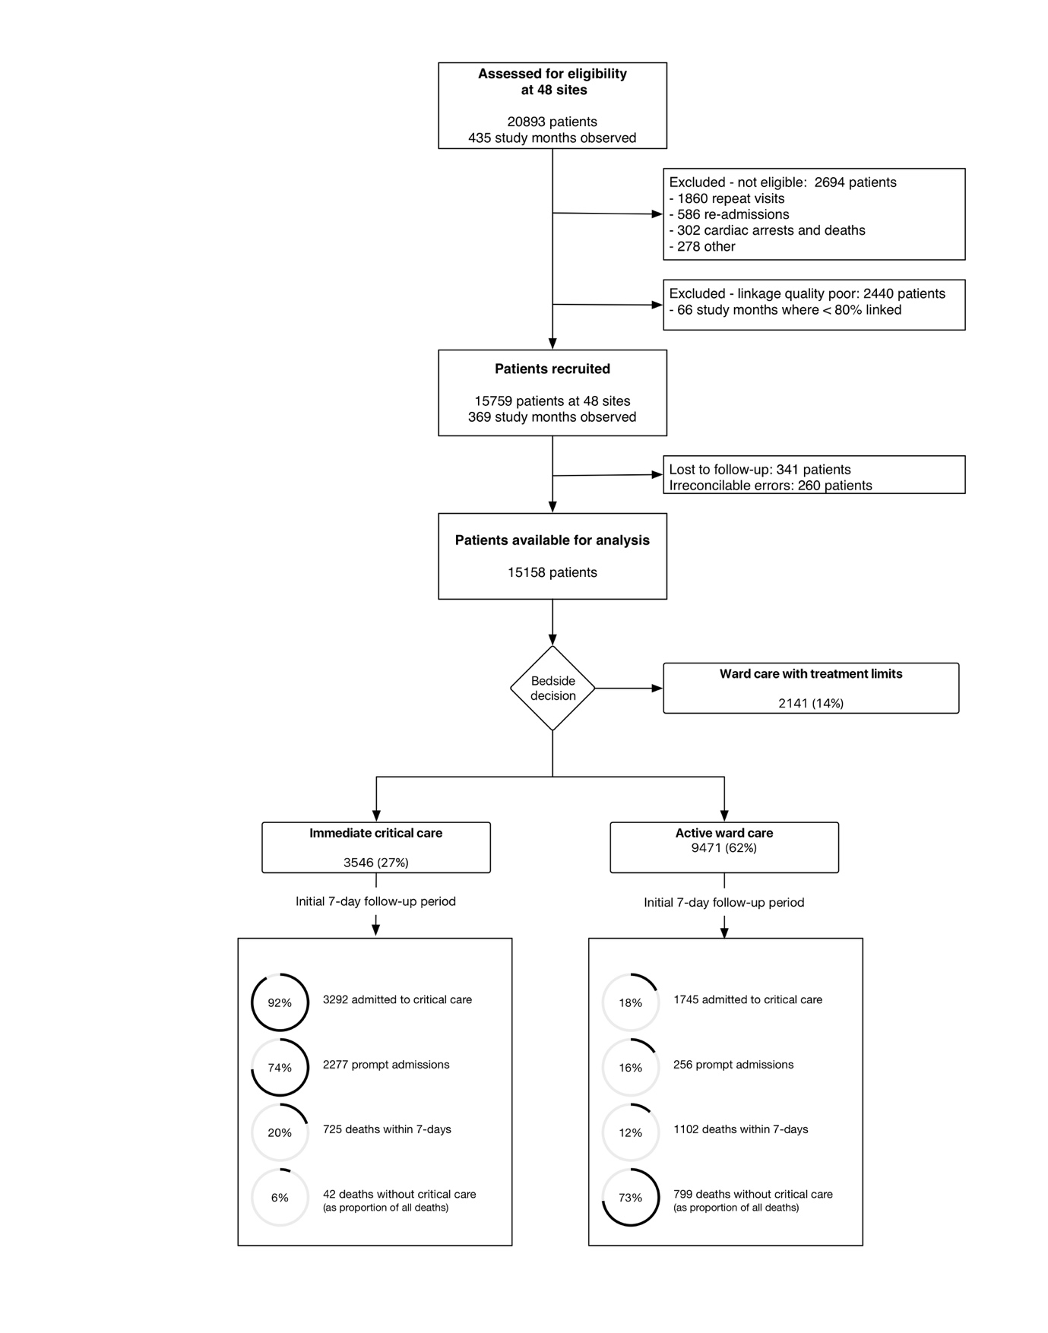

Figure 1: Ward referrals assessed for eligibility at participating hospitals, reasons for exclusion, and the decision made on ward assessment by critical care with first week outcomes.

Figure 2

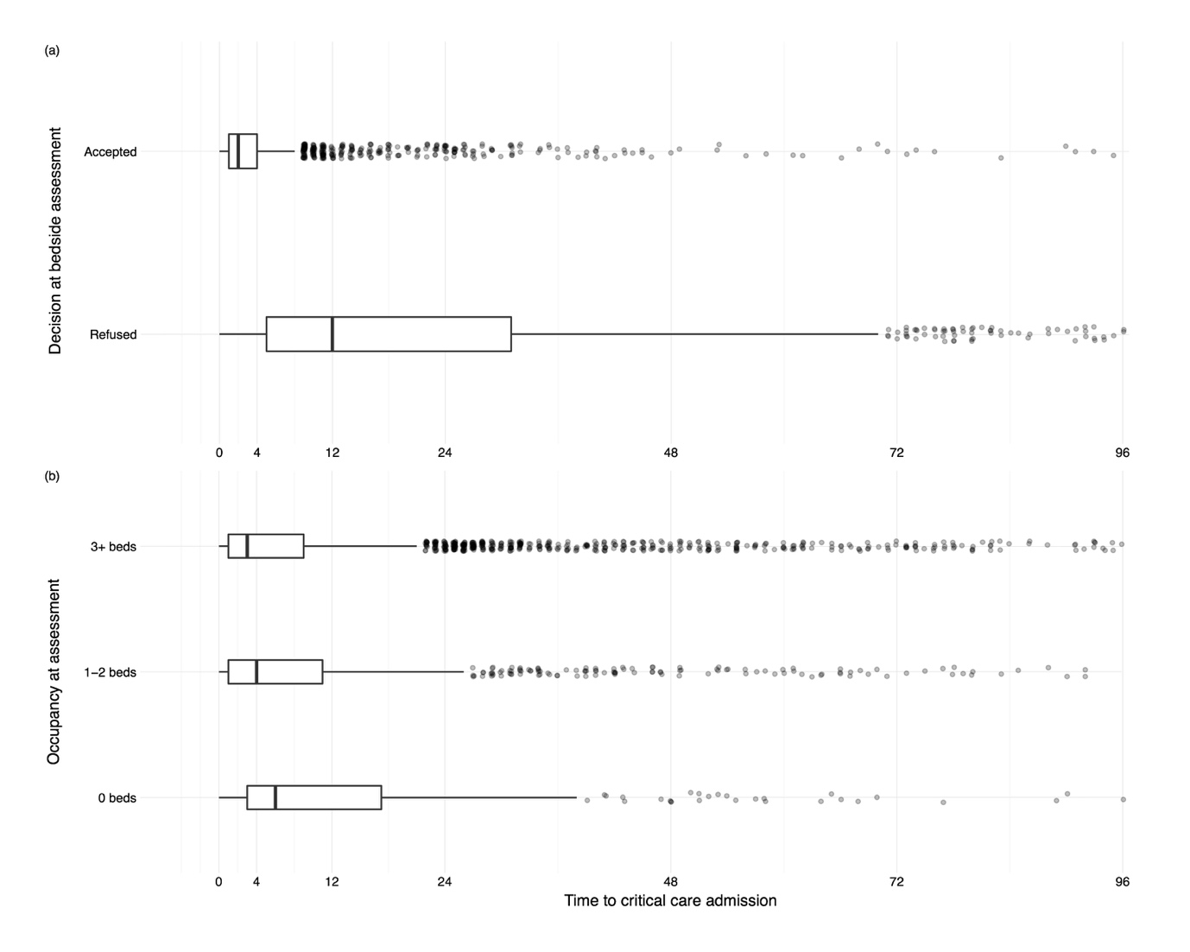

Figure 2: Time to admission to critical care following bedside assessment for the deteriorating ward patient by (A) the decision at the bedside assessment, and (B) by critical care occupancy.

# Supplementary Tables

# Supplementary Table 1

|  |  |  |  |  |  |  |  |
| --- | --- | --- | --- | --- | --- | --- | --- |
|  | All patients | | |  | NEWS High Risk patients | | |
|  | IRR (95%CI) | | p-value |  | IRR (95%CI) | | p-value |
| Teaching hospital | 1.085 | (1.014, 1.161) | 0.018 |  | 1.113 | (1.027, 1.207) | 0.009 |
| Admissions (per 1,000 overnight admissions) | 1.003 | (1.002, 1.004) | <0.001 |  | 1.005 | (1.004, 1.006) | <0.001 |
| Critical care outreach provision |  |  |  |  |  |  |  |
| None | 0.558 | (0.486, 0.640) | <0.001 |  | 0.631 | (0.536, 0.743) | <0.001 |
| Less than 7 days/week | 0.574 | (0.534, 0.616) | <0.001 |  | 0.628 | (0.577, 0.685) | <0.001 |
| 7 days/week | 0.697 | (0.655, 0.742) | <0.001 |  | 0.726 | (0.672, 0.783) | <0.001 |
| 24 hours/day 7 days/week | Reference | | |  | Reference | | |
| Critical care beds | 0.988 | (0.984, 0.992) | <0.001 |  | 0.989 | (0.984, 0.994) | <0.001 |
| Winter (Dec-Mar) | 1.091 | (1.031, 1.155) | 0.003 |  | 1.183 | (1.105, 1.266) | <0.001 |
| Weekend | 0.83 | (0.800, 0.860) | <0.001 |  | 0.867 | (0.818, 0.918) | <0.001 |
| Baseline incidence | 1.655 | (1.531, 1.788) |  |  | 0.557 | (0.523, 0.593) |  |

Supplementary Table 1: Baseline incidence (patients referred to and assessed by critical care per day) for participating hospitals for all patients, and for the subgroup meeting the National Early Warning Score (NEWS) High Risk criteria, and hospital and timing level factors affecting the rate.

Supplementary Table 2

|  |  |  |  |
| --- | --- | --- | --- |
|  | Hazard ratio (95% CI) | | p-value |
| Age category (years) |  |  |  |
| 18-39 | *Reference* | | |
| 40-59 | 1.98 | (1.65--2.37) | <0.001 |
| 60-79 | 3.07 | (2.59--3.64) | <0.001 |
| 80+ | 4.44 | (3.74--5.28) | <0.001 |
| Male | 1.08 | (1.01--1.15) | 0.016 |
| Sepsis diagnosis |  |  |  |
| Not septic | *Reference* | | |
| Unspecified sepsis | 1.14 | (1.03--1.26) | 0.011 |
| Genito-urinary sepsis | 0.67 | (0.57--0.77) | <0.001 |
| Abdominal sepsis | 0.96 | (0.85--1.08) | 0.465 |
| Chest sepsis | 1.30 | (1.21--1.40) | <0.001 |
| Pre-existing organ support | 1.10 | (0.98--1.24) | 0.110 |
| ICNARC physiology score |  |  |  |
| Day 0-6 effect | 1.07 | (1.06--1.07) | <0.001 |
| Day 7+ modifier | 0.97 | (0.96--0.98) | <0.001 |
| Reported to be peri-arrest |  |  |  |
| Day 0-6 effect | 1.62 | (1.38--1.90) | <0.001 |
| Day 7+ modifier | 0.62 | (0.48--0.80) | <0.001 |
|  |  |  |  |
| Assessment timing |  |  |  |
| Out-of-hours (7pm-7am) | 0.97 | (0.90--1.03) | 0.294 |
| Saturday/Sunday | 1.06 | (0.99--1.14) | 0.102 |
| Winter (Dec-Mar) | 1.04 | (0.97--1.12) | 0.253 |
| Bed pressure |  |  |  |
| Low (3 or more beds) | *Reference* | | |
| Medium (1-2 beds) | 1.11 | (0.99--1.25) | 0.086 |
| High (0 or fewer beds) | 1.07 | (1.00--1.15) | 0.060 |

Supplementary Table 2: Association between patient level predictors, and 90-day survival in a single level model to permit evaluation of effects that might be mediated, rather than confounded by, the hospital. For example, if poor survival occurs because a hospital runs critical care at full capacity then the effect of bed pressure would be underestimated in a multi-level model that attributed some of the mortality difference to the hospital effect instead.

# Supplementary Figures

Supplementary Figure 1

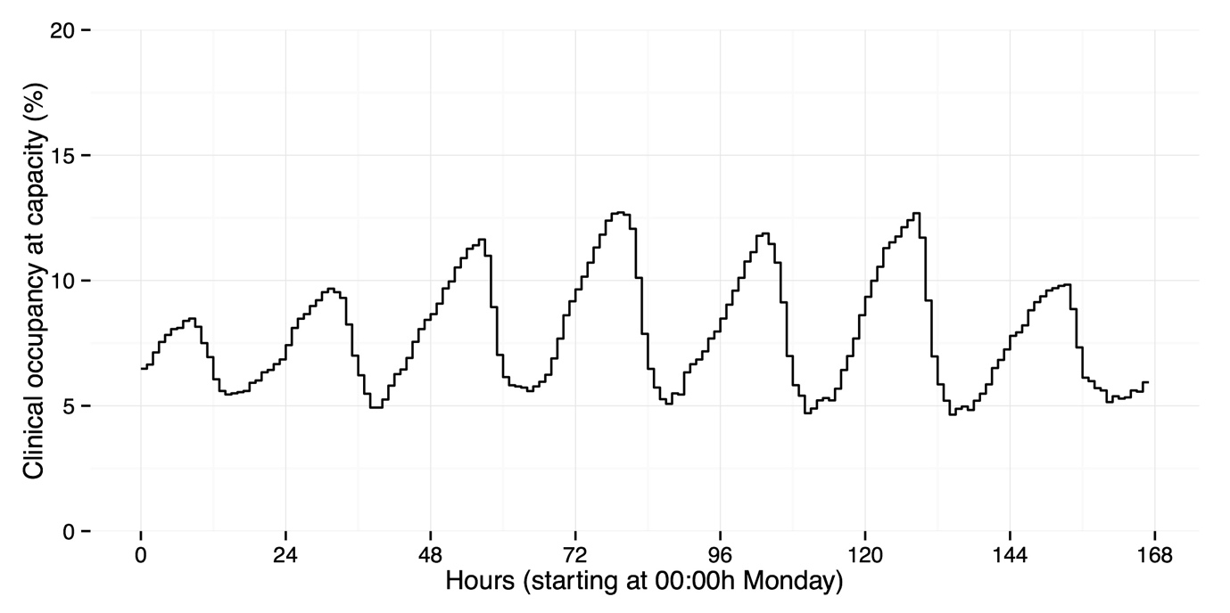  
Supplementary Figure 1: Mean proportion of units fully occupied by time of day and day of week averaged over all periods and units observed in the study.

Supplementary Figure 2

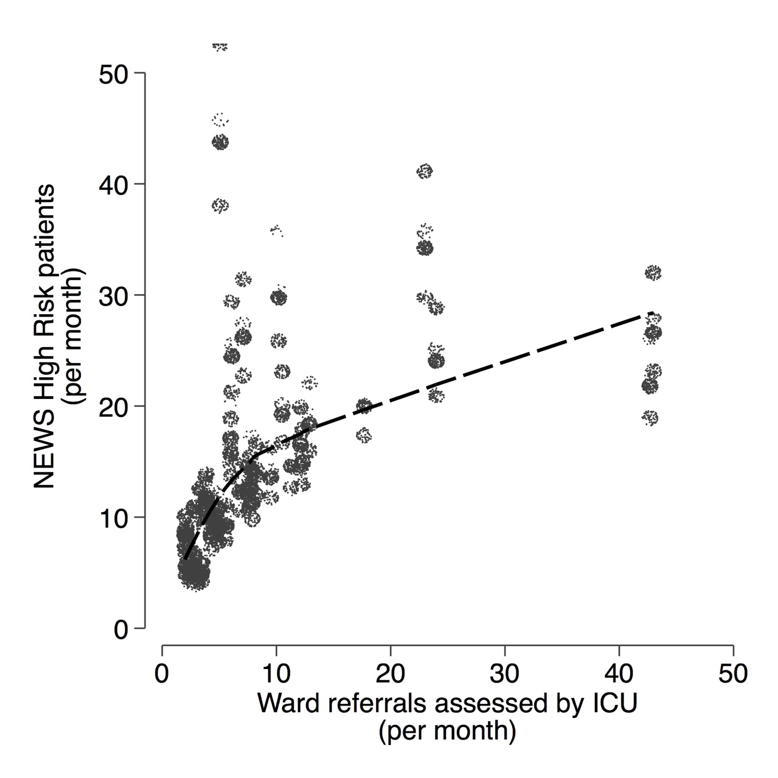

Supplementary Figure 2: Patients reported meeting the National Early Warning Score (NEWS) High Risk criteria plotted against all ward referrals to the ICU (per month) suggesting that as case finding increases the proportion of high risk cases found falls.

Supplementary Figure 3

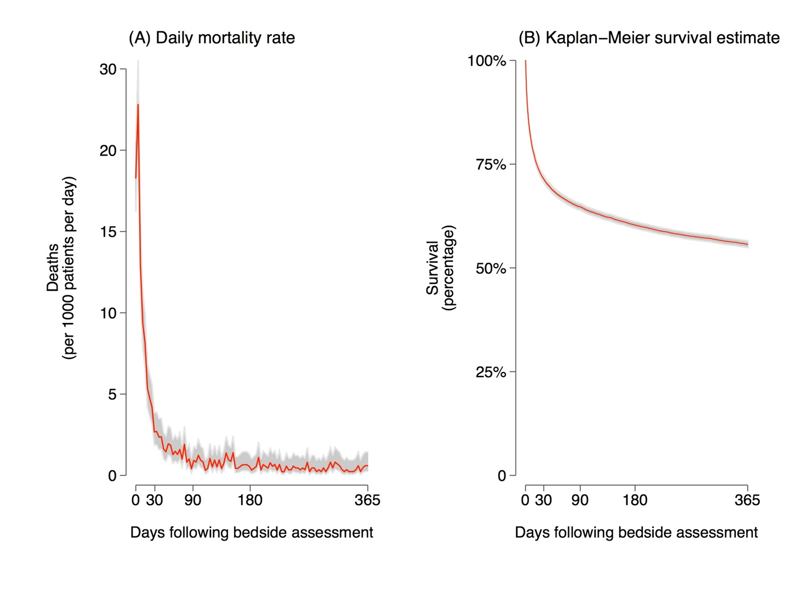

Supplementary Figure 3: Daily mortality rate (a) and survival curve (b) for all patients showing that the period of greatest risk immediately follows referral, and and then falls rapidly.

Supplementary Figure 4

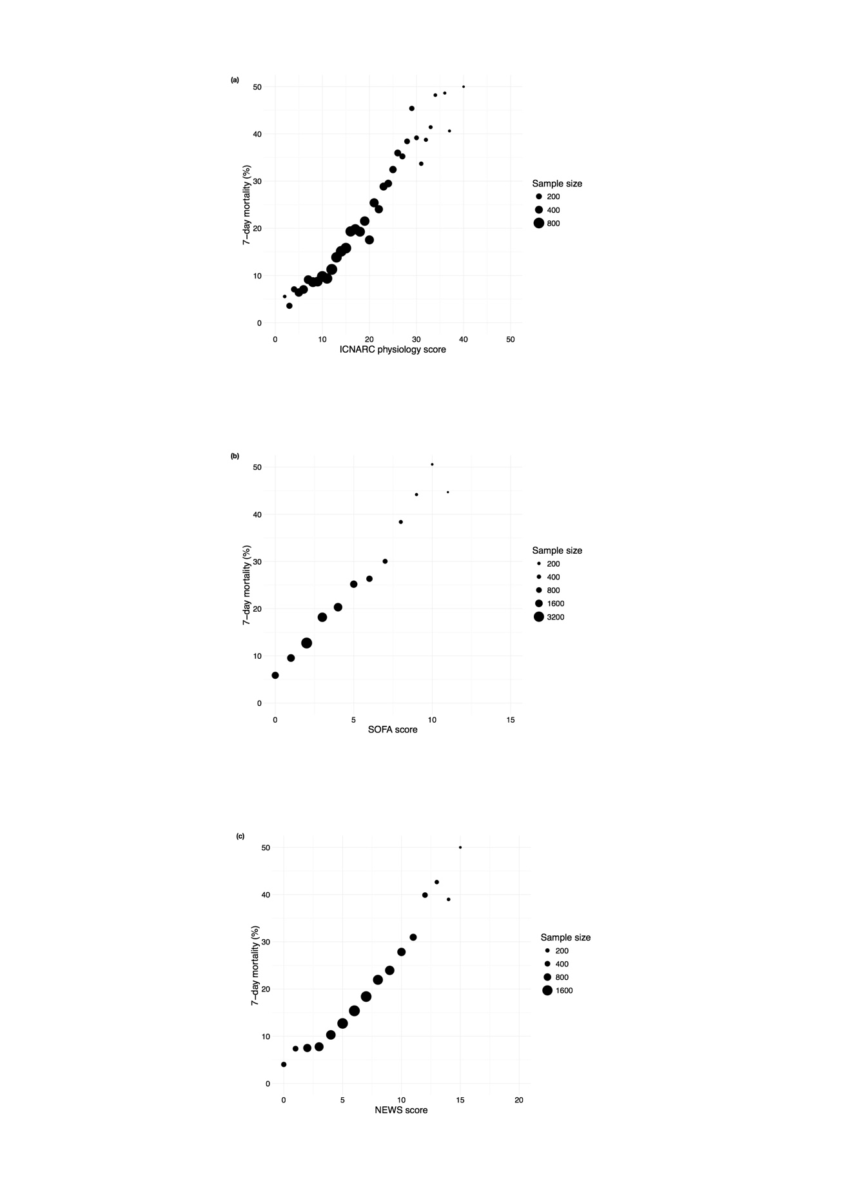

Supplementary Figure 4: Relationship between measured severity of illness and acute (7-day) mortality for (a) the ICNARC physiology score (b) the SOFA score, and (c) the NEWS score.

Supplementary Figure 5

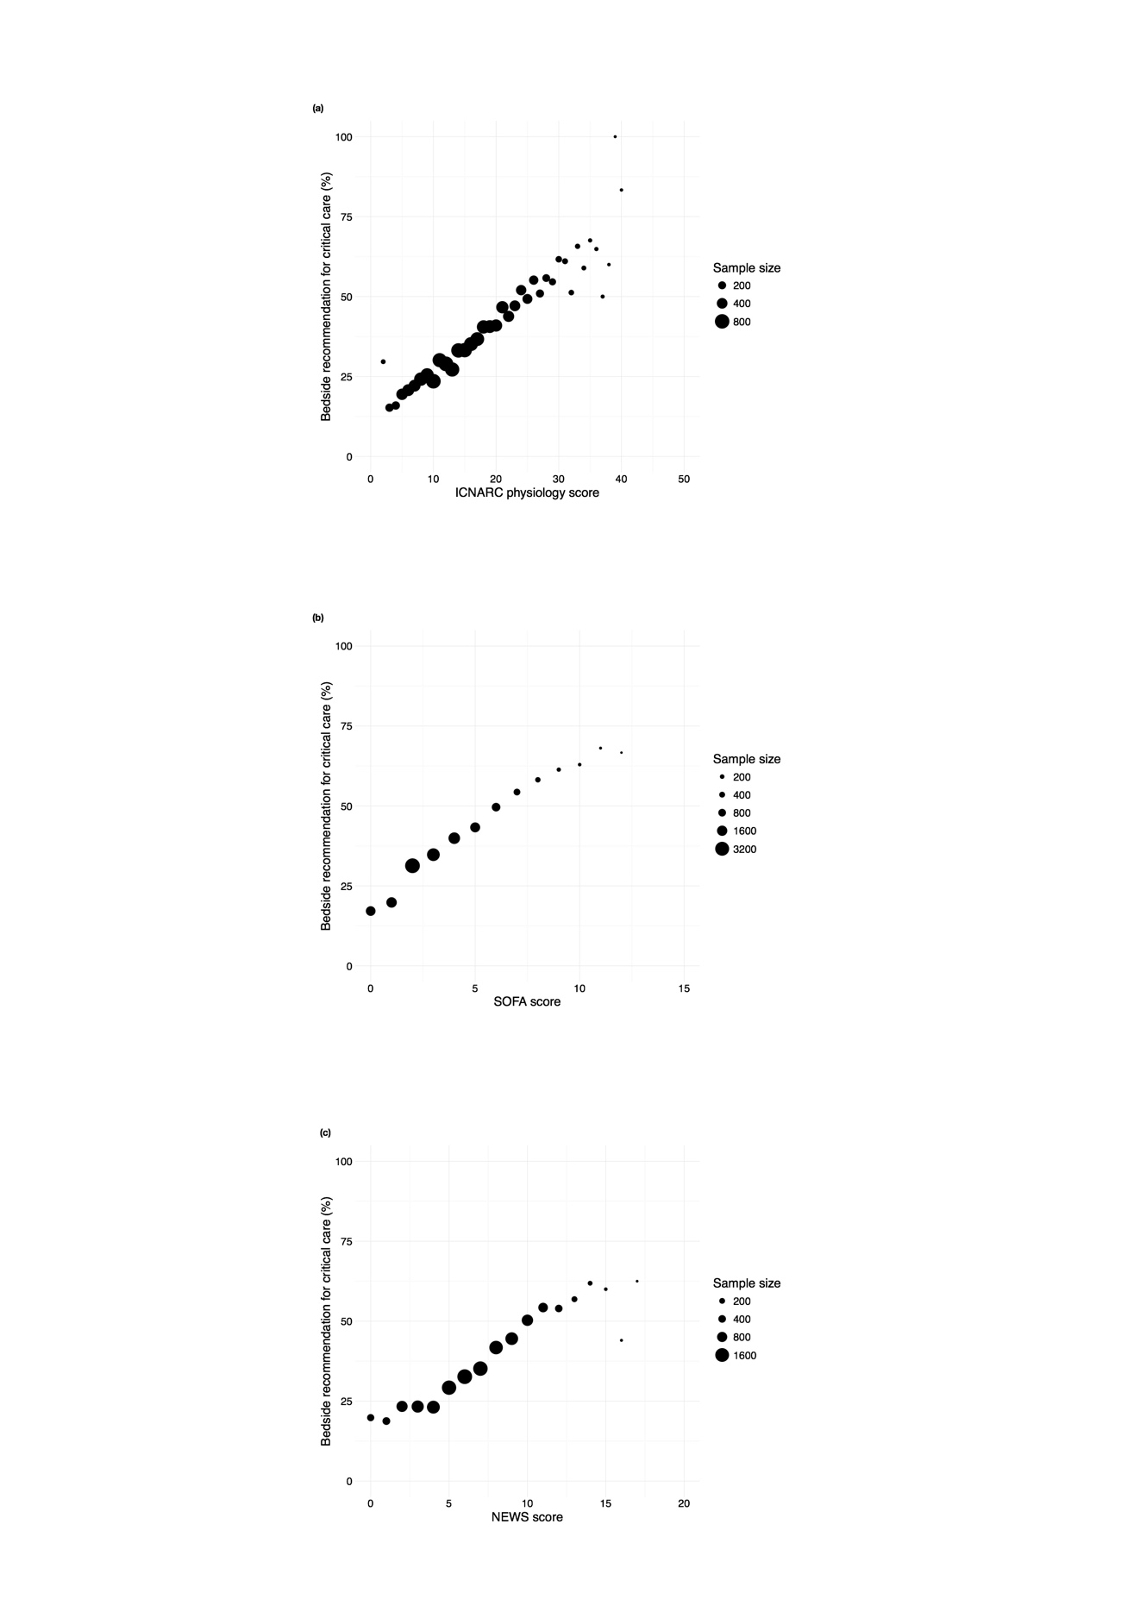

Supplementary Figure 5: Relationship between measured severity of illness and the recommendation for critical care made at the ward assessment for (a) the ICNARC physiology score (b) the SOFA score, and (c) the NEWS score.

Supplementary Figure 6

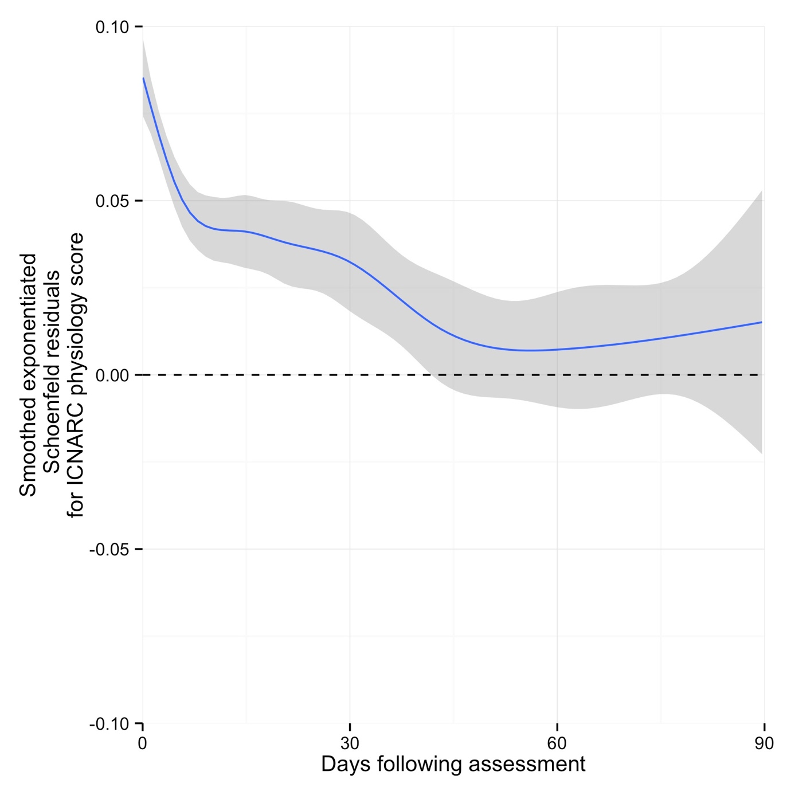

Supplementary Figure 6: Plots of smoothed exponentiated standardised Schoënfeld residuals for the ICNARC physiology score in the 90-day survival model demonstrating that the proportional hazards assumption is violated because of differential early effect on surviva.