Institute of space and defense electronics, vanderbilt university
ISDE: Hardware Testing Platform
Preliminary Design Review
Senior Design Project

Team Members:
Anas Alfuntukh
Nadiah Zainol Abidin
Jack Minardi (Project Leader)

Project Contact:
Dr. Daniel Loveless, Vanderbilt University

February 2012

Appendix
- Abstract
- Context
- Project Description
- Graphical User Interface Design
- Interface and Software Development Documentation
- Future Advancement
- Work Break Down and Schedule
- Resources and Hardware
- Validation and Verification
- Risks
- Table of Figures

- Abstract

- Context

Description of sponsor
The sponsor for this project is the Institute of Space and Defense Electronics (ISDE), while the advisor of the project is Dr. Loveless. ISDE was established by the Radiation Effects Group at Vanderbilt in January of 2003. The mission of ISDE is to ‘contribute to the design and analysis of radiation hardened electronics, the development of test methods and plans for assuring radiation hardness, and the development of solutions to specific problems related to radiation effects‘(ISDE). ISDE has extensive experience in conducting single-event tests. They have conducted their tests at facilities including Brookhaven National Laboratory, Michigan State University, and Indiana University. ISDE has access to a suite of radiation sources and fully quipped parts analysis laboratory.

Contributing to sponsors goals
The main reason behind this project is to save the time and cost of radiation testing the hardware for our sponsor. One hour of radiation testing the hardware costs the sponsor approximately $1000. If we can save a few minutes out of one hour, for the many days and weeks that ISDE takes to radiation test the ICs each time, we can help save an enormous amount of money and time.
The problem with the current method is, they can only generate data at the testing center, but only process the data once they get back to their own labs. This is a big problem, because if there were errors committed during the testing, they would not know unless they have processed the data. If the sponsor has to do redo any testing that usually costs more than $100 000, this is clearly a big loss to the sponsor.
To achieve this goal and also to rectify the problem with the current method, our team designed a software platform that will help the sponsor execute the hardware testing more efficient. This will cut down a significant amount of time and cost for each test. Our software will also help the tester to process data in real time while data is being generated, thus solving the problem of having to redo a radiation test due to configuration error.

- Project Description
  - Project structure and the environment
The high-level design of the project
We are designing a GUI to process and display real-time data from radiation experiments. The system needs to be extensible to allow the user to choose which analysis they would like to display for each experiment including choosing which devices are connected and/or monitored as well as what plots are displayed.

The platform
The platform will be Linux environment

The implementation language used
The implementation language used will be in python because the researchers that designed the current method for radiation testing have been doing it in python. Having the knowledge of handling codes in python would allow them to maintain the code after the completion of our initial project. Also, it would allow them to create new components and tests as they are necessary.

The expected lifetime of the project
The project lifetime is currently unknown, but the software will continue to be used for at least the next few years.

The software and hardware engineering tools
The testing hardware will communicate with the software through an Ethernet connection to the GBIP devices that are chained together. The GPIB is a General Purpose Interface Bus, an IEEE 488 standard parallel interface used for attaching sensors and programmable instruments to a computer. Using a 24-pin connector, up to 15 devices can be chained together. Tests will most likely be conducted in the radiation lab of Vanderbilt University. For the software, we will be using PyQt, Quartus, gnuplot tied together by Python programming language

- Graphical User Interface Design

4.0 Welcome Window
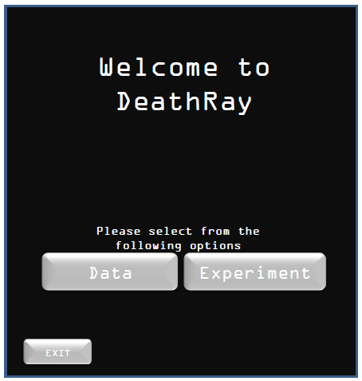

4.1.0 Data Window
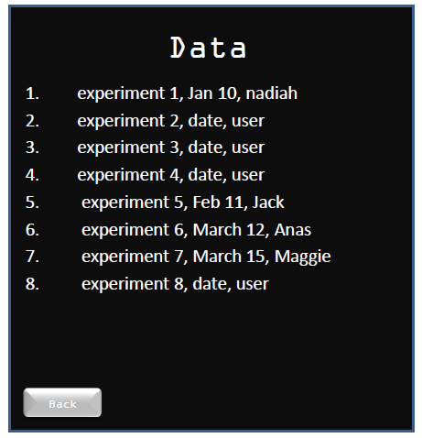

4.1.1 Selected Experiment
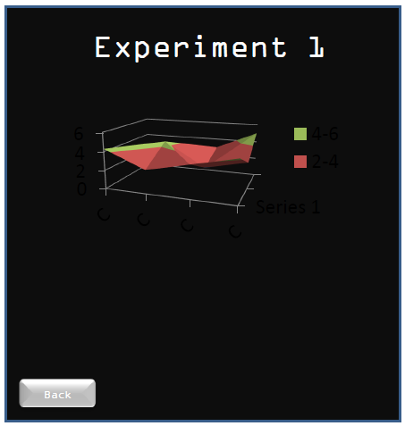
4.2.0 Experiment Window
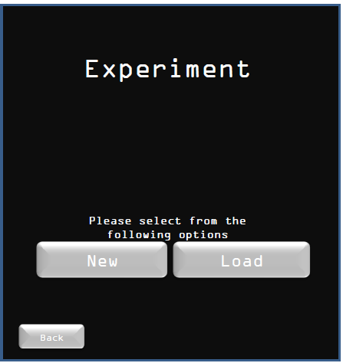

4.2.1.0 New Experiment Window
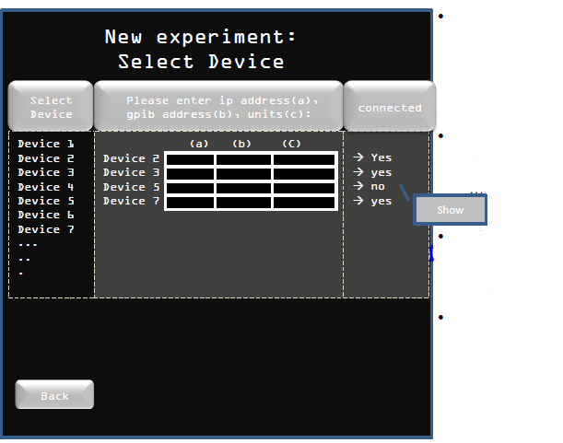

4.2.1.2 New Experiment: Device Configuration
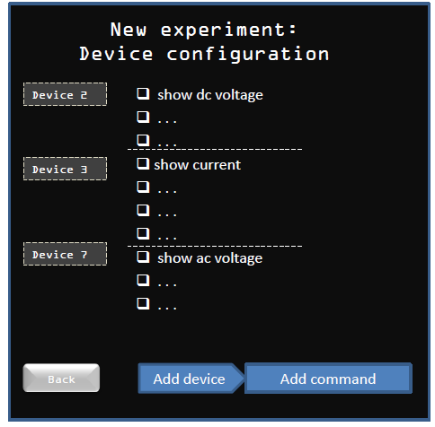

4.2.1.3 New Experiment: Selecting Plot Features and Data
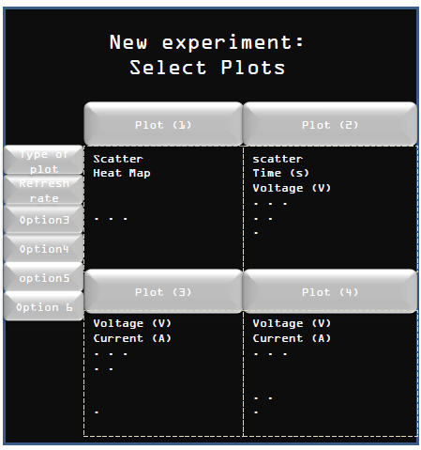
4.2.1.4 New Experiment: Confirming Experiment

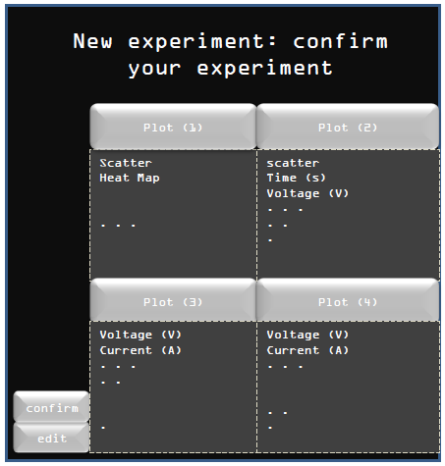
4.2.0 Experiment Window
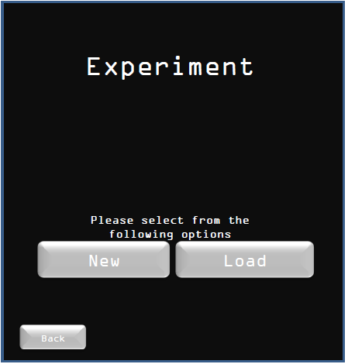

4.2.2.0 Load Experiment: Load Saved Configurations
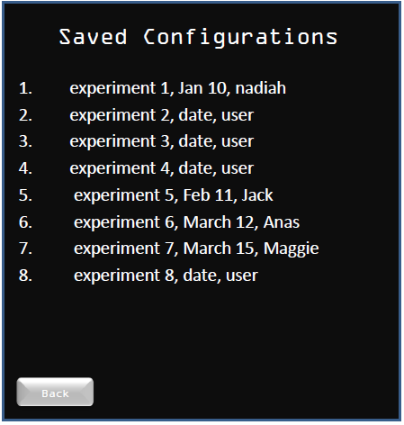

4.2.2.1 Load Experiment: Load Saved Configurations
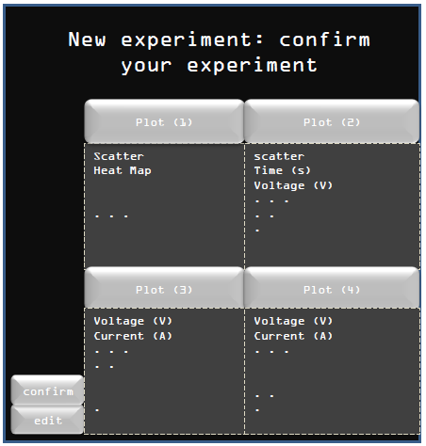

4.2.2.2 Load Experiment: Load Saved Configurations
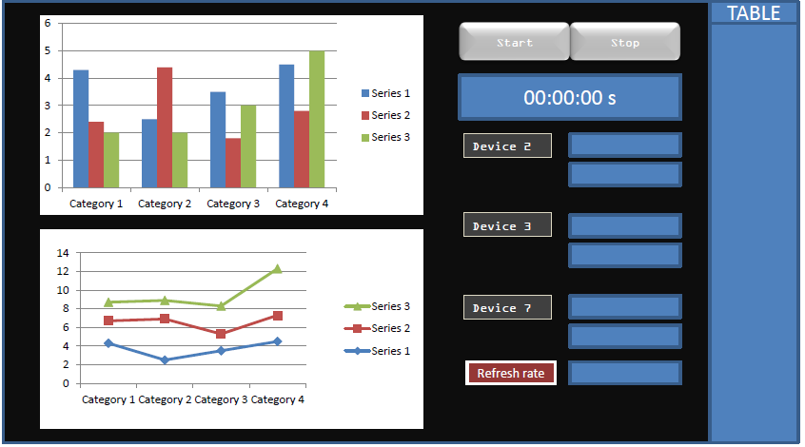

- Interface and Software Development Documentation
- Future Advancement

- Work Break Down and Schedule

Work Break Down
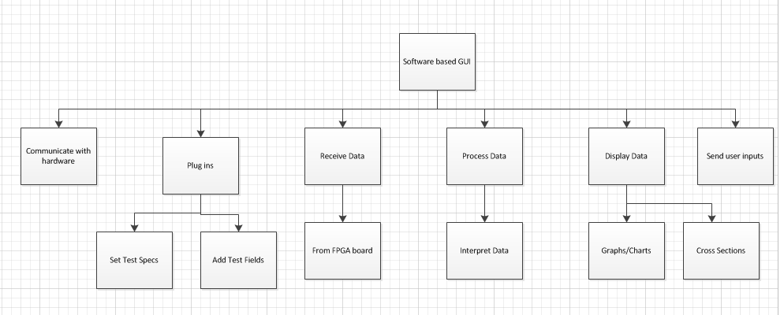

Flowchart of Work
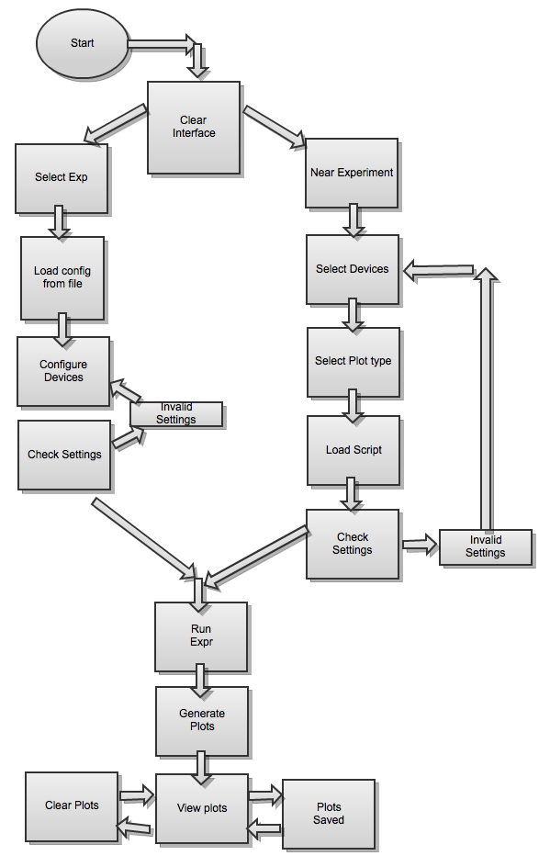

Network Diagram
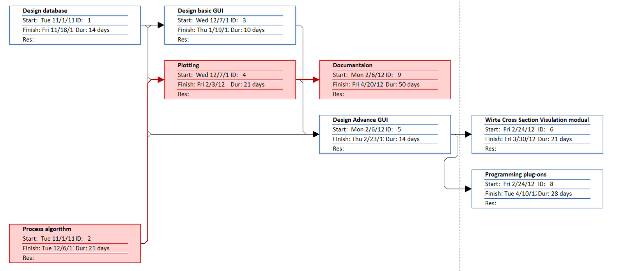

Gantt Chart
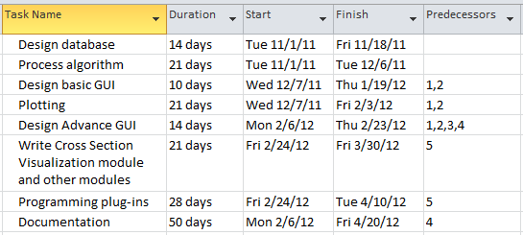

- Resources and Hardware

Resources required to fulfill components of the work breakdown structure
For all the components of the work breakdown structure, computer, python language program, and FPGA board is required. If we need to work in the lab, a graduate student or the advisor will be supervising us.
Communicate with Hardware
To communicate with the hardware, we need a GPIB. The GPIB device was already explained in the 2.0 section. GPIB uses Ethernet to communicate with devices. Each device is assigned a unique ID for this purpose. So far, this is the only means of communicating with the hardware specified by our sponsor.

Receive Data
  - From FPGA board
The FPGA board is connected to the device under testing (DUT). DUT has an infinite number of possible devices. We will also need Ethernet for the GPIB communication. DUT will provide us with the data scripts needed for our software. This will be done in the lab.
Display Data
- Graphs
- Cross Sections
To display data we will use gnuplot and tie it with the python program. It is a portable command-line driven graphing utility for linux, and many other platforms. gnuplot will help us to visualize mathematical functions and data interactively. This can be done in the lab or outside the lab.
Plug-ins
- Set test specs
- Add test fields
The plug-ins will be made using gnuplot and Quartus scripts, tied to Python as how the sponsor desires. We will be receiving guidance from Dr. Nine, a senior software engineer in ISIS to do the plug-ins.
Process Data and Interpret Data
To process data and interpret it, we still are using gnuplot tied to our python program. This can be done in the lab or outside the lab.

Send User Input
Sending user input is done using PyQt program. PyQt is a set of Python bindings for Nokia’s Qt application framework and runs on all platforms supported by Qt including Windows, MacOS/X and Linux. This will be done in the lab.

Work Breakdown Structure

