**GENERAL BIOLOGY OF PTERIDOPHYTS**

Pteridophyta are a group of plants which are well known as ferns and are considered as some of Earth’s first land plants. Pteridophytes are mostly terrestrial or aquatic and some species are also epiphytes that grow without soil on the branches of trees. More than 12,000 different species of ferns are distributed worldwide. The adult plant body in these plants is known as a sporophyte i.e. it shows differentiation into true roots, stem and leaves. The stem is mostly **herbaceous**. They are generally considered non-woody plants, but some giant ferns can be considered semi-woody. Leaves may be smaller or larger. They are "vascular plants" with well-developed internal vein structures (with xylem and phloem) that promote the flow of water and nutrients. Roots are simple and arise adventitiously along the rhizomes near the base of the stems.

The pteridophytes are (relatively) delicate plants that only grow in areas where there are suitably moist conditions. They favour sheltered areas under the forest canopy, along creeks and streams and other sources of permanent moisture. They cannot grow readily in hot dry areas like flowering plants and conifers. Ferns are strongly distinguished from other plants by their method of reproduction. Instead of producing seeds like other flowering plants, they reproduce by producing spores. Reproduction involves production of **spores** inside special structures called **sporangia** which occur on the ventral surface of fertile leaves called **sporophylls**.

The plants may be **homosporous** - producing only one type of spore or **heterosporous** - producing two different types of spores; smaller **microspores** and larger **megaspores**.

The spores germinate to produce a haploid gametophyte, called prothallus. The homosporous pteridophytes produce **bisexual** gametophytes while heterosporous pteridophytes produce **unisexual** gametophytes.

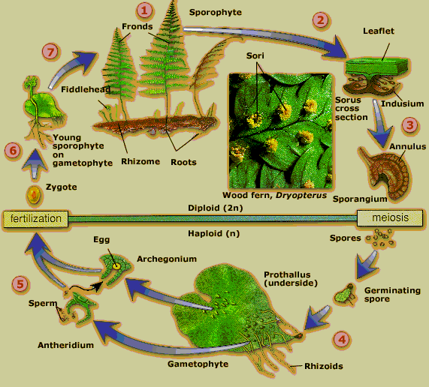In gametophytes, reproduction is of oogamous type. The male sex organs are called antheridia and female sex organs are called archegonia. Antheridia produce antherozoids and archegonia enclose the egg cell. Fertilisation requires water. The diploid zygote is retained in the archegonial venter (neck of archegonia) where it develops into an embryo. Subsequently it becomes a young sporophyte and grows into an independent adult plant. Thus the life cycle includes an alternation of diploid sporophytic generation with a haploid gametophytic generation. Sporophytic generation is dominant in the life cycle. Seed formation never takes place in living pteridophytes. An embryo develops in situ after fertilization and the sporophyte remains attached to the gametophyte till the development of root. Plants show clear alternation of generations. The sporophyte and gametophyte are independent of each other.

**Economic importance**

**Horticulture** – Many Pteridophytes or ferns are popular horticultural plants and are grown as landscape plants, for [cut foliage](http://en.wikipedia.org/wiki/Foliage) and also as [houseplants](http://en.wikipedia.org/wiki/Houseplant). E.g. [*Nephrolepis*](http://en.wikipedia.org/wiki/Nephrolepis) spp. (Boston fern), *Asplenium nidus* (The [Bird's Nest Fern](http://en.wikipedia.org/wiki/Asplenium_nidus)), etc.

**Fossil fuel** - Several hundred million years ago ferns and fern allies were the dominant terrestrial plants. Thus, the fossils of these plants have contributed greatly to the formation of our fossil fuels—coal, oil and [natural gas](http://science.jrank.org/pages/4569/Natural-Gas.html).

**Food** - Various non-western cultures have used the starch rich rhizome and stems of some fern species as a food. Tubers from the King fern (*[Ptisana salicina](http://en.wikipedia.org/wiki/Ptisana_salicina" \o "Ptisana salicina)*) are a traditional food in [New Zealand](http://en.wikipedia.org/wiki/New_Zealand) and the [South Pacific](http://en.wikipedia.org/wiki/Oceania). Fern tubers were used for food 30,000 years ago in Europe. Also some of the fern varieties like ostrich fern (*Matteuccia struthiopteris*), fiddleheads of [bracken](http://en.wikipedia.org/wiki/Bracken) (*Pteridium aquilinum*) and [cinnamon fern](http://en.wikipedia.org/wiki/Cinnamon_fern) (*Osmundastrum cinnamomeum*) are also known to served in salads or as a steamed vegetable.

**Medicine** - Herbalists have advocated some fern species for treatment of [ulcers](http://science.jrank.org/pages/7073/Ulcers.html), rheumatism, intestinal infections, and various other ailments.

**Biological Fertilizer** - Ferns of the genus *Azolla* commonly known as mosquito fern are very small, floating plants have ability to fix nitrogen from the air into compounds that can then be used by other plants, are used as a biological fertilizer in the rice paddies of Southeast Asia.

**Removal of heavy metals** - Ferns have been studied and found to be useful in the removal of heavy metals, especially arsenic, from the soil.

**Noxious weeds** - Several ferns are noxious [weeds](http://en.wikipedia.org/wiki/Weed) or [invasive species](http://en.wikipedia.org/wiki/Invasive_species). E.g. Japanese climbing fern (*[Lygodium](http://en.wikipedia.org/wiki/Lygodium" \o "Lygodium) japonicum*), mosquito fern (*Azolla* spp.) and [sensitive fern](http://en.wikipedia.org/wiki/Sensitive_fern) (*Onoclea sensibilis*).

Giant water fern (*[Salvinia molesta](http://en.wikipedia.org/wiki/Salvinia_molesta" \o "Salvinia molesta)*) is one of the world's worst aquatic weeds.