Basic Diagnostic and Coding Procedures
DSM-5-TR · Professional Tip · Dr. Brian Campbell · Revised 2024
Watch the narrated video presentation (about 6 minutes)
The information presented below was taken from the DSM-5-TR manual. Quotation marks are not utilized for direct quotations, because much of the information is directly quoted from the source.
American Psychiatric Association. (2022). Diagnostic and statistical manual of mental disorders (5th ed., text rev.). https://doi.org/10.1176/appi.books.9780890425787
INTRODUCTION
- Diagnostic codes are important for medical record-keeping, statistical analysis, and for third-party medical insurance payments.
- Medicare and Medicaid, as well as private insurance companies, use diagnostic codes as the basis for reimbursing individuals for the services rendered by providers.
- The World Health Organization's newest classification, the ICD-11 (International Classification of Diseases, Eleventh Revision), took effect worldwide on January 1, 2022. However, the United States has not yet adopted ICD-11. U.S. insurance claims still use the ICD-10-CM (International Classification of Diseases, Tenth Revision, Clinical Modification), and the ICD-11 has not been incorporated into the DSM-5-TR.
- The DSM-5-TR uses the ICD-10-CM codes. In the DSM-5-TR manual, only the ICD-10-CM codes are provided. A few codes change from time to time (updates take effect each October 1), so check the American Psychiatric Association's DSM-5-TR coding updates page (see Sources) for the current codes.
- Insurance companies only reimburse for certain (specific) diagnostic codes. For example, personality disorders are not generally reimbursed.
- You can let your clients be responsible for submitting their own receipts for reimbursement (with the diagnostic code that you provide to them), or your office may take the responsibility to file insurance claims on behalf of the client.
- If you decide to file insurance claims for your client, you normally have to apply to be a qualified provider of services for the insurance company your client is using. If you apply and are accepted to the panel of providers, you will be considered to be an “In-Network Provider.” However, some insurance companies will also accept claims from “Out-of-Network” providers.
- Since January 1, 2024, licensed professional counselors (called “mental health counselors” by Medicare) who meet Medicare's requirements can enroll in Medicare and bill it directly. Whether counselors can bill Medicaid depends on the state, so check your state's Medicaid program.
- The services you provide are billed with CPT (Current Procedural Terminology) procedure codes, and the ICD-10-CM diagnosis code explains why the service was needed. Different CPT codes are reimbursed at different rates. For example, psychological testing may be reimbursed at a different rate than a 45-minute therapy session.
- If you are going to provide billing services for your clients (and most clients expect that you will render this service), you will need to communicate with the client's insurance company and discuss details of “how, when, and where” you submit claims.
- Many insurance companies require that you have precertification/preauthorization before you can render certain services (such as psychological testing).
- Most insurance companies require that you submit your claims electronically. Therefore, you will need a computer and specialized “billing software.”
- There are companies that will handle the entire billing process for you, but they can be expensive.
THE BASIC DIAGNOSTIC DSM-5-TR PROCESS
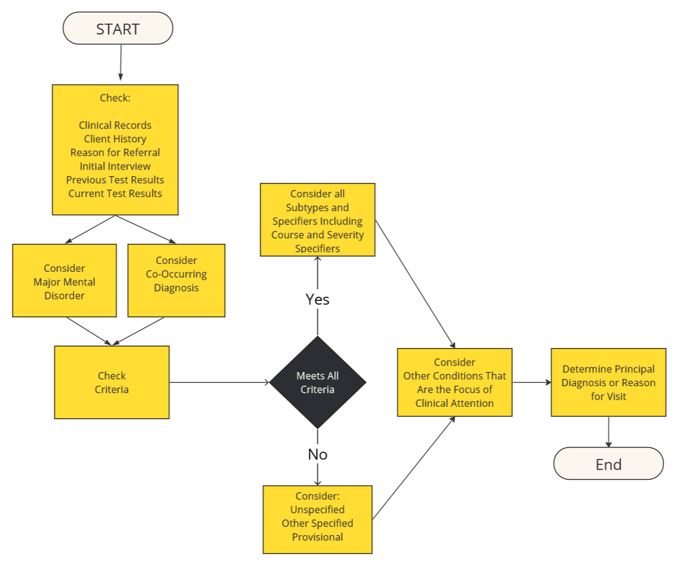
Figure 1. The basic DSM-5-TR diagnostic process. Start by checking the clinical records, client history, reason for referral, initial interview, and previous and current test results. Consider a major mental disorder and any co-occurring diagnosis, then check the criteria. If all criteria are met, add all subtypes and specifiers, including course and severity. If not, consider an unspecified, other specified, or provisional diagnosis. Then consider other conditions that may be a focus of clinical attention (Z codes), and determine the principal diagnosis or reason for visit.
THE DIAGNOSTIC PROCESS AND CODING PROCEDURES
Step 1: Explore the possibility that the client is exhibiting a major mental disorder
Review the background information:
- Client history
- Reason for referral
- Initial interview
- Prior test data
- Current test data
Step 2: Check criteria
In order to diagnose a major mental disorder, you must check to make sure that the diagnosis you are considering meets all of the criteria required and stipulated in the DSM-5-TR manual. This process of checking the criteria for the disorder is a central feature of the diagnostic process.
Typically, there are numerous criteria that must be met in order to diagnose the disorder under consideration. As you check to see if the criteria are met, you may need to check for additional information in the background data of the client, any test data, or the clinical records. You may also need to further interview the client and ask questions relevant to the specific criterion or criteria under consideration.
Step 3: Include any subtypes or specifiers
If all the criteria specified in the DSM-5-TR are met for a disorder, include any of the subtypes and/or specifiers that are listed for that disorder. Subtypes are designated in the criteria for a disorder by the instruction “Specify whether.”
Specifiers are designated in the criteria for a disorder by the instruction “Specify” or “Specify if.” A major disorder may include more than one specifier. It is important to consider all of the specifiers that are designated for a particular disorder.
Example:
F43.10 Posttraumatic stress disorder, with dissociative symptoms, with delayed expression (p. 303)
- “With dissociative symptoms” is the subtype.
- “With delayed expression” is the specifier.
Step 4: Add course or severity specifiers
If applicable to a disorder that meets the required diagnostic criteria, provide course (e.g., “persistent,” “in partial remission,” “in full remission,” “recurrent”) and severity (e.g., mild, moderate, severe, extreme) specifiers to the individual's current presentation. When coding disorders, these specifiers are listed following the name of the major disorder.
Example:
F94.2 Disinhibited social engagement disorder, persistent, severe (p. 299)
- “Persistent” indicates the course of the disorder.
- “Severe” indicates the severity of the disorder.
Note: The course and severity specifiers should only be used if the full criteria are met for the disorder under consideration. For example, if the principal diagnosis is provisional, then these specifiers should not be used (even if they are available for the disorder under consideration).
Step 5: Consider an unspecified disorder or other specified disorder
If full criteria are not met for a disorder under consideration, determine whether the symptom presentation meets the criteria for an “unspecified” or “other specified” designation.
Unspecified disorder: “Unspecified” is typically used when the client does not meet the criteria for a particular disorder, and the clinician chooses not to specify why the client doesn't meet the criteria. The client looks like he/she has some form of this disorder, but he/she does not technically meet the criteria for this disorder.
Duck analogy. Its overall appearance is that of a duck, but it doesn't have webbed feet (which is one of the criteria for calling it a duck). It must be some sort of new species. I think I'll use the “unspecified” diagnosis for this duck. I won't mention it doesn't have webbed feet. I'll just say it is “unspecified” because it looks like a duck, but it doesn't meet all the criteria for a duck.
Diagnosis for the duck: Duck (unspecified).

Example:
F44.9 Unspecified dissociative disorder (p. 348)
Other specified disorder: Use this if you know (and choose to provide) the specific reason that the presentation does not meet the criteria for any specified category within a diagnostic class. This is done by recording the name of the category, followed by the specific reason. For example, for an individual with clinically significant depressive symptoms lasting four weeks, but whose symptomatology falls short of the diagnostic threshold for a major depressive episode, the clinician would record:
Example:
F32.89 Other specified depressive disorder, depressive episode with insufficient symptoms (p. 209)
Duck example: Other specified duck, duck without webbed feet.

Step 6: Consider a provisional diagnosis (diagnostic uncertainty)
If all the criteria are not met for a major mental disorder, consider diagnosing the disorder as provisional. Place the term “provisional” in parentheses following a diagnosis when:
1. Not enough information is available to make a firm diagnosis.
Example: I still need more information to conclusively diagnose this as _____. However, it looks like _____ and, if I had more information, I believe I would be able to diagnose it as _____.
2. The client cannot provide an adequate history in order to determine if the full criteria are met for the disorder.
Example: The client can't provide enough information (or not enough information is provided in the case study) to allow me to definitely determine that he/she has this or that disorder. However, I believe if I could get more information, he/she would meet the criteria for the diagnosis I am listing.
3. The diagnosis relies on the “duration of the illness,” but this information is not available at the time of the assessment.
Example: I'm not sure if the symptom _____ has been present long enough to meet the criteria. However, if I had more information, I believe I would find that the symptom has been present long enough.
Coding of a provisional diagnosis:
F44.81 Dissociative identity disorder (provisional) (p. 330)
Step 7: Consider any additional comorbid (co-occurring) diagnoses
Oftentimes, a client may exhibit more than one major mental disorder. If so, you would follow the same steps as given above to determine whether the co-occurring diagnosis is confirmed or warranted (based on a consideration of the criteria for the disorder).
Step 8: Identify other conditions that may be a focus of clinical attention
If no major mental disorder is diagnosed (Step 1 above), then consider psychosocial or environmental problems that are not considered to be mental disorders but otherwise affect the diagnosis, course, prognosis, or treatment of an individual's mental disorder.
These “other conditions” are normally coded as Z codes. You can include Z codes even if no major diagnosis has been identified. Also, more than one Z code may be applicable. If so, the first Z code listed should be the most important Z code, and it can be identified as the principal diagnosis.
Z codes can be utilized with or without an accompanying mental disorder diagnosis:
- If it is a reason for the current visit;
- If it helps to explain the need for a test, procedure, or treatment;
- If it plays a role in the initiation or exacerbation of a mental disorder; or
- If it constitutes a problem that should be considered in the overall management plan.
The problems and conditions coded as Z codes are not mental disorders. Their inclusion in DSM-5-TR is meant to draw attention to the scope of individual issues relevant to clinical practice.
The relevant codes are discussed in the DSM-5-TR chapter entitled “Other Conditions That May Be a Focus of Clinical Attention.” The Z codes are located on pages 821–836 and are categorized under the following headings:
- Suicidal behavior and nonsuicidal self-injury (suicidal behavior is potentially self-injurious behavior with at least some intent to die; nonsuicidal self-injury is intentional self-inflicted damage to the body in the absence of suicidal intent).
- Abuse and neglect (e.g., child and adult maltreatment and neglect problems, including physical abuse, sexual abuse, neglect, and psychological abuse).
- Relational problems (e.g., parent-child relational problem, sibling relational problem, relationship distress with spouse or intimate partner, disruption by separation or divorce).
- Educational problems (e.g., illiteracy or low-level literacy, schooling unavailable or unattainable, failed school examinations, underachievement in school).
- Occupational problems (e.g., unemployment, change of job, threat of job loss, stressful work schedule, discord with boss and workmates).
- Housing problems (e.g., homelessness; inadequate housing; discord with neighbor, lodger, or landlord).
- Economic problems (e.g., lack of adequate food or safe drinking water, extreme poverty, low income).
- Problems related to the social environment (e.g., problems related to living alone, acculturation difficulty, social exclusion or rejection).
- Problems related to interaction with the legal system (e.g., conviction in criminal proceedings, imprisonment or other incarceration, problems related to release from prison, problems related to other legal circumstances).
- Problems related to other psychosocial, personal, and environmental circumstances (e.g., problems related to unwanted pregnancy, victim of crime, victim of terrorism).
- Problems related to access to medical and other health care (e.g., unavailability or inaccessibility of health care facilities).
- Circumstances of personal history (e.g., personal history of psychological trauma, military deployment).
- Other health service encounters for counseling and medical advice (e.g., sex counseling, other counseling or consultation).
- Additional conditions or problems that may be a focus of clinical attention (e.g., wandering associated with a mental disorder, uncomplicated bereavement, phase of life problem).
Step 9: Determine the principal diagnosis or reason for visit
Determining the principal diagnosis or reason for visit depends on the setting.
Hospital (inpatient) setting: If more than one diagnosis is given, the principal diagnosis is the condition established after study to be chiefly responsible for “occasioning the admission” of the client.
Outpatient setting: If more than one diagnosis is given, the “reason for visit” is the condition that is chiefly responsible for the ambulatory care and medical services given during the visit. In most cases, the principal diagnosis or reason for the visit is also the main focus of attention or treatment. It is often difficult (and somewhat arbitrary) to determine which diagnosis is the principal diagnosis or reason for the visit, especially when, for example, a substance-related diagnosis such as alcohol use disorder is accompanied by a non-substance-related disorder such as schizophrenia.
- The principal diagnosis (inpatient setting) or reason for visit (outpatient setting) is listed first if you diagnose more than one major disorder.
- The remaining disorders are listed in order of focus of attention in treatment.
- If the criteria are met for the principal diagnosis (or the reason for visit), then when you list the diagnosis you would include the qualifying phrase “(principal diagnosis)” or “(reason for visit)” following the diagnosis.
Examples:
F41.1 Generalized anxiety disorder (principal diagnosis) (p. 250), or
F41.1 Generalized anxiety disorder (reason for visit)
Note: If the principal diagnosis (or reason for visit) is a mental disorder caused by a medical condition (such as Alzheimer's disease), ICD coding rules require that the etiological medical condition be listed first. In that case, the principal diagnosis or reason for visit would be the mental disorder that is due to the medical condition, and it would be the second diagnosis listed. For maximum clarity, the disorder listed as the principal diagnosis or the reason for visit can be followed by the qualifying phrase “(principal diagnosis)” or “(reason for visit).”
Example:
I69.398 Cerebral infarction
F06.8 Obsessive-compulsive and related disorder due to cerebral infarction, with obsessive-compulsive disorder–like symptoms (principal diagnosis) (p. 291)
Note: If no major mental disorder is diagnosed, then “Other Conditions That May Be a Focus of Clinical Attention” (i.e., Z codes) could be listed first and could be designated as the principal diagnosis or reason for visit.
Examples:
Z56.9 Other problem related to employment (principal diagnosis) (p. 831), or
Z56.9 Other problem related to employment (reason for visit)
Coding Z codes
Example:
Z62.820 Parent-child relational problem, parent–biological child (p. 829)
Remember, the Z codes would “come after” you list any major mental disorder you diagnose and any co-occurring major mental disorders. The principal diagnosis (or reason for visit) is indicated by listing it first. The remaining disorders/problems are listed in order of focus of attention in treatment.
Example: Here is what a full diagnosis might look like for a client in an outpatient setting:
F41.1 Generalized anxiety disorder (reason for visit)
F81.0 Specific learning disorder, mild, with impairment in reading
Z62.820 Parent-child relational problem, parent–biological child
Z63.0 Relationship distress with spouse or intimate partner
Note: As shown in Step 8 above, there is a wide range of Z codes included in the DSM-5-TR. In general, you should limit the number of Z codes to 1–4. Otherwise, the codes start to lose their significance in diagnosis and treatment.
COMMUNICATING DSM-5-TR DIAGNOSES
Unfortunately, the DSM-5-TR does not offer details as to how to write DSM-5-TR diagnoses. For the sake of clarity, I would recommend the following formats.
Example 1: Client with a single disorder
F32.0 Major depressive disorder, single episode, mild, with anxious distress
- Given that there is only one mental disorder, it is assumed that this is the principal diagnosis (or reason for visit), and it is therefore not required to state “(principal diagnosis).” However, in most instances, more than one disorder will be present, and the specifier “(principal diagnosis)” or “(reason for visit)” should be used.
- In the DSM-5-TR, the words that constitute the name of the disorder are all capitalized. However, according to the APA Publication Manual (7th edition), the names of disorders should not be capitalized. This is especially applicable when the name of the disorder is used “in-text” (i.e., in a sentence). However, I recommend capitalizing the first word of the diagnosis when listing the diagnoses (see below).
- DSM-5-TR presents diagnostic specifiers in lowercase rather than capitalized letters.
- Although the DSM-5-TR manual lists the “severity” specifier last, in order to avoid confusion, it is best to place the severity specifier immediately after the name of the disorder (see below).
Example 2: Client with two mental disorders and one Z code
F41.1 Generalized anxiety disorder (principal diagnosis)
F81.0 Specific learning disorder, mild, with impairment in reading
Z64.0 Problems related to unwanted pregnancy
- There are no specifiers for GAD.
Example 3: Client with no major mental disorder but with two Z codes
Z62.820 Parent-child relational problem (principal diagnosis)
Z64.0 Problems related to unwanted pregnancy
APPENDIX: IMPORTANT TERMS, ACRONYMS, AND DEFINITIONS
Term | Meaning
DSM | Diagnostic and Statistical Manual of Mental Disorders
ICD | International Classification of Diseases
ICD-10-CM | International Classification of Diseases, Tenth Revision, Clinical Modification (the version used for U.S. diagnosis coding and billing)
CPT | Current Procedural Terminology (codes for the services you provide)
Z codes | Other Conditions That May Be a Focus of Clinical Attention (ICD-10-CM)
HIPAA | Health Insurance Portability and Accountability Act
APA | American Psychiatric Association
APA | American Psychological Association

Sources
- American Psychiatric Association (2022), DSM-5-TR: https://doi.org/10.1176/appi.books.9780890425787
- APA – Changes to ICD-10-CM codes for DSM-5-TR diagnoses: https://www.psychiatry.org/psychiatrists/practice/dsm/updates-to-dsm/dsm5tr-code-updates
- CDC/NCHS – ICD-10-CM: https://www.cdc.gov/nchs/icd/icd-10-cm/index.html
- WHO – International Classification of Diseases (ICD-11): https://www.who.int/standards/classifications/classification-of-diseases
- CMS – Marriage and Family Therapists & Mental Health Counselors: https://www.cms.gov/medicare/payment/fee-schedules/physician-fee-schedule/marriage-family-therapists-mental-health-counselors
Codes and Medicare details checked November 3, 2026. Always confirm codes against the current DSM-5-TR and ICD-10-CM before billing.
Dr. Brian Campbell

