|  |
| --- |
| A Self-organized Team: Managing Agile Content Development for Seminars |

|  |  |  |
| --- | --- | --- |
| Isabel Schwende *LeapMind Inc.  Tokyo, Japan* isabelschwende@yahoo.de | Yilang Wu *Graduate School of Computer Science and Engineering University of Aizu, Japan* d8152103@u-aizu.ac.jp | Anna Danielewicz-Betz *Faculties of Law and Business Administration Ludwig-Maximilians-Universität Munich, Germany* anna.danielewicz.betz@gmail.com |

Abstract - Regular courses offered in IT and engineering departments at universities around the world have been undergoing considerable advancements in terms of digitalisation. However, approaches to organizing face-to-face seminars, generally more informal in nature, are often less structured. Organizers of these kinds of non-mandatory and infrequent seminars face specific challenges; in particular pertaining to ways of guaranteeing continued attractiveness to the audience, long-term feasibility of the organizing approach, and accessibility of digital materials. In interviews with other seminar organizers and through literature review, we have found that there is often no training or resources provided to assist organizers in the process. This paper reports on the first-hand experiences of a self-organized team of engineering students using agile content development and online tools to overcome the obstacles of organizing seminars. We also present evidence that supports the improved attractiveness and accessibility of developing contents, as well as the feasibility of self-organizing approach. The data demonstrates the organizers’ equal involvement in the whole process, and points to their balanced workloads. It has moreover been observed that the time spent on content development decreases over time when following the proposed organization scheme. Our work constitutes the first step toward providing academics with documented guidance regarding the agile organizing process. We intend to contribute some guidelines to high quality seminar organization with increased accessibility.

Index Terms - Self-organized team, agile content development, seminar organization

# Introduction

Similar to some other universities around the world, The University of Aizu conducts monthly work-in-progress seminars (WIPS) that are thought to be an open platform for the faculty and students, offering an opportunity to discuss matters of mutual interest in a comfortable environment. Their organization used to be solely in the hands of faculty members, with the audience also consisting mostly of faculty and research staff. As part of the university’s internationalisation efforts, a student committee was appointed to take over the task of organizing WIPS. Shortly afterwards it became apparent that the six selected students had had only little experience in organizing seminars and the previous, out-dated organizing approach was not efficient enough to serve the purpose. After considering all the apparent difficulties, a new self-organized team was formed and the organizing approach was redesigned. The current state-of-the art WIPS have on-site seminar sessions, with a digital extension utilising certain Internet-based tools. (A promotion video is available on YouTube at: https://youtu.be/K6UMyuNn2ZU).

## I. Challenges

In order to learn more about the challenges for seminar organization and the different types of seminars, we conducted interviews with other seminar organizers at the same university (see Table 1).

There are essentially two distinct types of challenges in the organization process of this type of non-regular and non-mandatory seminars. One type pertains to language and cultural barriers and is not specific to any particular educational sessions. Such challenges can also be observed in regular lectures and exercises, for example. The other type of challenge is specific to seminars. However, the boundary between the two types is rather fuzzy, so that, depending on the individual seminar, other categorisations could also be valid.

*1) Unspecific challenges:* In our project we have observed that cultural and language barriers are general challenges. The University of Aizu is a bilingual university, where English and Japanese are both used in internal communication and instruction. However, since the student body mainly consists of Japanese students, and the international students are predominantly non-native English speakers, communication is a sensitive issue, as also reported, for example, by [1] and [2]. All graduate classes and official seminars at the university are held in English. In all the three seminar types referred to in Table 1, most of the attendees tend to be international students and researchers, with few Japanese students participating. Opinions are typically openly expressed by international students or researchers only. This could be attributed to the language barrier or to cultural differences. One possible issue might also be that attendees are hesitant to express their opinions, especially in English, when surrounded by many confident English speakers. Such differences may pose a problem in seminars that require everyone’s active participation.

Table 1. Comparison of three approaches to seminar organization

|  |  |  |  |  |
| --- | --- | --- | --- | --- |
| Comparison | | A | B | C |
| Research Seminars in Academic Community | International Seminar for Students | Our WIP Seminars |
| 1 | Purpose | Communicating research ideas and obtaining feedback about work in progress | Internationalisation and cross-cultural understanding, career advancement for students. | Improvement of communication between faculty, staff, and students, provision of a discussion platform for interesting topics in a relaxed environment. |
| 2 | Organizer(s) | One faculty member | 2-3 staff members from the International Office. | Team of 2-3 students |
| 3 | Workflow (main steps) | Regular face-to-face and email communication with other researchers when looking for a topic and speaker → Invitation of all researchers by email → Seminars held relatively informally → May result in research collaboration | A topic is requested by organizing staff, students or external stakeholders 2 months before → Student speakers are contacted → An internal proposal is submitted to the administration → Flyers are posted on campus → Email is sent to all students and information posted on the university academic system → Seminar is held → Information is posted on the International Office website for documentation | Brief regular team meetings WIPS cycle: Finding the Topic → Survey → Getting in Touch → Session → Analytics and Documentation  For details see III-B |
| 4 | Challenges | Finding speakers who are willing to present their ongoing research; keeping the interest high. | Finding a suitable date, time, and students who will participate is very time-consuming | Attractiveness, topicality, accessibility, and feasibility |
| 5 | Documentation (Records) | No documentation, only the talk abstract is kept in email archive. | Internal proposals are stored. Photos and textual information are posted either on university top page or International Office website (English/Japanese) | All materials are shared online between the organizers. Presentation slides, pictures, and video recordings of the sessions are shared on the WIP project blogging site. |
| 6 | Tools | Email and face-to-face communication | Email, university administrative system, face-to-face communication and bilingual website. Paper-based seminar proposals and reports for communication between organizers. | Online document hosting, Slack team communication platform, video platform, blog, project website, email, face-to-face  (see III-C for details) |
| 7 | Target audience and speakers | Fellow researchers from different departments and Ph.D. students | International and local students | Open to all university members, particularly faculty and students |

*2) Specific challenges:* A successful seminar usually requires not only individual skills and abilities but also productive collaboration among organizers. Since seminars can be seen as a vehicle for content transformation through communication, they are mainly subject matter orientated, aiming at concrete results in terms of knowledge or common understanding among participants. Therefore, the major challenges to successful development of seminar contents have been identified as

* **Attractiveness**: Seminars may not be attractive because of the language barrier, lack of interest and/or motivation. This is a very common problem, as also stated by the interview partner [A] (see Table 1). Yet another issue might be fuzzy content due to the organizers’ partial unfamiliarity with the topic that is usually provided by an external speaker. In such situations the content may not be detailed enough or well prepared for the audience to obtain a good overview or an in-depth view. This is essentially caused by communication problems between the organizers and speakers.
* **Topicality**: Most seminars of this kind have changing topics and only loosely follow a theme. This applies to all the seminar types listed in Table 1. Finding interesting topics to attract a wide audience is a major challenge, as confirmed by the organizer of seminar [A]. Topics would typically vary to a great extent, depending on the speaker of a given session. It can be difficult to connect the topics in a meaningful way. Our WIPS seminar series also struggled with this challenge in the beginning since the theme was yet to be found.
* **Accessibility**: There may be various communication barriers, e.g. due to differing digital literacy skills  and/or poorly documented contents. Many seminars are still delivered to a low number of participants and without documentation, so that the content is only available to the participants during the actual session. This is the case in both seminars studied for comparison. While [A] only makes the talk abstract accessible, [B] provide further information by email and as short entries on their website (see Table 1).
* **Feasibility**: For organizers, it can be hard to establish smooth collaboration due to the fact that tasks might be too complex or exceed the capacity of the team members. If the organizing approach is too rigid, this may also become an issue. This often results in seminars being either organized by a single organizer without a collaborative team [A] or by small teams of staff members in an official setting, as is the case in [B], where the organization steps are highly regulated.

Bearing in mind our goal of overcoming the challenges of content development for the seminar mentioned above, and simultaneously of reducing/eliminating any potential communication barriers, we present the literature review pertaining to organizing approaches to seminars. Then, we introduce our organizing approach – the WIPS cycle – applied to facilitate the agile content development, together with a set of online-based tools deployed to support the WIPS cycle. We then discuss the implications of our organizing approach and present evidence testifying to the efficiency of the WIPS approach. Finally, we draw conclusions, based on our experience of organizing the seminar series.

# Literature Review

## I. Technology-supported classes and their organization

University education is becoming increasingly digitalized. The term ”digital universities” has been coined by [3] to describe the growing usage of digital tools. As pointed out by [4], collaboration is key to success in the digital age. Consequently, digital tools are deemed important, as their usability is crucial for the acceptance and efficient application by both lecturers and students. The process of digital transformation at universities is, however, often either not documented at all or only documented internally. Recently, there has been an increase in research papers addressing various changes at digital universities, such as the utilisation of social media for teaching [5] or the effects of Massive Open Online Courses (MOOCs) [6]. Another major trend is Computer-Supported Collaborative Learning (CSCL), whereby digital learning platforms are used to foster collaborative learning among students [7]. The efforts investigated are, however, mostly geared towards regular class settings with fixed syllabi [8, 9]. There appears to be little research conducted on academic seminars, especially non-mandatory ones that do not complement lectures, as also observed by [10].

## II. Definitions of academic seminars

One of the main challenges in reviewing papers about seminar organization is a very wide definition of the concept itself [11]. In some contexts it can be understood as a sort of small conference or workshop with a number of speakers and a variety of topics. In other situations or in certain geographic areas such as the UK, seminars refer to mandatory teaching units paired with lectures [10], which could also be named tutorials or exercises. In this case, the teaching session is organized by teaching staff and covers the topics from the lecture in regular time intervals, usually once a week. A new subcategory of seminar was introduced in the context of open online learning services. Such seminars can be mandatory [12] or non-mandatory [13] and often follow a specific syllabus, with the classes taught in regular intervals, usually by a previously designated group of lecturers.

The third type is a non-mandatory, irregular or regular seminar that is offered to university students in a less formal setting, with the goal to provide information that can not be obtained from lectures, and with topics varying from session to session during a series. In [14] this kind of bi-monthly seminar was used to provide extended orientation in areas such as research skills, career development, and health and wellness advice. Our WIPS seminar and the other two types listed in Table 1 belong to the third type of seminar.

## III. WIPS and project-based learning

The WIPS organizing experience can also be viewed as a certain kind of Project-Based Learning (PBL) platform. Some research has been devoted to such a teaching and learning model, since it is part of a paradigm shift towards more student-centred education, similar to the flipped classroom teaching method [15]. PBL is usually defined as a learning method that involves a solution to a problem; set up as an educational project to be solved by students over a considerable period of time, resulting in an end product where the teaching staff is only involved in an advisory role [16]. The WIPS project matches this description rather well as students were asked to become organizers as part of an internationalisation project. Therefore, the project did not emerge from a regular class. Students were guided by several faculty members. The main difference is that PBL projects are usually carefully set up and planned in accordance with a class syllabus [17], while our student team was chosen primarily with the aim of offering seminars that would be more attractive to fellow students, with the educational side being of secondary nature. Thus, the affinity with PBL was not intended but rather evolved that way in the course of time.

## IV. Definitions of agile collaboration

Agile methods are widely adopted in industry, emphasising the importance of building highly interactive, self-organizing teams and that of close collaboration among all the stakeholders, coupled with such values as courage, openness, and respect [18]. With the prevalence of cross-organizational business processes, such skills of agile communication as mastering virtual collaboration in heterogeneous global teams constitute an essential core competence [19]. The agile principle is also in high demand in academic communities [20] for sustainable practice, which involves providing continuous feedback, learning from the previous iterations and aiming at improvement in the next iteration. There are no rigid rules; the concept of best practice does not apply to the agile process in a sense that what predominantly counts is keeping up the effort by taking the risk of making mistakes and then fixing them promptly for better practice. As a way of teaching agile collaboration in education, the authors of [21] propose student level agile practice through working in an agile environment, cooperating in agile groups, and building agile values and attitudes.

As for holding seminars, the role of organizers is crucial in coordinating the information transformation process smoothly. Organizational coherence and agile practice among organizers are considered to be the central success factors for seminars, especially when the organizing team mainly consists of students, and seminars are of open nature in terms of being project-based or interest-driven. Students’ communication preferences call for a self-organized or self-directed schema to enhance the organizational coherence. A study by [22] which explores team communication in a technology-enhanced project management course shows that students prefer working with the fellow students they already know, and like to communicate through the mix of face-to-face and synchronous as well as asynchronous channels. The state-of-the-art Internet-based teamwork and communication tools, such as Google services [23], provide a favorable agile environment, supportive of agile collaboration practice in self-organized teams.

In comparison with other collaborative approaches, such as the entrepreneurial organization in the business field, the self-organized team is usually structured in a loose manner. Both the entrepreneurial organization and the self-organized team can achieve their efficiency through teamwork. The main traits generally believed to be associated with entrepreneurship include growth, innovation, and flexibility [24]. Table 2 provides a brief comparison between the self-organized team and the entrepreneurial organization.

## V. Common digital tools

Technological advancements bring about new paradigms for communication [22]. The Internet-enabled environment fosters frequent and ad-hoc communication between team members [13].

Social media services are tools commonly used for broadcasting open seminars in real-time. There is a large collection of live seminars/webinars streamed world wide everyday to the media hub of video streaming services such as *Ustream* or *YouTube Live*; their audiences can experience the live seminars from anywhere simply by opening a Web link to the video. Furthermore, the social network of micro-blogging services, such as *Twitter* and *Sina Weibo*, assist in streaming live seminar contents, including text, images, and video clips; with the contents broadcast through the hash-tagged streams accessible in real-time or afterwards. In addition, the *Facebook Groups* service is used, among other things, for digitalising community-based seminars.

Teleconference tools are commonly used to remotely transfer rich information from the speakers to the audience in community-based seminars. *Appear.in* can bring seminar participants’ video chats together by a mere Web link. *Lync* (i.e. *Skype* for business) is a popular tool for controlling shared screens, AppDecks or PowerPointdecks. Similarly, *Gotomeeting* offers an advanced broadcasting service with a view of the speaker’s desktop or of a specific (demo) application.

Table 2. Comparison between the self-organized team and the entrepreneurial organization

|  |  |  |
| --- | --- | --- |
|  | Self-organized team | Entrepreneurial organization |
| Motivation of ‘getting together’ | Project-based learning | Business-driven |
| Intensiveness | More loose style, decentralised organization | Tightly interconnected |
| Feasibility | Agile collaboration based on advanced communication tools and feasible workflow of project implementation | Efficiency required in small companies as well as in small teams of organizers |
| Innovation | Has more flexibility in:  1) creating novel and interesting contents  2) implementing or testing new tools for better collaboration | Generating new business ideas and focusing on innovation for internal organization – successful IT enterprises tend to experiment with such internal structures |
| Growth | Knowledge is acquired and keeps on growing so as to be passed on to future members; appeal to public interest, including the local community, is the long term driving force toward sustainability of the self-organized team | Entrepreneurial behaviour involves risk taking and seeking unconventional ways of solving problems and creating value; continuous innovation is also a driving force in the quest for growth |

# Introducing WIPS

## I. The general idea of WIPS

The WIP seminar is designed to combine traditional on-site lectures with sharing information in a blog and on the project website. The session serves the function of providing participants with an overview about various topics, not necessarily research related.  Dedicated speakers, demonstrating expertise in a given topic are asked to present, followed by an interactive Q&A part during which participants have a chance to interact with the speaker. The speaker in question is either a regular researcher, a visiting researcher, or a student. All sessions are also recorded and uploaded to YouTube. We are convinced that traditional lecture sessions are best combined with a web-extension in order to make it possible for the audience to access the resources any time online.

A team of engineering students designed a flexible scheme that is easy to follow and enables an agile working style. However, it also has to be simple enough to allow adaptation in order to accommodate the needs of other organizers. It had taken several months and many team meetings to come up with an early version of the WIPS cycle presented in Fig. 1. This cycle was then incrementally improved until the point when it was used in the first seminar session. In the remaining part of this paper, we focus on our two core contributions: the WIPS cycle and the efficient use of Internet-based tools.

*II. The WIPS cycle*

Macintosh HD:Users:d8152103:Library:Mobile Documents:com~apple~CloudDocs:Projects:Omnigraffle:research:teamwork:seamless-repository:thesis:practice:content:wips_cycle.pdf

Figure 1. Illustration of the WIPS cycle

To facilitate the agile content development, based on successful practice, we propose the WIPS cycle. It is a schematic process map used to navigate through the process of organizing a seminar. Although it consists of different ‘stations’ arranged in a circle (see Fig. 1), it is a scalable and flexible framework for construction of a customised path and efficient development of content. We call them ‘stations’ rather than steps, since steps are associated with strict sequential order. Especially at the beginning, the stations can be iterated and passed over several times. It might be necessary to conduct a survey on the topic after getting in touch with potential speakers, for example. In the same way, it is also possible that a discussion with potential speakers might result in a topic change for a given session, so that one has to return to the first station.

All the stations in the WIPS cycle are described as follows:

* **Finding the topic**:  The upcoming subject is chosen by the organizing team. In this decision process either internal or external feedback can be used, e.g. based on an evaluation from a previous session, comments on the blog or a questionnaire. In the WIPS project phase, topics were proposed that were primarily of interest to the committee members. The final decision was made in a democratic manner after a discussion. For bigger teams, it might be useful to share a list of potential seminar topics or ask the audience at the end of the seminar to vote on the next seminar topic. In case of a single organizer for specific technical seminars, it might make sense to compile a list of potential topics and speakers to keep track of ideas. A variety of other decision strategies may also apply. A general schedule for the organizing process can be set at this stage, too.
* **Survey**:  Depending on the chosen topic, the organizers might not be much familiar with it at this stage. It may therefore be necessary to study some contents in order to identify a potential speaker. It might also be helpful to find out who the potential participants could be. In some cases when the organizers also act as speakers, this phase is used to prepare materials for the presentation. The survey results can be used to write a preliminary abstract prior to contacting potential speakers in the next station. The upcoming seminar’s suitable time and place are tentatively set during this stage and suggested to external speakers.
* **Getting in touch**:  One of the main tasks at this stage is to contact all potential speakers with the preliminary abstract and date suggestions for the seminar session to take place. A discussion phase is started, which usually constitutes of meetings between the organizers and speakers. The contents are specified and details concerning the presentations are negotiated. Once the topic is fixed and an updated abstract completed, communication with prospective participants starts. During this stage, information materials such as emails, flyers, blog posts or updates on the website are to be created and sent to the audience.
* **Session**:  This phase includes all the tasks for the on-site or online session, such as preparing the venue and giving the introductory speech. Another important task is recording live contents. It can also be necessary for the organizers to moderate the discussion following the presentation. After the seminar, the organizers might have to clean up the session venue.
* **Analysis and documentation**:  The seminar contents are digitalized, if necessary, and uploaded to the WIPS blog, with links shared over the Internet and by email to ensure accessibility. The analysis part is included in this step to account for reflections on the organizing process and feedback from the session to be integrated in the next organizational iteration.

*III. Internet-based tools*

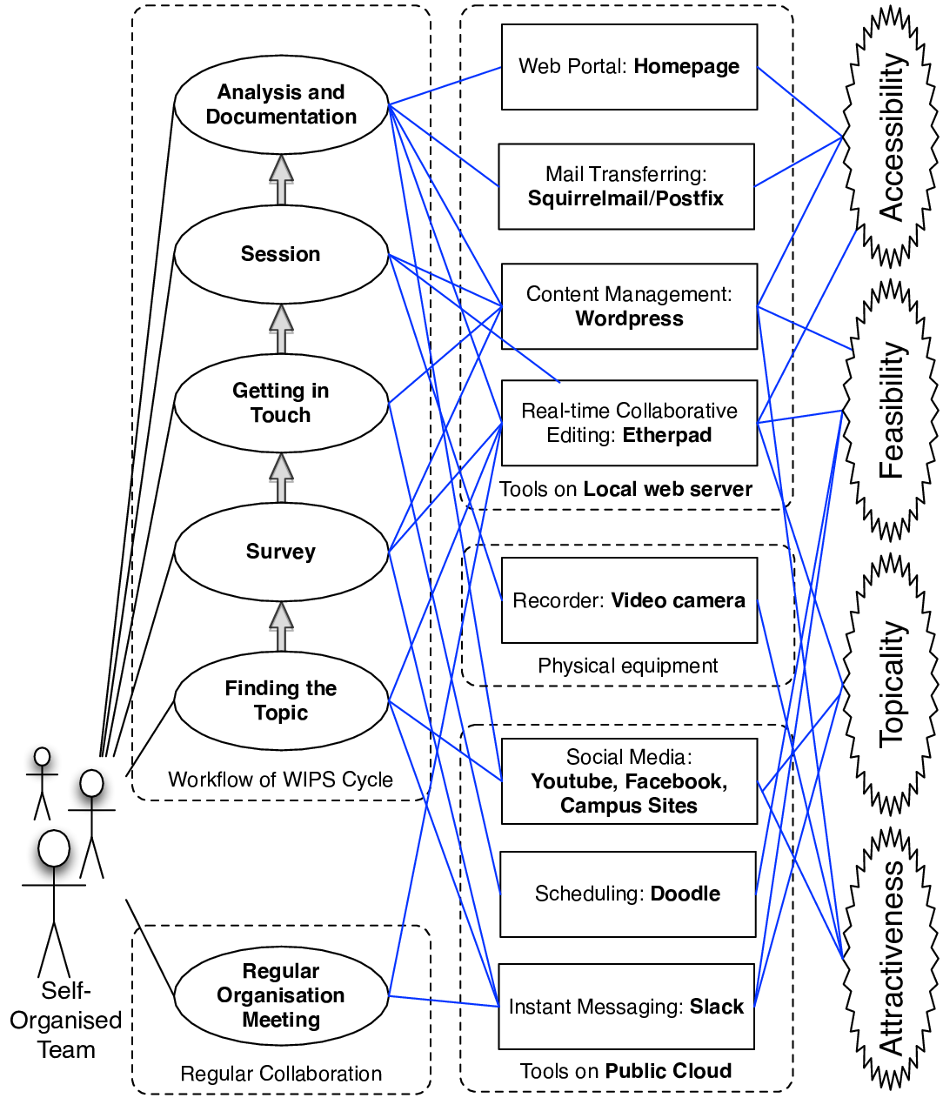

Figure 2. Internet-based tools for self-organized teamwork and agile content development

The WIPS cycle defines a collaborative workflow for seminar content development. However, when applied on its own, it lacks systematic support that would enable efficient task execution. Thus, we have taken advantage of numerous Internet-based tools to build an agile collaboration environment for WIPS (see Fig. 2). To support self-organized teamwork, we have incorporated our local Web server and used filming equipment, as well as public cloud services, in the effort to facilitate the WIPS cycle workflow and general collaboration synthetically towards overcoming the challenges of attractiveness, topicality, accessibility, and feasibility. We use *Slack* as an instant communication tool to efficiently interconnect the organizers; *Etherpad* as a collaborative note-taking tool for team meetings, and *Doodle* as a scheduling tool for seminars. Moreover, to support agile content development, we use *Etherpad* to record and revise contents interactively; *Wordpress* as a blogging system for publishing and extensive sharing of the contents. Additionally, we resort to *Squirrelmail* and *Postfix* as mail transferring tools to notify seminar participants and also to take advantage of the social media such as Facebook and YouTube, as well as the campus sites to identify and retrieve the trending topics or broadcast our contents. The deployment of the Internet-based tools has resulted in a simple scheme to follow in terms of organizational stations, allowing for a collaborative decision-making mechanism to be in place. Furthermore, the self-organized student committee can utilise interactive ways of motivating one another and share innovative ideas related to facilitation of modern technology. The team members also have different technical skills, such as web programming and server management. This broad mix of talents and skills is essential for successful organization of WIPS.

# Discussion

## I. Evidence of effectiveness of the proposed method

During this project we have recorded all the work hours of our committee members to demonstrate that by using the presented organizing approach the time required for completion of many steps of the WIPS cycle is being reduced at the second iteration compared to the first iteration. This suggests that having a clear road map for the process can help work more efficiently. We also have visitor data from our blog that proves a rather high interest in the topics offered, as expressed by those unable to attend the actual seminar.

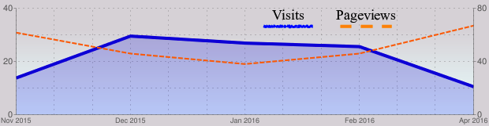

Figure 3. WIPS contents online hits from the local network on campus (with spam and spiders exempted)

The evidence supports an improved accessibility and attractiveness of the redesigned seminar series. The fact that seminar contents are published online and are readily accessible, naturally enhances receptiveness. In addition, the blog hits from the campus local network (see Fig. 3) point to continuous interest in the WIPS contents after the onsite seminar. For example, around 30 participants experienced the video-recorded seminar (Oct. 2015) virtually, and the monthly hits remained at a steady interest level for over two months.

When comparing the organizers’ collaboration performance with reference to July 2015 and October 2015 seminars, respectively, and with both seminars following the WIPS cycle, one can see that the collaboration tools were used to a larger extent when organizing the October seminar session.

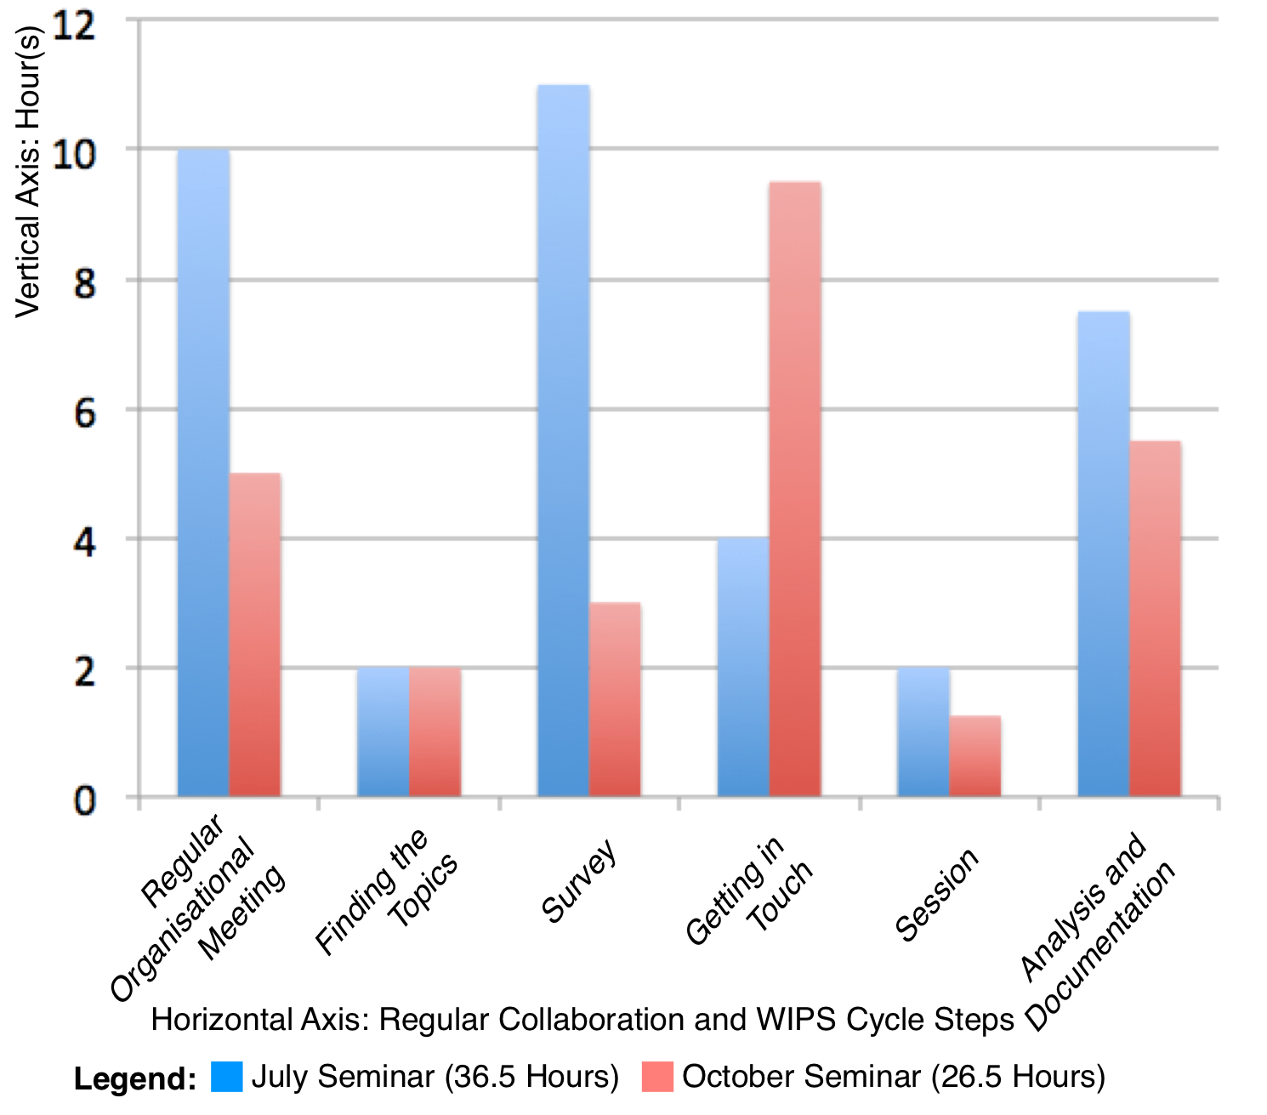

Figure 4. time spent on seminar organization: comparison between july 2015 and october 2015

As depicted in Fig. 4, the organizers spent less time developing content for the October seminar than for the July one. The time expense for the regular organization meetings was greatly reduced due to the efficiency of tool-based communication. Moreover, content development performance throughout the WIPS cycle was also improved. For instance, the time spent on the ’survey’ was reduced since collaborative online documentation had eased the content development.

The daily heat map of the organizers’ time expense in July 2015 and October 2015 seminars is shown in Fig. 5. Judging from the sparser distribution of the heat grids for the October seminar, the aforementioned collaboration tools have helped reduce the intensiveness of teamwork. Furthermore, by comparing the heat maps of each organizer, the working load turned out to be equally distributed, which confirms the satisfactory results of self-organized teamwork.

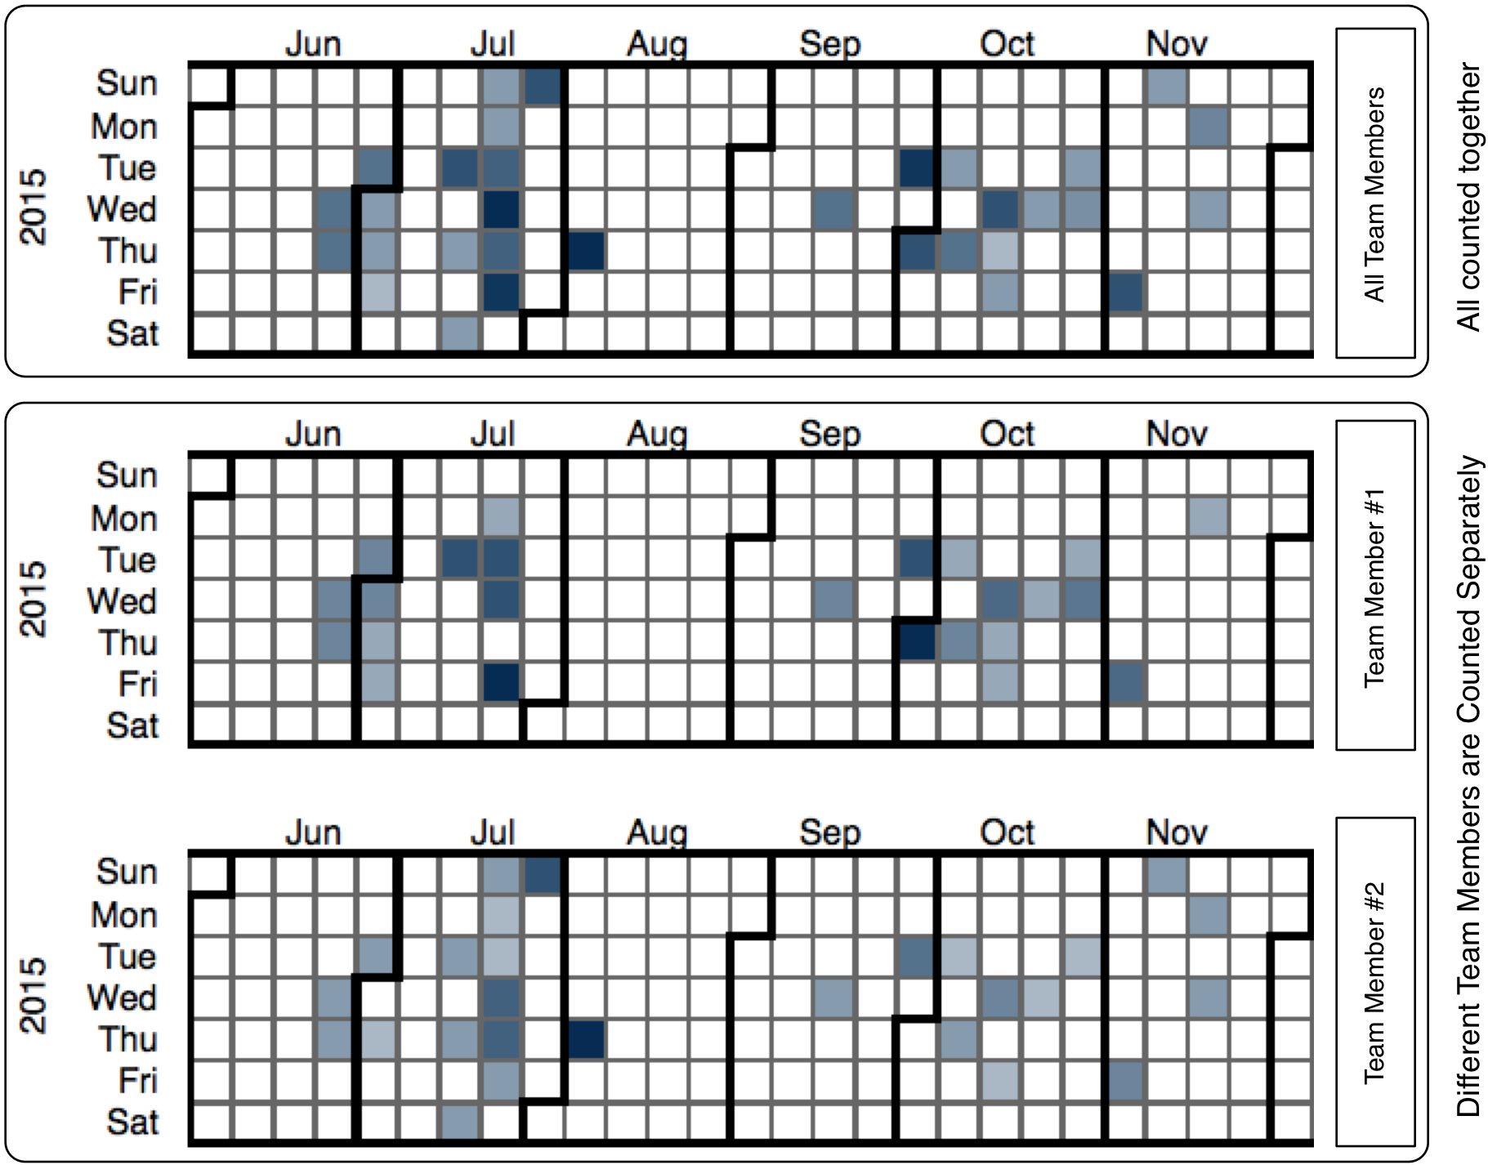

Figure 5. Team member time log heat map from July 2015 and October 2015 seminars

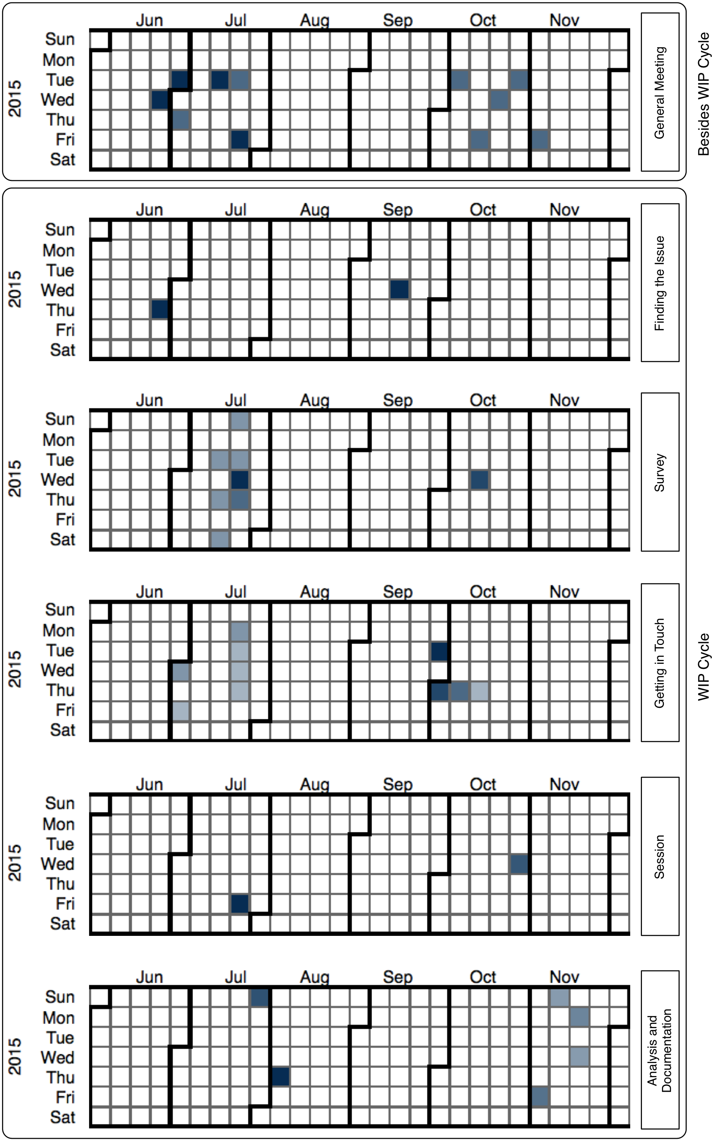

figure 6. time log heat map of the WIPS cycle in July 2015 and October 2015 seminars

The daily time expense heat map for operating every station of the WIPS cycle during the July and October seminars is shown in Fig. 6. As can be seen, the regular organizational meeting follows the WIP cycle of content development for one single seminar. The time expense for the survey stage is reduced, with the main reason being that, based on the agile content development process, the other steps in the WIPS cycle also contribute to enriching the survey contents without any extra time expense.

## II. Limitations and tentative future directions

Although this organizing approach was designed to provide enough flexibility and simplicity to be applied in other cases as well, there are limitations to our method. One of the core motivations behind designing the WIPS cycle was to formalise the process in order to make it ‘user friendly’, so to speak, so that organizers with little experience could use it when building teams. Collaborating efficiently is made easier when one has a fixed framework. The main limitation is that, by definition, this approach targets teams with at least two members. Individual organizers doing all the work alone cannot make use of collaborative online-based tools such as *Etherpad* or *Slack*.

Moreover, our approach is highly tailored to the seminar type defined above (see section II-B), therefore it also might not be applicable to research workshops or exercises associated with a lecture series. In many of these cases, there is either no repetitive element of the organizing work or the speakers and topics are already pre-determined. It could be interesting to see how such formulated organizing approach compares to our approach.

Although this project has been in active development for one year and a half, only two seminar sessions actually took place that followed our new approach. This restricts our ability to draw more general conclusions about the effectiveness of the method. One major task for future research is to see how other teams would use our method, hence our effort to make our data and approach publicly available.

With the digitalisation process constantly affecting the tools used at universities, it remains an open question which of the tools and online systems proposed here will eventually become standard and which will go out of use. Although some preliminary data have been obtained and experience using online tools collected, it would be useful to have more data for future analysis.

# Conclusion

Student members of the self-organized team earn valuable experience for their future careers. There are relatively many opportunities to attend events at the university, however not so many for students to organize a public event themselves, and even less of a chance to join an organizing team and deal with multiple tools for agile content development. Providing such kind of experience and professional tools for organization by teams could also be a business idea by itself.

Furthermore, it should be stated that the seminar’s attractiveness does not only depend on the topics presented, but also on the speakers who share their knowledge and opinions; the atmosphere of participating in a live event, and the shared materials. Since the public interests are not easy to identify and measure, we have collected the trending topics from the in-campus news site and also the SNS community. Intensive face-to-face communication may also be involved. Collaborative note taking and sharing, using the support tools, is highly recommended when identifying the up-coming ideas and topics. Alternatively, the organizing team may be in charge of selecting the topics, as confirmed by our interviews. In order to choose ‘popular’ speakers, the strategy of targeting international students who seem well connected and integrated can be applied. Finally, to attract and involve more ‘participants’, all the seminar resources and presentations are accessible online, without physical attendance required.

In this paper, we have presented the so-called WIPS cycle, created to guide the open seminar organizers in coordinating feasible tasks leading to successful preparation of interactive seminars. In addition, we have also introduced a set of Internet-based collaboration and content development tools aimed at optimised agile seminar organization, i.e. a quick completion of the tasks assigned and the iterative improvement of the results. In-depth interviews with other seminar organizers have revealed that contacting and then on-going communication with prospective speakers and participants constitute the biggest challenge. The communication process can, however, be significantly facilitated by social media, for example, as shown by our data depicting the visitors log at the project blogging site. We have further observed that using the WIPS cycle reduces the working hours of the team over time and that online communication tools help balance the work loads of all the team members.

Moreover, based on the literature review pertaining to the topic at hand, we can state that research on organizing the kind of seminars discussed here is rather underrepresented in the overall research efforts aiming at improvement of communication and teaching methods in tertiary institutions. This proves that further exploration of agile seminar organization is required, with our paper contributing to the discussion of interactive seminars with easily accessible digital resources.

# Acknowledgements

The authors would like to thank the interview partners (Prof. Igor Lubashevsky, Mr Tatsuki Kawaguchi, and the staff of the International Student Office) for their valuable insights concerning different approaches to seminar organization. We would also like to thank a former member of the organizing committee, Tashi Abe, for his comments. Finally we wish to give credit to Luyi Huang and Inoue Hiroki for our promotion video.

# References

### [1] V. Popov, D. Brinkman, H. J. Biemans, M. Mulder, A. Kuznetsov, and O. Noroozi, “Multicultural student group work in higher education: An explorative case study on challenges as perceived by students,” *Int. J. Intercultural Relations*, vol. 36, no. 2, pp. 302–-317, 2012.

### [2] A. Danielewicz-Betz and T. Kawaguchi, “Multicultural (mis)communication in IT research labs,” in *Proc. IEEE* *Professional Communication Conference (IPCC)* 2014, pp. 1–5.

### [3] J. J. Duderstadt, D. E. Atkins, and D. E. van Houweling, *Higher education in the digital age: Technology issues and strategies for American colleges and universities*. Westport, CT: Greenwood Publishing Group, 2002.

### [4] R. Hazemi, S. Hailes, and S. Wilbur, *The digital university: reinventing the academy*. Berlin: Springer Science & Business Media, 2012.

### [5] P. A. Tess, “The role of social media in higher education classes (real and virtual) – a literature review,” *Comput. in Human Behavior*, vol. 29, no. 5, pp. A60-A68, 2013.

### [6] T. R. Liyanagunawardena, A. A. Adams, and S. A. Williams, “Moocs: A systematic study of the published literature 2008-2012,” *Int. Review of Research in Open and Distributed Learning*, vol. 14, no. 3, pp. 202-227, 2013.

### [7] D. Shawky, T. Said, A. Badawi, and R. Hozayin, “Affordances of computer-supported collaborative learning platforms: a systematic review,” in IEEE *Interactive Collaborative Learning (ICL),* 2014, pp. 633-651.

### [8] R. Vivian, K. Falkner, N. Falkner, and H. Tarmazdi, “A method to analyze computer science students teamwork in online collaborative learning environments,” *ACM Trans. on Computing Educ. (TOCE)*, vol. 16, no. 2, p. 7, 2016.

### [9] J. Stieger, A-C. Thelen, U. Bach, A. Richert, and S. Jeschke, “Challanges of large group study courses in engineering education,” in *Automation, Communication and Cybernetics in Science and Engineering 2013/2014*. Springer, pp. 503-511, 2014.

### [10] G. Gbadamosi, “Should we bother improving students attendance at seminars?” *Innovations in Educ. and Teaching Int.*, vol. 52, no. 2, pp. 196-206, 2015.

### [11] E. R. A. Seligman, "The Seminar: Its Advantages and Limitations." *J. Political Econ.*, vol. 20, no. 2, pp. 153-162, 1912.

### [12] M. Gersch, C. Lehr, and P. Weber, “Virtual collaborative learning in international settings – the virtual seminar net economy,” *Proc. INTED2011*, pp. 5078–5085, 2011.

### [13] J. Fusco, S. Haavind, J. Remold, and P. Schank, “Exploring differences in online professional development seminars with the community of inquiry framework,” *Educational Media International*, vol. 48, no. 3, pp. 139-149, 2011.

### [14] K. Luchini-Colbry and T. Gonzalez, “Finish my research! Find a job! Feel better! Seminars to support engineering graduate students professional and personal goals,” in *Proc. 2014 ASEE National Conference.* Indianapolis, IN, 2014.

### [15] J. L. Bishop and M. A. Verleger, “The flipped classroom: A survey of the research,” in *Proc. ASEE National Conference*, Atlanta, GA, 2013.

### [16] L. Helle, P. Tynjala, and E. Olkinuora, “Project-based learning in post-secondary education – theory, practice and rubber sling shots,” *Higher Educ.*, vol. 51, no. 2, pp. 287-314, 2006.

### [17] J. W. Thomas, *A review of research on project-based learning*. San Rafael, CA: Autodesk Foundation, 2000.

### [18] K. Beck, *Extreme programming explained: embrace change*. Boston: Addison-Wesley Professional, 2000.

### [19] K. Bergener, J. vom Brocke, S. Hofmann, A. Stein, and C. vom Brocke, “On the importance of agile communication skills in BPM education: Design principles for international seminars,” *Knowledge Management & E-Learning: An Int. J. (KM&EL)*, vol. 4, no. 4, pp. 415-434, 2013.

### [20] V. Kamat and S. Sardessai, “Agile practices in higher education: A case study,” in *AGILE India, 2012*. IEEE, 2012, pp. 48-55.

### [21] M. Kropp, A. Meier, M. Mateescu, and C. Zahn, “Teaching and learning agile collaboration,” in *Proc of Software Eng. Educ. and Training (CSEE&T)*, 2014, pp. 139-148.

### [22] C. Bohm, R. Motschnig, and L. Obiagwu, “Communication and media use in self-organized teams in a technology-enhanced project management course,” in *World Conference on Educ. Multimedia, Hypermedia and Telecommun. (EDMEDIA) 2013*, June 2013. [Online]. Available: http://eprints.cs.univie.ac.at/3893/

### [23] B. Clapp and J. Swenson, “The collaborative classroom: New technology brings new paradigm,” *Atlantic Marketing J.*, vol. 2, no. 3, p. 6, 2013.

### [24] H. Stevenso and J. C. Jarillo. "A paradigm of entrepreneurship: Entrepreneurial management." *Entrepreneurship*. Berlin & Heidelberg: Springer, pp. 155-170, 2007.

# About the Authors

Isabel Schwende,M.Sc., is a machine learning researcher at LeapMind Inc. in Tokyo, Japan. She obtained her B.Sc. from the University of Greifswald, Germany and her M.Sc. from the University of Aizu, Japan. She was a Ph.D. student at the University of Aizu for two years, serving as the leader of the WIPS committee. Her research interests include machine learning and deep learning, but also efficient methods of collaboration, team development, and innovation management.

Yilang Wu received his dual B.Sc. in Software Engineering and Computer Science and Engineering from the Harbin Institute of Technology, China and the Dublin Institute of Technology, Ireland; and M.Sc. in Computer Science and Engineering from the University of Aizu, respectively. He is currently pursuing a Ph.D. in Computer Science and Engineering at the University of Aizu. His current research interests include data analysis and pervasive computing.

Anna Danielewicz-Betz, Ph.D., is a business English lecturer at Ludwig-Maximilian University of Munich, Germany. She has worked internationally throughout her career for institutions such as Prince Sultan University, Riyadh, Saudi Arabia, Ludwig-Maximilian University of Munich, Germany, and recently as associate professor at the Centre for Language Research, University of Aizu, Japan. Her research interests include business/corporate communication, socio-pragmatics, interdisciplinary studies (e.g. forensic linguistics) and internationalisation of higher education. She also is an experienced business consultant and trainer offering customised in-house business English courses and coaching services for multinational companies.