# TVC Denton Parenting and Discipleship Survey

# Who are our parents?

There was a total of 72 survey respondents (*n =* 72), with an overwhelming majority of parents with children from 0-5. Figure 1 below shows the demographic breakdown of parents who responded in this survey.

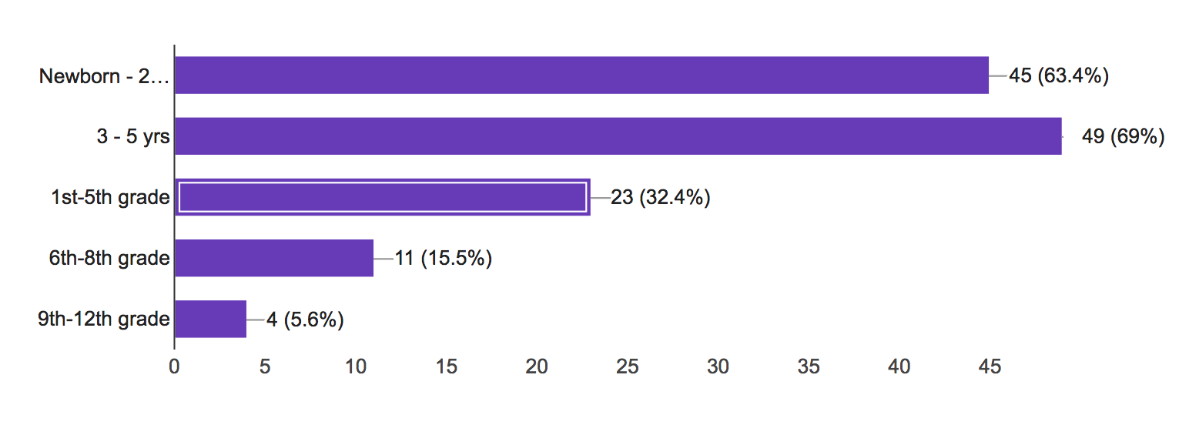

**Figure 1.** Breakdown of children’s ages

Interestingly, a large percentage of parents reported use books or articles (85.9%) for parenting information as opposed to resources from church (just 46.5%). They also seek advice from their immediate circle of friends and family.

# What do current family rhythms look like?

In terms of **weekly schedules**, parents in this sample have prioritized Sunday Worship (97.2% of respondents), home group (77.5%), and school-related commitments (39.4%). A smaller percentage of parents indicated commitments to additional bible studies (33.8%), sports (35.2%), and volunteering (18.3%). When spending family time together, family responses were fairly evenly divided among watching TV, outdoor activities, playing games, or going out.

Families in this sample also are actively disciplining their children with 69% of respondents reporting that they read or talked about the Bible together at least once a week. However, only 16.7% of respondents reported using resources from the church. Instead, parents tended to use other resources (37.9%) or come up with their own material (27.3%). Additionally, about 50% of respondents do not attend church wide prayer.

In terms of **yearly** rhythms, the respondents indicated specific busyness and stress around the beginning of the fall and spring semesters and holidays.

# How equipped are families?

Framing the results within the current paradigm of 1) basics of Christian faith, 2) wisdom, and 3) cultural topics, **it is clear that families currently feel most equipped to teach their children about the basics of the Christian faith** as 74.6% of families felt confident in that category. In terms of wisdom and cultural topics, **parents felt most confident teaching children about boundaries around media and technology (12.9%). This could be due, in part, to the forum on that particular topic.** No other wisdom/cultural topic received any significant amount of confidence from parents.

Interestingly, parents felt least confident teaching their children in a variety of wisdom/cultural topics, **with sex and sexuality receiving the largest number of responses (35.3%**). This is unsurprising yet significant since the majority of parents in this survey had children from 0-5. This means that the importance of a topic like sex and sexuality will likely continue to grow over time. Figure 2 shows the breakdown of topics that parents are least confident discussing with their children.

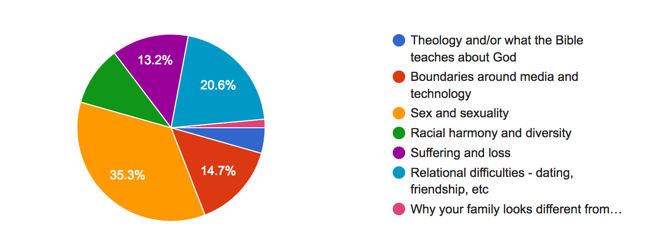

**Figure 2.** The areas parents feel least confident to talk about with their children

# Where are parents struggling?

The survey asked two open-ended questions—the first question asked where respondents **needed additional encouragement and equipping** and the second question asked where they see other parents needing more encouragement and equipping. Since this was an open response, I coded the responses into 13 categories. Table 1 below shows the four most frequent responses.

**Table 1.** Where Parents need equipping and encouragement

|  |  |
| --- | --- |
| **Response** | **Frequency** |
| Discipline and behavior | 24 |
| Parenting and discipling children in **everyday** life | 12 |
| Modeling their faith to their children. | 5 |
| General wisdom in parenting | 4 |

The most striking finding here **is the need for equipping and encouraging around the area of discipline and behavior**. However, examining this within the context of the overall sample, this finding makes sense as there are a large majority of parents raising 0-5 year olds. Discipline at that age can be difficult to parse out, especially for first-time parents.

Another key finding here is that parents seem to need particular encouragement around the everyday routines of parenting. Again, this is no surprise due to the age of children within the sample, but it still reveals a real need for support/encouragement for parents, especially parents with young children.

“

I feel like we could do better as a body encouraging each other in our parenting adventure. I have overheard some not very uplifting and semi-judgemental conversations within the church.

# Within the structures of the church, what has discouraged parents?

Since this was an open response question, I coded responses into 12 categories of responses. Most of the categories (8 out of 12 categories) were only mentioned once. However, the four most common responses provide some helpful insight. Those four responses can be seen in table 2 below.

**Table 2. Discouraging structures open response**

|  |  |
| --- | --- |
| **Response** | **Frequency** |
| Lack of community catered specifically for parents | 7 |
| Being turned away at Sunday Services | 6 |
| Lack of programs or activities specifically geared toward children (outside of Sunday) | 4 |
| Perception of division among parenting styles | 2 |

The top two responses (which represent about 20% of the total sample) are significant, or at least interesting, in that they speak to issues impacting the spiritual health of the **adult** and not necessarily the child. For instance, parents are reporting a need for intentional, specific, and structured opportunities to meet with and be in community with other parents. And while being turned away from Sunday services does have negative implications for the child, it also hinders the parents from worshipping because they have to care for their (probably ages 0-5) child during the service.

# What could the church do to equip, encourage, or serve parents (according to parents)?

This, too, was an open-ended response question. Therefore, I coded responses into 12 categories. Table 2 below shows the frequency of their responses.

**Table 3.** Ways the church can equip, encourage, or serve parents

|  |  |
| --- | --- |
| **Response** | **Frequency** |
| Provide events (forums, classes, workshops) | 12 |
| Provide more resources (online, take-home-sheets, etc.) | 9 |
| Provide more adult discipleship with childcare | 5 |
| Provide structured community for parents | 5 |
| Provide opportunities to learn WITH children (e.g., family discipleship night) | 2 |
| Provide avenues for mentorship for young parents | 2 |

# Key Takeaways

1. **Our parents care about discipling their children well.** The most encouraging takeaway is that, amongst all of the difficulties and discouragements of parenting, the parents who responded in this survey desire to be equipped. Of course, there is self-selection bias in that those who responded likely responded because they care about the discipleship of their children. Regardless, though, 75% of respondents felt confident teaching their children about the character of God. This is important. Additionally, a large percentage of respondents desired more events (classes, workshops, forums), more resources (online and otherwise), and more structured fellowship time. This reveals a general desire to learn more—something we already knew but is encouraging and confirmed in the data.
2. **The large number of parents with young children (0-5) has important implications for the future.** While an obvious finding, the survey results show a particularly skewed distribution of parents with young children. This could explain the relative apprehension in teaching and training children around wisdom and cultural issues.That is, most parents aren’t having to think through issues of sexuality or race with their children. However, in 5-10 years, our middle school population will be larger than we’ve ever experienced in the history of the church. And parents will not suddenly become equipped to teach and have conversations around wisdom and cultural issues if they are not trained in them now.
3. **The church might consider explicit training on discipline.** Many respondents (24 family units) felt unprepared to ill-equipped in the area of discipline. While the data does not reveal what specific aspects of discipline that parents are needing more equipping in, it is safe to assume that a biblical, gospel-centered teaching on discipline would be beneficial to parents. Again, considering the relative youth of the sample, perhaps a focus on age-appropriate discipline, expectations, and motivations (Christ-centered to be sure) could be particularly helpful.
4. **Building community among parents will address multiple issues.** A large number of parents (12 family units) reported needing encouragement in the struggle of everyday life as a parent. Additionally, 7 family units reported a lack of fellowship and community with other parents as being a source of discouragement. Taken together, the data suggests the importance of community and fellowship among parents. While this is something we have already discovered and have committed to, we ought to remember the complicated and busy rhythms of the daily lives of many parents with young children. We discovered that only about half of the respondents are attending churchwide prayer, which is one of the best venues for fellowship outside of the gathering. So, considering a time, place, and venue for fellowship that can draw the largest number of parents will be an important exercise.
5. **Getting turned away on Sunday has broad implications.** Six family units mentioned that getting turned away on a Sunday was discouraging for a variety of reasons, but one particular comment speaks to the importance of addressing the space issue. This respondent expressed concern over not being able to bring non Christian friends, which has implications well beyond just being turned away. Perhaps we could consider the potential for substitute teachers or parent volunteers. At the very least, it may be beneficial to investigate the root cause of parents getting turned away (i.e., is it due to lack of physical space or lack of volunteers?). If it is a lack of volunteers, perhaps challenging more folks in the church to serve for a season in little village is a potential solution.