**Reading Discussion Questions**

1. What were some of the examples of knowledge bases that were mentioned in the academic article?
2. What are the three components of a knowledge base according to the article?
   1. Concepts, Instances, and Relationships
3. What is the difference between a domain-specific KB and a global KB? What are some examples of each?
   1. Domain-specific captures C,I, and R in a relatively well-defined domain of interest. Gloab KB attempts to cover the entire world.
4. What kind ofKB are we creating in this course?

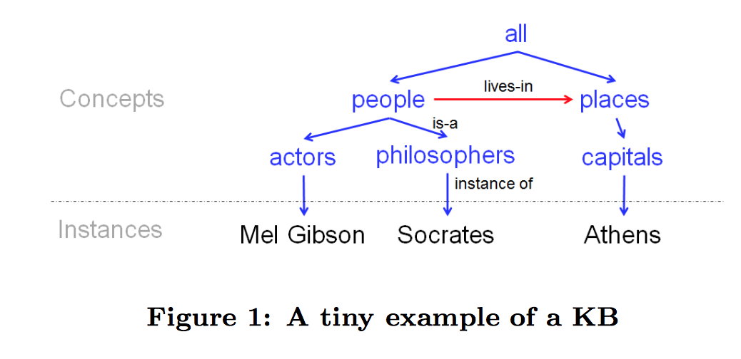

**Create a concept, instances, relationships tree for the following on IMDB.**

Blair Witch Project

Heather Donahue

Boys and Girls

It’s always sunny in Philadelphia

Rob McElhenney

Charlie Day

Kaitlin Olson

The drew carey show

Ryan Stiles

Astro Boy

Eugene Levy

National Lampoon’s Vacation