# A Usability Study of the Willis Library Technology and Computer Operations’ Intranet

### Autumn Hood

### Executive Summary

This report explains the methodologies and results of a series of usability tasks that took place over the course of 4 months from July, 2014 to November, 2014. The study served as the main component of an independent study course, TECM 5900. Throughout the duration of the course, I worked diligently with my instructor, several research assistants, and personnel from the Willis Library Technology and Computer Operations (LibTACO) department to determine any usability flaws of the LibTACO intranet.

The study yielded 5 major findings:

* Finding 1: Users don’t understand the naming conventions of the site and the labels do not meet their

expectations

* Finding 2: Users do not understand the information architecture of the website, as well as the organization of

individual pages

* Finding 3: Users don’t trust the older information on the intranet
* Finding 4: Multiple documents with similar titles lead users to false-positive conclusions
* Finding 5: The content on the intranet is not skimmable

To address these findings, I present the following recommendations:

Recommendation 1: Rename headings and content labels using natural, widely understood language Recommendation 2: Reorganize the information architecture to meet user’s expectations Recommendation 3: Remove old and/or irrelevant data

Recommendation 4: Remove redundantly named content to decrease false-positives

Recommendation 5: Make pages more skimmable by including more top-level headings and by reducing the number of links/amount of content available on consecutive landing pages

Recommendation 6: Use an authorized vocabulary to input metadata and keywords to increase success rate of user

searches

Implementing these recommendations will likely increase users’ success using the intranet, as well as their satisfaction during and after using the site. If these recommendations are applied, further usability and user experience (UX) studies would be necessary to determine what issues, if any, remain.

# Contents

Executive Summary 2

Introduction 4

Card sorts 5

Methodology 5

Results 6

Heuristic evaluation 6

Positive aspects of the LibTACO intranet 7

Home page 7

Navigation 7

Design 9

Language 9

Searchability 10

Scannability 10

Usability and user experience tests 11

Goals of testing 11

Methodology 11

Usability test results 11

Major findings 13

Observations 15

Recommendations 17

Conclusion 18

References 19

Appendix A: Proposed Information Architecture Wireframe 20

Appendix B: Card Sort Correlation Matrix 21

Appendix C: Pre-Testing Questionnaire 23

Appendix D: Example Authorized Vocabulary 24

Appendix E: Usability Testing Tasks 25

### Introduction

On April 25th, 2014, I met with Willis Library Technology and Computer Operations (LibTACO) manager Wayne Hoyt and my instructor in the Department of Technical Communication, Dr. Erin Friess, to discuss a 16-week usability project. The LibTACO department manages Willis’ IT related infrastructure, including Laptop Checkout services, 24 hour Student Computing Commons, building maintenance, renovations and repairs, helpdesks, and many other initiatives that help students, faculty, and staff.

The project would benefit the LibTACO department by providing recommendations to improve the usability and UX of the site, and the project would benefit my understanding of and experience in conducting usability studies. The project would include:

* Addressing the current state of usability and user experience (UX) on the LibTACO intranet
* Performing a series of card sorts to assess the strength of the site’s information architecture (IA)
* Conducting a heuristic evaluation to examine how the site compares with web standards
* Executing a series of usability tests to identify the ease of navigation, task completion rates, and qualitative

impressions of the site’s design

* Recommending ways to improve the effectiveness and overall experience of using the intranet for current and future generations of employees

### What is usability and user experience?

The International Organization for Standardization (ISO) defines usability in standard ISO 9241-11:1998 as “the extent to which a product can be used by specified individuals, or users, to achieve goals with efficiency, effectiveness, and satisfaction” (Barnum 2011). User experience, on the other hand, pertains to “the overall

experience of a person using a product such as a website or computer application, especially in terms of how easy or pleasing it is to use” (Oxford Dictionaries 2014). This study did not directly address UX factors of the LibTACO intranet; however, we can still tangentially gather preliminary assumptions about UX by studying usability.

With the guidance of my instructor, Dr. Friess, the help of various research assistants, and the continued

cooperation of the UNT LibTACO department, I have compiled this report, which includes the following:

* The methodology and results of a series of card sorting activities
* A heuristic evaluation of the intranet
* The call for an authorized vocabulary and recommended implementation methods
* The methodology and results of a set of usability and user experience (UX) tests
* Final recommendations (including a wireframe) for the LibTACO intranet

### Card sorts

The first procedure in this study was 4 card sorts that took place over 2 days in July 2014.

In a card sort, participants engage with either virtual or real cards that contain pieces of content from a website. Users then structure and group the cards in a way that makes sense, effectively informing usability researchers of potential information architectures (IAs). By combining the results of multiple card sorts, usability researchers can identify correlations among pieces of content, thus generating IA schemas that are likely to be effective and intuitive for many users.

Card sorts are primarily helpful in understanding what content of a website (or in this case, intranet) users associate with one another, which in turn can help develop an information architecture (IA). IA is the study and design of the organization of digital media to enhance usability and UX aspects; studying IA is one of the most effective ways of creating an organizational structure for a website because it aims to organize, structure, and label the content of

a website. Additionally, card sorts can help usability researchers gather and analyze data from actual users on how best to structure a site’s navigation, create top-level categories and subcategories of content, and meaningfully name content (Righi et al. 2013). A successful IA organizes and labels the content of a website so that users can find information quickly and complete tasks.

## Methodology

I conducted card sorts with 4 participants. The participants were unaffiliated with the LibTACO department and have never visited the intranet. The ages of the participants range from age 24 to 34, and the group as a whole consisted of 2 males and 2 females. The educational levels of participants range from high-school diplomas to current enrollment in a graduate program at UNT. Prior to the card sort, participants answered questions from a brief interview. The interviews included sought information about participants’ demographic information, their internet habits/tasks, and the frequency with which they use the internet. The complete pre-testing interview can be found in Appendix C.

After the interviews, participants were given a stack of 31 index cards with a content heading (or label) written on each card. Content headings were taken from the LibTACO intranet; for example, a card could say “Forms,” “View Options,” or “Dashboard.” Many of the content headings were taken verbatim from the site, but a few were re- named so that they would make sense to users who did not have the entire context of the site to understand their meaning. Participants were also told they could ask questions if they didn’t know what any of the content headings meant.

Participants sorted the cards into logical groupings and then labeled each group, regardless of how they thought these groupings were labeled on the website. In addition, participants were encouraged to employ the think aloud protocol, in which they spoke aloud to describe their thought processes as they made grouping and labeling choices.

To analyze the results of the card sorts themselves, I relied on best practices set by Righi et al. (2013). First, I combined the data from the 4 card sorts (card groupings and labels provided by our participants) into a correlation matrix, which helped me determine associations between the content headings. I determined these associations by assessing how often cards were paired with one another in the same group. By analyzing these correlations, I can further articulate possible structurings of the intranet, as well as appropriate category labels. I analyzed those card groupings, and for each grouping I assigned a category label based on participant input and website navigation heuristics (discussed more thoroughly in the Heuristic Evaluation section).

## Results

The results of the interviews allowed me to understand how often the participants use the internet and for what tasks to account for any outliers that may have existed among the card groupings. The interviews indicated that all the participants use the internet every day for a variety of functions, such as paying bills and other errands,

entertainment, and communication. All participants reported general comfort with using the internet and interacting with websites.

The results from the card sort indicate what information participants frequently associated with others. This information allowed me to determine potential IA frameworks. However, aside from formulating a possible IA, the card sort results also helped me determine what information does not belong on the intranet at all. Table 1 shows the content the LibTACO department should consider omitting from the intranet. The content headings in Table 1 reflects those that at least 3 out of the 4 participants identified as not belonging on the website or had no to low correlation with any other card. Most of the justification for the omitting the content cards in Table 1 was that the content seemed redundant, inappropriately named, or unnecessary to complete the common tasks of the LibTACO intranet’s users. Table 2 includes some qualitative remarks participants made about various content headings. The full correlation matrix can be found in Appendix B.

## Table 1: Cards identified as not belonging on the LibTACO intranet

|  |  |
| --- | --- |
| Links | All things |
| Stuff | Past events |
| Recently updated |  |

**Table 2: Qualitative remarks participants made about the content headings**

|  |  |
| --- | --- |
| “Stuff ” is worthless and tells me nothing. We can put it in the trash. | “Dashboard” seems like “Manage Portlets” and “Site Setup.” |
| What is “Help”? | I feel like “News” would be at the top bar. |
| “Past Events” is kind of like “News.” | [Put] all the documents together. |
| (Referring to “All Things”): What does that even mean? | Is there a Contact button? I’d set up an option to email. |

### Heuristic evaluation

After the conducting the card sorts, I completed a heuristic evaluation of the LibTACO intranet. A heuristic evaluation examines the characteristics of a user interface (UI) and analyzes how well it applies design, language, content, navigation, and other conventions described in best practice studies. Heuristic evaluations are useful in helping usability researchers articulate how a site can improve its navigation, design, and communication strategies by implementing methods that have already proven effective for digital media. Additionally, heuristic evaluations are exceptionally practical to perform in a busy workplace, because usability researchers can gain information without having to perform formal usability and UX studies.

One important aspect of analyzing heuristic evaluations is that not all usability issues are equal. Some weigh very

low on a user’s ability to complete tasks, generally acting more as annoyances that users can generally put up with to do what they need to do. However, other issues may actually frustrate a user to the point of giving up or literally impede them from performing certain tasks; these issues are referred to as “severe” or “catastrophic.” And of

course, other issues lie in between these two extremes. This report will list these issues by order of importance from “severe,” “moderate,” and “low.”

In conducting the evaluation, I looked at a variety of website conventions, and synthesized them to fall into the following categories: Home Page, Navigation, Design, Language, and Searchability. However, before explaining in what areas the LibTACO intranet can improve, I will first examine the positive aspects the site already.

## Positive aspects of the LibTACO intranet

* The intranet employs judicious white space, which allows the user to separate content and designate sections. White space also makes the text of webpages more readable and skimmable.
* By having a top-horizontal navigation bar, the intranet adheres to users’ schemata (or expectations) of where to

access parts of the site.

* The intranet includes a link to a sitemap, which allows users to further understand the organization of a structure. Although the current organization needs to be redone and certain content headings need to be renamed, if the LibTACO department implements the changes recommended in this report, the sitemap can be extremely useful.
* The intranet enables access to the homepage from all other subpages. Specifically, the intranet uses a clickable logo on the top-right corner of each webpage that links users back to the homepage, which is a feature many users have come to expect.
* The homepage on the intranet is an appropriate (short) length that allows users to see all the content that is housed on that page without “scrolling beyond the fold,” or use the mouse to scroll the page down to reveal more content.

Now, I will discuss areas of improvement for the LibTACO department to consider as they make changes to the intranet.

## Home page

*Purpose statements—moderate*

Many homepages (and sometimes subpages) of a website include a statement that explains what the site does or who it is for. Although this site in particular is an internal intranet that only employees with passwords may access, it can still help novice users understand its purpose and identify what tasks they can complete there. A “statement of purpose” would also improve the other pages of the site, no matter how brief or obvious they may seem. For example, on a page titled “Process Documents,” a statement of purpose could read: “This page is where student technicians and other LibTACO employees can view, submit, edit, and save documents that describe the authorized processes for various functions of the department.”

## Navigation

*Number of tabs—severe*

Currently, the main navigation bar is daunting to new users. The number of navigational links and possible paths are overwhelming, which causes users to not know where to start first. With time, of course, users will become familiar with the site and hence understand its structure. However, usability/UX heuristics (including successful IA) aim to make the organization, language, and design of websites intuitive so that even first-time users of a site will understand its organization and have a clear path to follow to complete tasks.

Current research suggests that users want less, or at least more streamlined, information that is organized so that specific audiences can get the information they need. Additionally, users don’t mind having more content to wade through as long as they are making “confident clicks,” and feel sure that each click is taking them closer to their destination.

According to Righi et al., “for most cognitive tasks, people are most comfortable with about seven plus or minus two distinct items to consider” (2013); these items are often depicted as tabs on a website. Based on this information, I recommend the LibTACO department reduces the number of main navigation tabs to 5-9 tabs.

Currently, the homepage has 12 main navigation items: Calendar widget, “Home,” “Documents,” “Forms,” “Links,” “News,” “Events,” “Advanced Search,” “FrontRange HEAT,” “All things,” “SPAM PROCEDURE,” and “Recent Changes” (See Figure 1).

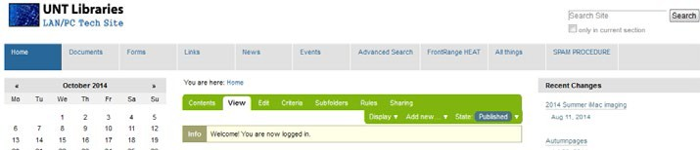

## Figure 1: The main Navigational bar of the LibTACO intranet.

Additionally, all items on a navigation bar should be of equal importance, be pieces of information/

tasks commonly sought by users, and should not be able to fit into other categories. For example, “SPAM PROCEDURE” is a tab in the navigation bar, but it shouldn’t be for all 3 of the previous reasons:

1. “SPAM PROCEDURE” leads to a page that says “If you get a suspected SPAM email follow this procedure.” However, reacting to SPAM emails is not the main function of many of the users of this site. Additionally, there are not any actual directions on the page, as though a link was broken or content was deleted.
2. Secondly, what to do should one receive Spam mail is important information, but likely very rarely sought. However, the employees reference items such as “Documents” and “News” almost every day for their job duties, thus solidifying those items’ placement on the navigation bar.
3. Finally, what employees should do if they receive Spam mail is just one of many processes they need to follow as part of their job. This process could fit into a much broader category, simply called “Process Documentation” or something similar.

The same principles apply to other areas of the navigation bar, like “Forms” and “Events”.

*Breadcrumbs—moderate*

Many webpages provide users with some kind of feedback to indicate where they are within a site’s organizational hierarchy without having to access the sitemap. One common method is to employ the use of “breadcrumbs” (Figure 2), which matches link text to each page’s heading and creates a virtiual map of what pages led users to where they are within a website.

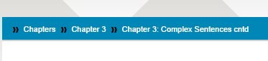

## Figure 2: Breadcrumbs on an e-textbook site

## Design

*Page length—moderate*

The Documents, Links, and News pages (pages with much of the site’s relevant content) all require several scrolls to get to the bottom. However, web page length is a key factor in a users’ ability to quickly see and accurately identify content. One way to do decrease page is to create broader categories on each page that will take users to their specified destinations. By creating these broader categories, the LibTACO department would simultaneously be enhancing the separate element of design, which is a page’s ability to facilitate scanning of information.

*Levels of Importance—moderate*

The current page layout does not convey which information is more useful, important, or frequently-accessed by users. Web design conventions dictate that the most important or most frequently used information should appear first, from left-to-right and from top-to-bottom.

## Language

*Descriptive Labels—severe*

Labels on the LibTACO intranet should be just as meaningful to users who have been recently hired as they are to those who have worked for the department for years. Some of the labels on the LibTACO intranet are not universally expressive and only have learned meaning; notably, the navigation tabs “Stuff ” and “All Things.” Additionally, some labels do not lead to information users expect to see; for example, in the usability tests, users were surprised to see that the “News” tab does not lead them to actual news stories, but rather an amalgamation of content that users could not easily or consistency define.

However, aside from the navigation items, many links and pieces of content are also inappropriately vaguely named, such as the documents “Group Policy,” “UNT Logon Notification,” “Live Meeting PDF,” and “Printers,” to name a few. One solution to address the non-descriptive labels would be for the LibTACO department to create a standardized content-naming convention. Table 2 includes a possible structure to implement such a naming convention. However, the LibTACO department could implement a less specified naming convention (such as by leaving off the “Type of Content” convention).

## Table 3: Possible content-naming convention

|  |  |  |  |
| --- | --- | --- | --- |
| **Convention** | **Type of Content** | **Summary of Contents** | **Date created or**  **modified** |
| **Semantics** | The first words of a con- tent label would indicate what kind of document to which the link will lead. | Summaries would be as descriptive as pos-sible in a few words. Summaries would name specific mod- els, actions, | All employees would adhere the dating method LibTACO decides to use. |
| **Possible types** | News_ Procedure_ Product_ Event_ Checklist_ Policy_ | WillisClosingEarly_ CreatingaLogin_ Windows8_ ReportingSpam_ FacultySocial_ PerformAMWalkthru_ CallinginSick_ | Month/Year Day/Month/Year |
| **Example** | Procedure_SettingupCanonPrinters_08/2014 | | |

## Searchability

*Inconsistent keywords—severe*

Currently, users may experience frustration because of uncertainty over which terms to use when searching for content on the intranet. One solution to this is for the administrators of the keywords to implement an authorized, or controlled, vocabulary, or control over what terms can be used to describe what content. The purpose of an authorized vocabulary is to provide consistency among the keywords (or any type of content) to increase the number of successful searches.

Vocabulary control is important to end users because humans have developed multiple ways of phrasing the same ideas. Vocabulary control helps limit the number of combinations people can use to form search queries; thus, users are more likely to pick terms that have meaningful relationships to documents and content within the site, thus increasing the reliability and effectiveness of searches. Vocabulary control is also important to technical users, or those who create, manage, and update content of the site itself from the back end, because it helps them create consistency and validity among the keyword representations. To implement a controlled vocabulary, the LibTACO department should implement an authorized vocabulary in the form of a thesaurus.

The thesaurus implements vocabulary control by containing an informative, syndetic structure, a structure that

indicates semantic relationships. The three kinds of semantic relationships in the thesaurus would be:

* Use/Use For (U/UF): compares two synonyms or near synonyms and indicates which is the authorized term and which not to use. For example, the thesaurus manager can make “Computer” the authorized term and direct users to not use a synonym, such “Hardware,” by indicating “U Computer; UF Hardware” in the thesaurus structure.
* Broader term/Narrower term (BT/NT): compares two words and indicates when one word is specific example of a general concept (or vice versa). For example, a thesaurus that has “Computer” as a heading can indicate that a broader term is machine and a narrower term is laptop by reading “BT Machine” and “NT Laptop.”
* Related term (RT): provides related words to the particular entry. Related terms indicate subjects that are similar to the authorized term, but not interchangeable with it. For example, under the term “Computer,” the indexer can relay related terms by writing “RT Operating System” and “RT Updates.”

Each of the preceding semantic relationships are also examples of mandatory reciprocals, or words that must appear in a set that explains their relationship to one another. Using again the previous U/UF example, each term (both “Computer” and “Hardware”) must appear separately as a first-level heading; it is not enough to notate “UF Hardware” under “Computer” without “U Computer” under “Hardware.” The same principle applies to BT/NT entries and RT entries. To implement the thesaurus, LibTACO employees could use a word processor to create new entries. At least one employee would also have to be charged with managing the thesaurus and updating it as needed. Please refer to the sample thesaurus in Appendix D to view an example of a thesaurus and controlled vocabulary the LibTACO department could implement.

## Scannability

On certain pages, users are going to search for items based on what they think items are called. However, on certain pages (such as the News page), items appear to be organized chronologically, with the most recently updated items appearing first. However, when a document was last updated is unimportant and likely unknown to an average user. Instead, the LibTACO department should consider arranging items in alphabetical order, or to at least give the option to sort by name or by date. Arranging items alphabetically would allow users to scan a page much like they would scan a dictionary or glossary for a specific term.

### Usability and user experience tests

## Goals of testing

The primary goals of testing were to see how participants navigated the intranet and what broad tasks with which they

would struggle. The recommendations I make in this report will improve the LibTACO intranet in the following ways:

* Intuitiveness of the IA
* Ease of navigation
* Confidence of users while interacting with the intranet

## Methodology

To gather input from a variety of users, I held usability tests from a total of 6 participants; 2 non-users of the intranet, 2 novice users who had only been working at the LibTACO department for 2 weeks or less, and 2 experienced users who had between 2 and 3 years of experience using the intranet each. Although my study is of a small scale, the results are still significant; according to usability and user experience researcher Jakob Nielsen, around 4-5 participants will uncover 80% of a website’s flaws. This 80% encompasses the “big picture” problems of a website and is more than can be realistically fixed from one round of testing. Additionally, after the first 4-5 participants, additional users are less and less likely to uncover new information.

Each test involved three people:

* A participant of one of the categories mentioned above
* A research assistant who administered tasks and interacted with the participant (the “facilitator”)
* Myself, as the data logger/note taker (the “observer”)

The facilitator and the observer both used laptops that had different functionalities of Morae software programmed into it. The facilitator’s laptop recorded the participant’s interaction with the intranet as well as mouse movements and mouse clicks. The observer’s machine was programmed to track the time and success rate of each task. Once again, participants were encouraged to use the think aloud protocol, which was extremely helpful in understanding users’ thought processes and possible reasons for task successes/failures. Appendix E contains the tasks participants were asked to complete.

Before each participant attempted the tasks, the facilitator used the pre-testing questionnaire from the card sorts to determine participants’ levels of familiarity with the intranet and using websites and computers in general.

## Usability test results

After the six sessions were completed, the data recorded from both laptops was analyzed using Morae Manager. Using Manager, I was able to meaningfully synthesize metrics such as time on task, success/failure rates, and qualitative feedback into visual aids such as charts and video clips.

*Positive aspects of the LibTACO intranet*

* Users identified the “Documents” and “Forms” pages as pages that contained ample or significant content. Although they often became confused once they landed on these pages, their draw to it indicates that with a restructuring of the IA and relabeling of the content, these pages can be extremely useful to users.
* Users could easily find the “Morning Walkthrough Checklist” for task 2. All users found this form with ease in

completing Task 2.

*Usability problems*

Figure 3 indicates the time spent by each user on each task before they either a) successfully completed the task, b) incorrectly thought they had finished the task, or c) gave up completing that task all together. (Participants match in both graphs—so Participant 1 in Figure 3 is the same person as Participant 1 in Figure 4). Task 5, “Change a Windows

Computer Name,” took the longest on average, and Task 3 “Public Laptop Checkout,” required the single longest period

of time needed to finish a task.

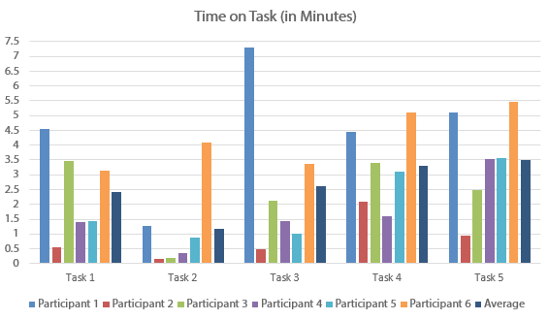

## Figure 3: Time on task for each participant

Figure 4 displays the success rates for each task. The ratings are as follows:

* “1” indicates that the participant successfully completed the task with ease, or within 1.5 minutes
* “2” indicates that the participant successfully completed the task, but did so with difficulty. Tasks were assigned

a rating of “2” if the participant required more than 1.5 minutes to complete it.

* “3” indicates that participants failed to successfully complete the task.
* A checkered pattern indicates that the participant failed to successfully complete the task, but thought that he or she had completed the task successfully. This trend directly ties to Major Finding 4.

During Tasks 1 and 5, 5 out of the 6 participants failed to complete Tasks 1 and 5; however, multiple users thought they had completed the tasks. Additionally, all participants gave up completing Task 4.

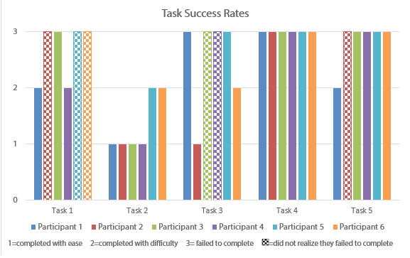

## Figure 4: Participants’ success rates

### Major findings

The results of this study indicate 5 major findings that comprise most of the usability issues. A short video clip that showcases multiple instances of the same problem supports the claim of each major finding.

## Finding 1: Users don’t understand the naming conventions or don't see labels they expect to see.

**Finding 2: Users do not understand the information architecture or the website or the**

**organization of several individual pages.**

**Finding 3: Users don’t trust the older information on the intranet.**

**Finding 4: Multiple documents with similar titles or titles lead users to false-positive conclusions**

**(meaning they thought they'd finished the task but had not found the content I was looking for).**

**Finding 5: The content on the intranet is not skimmable.**

## Observations

Aside from my 5 major findings, there were other notable user comments that can be grouped into 3 major categories.

## Observation 1: When users could not understand content labels or the organization, they became

**unsure of their actions**

**Observation 2: Being unable to successfully navigate the website led users to give up completing certain tasks, indicating a poor user experience.**

**Observation 3: Users demonstrate a heavy reliance on the search function of the website, implicating even more the need for an authorized vocabulary.**

### Recommendations

To address the major usability issues of the LibTACO intranet, I present the following 6 recommendations:

**Recommendation 1: Rename content headings and other labels using natural, widely understood language** Keeping/creating navigation labels that have clear or inherent meaning (such as Documents), as opposed to assigned or learned meaning that users must memorize (such as “All Things” or “Stuff ”) will help users understand the scope and purpose each piece of content, each individual page, and the intranet as a whole. Additionally, users will be able to more successfully predict where each click will take them if the language is simple and has intrinsic connotations. Managers of the intranet should establish and enforce criteria and procedures for publishing new content to the intranet to uphold meaningful naming conventions.

## Recommendation 2: Reorganize the information architecture to meet user’s expectations

The Wireframe in Appendix A suggests a new IA that reflects strong content correlations from the card sorts. Additionally, the results from the card sorts and the heuristic evaluation also indicate that the LibTACO department would benefit from the following actions:

* Reducing the number navigation links on the home page from 5-9; iincluding drop-down menu items to show subcategories of main navigation links (including subcategories) will decrease the number of menu items from the home page.
* Merging redundant content from the site (such as “Recent Changes”/”Recently Updated” or “Events”/”Past Events”/”Calendar”).

Although the number of participants in this particular study is too small to yield a definitive IA, the results can still indicate potentially successful organizations. Additionally, these results can be useful in creating significant points of investigation for subsequent usability studies. By following these recommendations, the LibTACO department

can create a navigation structure with links that allows users to quickly and accurately get the information for which

they’re looking.

## Recommendation 3: Remove old and/or irrelevant data

Many users assume that old information is irrelevant, so when they see that content has not been updated for many years, they assume that all the content on that page is irrelevant, regardless of whether or not it actually is. This is especially true in a department whose work is technologically based, such as the LibTACO department, because of the rapid rate with which software, hardware, and other aspects of technology change. The LibTACO intranet can increase users’ trust of their content while simultaneously adhering to Recommendations 4a and 6 below by eliminating redundant, unused, or dated content.

## Recommendation 4: Remove redundantly named content to decrease false-positives

Because many of the pieces of content on the site are similarly named, users may mistake them for one another. In a real-world context, this could cause LibTACO employees to either follow the incorrect documentation and/or have to re-perform some actions because they performed them incorrectly the first time.

## Recommendation 5: Make pages more skimmable by including more top-level headings and by reducing the number of links and content available on each pages. Create more sub-pages to house the information that used to be located on one page

Users depend on devices such as headings to locate information that is relevant to them. However, when pages become too saturated with headings and other content, these locators lose their effect. Decreasing the amount of content on pages will allow users to clearly see in which direction they need to go or whether or not that page has information they need.

The large amount of content on most pages of the intranet presents another problem: the higher the number of possible paths users can take to get to their desired location, the higher the likelihood they will choose the wrong path. Furthermore, studies have shown that users dislike having to bounce back and forth between links on a page (Spool

2008). However, users typically do not mind having to make more clicks so long as they are making confident clicks,

wherein they are sure they are heading to the right direction.

## Recommendation 6: Use an authorized vocabulary to input metadata and keywords to increase success rate of user searches

Although my usability study did not directly reveal a problem with the searchability, I was told in the interviews with the LibTACO employees and the department manager that the random assignment of metadata and keywords made searching for content more like “guessing games” than intelligently formed queries. The reason for this inconsistent search results and search success rates likely has to do with the fact that whenever anyone uploads new content, they are using an individualized method of associating keywords and metadata.

Implementing a thesaurus that contains an authorized vocabulary would increase the consistency with which users tag content, thus increasing the success rates of search queries. In order to have lasting results, someone must be in charge of maintaining and updating the thesaurus as necessary. The following video suggests the importance of the search function for the LibTACO employees, stressing the need to control how users describe and tag content.

### Conclusion

This preliminary study has aimed to analyze the current state of the usability of the LibTACO department’s intranet in order to provide recommendations on ways to improve the usability and user experience. The LibTACO department should continue to conduct iterative, small-scale usability and user experience tests after applying recommendations from this report, as well as whenever the site grows or changes. Additional insights would require a more comprehensive study on the new website once the recommendations in this report have been addressed.

Thank you for considering me to assess the usability of the LibTACO intranet and for taking the time to read this study. As the LibTACO department takes the recommendations and observations in this report into consideration, I encourage personnel to contact me with any questions or for further explanation at autumnhood1 at gmail dot com.

### References

Barnum, Carol. (2011). Usability testing essentials ready, set-- test! Amsterdam: Morgan Kaufmann. ISO 9241-11:1998. (1998, January 1). Retrieved September 3, 2014, from <http://www.iso.org/>

Oxford Dictionaries. 2014.

Raign, Kathryn. (Image). 2014. Write Now! [e-textbook]. Retrieved September 12, 2014 from: unt.grtep.com

Righi, C., James, J., Beasley, M., Day, D., Fox, J., Gieber, J., Ruby, L. (2013). Card Sort

Analysis Best Practices. Journal of Usability Studies, 8(3), 69-89.

Spool, Jared. (2008). The Right Information. User Interface Engineering. Retrieved November 11, 2014 from [http://www.uie.com.](http://www.uie.com/)

### Appendix A: Proposed Information Architecture Wireframe

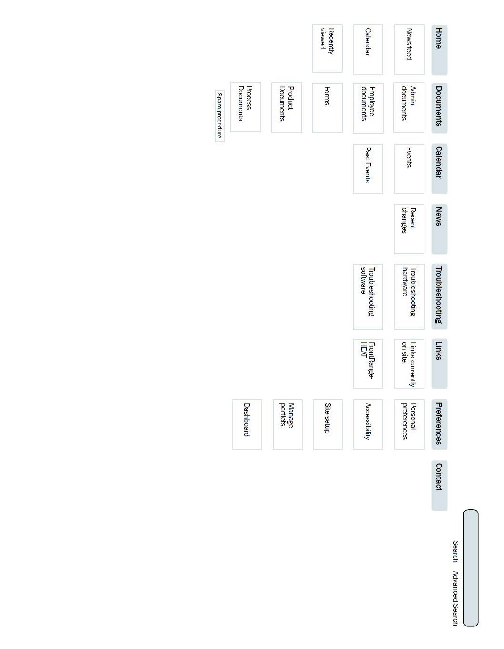

### Appendix B: Card Sort Correlation Matrix

This appendix (continued on the next page) includes the correlation matrix used to both generate a proposed information architecture and create appropriate tasks for usability tests. The matrix includes all the cards participants sorted during card sorts.

The correlation matrix visually shows how often participants associated different pieces of content with one another. The lower the number in a cell, the lower the correlation, or number of associations, between the two corresponding cards. The highest possible number in this matrix is 4, which would indicate that all 4 participants put the two corresponding cards in the same group. For visual aid, I altered the matrix so that the higher the correlation, the darker the individual cell.

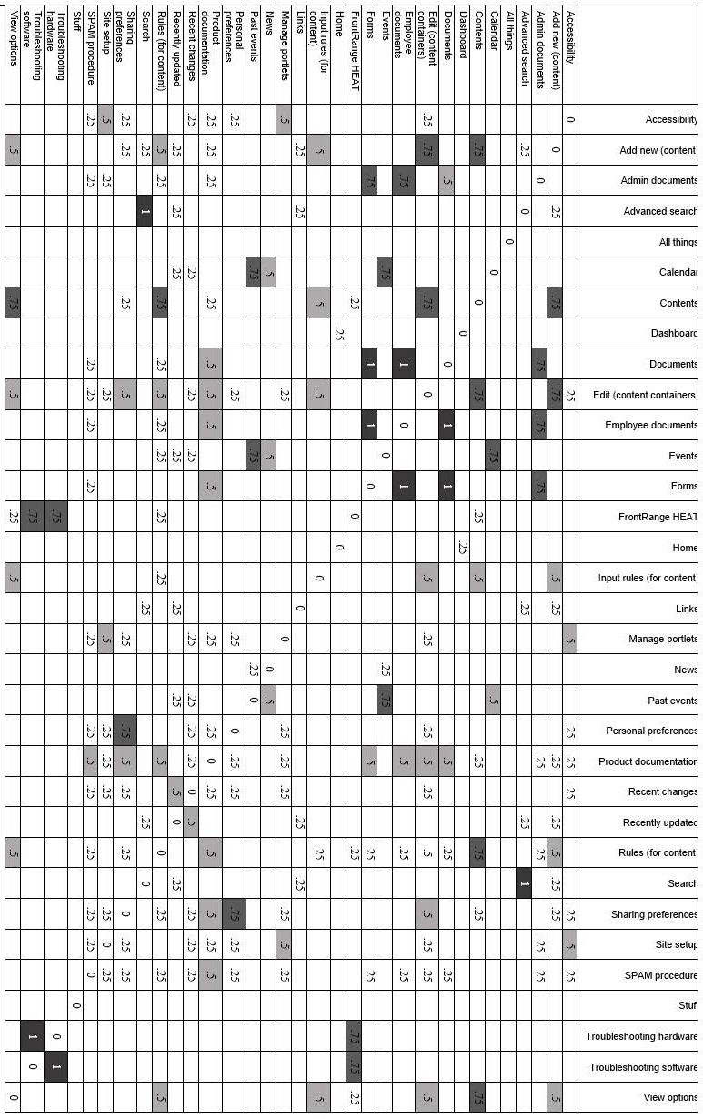

### Appendix C: Pre-Testing Questionnaire used for Card Sort and Usability Testing

This appendix contains the questions asked of participants before both the card sorts and the usability tests. The

first 4 questions were asked in only the usability testing activities, while the last 4 were asked in both activities.

## Questions asked only in the usability testing activities

1. Have you ever used the LibTACO intranet? If so, how many times or for how long have you been using it?

n Skip to question 5 if participant answers “no.”

1. What was the last task you remember needing to do there? Were you successful?
2. How would you describe your experiences with using the LibTACO intranet?
3. Do you feel that the LibTACO intranet meets your needs and expectations?

## Pre-test interview questions asked in both card sorts and usability tests

1. How many days a week do you use the internet?
2. How many hours a day, if applicable?
3. How often do you use the internet for the following tasks:
   1. Work:
   2. Outside of work responsibilities:
   3. Shopping:
   4. Entertainment:
4. What are some of your favorite websites?

### Appendix D: Example Authorized Vocabulary

This appendix contains a sample authorized vocabulary, in which U = Use, UF = Use for, BT = Broader term, NT

= narrower term, and RT = related term.

Admin Documents

BT Documents

RT Employee Documents Computer

U Hardware RT Machine RT PC

NT Laptop NT Desktop

Desktop

PC

Process

NT Mac NT PC

UF Machines

BT Operating System RT Mac

UF Steps UF How-to

UF Procedure

RT Laptop BT Computer

Documents

NT Admin Documents NT Employee Documents NT Process Documents NT Product Documents RT Forms

Employees

U Users

Employee Documents

BT Documents

RT Admin Documents Hardware

UF Machines

BT Product

Help

U Troubleshooting How-to

U Process

Laptop

RT Desktop BT Computer

Library

U Willis

Mac

BT Software

BT Operating System RT PC

Machines

U Hardware

News

RT Recent Changes

RT Recently Updated

Operating System

BT Software

Process Documents

BT Documents

RT Product Documents Procedure

U Process

Product

NT Hardware Product Documents

BT Documents

RT Process Documents Recent Changes

UF Recently Updated

RT News

Recently Updated

U Recent Changes

RT News

Steps

U Process

Software

NT Mac

NT Operating System NT PC

Technicians

U Users

Troubleshooting

UF Help

NT Troubleshooting Hardware NT Troubleshooting Software

Users

UF Employees UF Technicians

Willis

UF Library

RT Work

Work

U Willis

### Appendix E: Usability Testing Tasks

This appendix contains the pre-usability testing briefing and usability tasks read to participants. Participants also

received their own copies of the scenario and tasks below.

### Usability Test Scenarios

You are a student employee for the UNT Willis Library helpdesk. Specifically, you work for the Library Technology

and Computer Operations (LibTACO) department, and some of your common functions include

* Installing new hardware and software in the Willis Library
* Working with PC and Mac operating systems regularly
* Helping library staff and patrons with computer issues
* Performing regular checks to ensure quality performance from all the machines
* Updating programs as often as necessary
* Attending occasional department meetings

As you’re working through these tasks, please remember to avoid using the searching function of the website or

“Ctrl+F.”

### Task 1: Surplus a laptop

You’ve just been informed that the library has to surplus 5 laptops. Your boss has put you in charge of this process, but you’ve never done it before so you decide to look it up first.

## Task: Find out how to properly surplus a laptop from the Willis Library.

### Task 2: Perform a routine walkthrough

Your next three shifts are morning shifts, so you’ll have to perform the Morning walkthrough. You haven’t worked a morning shift in 6 months, so you decide to look up how to do it before you go in. However, you want to use the one that is a live form so you can just take your iPad with you.

## Task: Find the Morning Walkthrough Checklist that is a live form.

### Task 3: Public Laptop Checkout

A new student worker at the Willis library has asked you to help him find out the proper procedures for checking out laptops to other students through the library. You know you’ve seen something about it on the LibTACO intranet, so you decide to look there first.

## Task: Find out where to go to properly check out laptops to students through the library.

### Task 4: Wimba Live Classroom Training

Your boss feels like it’s time to provide another training session on Wimba Live Classroom, a live chat application used on the UNT Learn system. He’s asked you to find out when the last time this training was offered so he can be sure of his decision.

## Task: Find out when the last Wimba Live Classroom training session was offered.

### Task 5: How to Change Windows Computer Names

You have been put in charge of training the new hires for the Fall semester. One thing you’re going to teach them is how to change the name of a Windows computer. Before you show them how to do it, you want to brush up on the process yourself so you don’t give them any misinformation.

## Task: Find out how to change the name of a Windows computer.