By using python’s matplotlib and numpy, I got the following figures:

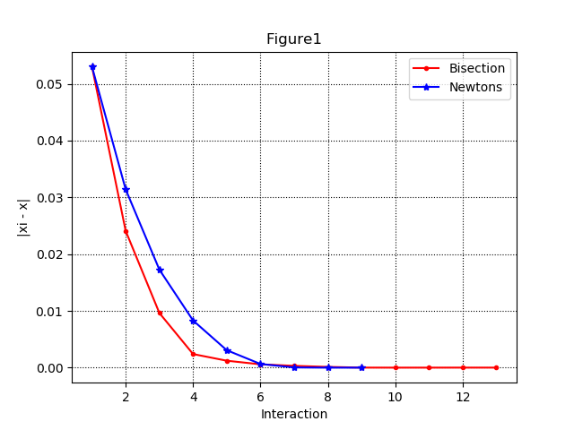

If we just look at Figure1, it seems that Bisection method approaches the root faster than Newton’s at first. To make it clear, a different figure is made in logarithmic form:

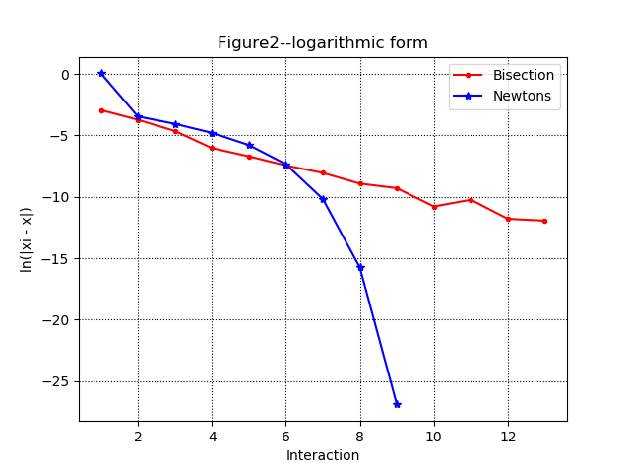

Now, it is pretty obvious that Newton's method converges much faster, even faster than the logarithm while Bisection Method converges as fast as logarithm.

**Appendix:**

#Draw.py for Figure 1:

import matplotlib.pyplot as plt

import numpy as np

file = open("C://Users//18123//Desktop//Assignment3_YiminZhao_CentOS7.6//NewtonsMethod.txt")

NewtonsMethod = np.asfarray(file.read().split('\n'))

file1 = open("C://Users//18123//Desktop//Assignment3_YiminZhao_CentOS7.6//bisection.txt")

Bisection = np.asfarray(file1.read().split('\n'))

iteration = np.array(range(1, len(Bisection)+1))

iteration_ = np.array(range(1, len(NewtonsMethod)+1))

plt.plot(iteration, Bisection, color="red", marker = '.', label='Bisection')

plt.plot(iteration_, NewtonsMethod, color='blue', marker = '*',label='Newtons')

plt.xlabel("Interaction")

plt.ylabel("|xi - x|")

plt.title("Figure1")

plt.grid(color="k", linestyle=":")

plt.legend()

plt.show()

#Draw_L.py for Figure 2:

import matplotlib.pyplot as plt

import numpy as np

file = open("C://Users//18123//Desktop//Assignment3_YiminZhao_CentOS7.6//NewtonsMethod_L.txt")

NewtonsMethod = np.asfarray(file.read().split('\n'))

file1 = open("C://Users//18123//Desktop//Assignment3_YiminZhao_CentOS7.6//bisection_L.txt")

Bisection = np.asfarray(file1.read().split('\n'))

iteration = np.array(range(1, len(Bisection)+1))

iteration_ = np.array(range(1, len(NewtonsMethod)+1))

plt.plot(iteration, Bisection, color="red", marker = '.', label='Bisection')

plt.plot(iteration_, NewtonsMethod, color='blue', marker = '*',label='Newtons')

plt.xlabel("Interaction")

plt.ylabel("ln(|xi - x|)")

plt.title("Figure2--logarithmic form")

plt.grid(color="k", linestyle=":")

plt.legend()

plt.show()