# Paper

Yost, K.E., Satpathy, A.T., Wells, D.K. *et al.* Clonal replacement of tumor-specific T cells following PD-1 blockade. *Nat Med***25,**1251–1259 (2019). <https://doi.org/10.1038/s41591-019-0522-3>

# data

droplet-based 5′ single-cell RNA-sequencing from 11 patients（response: 6 Yes,5 No） with advanced basal cell carcinoma (BCC) before and after anti-PD-1 treatment in site-matched primary tumors. 52218 cells.

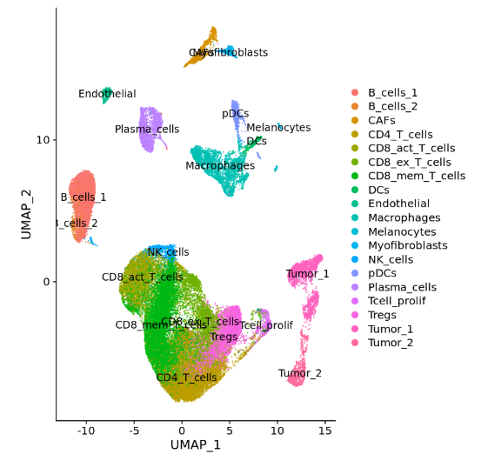

|  |  |  |  |  |  |  |
| --- | --- | --- | --- | --- | --- | --- |
| Patient | Tumor Type | Treatment | Ongoing Vismodegib treatment | Prior treatment | Response | Best % change |
| su001 | BCC | Pembrolizumab | + | Vismodegib | Yes | -81 |
| su002 | BCC | Pembrolizumab | - | Vismodegib | Yes | 0* |
| su003 | BCC | Pembrolizumab | - | Vismodegib | Yes | -100 |
| su004 | BCC | Cemiplimab | - | - | Yes | -25 |
| su005 | BCC | Pembrolizumab | - | Vismodegib | No | 5 |
| su006 | BCC | Pembrolizumab | + | Vismodegib | No | -11 |
| su007 | BCC | Pembrolizumab | - | Vismodegib | No | 10 |
| su008 | BCC | Pembrolizumab | + | Vismodegib | No | 0 |
| su009 | BCC | Cemiplimab | - | Sonidegib | Yes | -62 |
| su010 | BCC | Pembrolizumab | - | - | No | 10 |
| su012 | BCC | Cemiplimab | - | Vismodegib | Yes | -57 |

Pre treatment: 20969 cells

Post treatment: 31249 cells