Microsoft Office Standard 2007

**Microsoft® Office Standard 2007 is the essential office software for small business and home computer users. With the Microsoft Office Fluent™ user interface, enhanced graphics and formatting, powerful new time and e-mail management tools, and more reliability and enhanced security, Office Standard 2007 makes it easier and more enjoyable to get things done.**

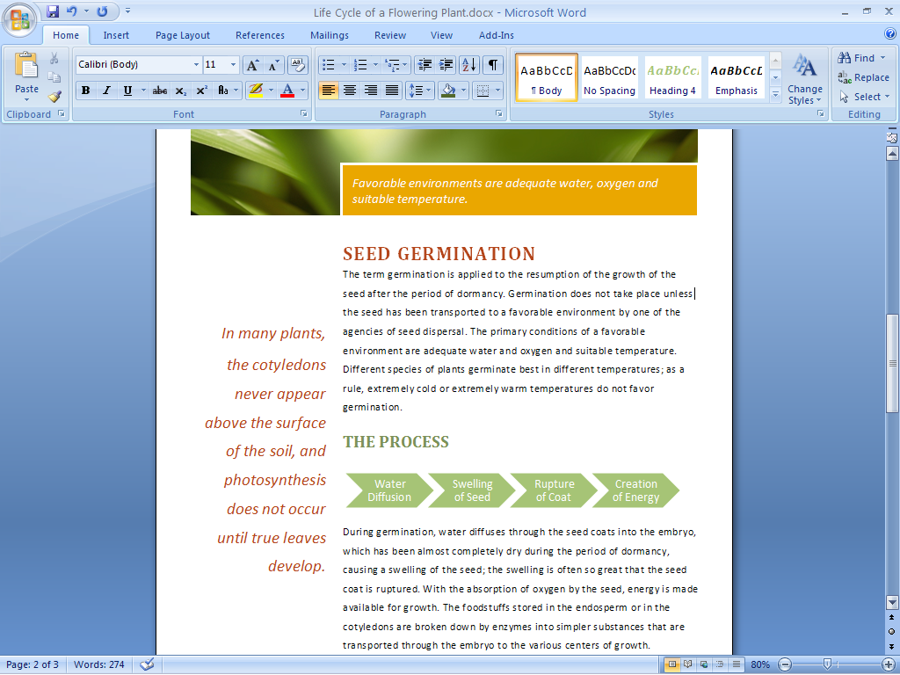

The streamlined workspace and easy-to-browse tabs make program features easier to find and use.

Find Commands and Help Easily

The Office Fluent user interface and an enhanced Help system get you started.

Get more out of the Microsoft Office system.

The Office Fluent user interface for Microsoft Office Word 2007, Microsoft Office Excel® 2007, and Microsoft Office PowerPoint® 2007 has been designed to make program features easier to find and use. Commands are organized into a set of easy-to-browse tabs that correspond more directly to the things you do most in the Microsoft Office system. Formatting galleries with live previewing take the place of complicated dialog boxes, so you can simply pick and click to get the effects you want.

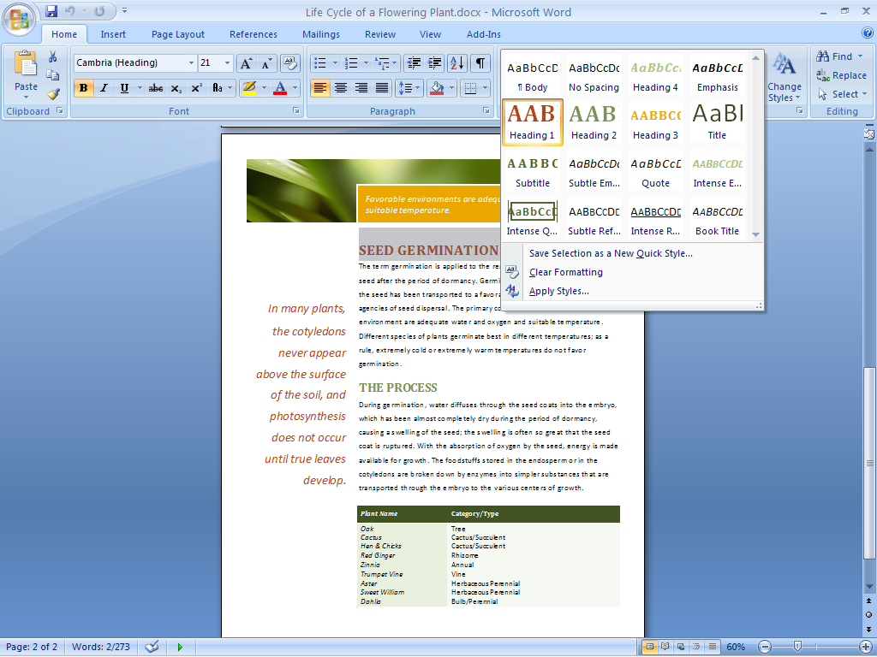

Formatting galleries make it easier to find and apply formatting changes.

Find the help you need.

Office Standard 2007 provides more direct links to Help content than ever before. Take advantage of close coordination between Help in the program and Help available on the Internet (when connected). Larger, more informative ScreenTips provide quick access to information about a command.

Get started with ease.

An improved Getting Started experience in Office Standard 2007 helps reduce the learning curve for new users. Online tutorials offer step-by-step instructions for using your Microsoft Office system software.

Create High-Quality Documents

New graphics, text tools, and formatting galleries help you produce high-quality documents you can be proud of.

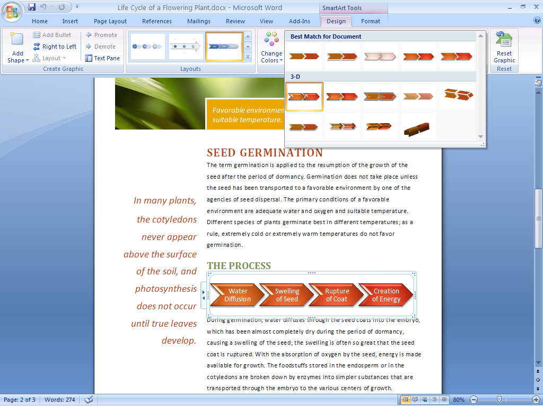

Insert graphics and charts such as these into your documents to make them more appealing.

Reduce frustration with bullets and tables.

With the addition of more consistent numbering, bullet, and table features in Office Standard 2007, you can reduce time spent reformatting your Word documents.

Give your work a professional look.

With Office Standard 2007, you can give your documents a more professional look by using rich design and typography tools, including 3-D effects, shadows, glows, blurs, and a gallery of many different standard chart and diagram types.

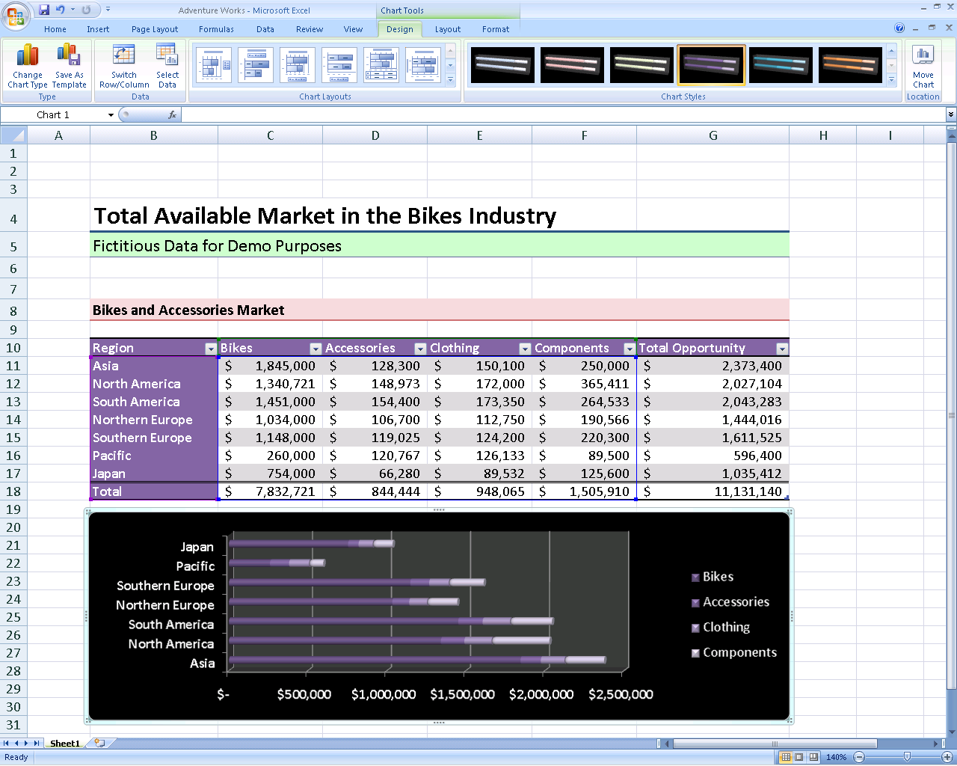

Use the new diagram and improved charting tools to create rich and stunning visuals and charts.

Maintain consistency across applications.

With Document Themes, you can apply and preserve a consistent look for tables and text across Word documents, Excel spreadsheets, and PowerPoint presentations. This predictability means that when you cut and paste objects between programs, the items maintain their appearance.

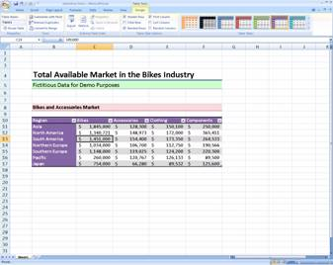

Quick and easy-to-use table styles help ensure that your tables look great and are consistent across Word documents, Excel spreadsheets, and PowerPoint presentations.

Preview your changes quickly.

With Live Preview, you can quickly preview proposed changes to your document while you’re working on it without having to repeatedly search through drop-down menus. By test-driving your proposed formatting, you can save time and experiment more easily.

Organize Your Time and Communications

Microsoft Office Outlook® 2007, included in Office Standard 2007, helps you organize your time and to-do tasks by organizing your e-mail, calendar, and contacts.

Organize your appointments.

With new calendar views, you can compare two calendars side by side or with one on top of the other. In addition, you can place and track tasks directly on your calendar.

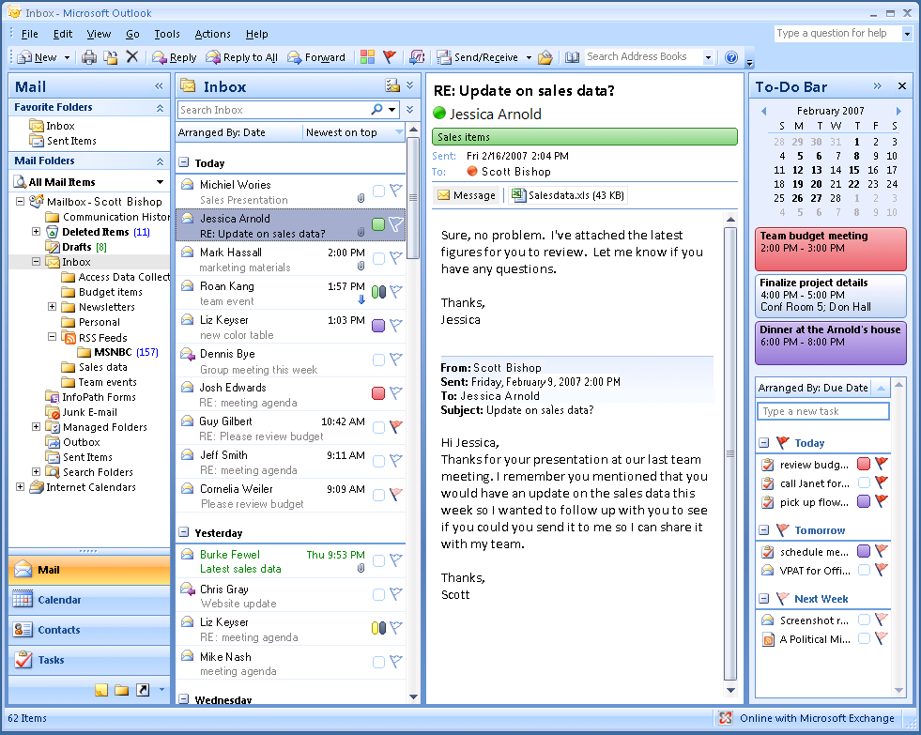

New calendar views and a To-Do Bar make it easier to manage   
your time.

Keep on top of your action items.

Office Outlook 2007 features a new To-Do Bar that centralizes tasks, calendar information, and e-mail messages flagged for follow-up.

Subscribe to relevant information   
using RSS.

Really Simple Syndication (RSS) is a technology you can use to subscribe to your favorite Web site news, online newspapers, blogs, and other Web content. RSS subscriptions in Office Outlook 2007 capture all of the RSS feeds you subscribe to in a designated folder that updates automatically (an additional fee-based RSS subscription is required).

Find what you need.

Office Outlook 2007 provides an Instant Search tool that you can use to quickly find information in any of the Outlook modules such as e-mail, calendars, and tasks.

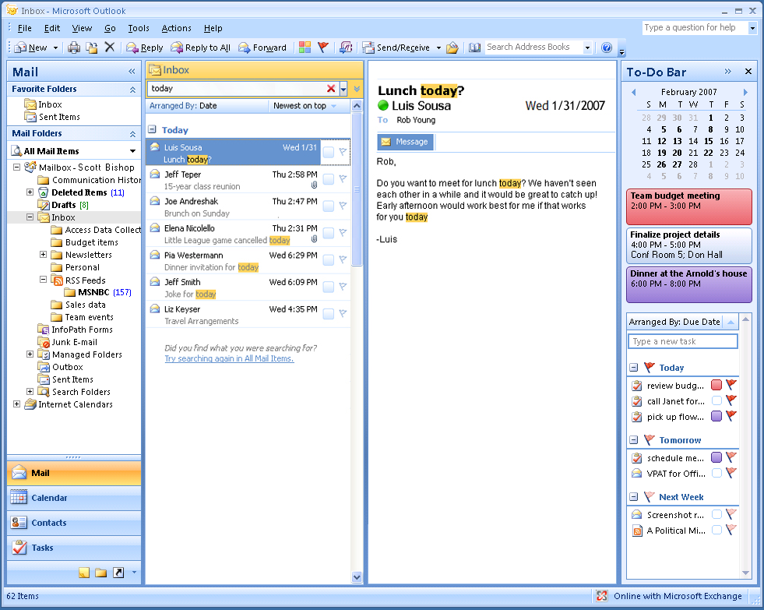

Instant Search includes “hit” highlighting (noted above in yellow)   
so that relevant results are easy to find.

Work with Enhanced Security and Reliability

Office Standard 2007 provides an improved junk e-mail filter, automatic document recovery, and the Document Inspector to help you work with more confidence and enhanced security.

Help protect against junk e-mail.

Office Standard 2007 includes an enhanced Outlook junk e-mail filter to help reduce electronic spam sent to your inbox and help protect against potentially harmful attachments.

Keep “phishers” away.

Office Outlook 2007 also includes security enhancements to help prevent “phishing,” which is a fraudulent e-mail attempt to trick you into providing financial or personal information.

Share documents with greater peace   
of mind.

Detect and remove unwanted comments, hidden text, or personally identifiable information in your documents using the Document Inspector.

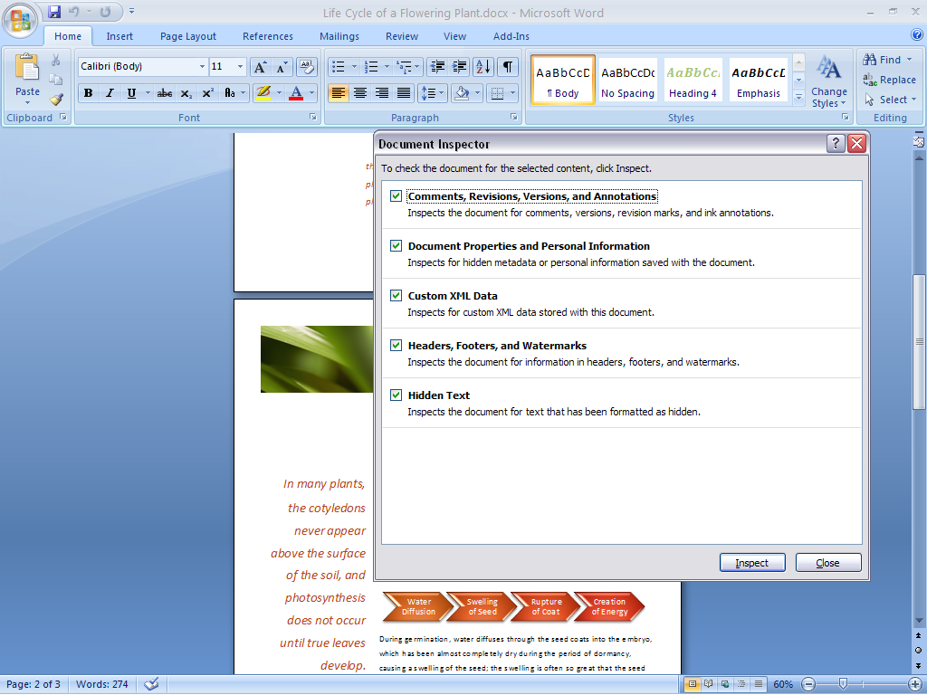

The Document Inspector helps find and remove potentially sensitive “hidden” information from your documents, presentations, and spreadsheets.

For More Information

Learn more about Office Standard 2007 and the Microsoft Office system at [www.microsoft.com/office/suites/standard](http://www.microsoft.com/office/suites/standard).

For complete system requirements, visit [www.microsoft.com/office/suites/standard](http://www.microsoft.com/office/suites/standard).

This document is for informational purposes only. MICROSOFT MAKES NO WARRANTIES, EXPRESS OR IMPLIED, IN THIS SUMMARY.

The example companies, organizations, products, domain names, e-mail addresses, logos, people, places, and events depicted herein are fictitious. No association with any real company, organization, product, domain name, e-mail address, logo, person, place, or event is intended or should be inferred.

MSlogo_k_1118© 2006 Microsoft Corporation. All rights reserved. Microsoft, Excel, the Office logo, Fluent, Outlook, and PowerPoint are either registered trademarks or trademarks of Microsoft Corporation in the United States and/or other countries. All other trademarks are property of their respective owners.