Building a HomeBrew 3-500Z Plate Power Supply
Part Two: Initial Wiring
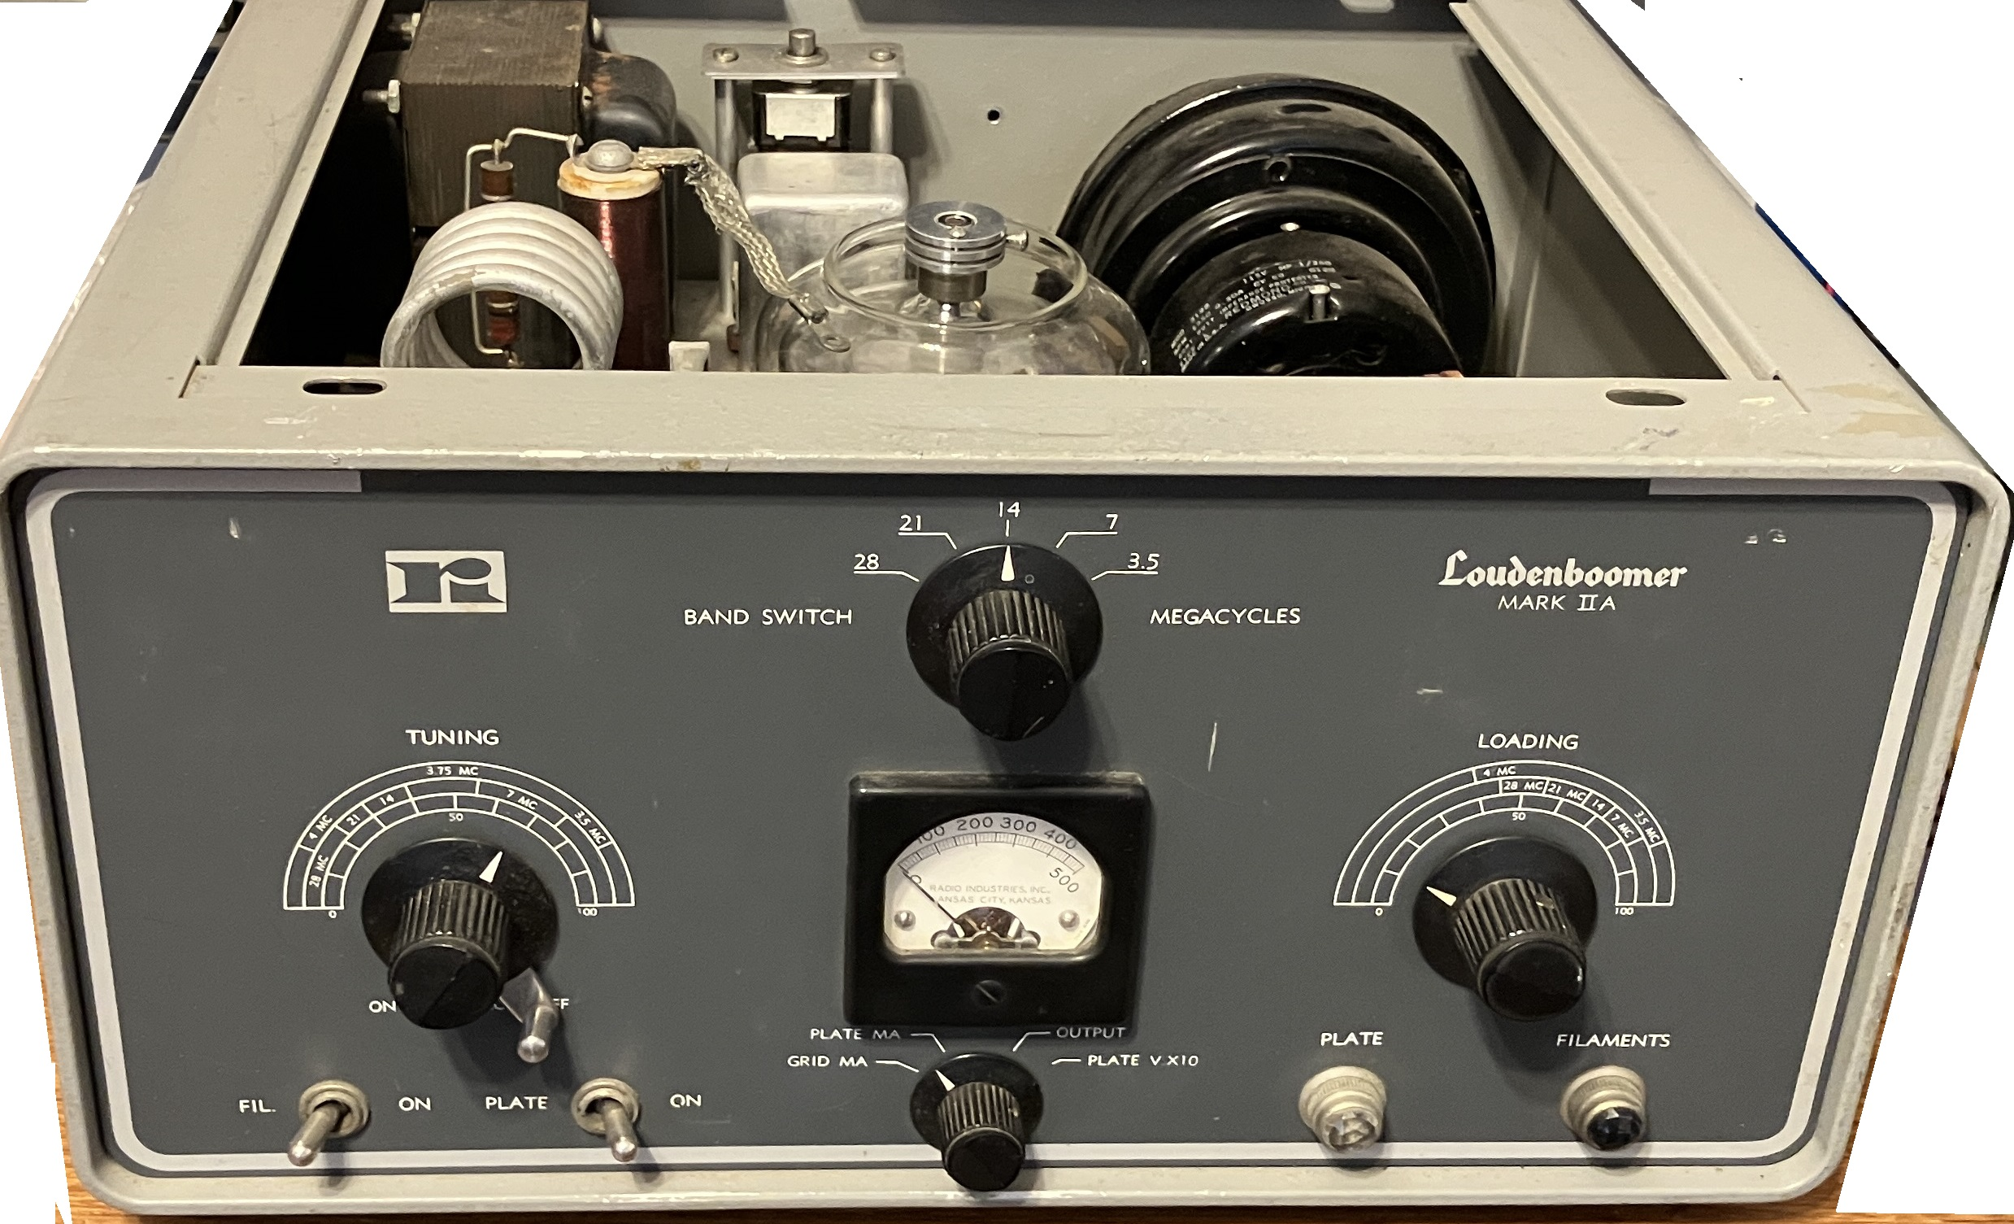Hallicrafters HT-45 Loudenboomer Single Tube Amplifier
by Gordon Gibby KX4Z

This is the 2nd in a series detailing the construction of a high voltage power supply for a single- or double-3-500z amplifier. The design is based on 3D-printing the chassis and cabinet, allowing for easy replication and minimal construction skills. Normally difficult items such as oddly-shaped cutouts for meters are easy to accommodate in 3D printing and front panel labels can even be provided using different colors in layers of 3D printing.

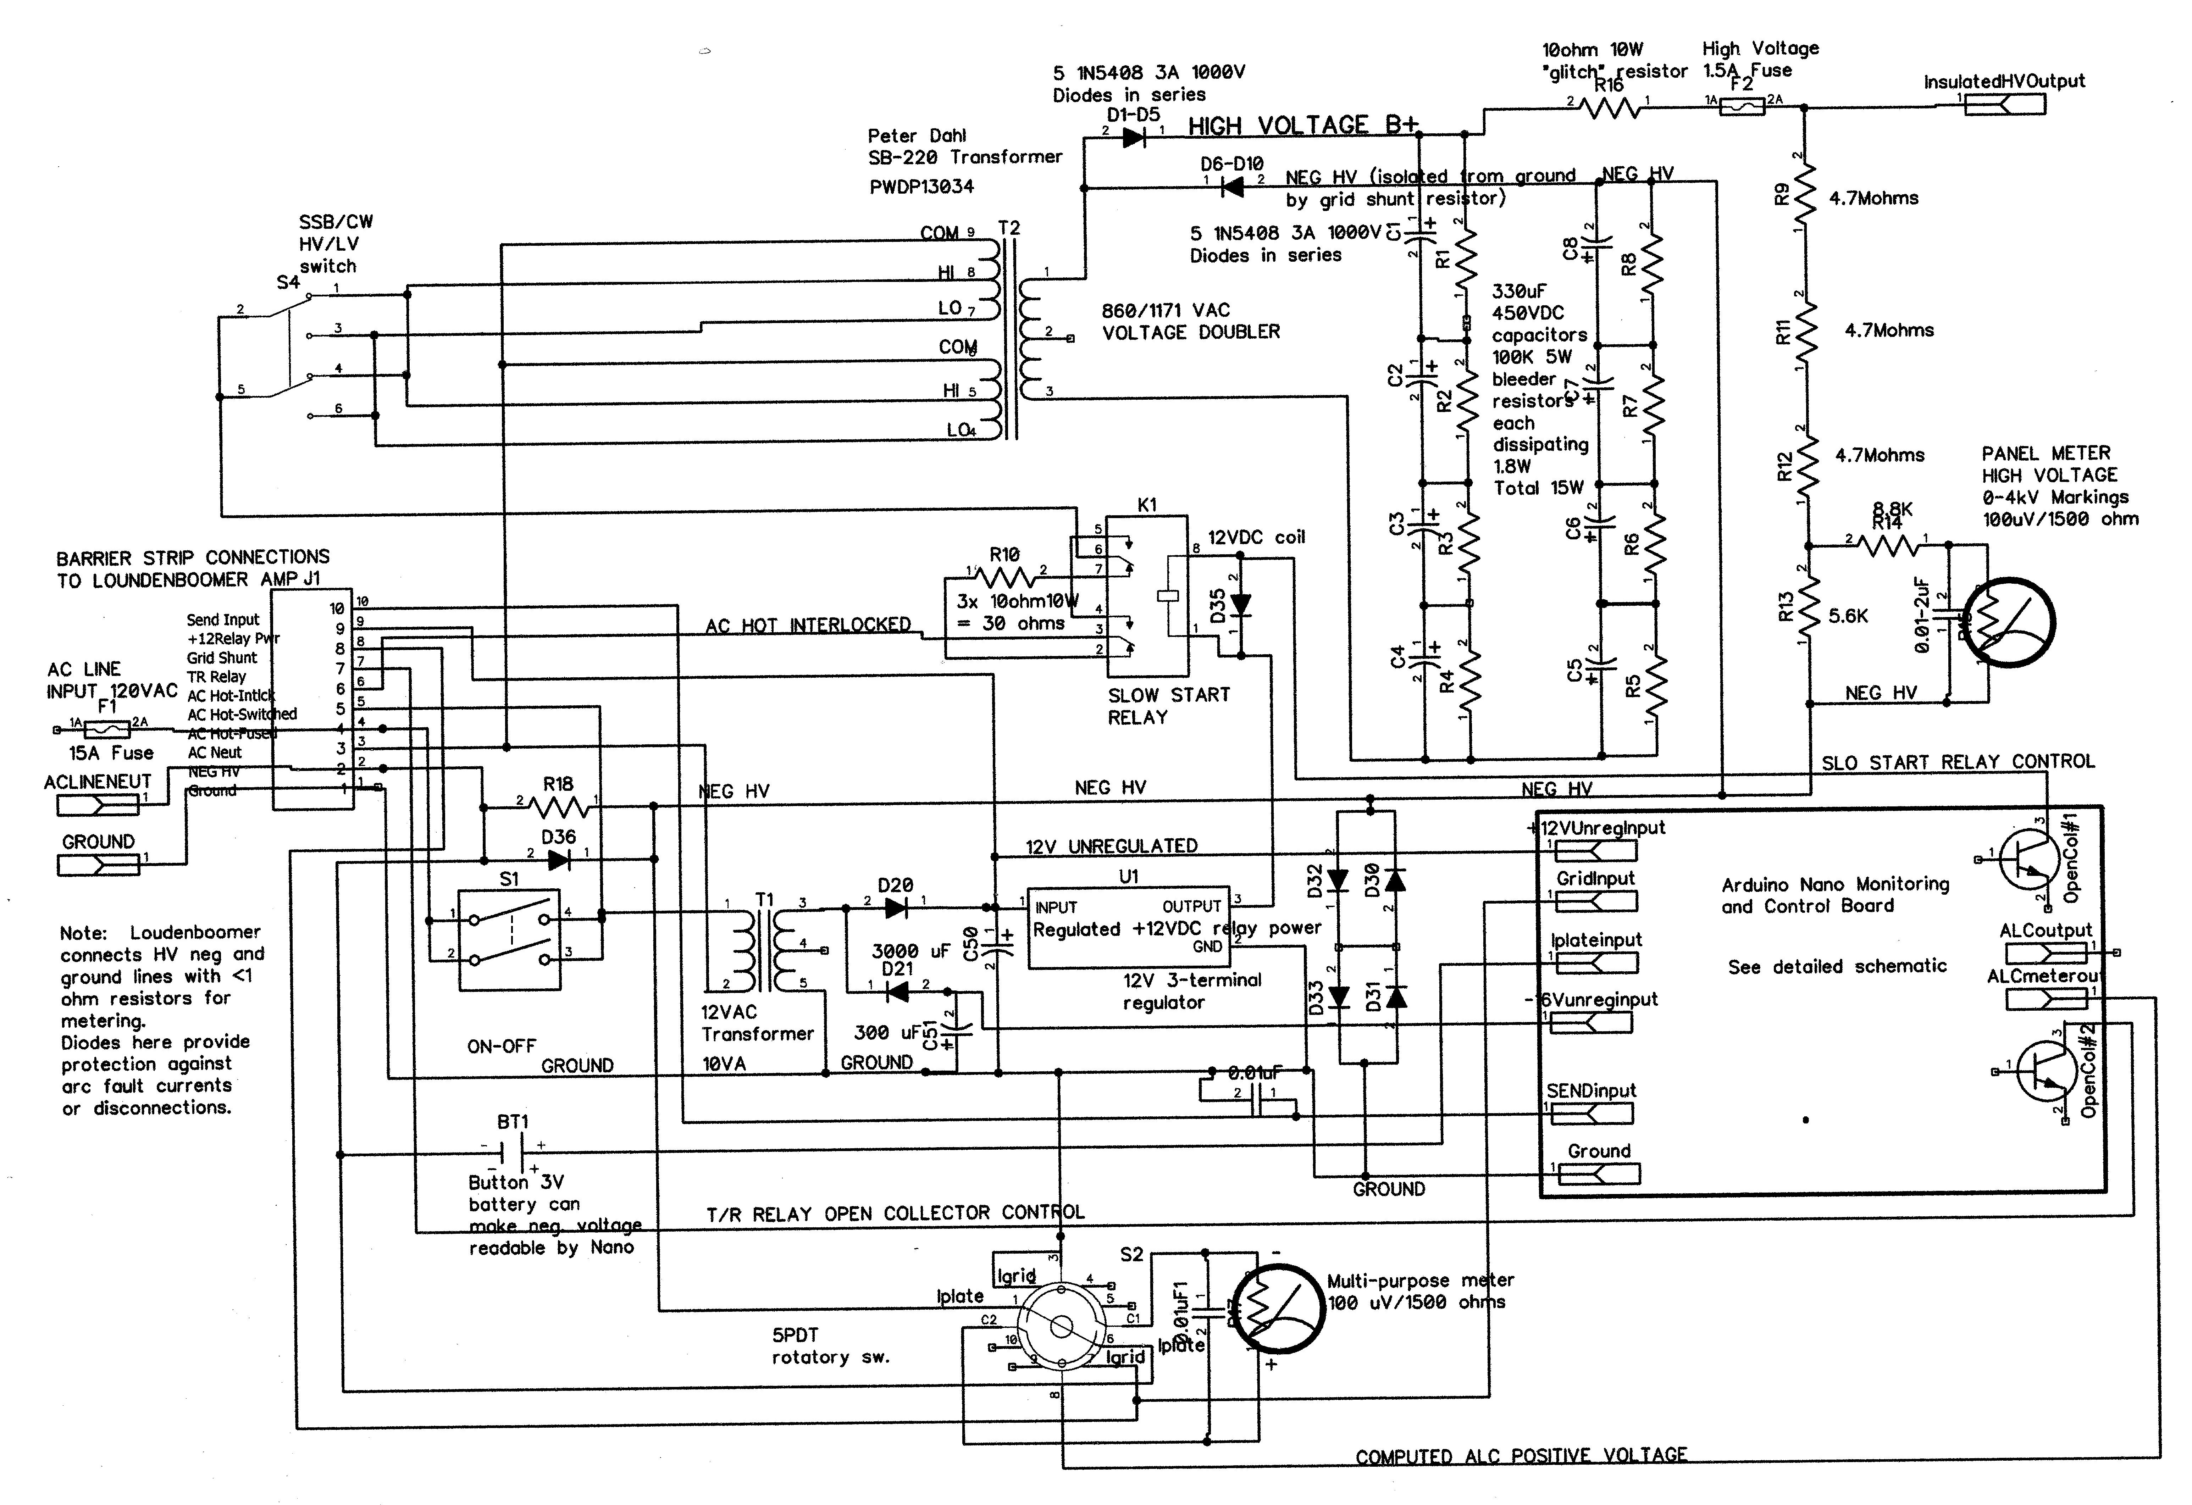

POWER SUPPLY SCHEMATIC

CIRCUIT OPERATION
The high voltage portion of the power supply is simply a copy of the Heathkit SB-220 voltage doubler. The filter capacitor system can be thought of as two separate banks, each four capacitors fed by a diode. On the positive going half period, through the series diode string D1-D5 the left bank charges; on the negative going half period, the right bank charges through diode strong D6-D10. Each such bank has 330/4 = 82 uF capacitance. Each bank gets charged once each 16.7 millisecond cycle, and is expected to supply an average current of about 330 mA. Since Q = CV for capacitors, the voltage droop can be calculated as 0.0055 amp-seconds = 82E-6 F * deltaV ==> droop = 67 volts for a single 3-500Z amplifier At an average voltage of about 1600 volts per bank, this is on the order of 4% ripple, and the two banks are time-separated so the total effective ripply may be even less.

The bleeder resistors service to even out the voltages between capacitors and also safely discharge the capacitors when power is removed.

Power arrives to the high voltage supply through series of front panel toggle switch, cabinet interlock switch (in the amplifier) and through a slow-start resistor that gets bypassed by a relay after the initial surge current. (The timing controlled by the Arduino board later to be constructed.)

A simple low voltage supply provides unregulated positive voltage to intermittently operate T/R (bypass) relays in the Amplifier, and regulated +12 for the slow-start relay The latter is the only load most of the time and the unregulated voltage was higher than comfortable so a simple regulator was added The two T/R bypass relays in the Amplifier add enough load so that they see reasonably near to +12V and do not need regulation. The supply also provides a negative voltage for the op amp on the Arduino board to provide a negative ALC voltage to the exciter transmitter.

Voltage metering of the high voltage is continuous by one panel meter through dropping resistors, and this also will allow the Arduino to check for blown high voltage fuse and remove any excitation from the 3-500Z.

A second panel meter can be switched to measure plate current from a 0.33 ohm resistor in the negative HV line, or to access the grid shunt resistor voltage in the Arduino to measure grid current The grid current voltage is also made available to the Arduino for ALC computation.

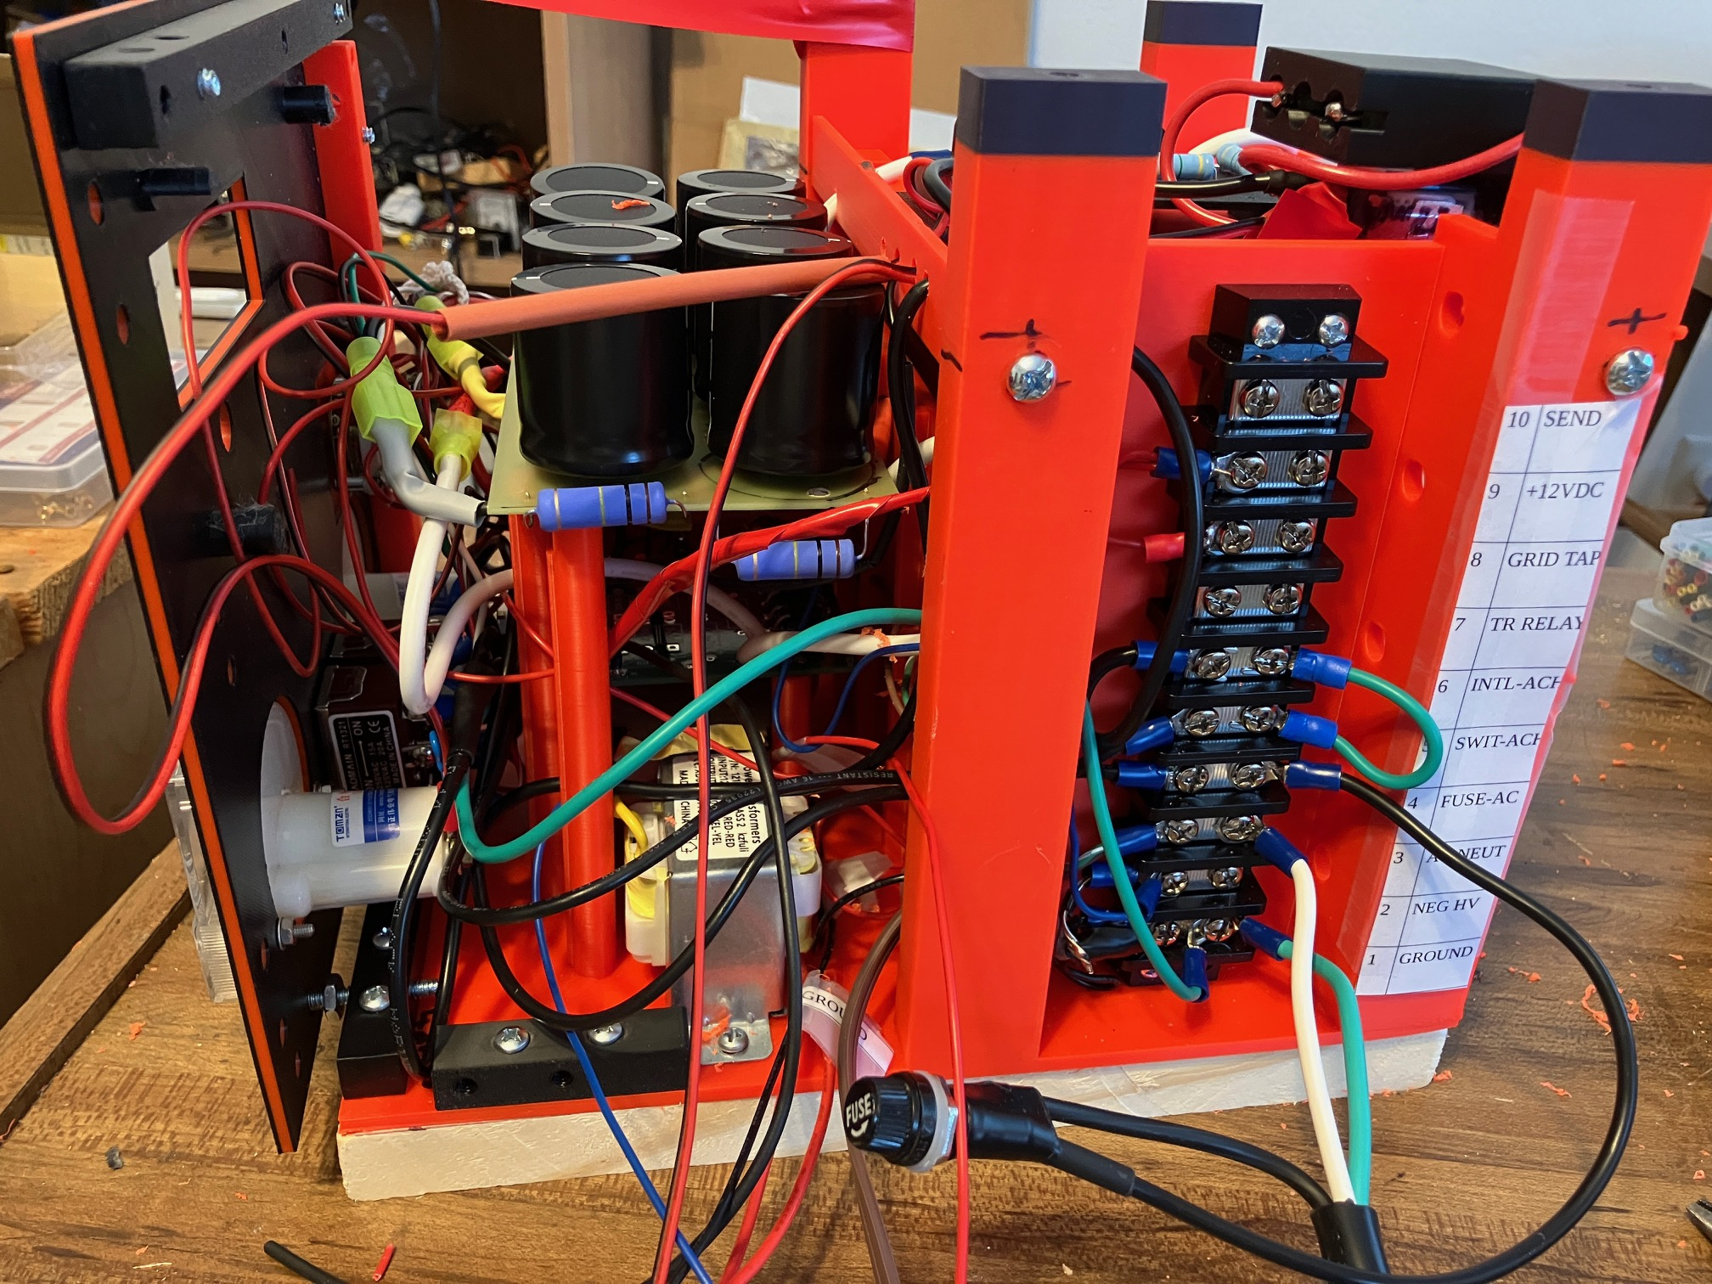
Perspective view from the left side shows the tiered circuit boards, and how the wiring behind the front panel toggle switches takes up too much room. The 10-terminal barrier strip that interfaces to the amplifier is at the left rear. The new tray just above the transformer can almost be seen. The panel mount fuse will mount on the back panel of the final enclosure.

PROGRESS
For the last two weeks, I've been working on constructing and mounting the three printed circuit boards of the 3+ kV power supply and wiring up much of the system.

Circuit Boards:
- Low Voltage (+12 Unregulated, -16 Unregulated; 12V Regulated) (bottom board; build on simple electronic perfboard)
- Rectifier and plate current shunt resistor board (middle board; Harbach https://harbachelectronics.com/shop/heathkit-sb220-sb221/rm-220-rectifermetering-board/; the cathode biasing portion is not used as those components will be inside the amplifier enclosure).
- High Voltage Filter Capacitor board (top board; Harbach https://harbachelectronics.com/shop/heathkit-sb220-sb221/fb-220-replacement-filter-capacitor-block/ )

Three sets of nested pillar/posts allowed the bottom board to be mounted first, then the middle and the top on top of all of it.

For the moment I have not yet tackled the Arduino/Nano board. This will be a modified and re-purposed "KX4Z Sequencer" board. (Github repository for Gerber, etc: https://github.com/docvacuumtubes/Sequencer ) That should come next month. A new sketch will be needed, but that doesn't appear difficult. The tasks of the board will include:

- Monitoring Grid Current and generating negative voltage ALC (0- negative 4VDC) to go to exciter
- Create positive going ALC voltage to go to multi-purpose panel meter option
- Monitor fused high voltage to detect arc fault (and then bypass amplifier to prevent grid damage)
- Monitor SEND input (ground to go into "transmit") -- and operate T/R (bypass) relay in Loudenboomer

"Glitch Resistor" & Fuse Protection Against ARC Fault Currents
The high voltage output goes through a 10 ohm glitch resistor which protects the circuitry from otherwise devastating damage in the event that a slightly gassy 3-500z tube arcs from plate to grid or cathode. The Heathkit SB--220 didn't have this protection. I was able to place that resistor horizontally between two of the "fins" on the finned vertical baffle that was 3D printed just forward of the transformer, for such mounting. The fins of that baffle also allowed drilled holes to separate and fix the position of transformer wiring.

More Real Estate
I needed more "real estate" than just the three circuit boards for at least three additional items. Further, the vertical pillars on the sides of the power transformer needed more support. Therefore I designed and 3D printed a horizontal platform of 4mm thickness designed to go above the transformer. Threaded 10-24 holes in the platform accept screws passing through a drilled hole in each pillar. The result is a well-insulated platform and considerably improved rigidity of the pillars designed to support lifting handles on top of the case

This above-transformer platform allowed placement of three items:

- A 3-D printed assembly that holds an inexpensive 12-V coil relay to provide the "slow start" feature, and three 10-ohm 10-watt resistors in series, that the relay allows in series with the high voltage and filament transformers' primary, and then can bypass when the initial current surge is over. The original Heathkit SB-220 didn't have this, but Harbach and other mods allow many to add it to their amplifiers to reduce stress on the power supply components and potential mechanical damage to the filaments from the high current surge. (Other writers have found that the tube's elements are not at significant risk with the usual surge current.)1
- High voltage series fuse on the amplifier side of the 10-ohm "glitch resistor." In my experience with SB-200 amplifiers, a 3AG fuse works pretty well to interrupt the arc current if a tube arcs. Many original 3-500Z amplifiers didn't include this. It is said that an arc will do considerable damage to the rectifier/capacitor string, without the glitch resistor/fuse protection.
- The high voltage string of resistors that allow direct analog metering of the high voltage, positioned by choice on the amplifier side of the fuse. (My available perf-boards are poor quality, so I just printed a small raised board with spaced holes to allow mounting components.)

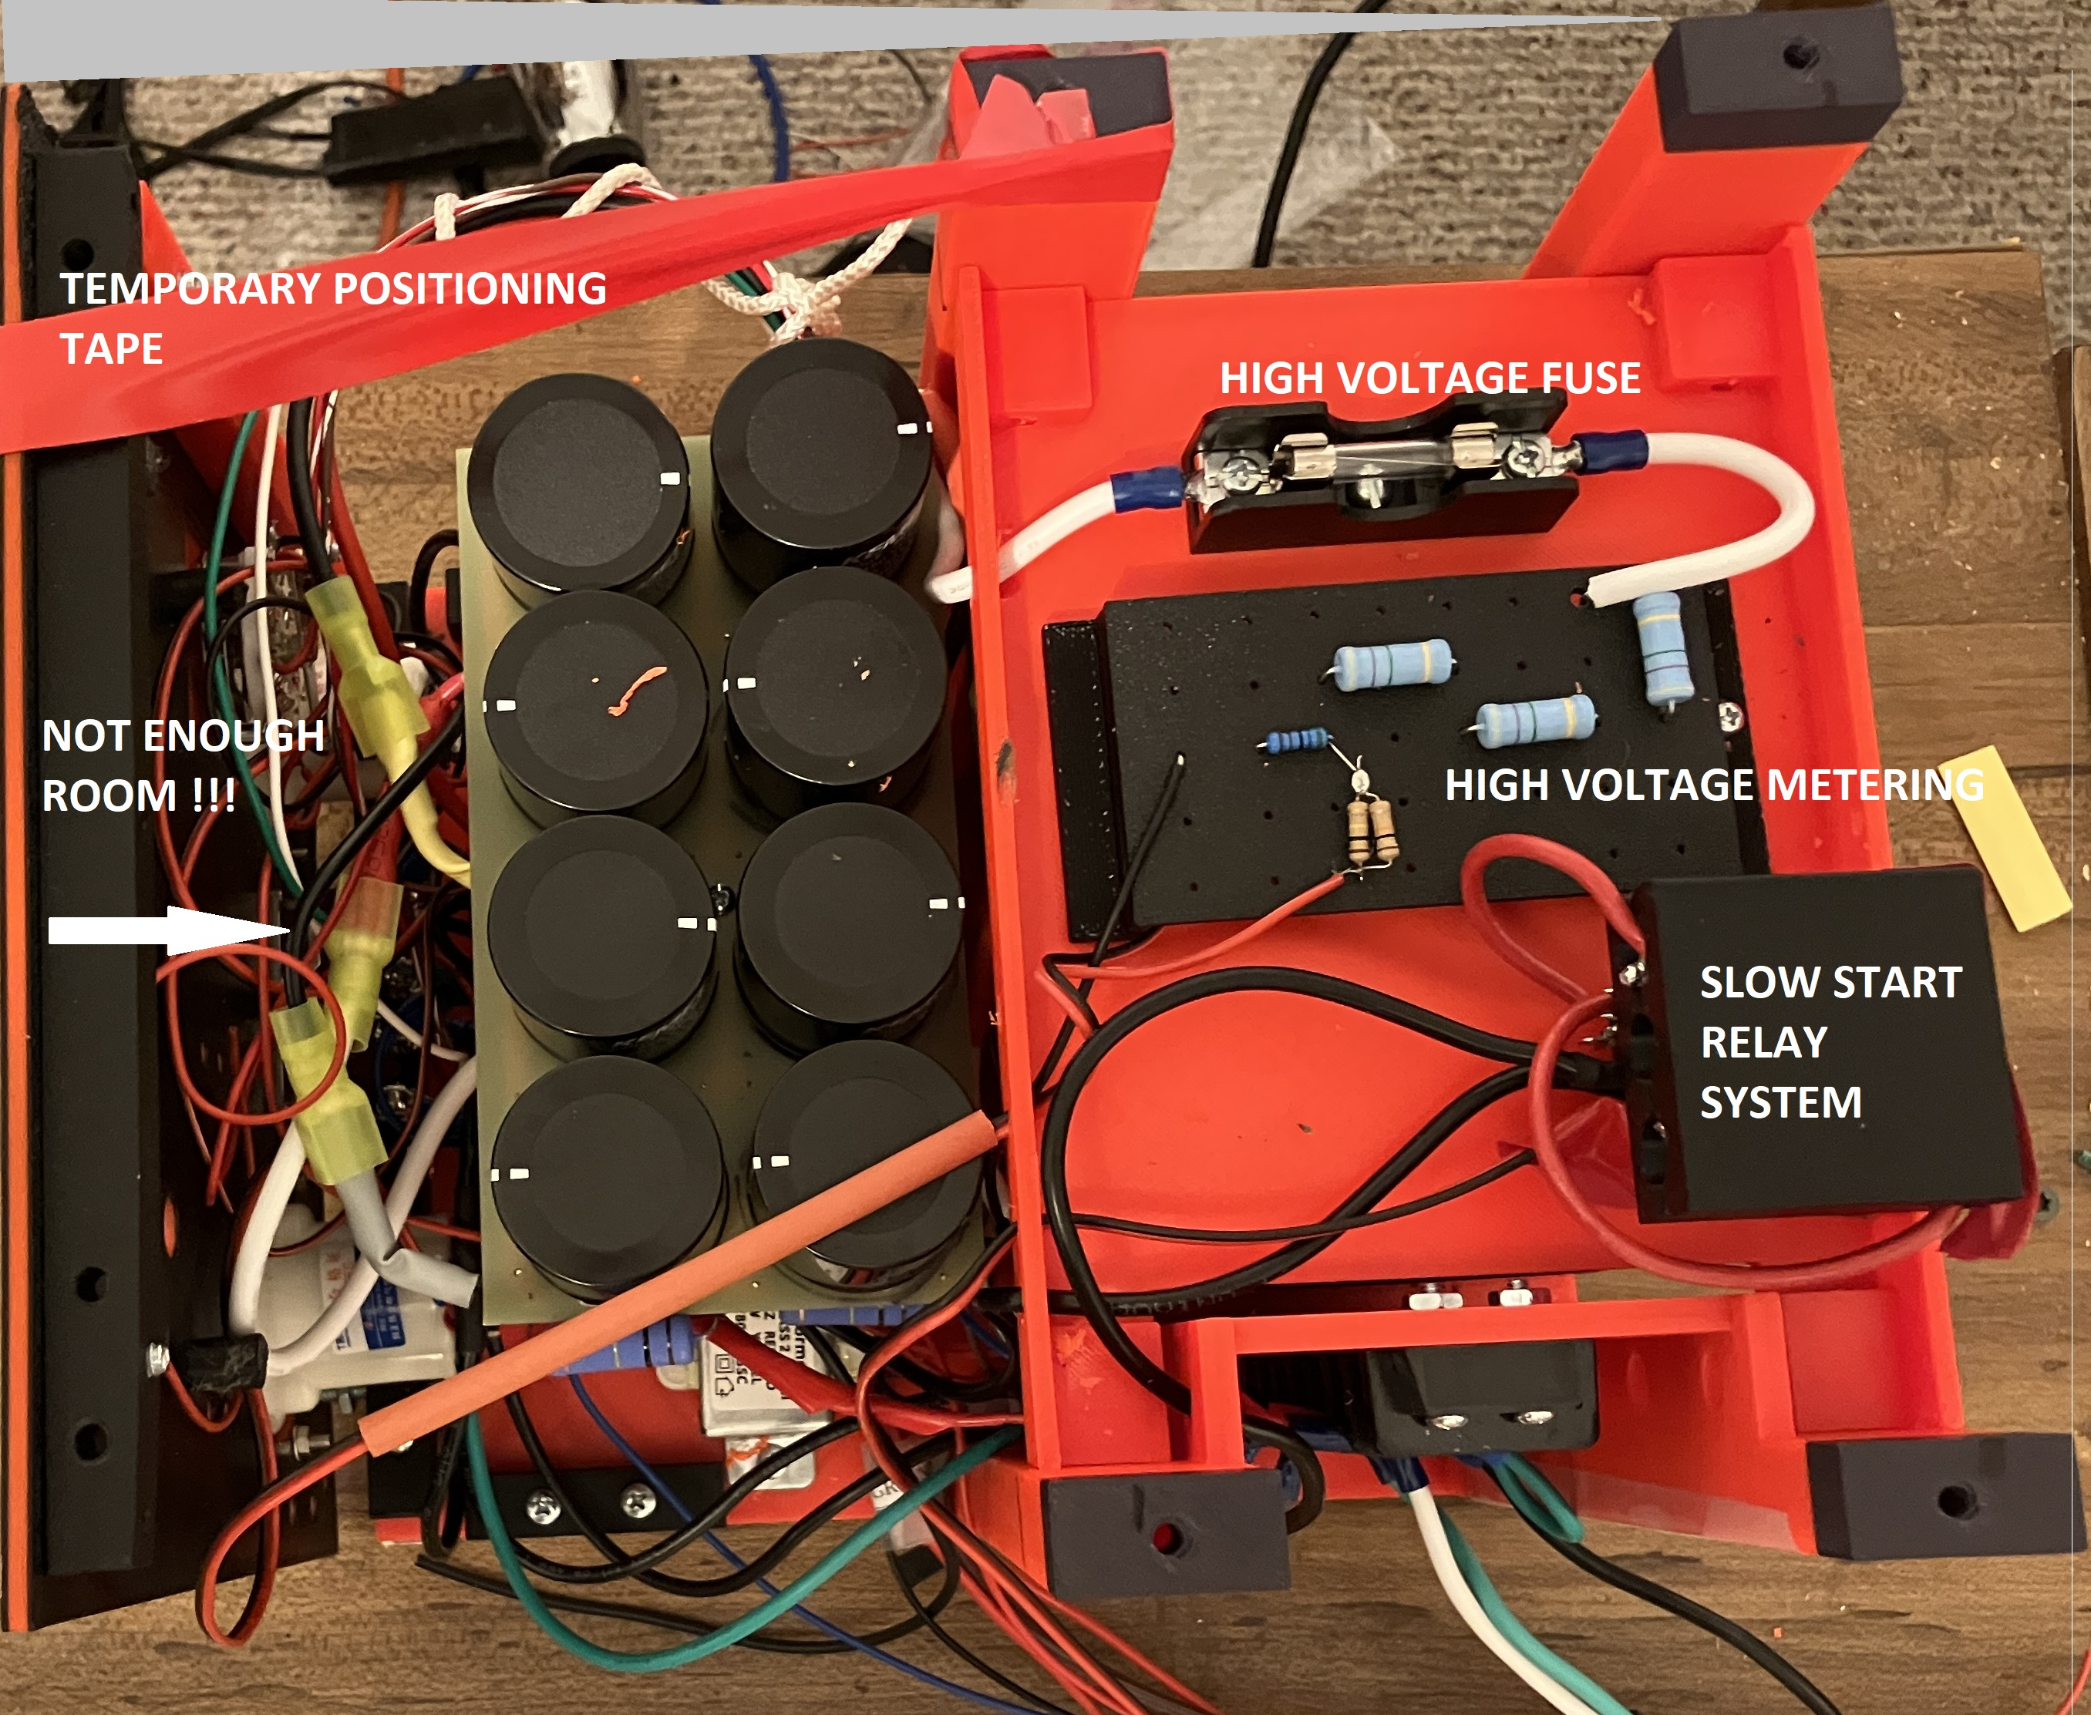
TOP VIEW 10/16/2026 shows the contents of the added "tray" above the transformer as well as how the wiring behind the front panel switches has become a problem.

Placing the HV metering resistor string on the amplifier side of the fuse has a big additional benefit. In the event of a tube arc, when the high voltage is disconnected by the fuse, you do NOT want RF input power to be seen by the 3-500Z grid, as it may self-destruct from the resulting current with no plate high voltage. Having the voltage sensing on the amplifier side of the fuse allows the Arduino Nano circuitry to monitor the status of the High Voltage and immediately bypass the amplifier (using the T/R relay) in the even of a fuse blow.

The holes that were 3D printed in the supports to either side of the 10-terminal barrier strip and also in the baffles surrounding the printed circuit boards were a great help in stabilizing the position of power supply wiring.

Cardboard Insulation
To help isolate the low voltage supply on the bottom of the circuit board stack from high voltage wire going to the rectifier printed circuit board, I used a piece of cardboard with circular holes to fit over the posts for the rectifier board. That worked nicely to separate the two.

SELF-CREATED PROBLEM: I should have remembered the limited clearance behind the screw terminals of the large toggle switches and the baffle just behind them, visible in the photo in Part 1 of this series. I didn’t. Instead I proceeded to crimp and solder very nice spade terminals on all the primary wires and use them to connect nicely to the screw terminals -- and created a massive obstruction to getting the front panel to recess enough to fit! The solution will be to remove the crimp ring/spade terminals and just solder the primary wires to the terminals on the switches. This will save a lot of space and allow the front panel to mate flush with the base-board. This is a very compact power supply!

CAREFUL HV WIRING: A lot of thought was given to the wire for the high voltage wiring. Dry air has the ability to withstand as much as 3kV per millimeter, but providing conservative insulation and space around high voltage wiring may protect against unexpectedly high field strengths caused by sharp points rather than perfectly rounded edges on high voltage carrying conductors. While the original Loudenboomer was wired with fairly common hookup wire for the high voltage wiring, I chose to order some wire rated to 30kV with much thicker insulation. Next, I need to work on LEAD DRESS so that all wires have good clearance and aren't touching something such as a hot resistor that would result in failure eventually.

In another portion of this series, I'll explain some of the work going on with the Amplifier cooling system; and in later issues, the T/R relays in the Loudenboomer and the design of the Arduino Nano power supply controller board.

