Basic Integration Printer Test

1" top and bottom margins, 1.25" left and right margins. This paragraph starts off with a 1/2" indent. Title text formatted in font, Times New Roman font,18 point, single underline. Times New Roman is a TrueType font. The paragraph text is formatted using Times New Roman font, 10 point, no underline, justified. All formatting information particulars for each test will be footnoted.

Special Characters & Leader Tabs:
Do the following special characters print in Word? A key sequence is listed beside each character description so that you can generate the character under Windows Write. The leader tabs are formatted so that they end at the same place. Do they print as such? If not, enter the bug.

Bullet (Alt+0183) •
Copyright (Alt+0211) ©
Greek delta (Alt+098) β

Umlauted A (Ctrl-Shift', A) Ä

ANSI and International Characters:
Arial

 | -0 | -1 | -2 | -3 | -4 | -5 | -6 | -7 | -8 | -9 | -A | -B | -C | -D | -E | -F
 |  | ! | " | # | $ | % | & | ' | ( | ) | * | + | , | - | . | /
2- | 32 | 33 | 34 | 35 | 36 | 37 | 38 | 39 | 40 | 41 | 42 | 43 | 44 | 45 | 46 | 47
 | 0 | 1 | 2 | 3 | 4 | 5 | 6 | 7 | 8 | 9 | : | ; | < | = | > | ?
3- | 48 | 49 | 50 | 51 | 52 | 53 | 54 | 55 | 56 | 57 | 58 | 59 | 60 | 61 | 62 | 63
 | @ | A | B | C | D | E | F | G | H | I | J | K | L | M | N | O
4- | 64 | 65 | 66 | 67 | 68 | 69 | 70 | 71 | 72 | 73 | 74 | 75 | 76 | 77 | 78 | 79
 | P | Q | R | S | T | U | V | W | X | Y | Z | [ | \ | ] | ^ | _
5- | 80 | 81 | 82 | 83 | 84 | 85 | 86 | 87 | 88 | 89 | 90 | 91 | 92 | 93 | 94 | 95
 | ` | a | b | c | d | e | f | g | h | i | j | k | l | m | n | o
6- | 96 | 97 | 98 | 99 | 100 | 101 | 102 | 103 | 104 | 105 | 106 | 107 | 108 | 109 | 110 | 111
 | p | q | r | s | t | u | v | w | x | y | z | { | | | } | ~ | 
7- | 112 | 113 | 114 | 115 | 116 | 117 | 118 | 119 | 120 | 121 | 122 | 123 | 124 | 125 | 126 | 127
 | € |  | ‚ | ƒ | „ | … | † | ‡ | ˆ | ‰ | Š | ‹ | Œ |  | Ž
8- | 128 | 129 | 130 | 131 | 132 | 133 | 134 | 135 | 136 | 137 | 138 | 139 | 140 | 141 | 142 | 143
 |  | ‘ | ’ | “ | ” | • | — | – | ˜ | ™ | š | › | œ |  | ž | Ÿ
9- | 144 | 145 | 146 | 147 | 148 | 149 | 150 | 151 | 152 | 153 | 154 | 155 | 156 | 157 | 158 | 159
 |  | ¡ | ¢ | £ | ¤ | ¥ | ¦ | § | ¨ | © | ª | « | ¬ |  | ® | ¯
A- | 160 | 161 | 162 | 163 | 164 | 165 | 166 | 167 | 168 | 169 | 170 | 171 | 172 | 173 | 174 | 175
 | ° | ± | ² | ³ | ´ | µ | ¶ | · | ¸ | ¹ | º | » | ¼ | ½ | ¾ | ¿
B- | 176 | 177 | 178 | 179 | 180 | 181 | 182 | 183 | 184 | 185 | 186 | 187 | 188 | 189 | 190 | 191
 | À | Á | Â | Ã | Ä | Å | Æ | Ç | È | É | Ê | Ë | Ì | Í | Î | Ï
C- | 192 | 193 | 194 | 195 | 196 | 197 | 198 | 199 | 200 | 201 | 202 | 203 | 204 | 205 | 206 | 207
 | Ð | Ñ | Ò | Ó | Ô | Õ | Ö | × | Ø | Ù | Ú | Û | Ü | Ý | Þ | ß
D- | 208 | 209 | 210 | 211 | 212 | 213 | 214 | 215 | 216 | 217 | 218 | 219 | 220 | 221 | 222 | 223
 | à | á | â | ã | ä | å | æ | ç | è | é | ê | ë | ì | í | î | ï
E- | 224 | 225 | 226 | 227 | 228 | 229 | 230 | 231 | 232 | 233 | 234 | 235 | 236 | 237 | 238 | 239
 | ð | ñ | ò | ó | ô | õ | ö | ÷ | ø | ù | ú | û | ü | ý | þ | ÿ
F- | 240 | 241 | 242 | 243 | 244 | 245 | 246 | 247 | 248 | 249 | 250 | 251 | 252 | 253 | 254 | 255
 | -0 | -1 | -2 | -3 | -4 | -5 | -6 | -7 | -8 | -9 | -A | -B | -C | -D | -E | -F

Fields
There are three types of fields, marker, display, and result. Marker fields should be invisible when printed. Display fields should consist of a picture when printed, and result fields should yield the correct mathematical result when printed. Make sure that result fields are updated at time of printing. This is a checkbox option in the Tools/Options/Print menu.

Result Field: 90 90 should be printed
Display Field: • • should be printed (Alt+0183)
Marker Field: Nothing should be printed.
The field code is:{tc "{seq appendix \* Alphabetic}-{seq figure}"}

Format Columns: Equal Width Column
One Column

This column is six inches in width. The left and right margins of this document are set at 1.25 inches. Verify that this column is indeed six inches in width. If it isn't, write up that bug!

Two Columns

This column of text is 2.75 inches (that's two and three-quarters of an inch) wide. The two columns here are both of this width. There is 0.5 inches between the columns. In addition, the left margin of the first column and the right margin of the second column should line up with the left and right margins of the first column. The columns should appear balanced, the text being fully justified. Verify that each of these columns are indeed 2.75 inches wide. Please also verify the 0.5 inch space between the columns. The edges should not appear ragged.

Three Columns

There are three equally wide columns of text here. Each column is 1.625 inches (that's one and five-eighths of an inch) wide. The three columns here are both of this width. There is 0.5 inches between the columns. In addition, the left margin of the first column and the right margin of the third column should line up with the left and right margins of the first column. The columns should appear balanced, the text being fully justified. Verify that each of these columns are indeed 1.625 inches wide. Please also verify the 0.5 inch space between the columns. The edges should not appear ragged.

Variable Width Columns:
Left Small Column, Right Wide Column

The two columns here are not of the same width. There is 0.5 inches between the columns. The first column is 1.83 inches wide. The second column is 3.67 inches wide. In addition, the left margin of the first column and the right margin of the second column should line up with the left and right margins of the first column. The columns should appear unbalanced, the text being fully justified. Verify that each of these columns are indeed 1.83 and 3.67 inches wide respectively. Please also verify the 0.5 inch space between the columns. The edges should not appear ragged.

Left Wide Column, Right Small Column

The two columns here are not of the same width. There is 0.5 inches between the columns. The first column is 3.67 inches wide. The second column is 1.83 inches wide. In addition, the left margin of the first column and the right margin of the second column should line up with the left and right margins of the first column. The columns should appear unbalanced, the text being fully justified. Verify that each of these columns are indeed 3.67 and 1.83 inches wide respectively. Please also verify the 0.5 inch space between the columns. The edges should not appear ragged.

Format Columns: Line Between

Left Wide Column, Right Small Column

The two columns here are not of the same width. There is 0.5 inches between the columns. The first column is 3.67 inches wide. The second column is 1.83 inches wide. In addition, the left margin of the first column and the right margin of the second column should line up with the left and right margins of the first column. The columns should appear unbalanced, the text being fully justified. There should be a vertical line inbetween the columns acting as visual separators. Verify that each of these columns are indeed 3.67 and 1.83 inches wide respectively. Please also verify the 0.5 inch space between the columns. The edges should not appear ragged.

Three Columns

There are three equally wide columns of text here. Each column is 1.625 inches (that's one and five-eighths of an inch) wide, separated by a vertical line. The three columns here are both of this width. There is 0.5 inches between the columns. In addition, the left margin of the first column and the right margin of the third column should line up with the left and right margins of the first column. The columns should appear balanced, the text being fully justified. Verify that each of these columns are indeed 1.625 inches wide. Please also verify the 0.5 inch space between the columns. The edges should not appear ragged.

Equations:
Here are some equations generated in MathType. Each one is followed by the mathematical description of the equation. Are each of these equation descriptions represented properly in printed form?

Here are some equations generated in WinWord. Each one is followed by the mathematical description of the equation. Are each of these equation descriptions represented properly in printed form?

3 by 3 matrix. 1 2 3 in first row, 2 3 1 in second row, 3 1 2 in third row.

"x is equal to one half"

"The quadratic equation: x is equal to negative b plus the square
root of b square - 4 times a times c divided by 2 times a"

The prefix "re" lies directly above the word "Visionary Manuals"

"a divided by b"
"Average is equal to sum divided by count"
"The integral from one over the square root of b to negative third root of a of e to the nth power." The sum of the square root of i taken from i = 0 to n squared, multiplied by pi

The multiplicative sum of the square root of i taken from i = 0 to n squared, multiplied by pi

p is the set of all elements containing x,y, and z.

Tables:
Verify the following elements in the tables: border line width, border style, border intersections, table cell shading, text wrap in table, character formatting in table, and decimal tab alignment in table column.

This table contains double line borders around the edges and single line borders around the individual cells. | 567,845.56 | Right Aligned, bolded, strikethrough
25 % shading in this column. | 67,887.47 | Centered, allcaps
 | 635,733.03 | Left Aligned, Small caps

AutoColor Text:
Text should appear in white on a black background in the example below. If you don't see the text, it's a bug!
This autocolor text test has passed if you can read this!

Font & Shading Cascade:
Each of the two text columns should form a nicely shaped triangle. The length of each line should be longer than the previous one. The degree of shading used on each line is darker than the previous line. Make sure that no two lines use the same shading pattern. It's a bug if two lines use the same shading. Verify correct border thickness and border line joining. No lines should cross into each other.

Times New Roman 8 pt. 3/4 pt box border 5 % shading
Times New Roman 9 pt. 3/4 pt shadow border 10% shading
Times New Roman 10 pt. 3 pt box border 20% shading
Times New Roman 11 pt. 3 pt shadow border 25% shading
Times New Roman 12 pt. 3/4 pt box dbl bdr 30% shading
Times New Roman 14 pt. 3/4 pt box dbl shdw 40% shading
Times New Roman 16 pt. 50% shading
Times New Roman 18 pt. 60% shading
Times New Roman 20 pt. 70% shading
Times New Roman 22 pt. 75% shading
Times New Roman 24 pt. 80% shading
Times New Roman 26 pt. 90% shading

Underlining
This line of text is single underlined. Baseline/Underline Spacing Test: Verify that correct spacing exists between the text baseline and the underline, about 1 point of space for 12 point text, proportionally more or less depending on the font size used. Underline Positioning and Length Test: Verify that the underlining for an italicized j and l start and end at a reasonably correct space for each underline style. 4, 10, and 72 point sizes are tested here,
jjj Single underline, 4 point italicized text Small Caps ^{super}_{subscript fff}
jjj Word underline, 4 point italicized text Small Caps ^{super}_{subscript fff}
jjj Double underline, 4 point italicized text Small Caps fff
jjj Dotted underline, 4 point italicized text Small Caps fff
jjj Single underline, 12 point italic text Small Caps fff
jjj Word underline, 12 point italic text Small Caps fff
jjj Double underline, 12 point italic text Small Caps fff
jjj Dotted underline, 12 point italic text Small Caps fff
j Single ul, 36 pt italic text Small Caps f
j Word ul, 36 pt italic text Small Caps f
j Double ul, 36 pt italic text Small Caps f
j Dotted ul, 36 pt italic text Small Caps f
This is a test of underline weight averaging. 8 pt text. Notice the ever enlargening text. 9 pt. Verify that the underline for each line appears in the same weight. 10 pt. Does the underline look good? 11 pt.This weight in this line should be different from the weight and baseline/underline spacing used in the next line. 12 pt.14 pt.16 pt.18 pt.20 pt.22 pt.24 pt.

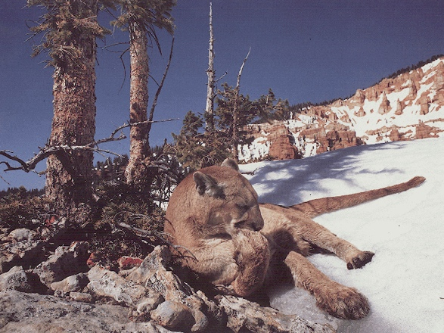Graphics

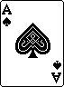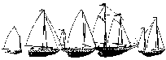

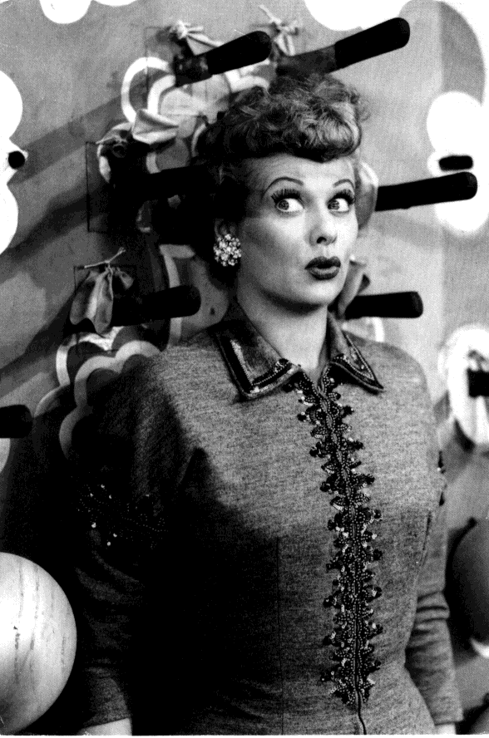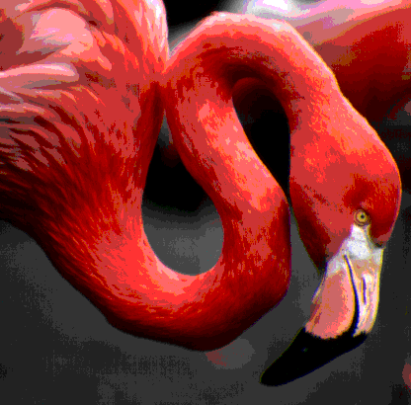

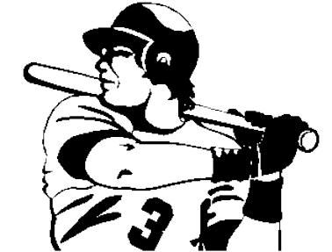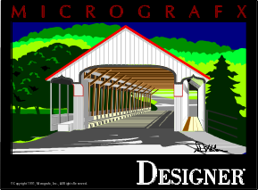The previous page contains 7 pictures. Check the image quality, size and positioning each of picture carefully. Look for banding problems, chunks of the image missing, and contrast problems.

Picture 1 is a photograph of a lady with several knives around her head. This is a 16-color greyscale TIFF image. Its original size is 3.92" wide by 5.92" tall. The graphic has a single border around its edges. Note: The bottom border is slightly larger than the graphic. A small white area between the border and the graphic exists and is by design, not a bug. The picture's dimensions are 1.96" x 2.96", scaled down 50% of its orignal size. The picture is horizontally positioned 0.75" relative to the page and vertically positioned 2.5" relative to the page.

Picture 2 is a monochrome OS/2 DIB of an Ace of Spands, printed in the header. Its original size is 71x96 pixels or 0.59" x 0.8". The picture is horizontally positioned 3" relative to the page and vertically positioned 2.5" relative to the page.

Picture 3 is a 256-color DIB of a cougar in the wild. There should be a cougar licking its paw in the middle of the picture, sitting on a bed of snow and ricks, next to a couple of trees. In addition, there is a nice blue sky. The picture's original size was 5.33" x 4.00", but has been scaled down to 50% to 2.67" x 2". The picture is horizontally positioned 4.5" relative to the page and vertically positioned 1.75" relative to the page.

Picture 4 is a monochrome TIFF picture of a bunch of small sailboats. This picture has been scaled down by 25%. The dimensions of the picture are 2.04" x 0.74". The picture is horizontally positioned 3.0" relative to the page and vertically positioned 4.75" relative to the page.

Picture 5 is a Windows metafile of an old wooden bridge. The graphic uses many colors. Its dimensions are 1.51" x 1.42". This picture was scaled down by 50%. The picture is horizontally positioned 5.5" relative to the page and vertically positioned 5.25" relative to the page.

Picture 6 is a monochrome EPS file containing a TIFF screen representation. It is a picture of a baseball player holding a bat with the number 3 on his chest. The picture is bordered to deliniate its edges. This picture is 1.97" x 1.49", scaled down to 45% of its original size. The picture is horizontally positioned 0.75" relative to the page and vertically positioned 6.5" relative to the page.

Picture 7 is a 256-color pallete-color TIFF image. It is the neck and head of a pelican on a large dark gray and black background. The image is 2.89" x 2.85", scaled down by 50% for this document.

